**PYTHON**

**Python Introduction**

**What is Python?**

Python is a popular programming language. It was created by Guido van Rossum, and released in 1991.

It is used for:

* web development (server-side),
* software development,
* mathematics,
* system scripting.

Python Features Python is a dynamic, high-level, free open source, and interpreted programming language. It supports object-oriented programming as well as procedural-oriented programming. In Python, we don’t need to declare the type of variable because it is a dynamically typed language. For example, x = 10 Here, x can be anything such as String, int, etc. In this article we will see what characteristics describe the python programming language.

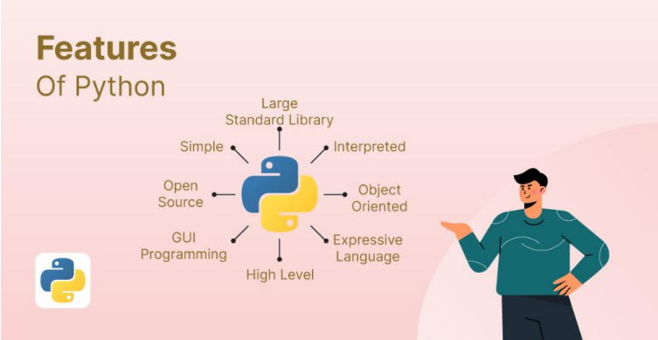

**Features in Python**

1. Free and Open Source
2. Easy to code Python is a high-level programming language.
3. Easy to Read As you will see, learning Python is quite simple.
4. Object-Oriented Language One of the key features of Python is Object-Oriented programming.
5. Interpreted Language:

**Why Python?**

* Python works on different platforms (Windows, Mac, Linux, Raspberry Pi, etc).
* Python has a simple syntax similar to the English language.
* Python has syntax that allows developers to write programs with fewer lines than some other programming languages.
* Python runs on an interpreter system, meaning that code can be executed as soon as it is written. This means that prototyping can be very quick.
* Python can be treated in a procedural way, an object-oriented way or a functional way.

**Python Syntax compared to other programming languages**

* Python was designed for readability, and has some similarities to the English language with influence from mathematics.
* Python uses new lines to complete a command, as opposed to other programming languages which often use semicolons or parentheses.
* Python relies on indentation, using whitespace, to define scope; such as the scope of loops, functions and classes. Other programming languages often use curly-brackets for this purpose.

**First Program:**

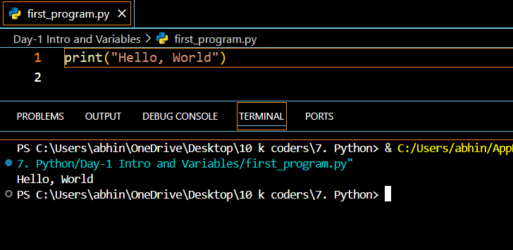

**Python Variables**

Python Variable is containers that store values. Python is not “statically typed”. We do not need to declare variables before using them or declare their type. A variable is created the moment we first assign a value to it. A Python variable is a name given to a memory location. It is the basic unit of storage in a program.

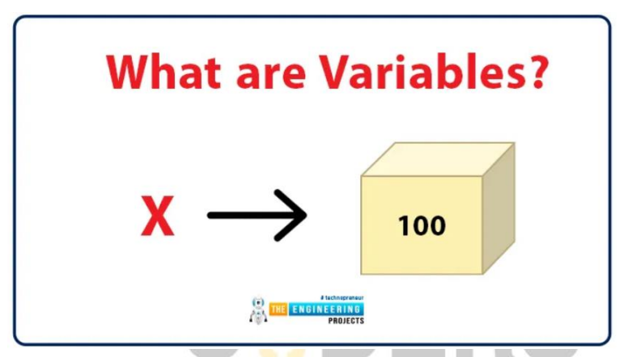

**Example of Variable in Python**

An Example of a Variable in Python is a representational name that serves as a pointer to an object. Once an object is assigned to a variable, it can be referred to by that name. In layman’s terms, we can say that Variable in Python is containers that store values.

var = "10KCoders"

**Variables Assignment in Python**

Here, we will define a variable in python. Here, clearly we have assigned a number, a floating point number, and a string to a variable such as age, salary, and name.

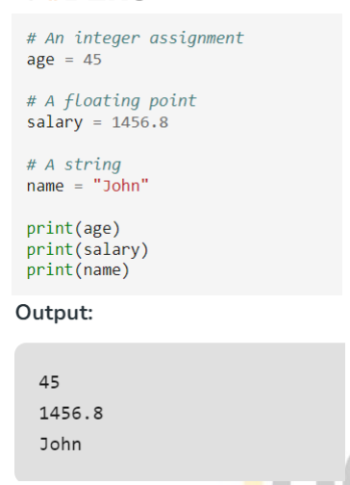

**Declaration and Initialization of Variables**

Let’s see how to declare a variable and how to define a variable and print the variable.

**For example:**

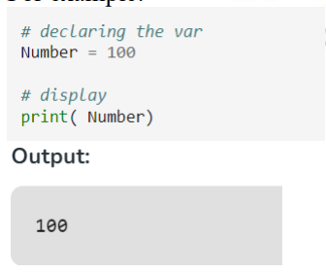

**Redeclaring variables**

in Python We can re-declare the Python variable once we have declared the variable and define variable in python already.

**For example**:

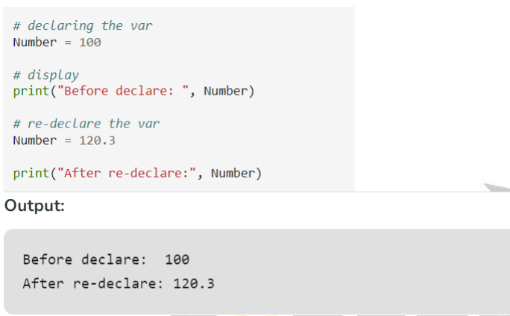

**Python Assign Values to Multiple Variables Also,**

Python allows assigning a single value to several variables simultaneously with “=” operators.

**For example:**

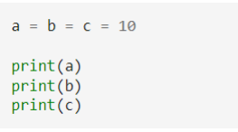

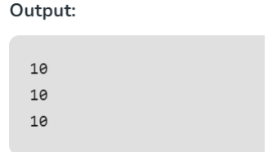

**Assigning different values to multiple variables**

Python allows adding different values in a single line with “,” operators.

**For example**

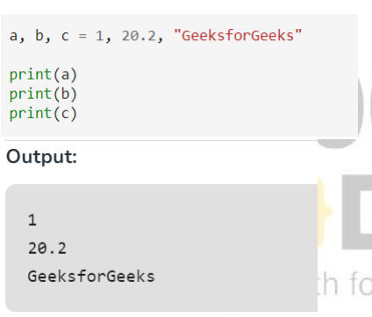

**Python Installation:**

https://www.tutorialspoint.com/how-to-install-python-in-windows

**Python Syntax:**

**Python Indentation**

* Indentation refers to the spaces at the beginning of a code line.
* Where in other programming languages the indentation in code is for readability only, the indentation in Python is very important.
* Python uses indentation to indicate a block of code.

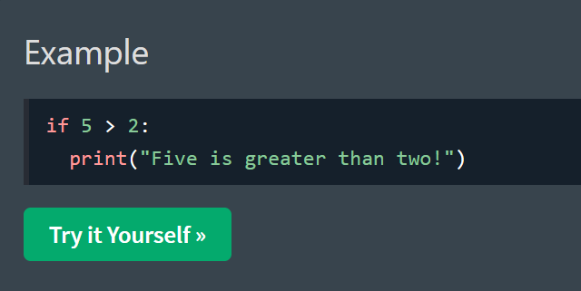

**Python Comments**

* Comments can be used to explain Python code.
* Comments can be used to make the code more readable.
* Comments can be used to prevent execution when testing code.

**Creating a Comment**

Comments starts with a #, and Python will ignore them:

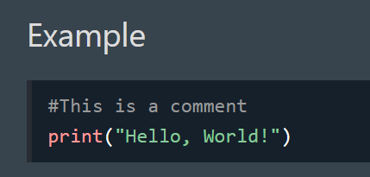

**Multiline Comments**

Python does not really have a syntax for multiline comments.

To add a multiline comment you could insert a # for each line:

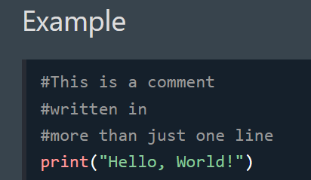

**Python Data Types**

**Python Data Types**

Python Data types are the classification or categorization of data items. It represents the kind of value that tells what operations can be performed on a particular data. Since everything is an object in Python programming, Python data types are classes and variables are instances (objects) of these classes.

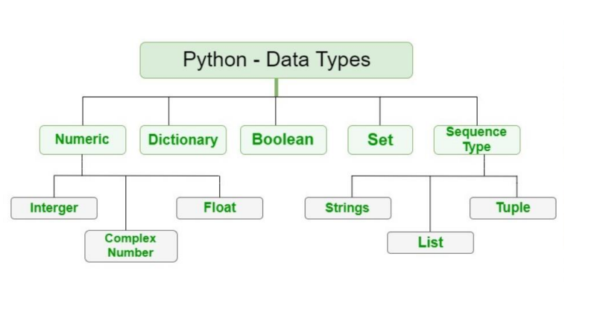

The following are the standard or built-in data types in Python:

* Numeric
* Sequence Type
* Boolean
* Set
* Dictionary

**Numeric Data Types in Python**

The numeric data type in Python represents the data that has a numeric value. A numeric value can be an integer, a floating number, or even a complex number.

**Integers** – This value is represented by int class. It contains positive or negative whole numbers (without fractions or decimals). In Python, there is no limit to how long an integer value can be.

**Float** – This value is represented by the float class. It is a real number with a floating-point representation.

**Complex Numbers** – A complex number is represented by a complex class. It is specified as (real part) + (imaginary part)j .

**For example** – 2+3j

**Note** – type() function is used to determine the type of Python data type.

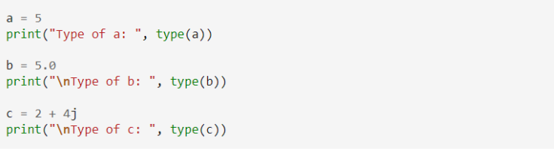

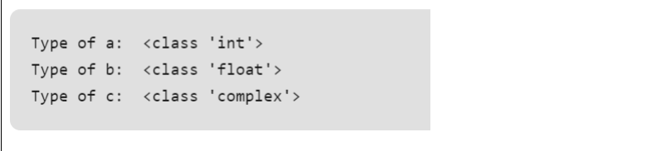

**Sequence Data Types in Python**

The sequence Data Type in Python is the ordered collection of similar or different Python data types. Sequences allow storing of multiple values in an organized and efficient fashion. There are several sequence data types of Python:

* Python String
* Python List
* Python Tuple

**String Data Type**

Strings in Python are arrays of bytes representing Unicode characters. A string is a collection of one or more characters put in a single quote, double-quote, or triple-quote.

**Example:** This Python code showcases various string creation methods. It uses single quotes, double quotes, and triple quotes to create strings with different content and includes a multiline string. The code also demonstrates printing the strings and checking their data types.

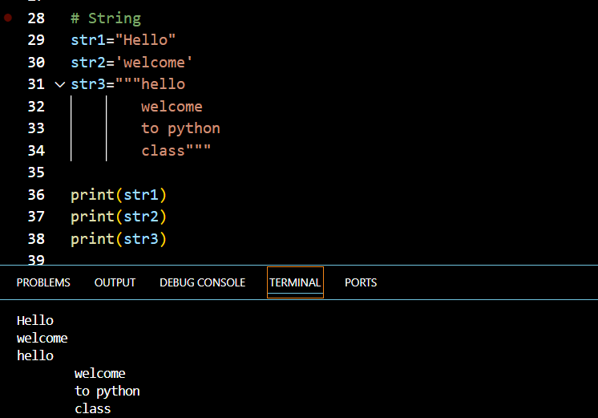

**List Data Type**

Lists are just like arrays, declared in other languages which is an ordered collection of data. It is very flexible as the items in a list do not need to be of the same type.

**Creating a List in Python** Lists in Python can be created by just placing the sequence inside the square brackets[].

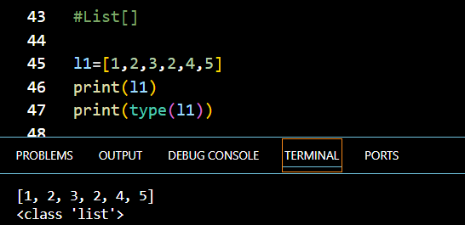

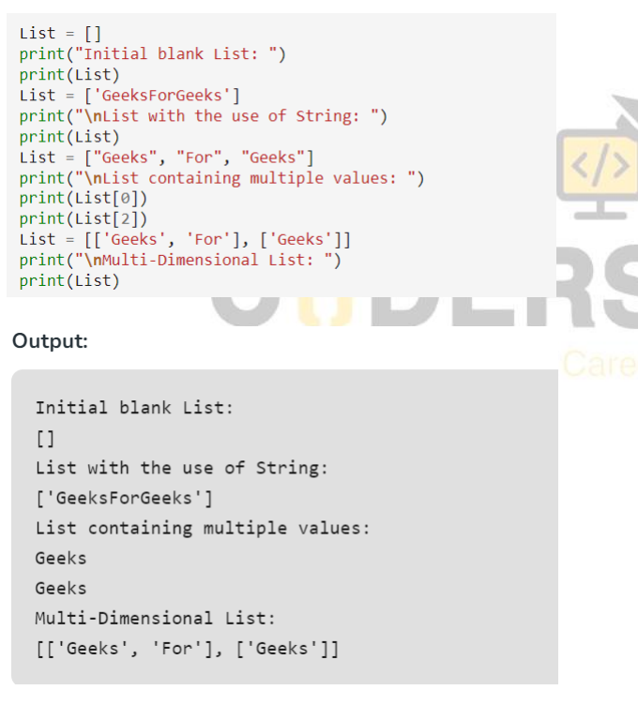

**Tuple Data Type**

Just like a list, a tuple is also an ordered collection of Python objects. The only difference between a tuple and a list is that tuples are immutable i.e. tuples cannot be modified after it is created. It is represented by a tuple class.

**Creating a Tuple in Python**

In Python Data Types, tuples are created by placing a sequence of values separated by a ‘comma’ with or without the use of parentheses for grouping the data sequence

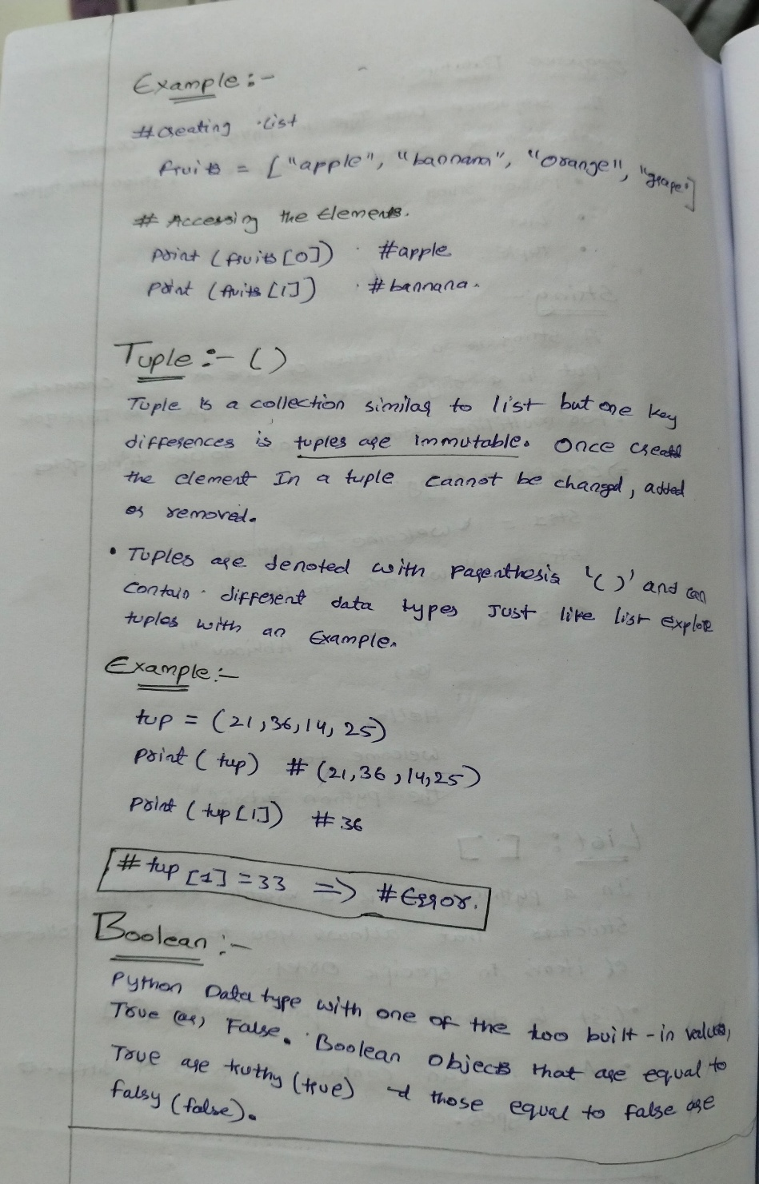

**Boolean Data Type in Python**

Python Data type with one of the two built-in values, True or False. Boolean objects that are equal to True are truthy (true), and those equal to False are falsy (false). However non-Boolean objects can be evaluated in a Boolean context as well and determined to be true or false. It is denoted by the class bool.

**Note** – True and False with capital ‘T’ and ‘F’ are valid booleans otherwise python will throw an error.

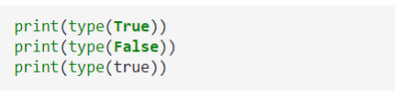

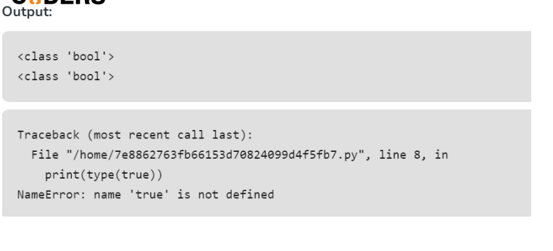

**Set Data Type in Python**

In Python Data Types, a Set is an unordered collection of data types that is iterable, mutable, and has no duplicate elements. The order of elements in a set is undefined though it may consist of various elements.

**Create a Set in Python**

Sets can be created by using the built-in set() function with an iterable object or a sequence by placing the sequence inside curly braces, separated by a ‘comma’. The type of elements in a set need not be the same, various mixed-up data type values can also be passed to the set.

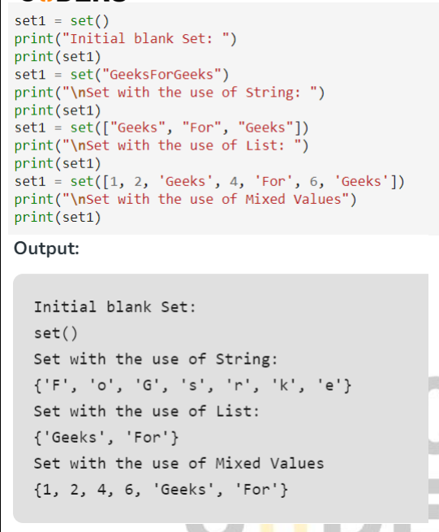

**Dictionary Data Type in Python**

A dictionary in Python is an unordered collection of data values, used to store data values like a map, unlike other Python Data Types that hold only a single value as an element, a Dictionary holds a key: value pair. Key-value is provided in the dictionary to make it more optimized. Each key-value pair in a Dictionary is separated by a colon : , whereas each key is separated by a ‘comma’

**Create a Dictionary in Python**

In Python, a Dictionary can be created by placing a sequence of elements within curly {} braces, separated by ‘comma’. Values in a dictionary can be of any datatype and can be duplicated, whereas keys can’t be repeated and must be immutable.

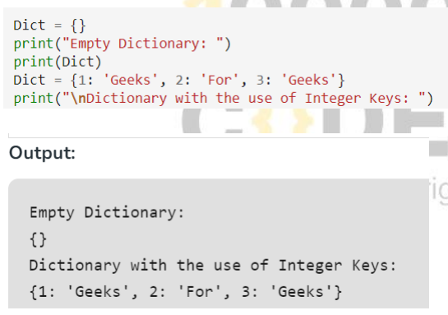

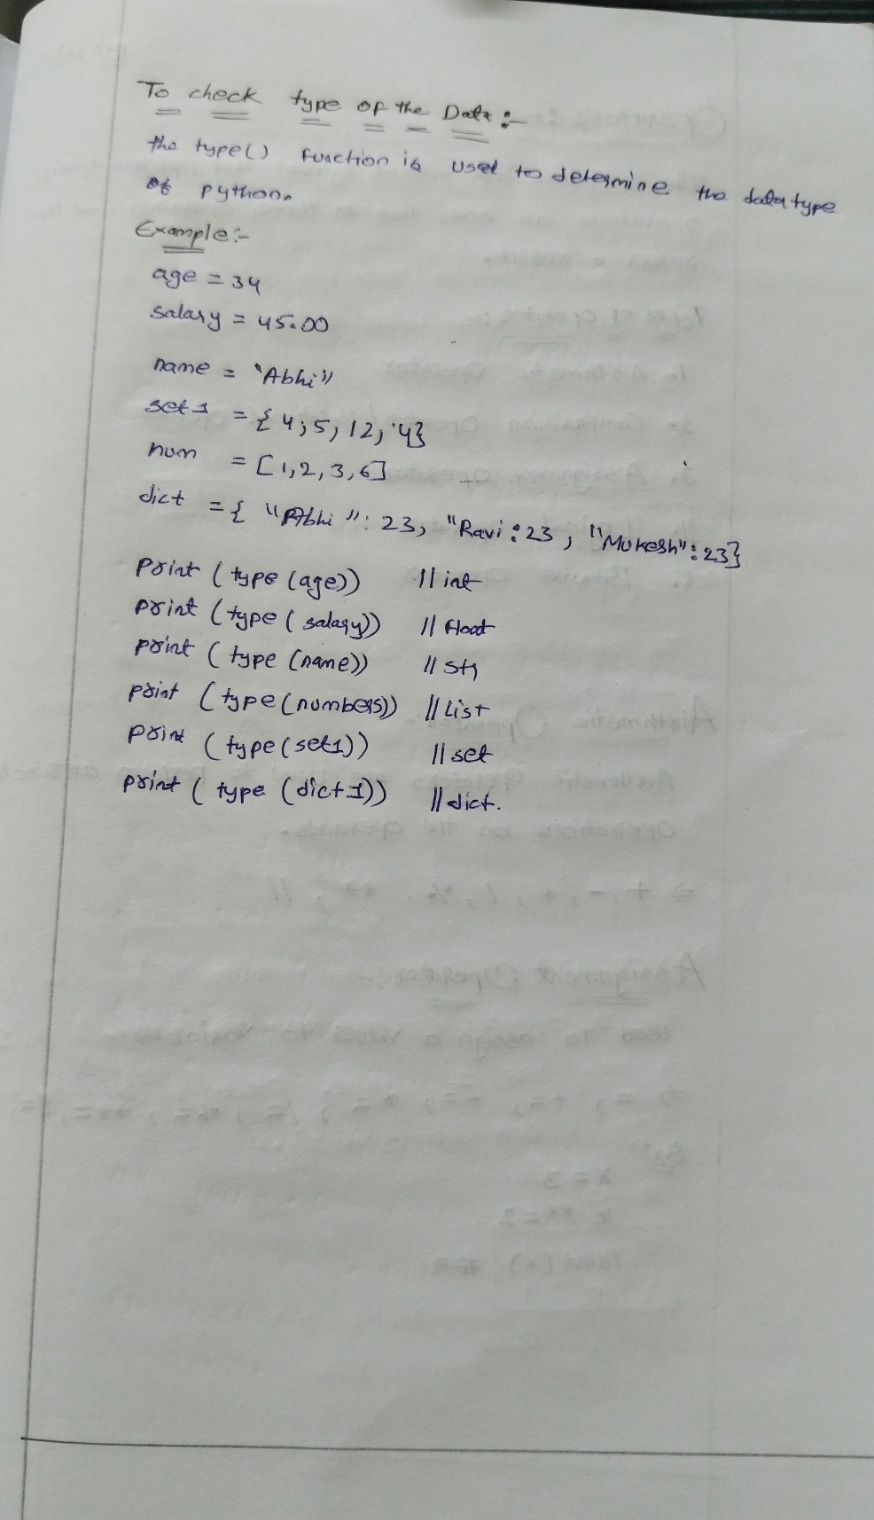

**Operators**

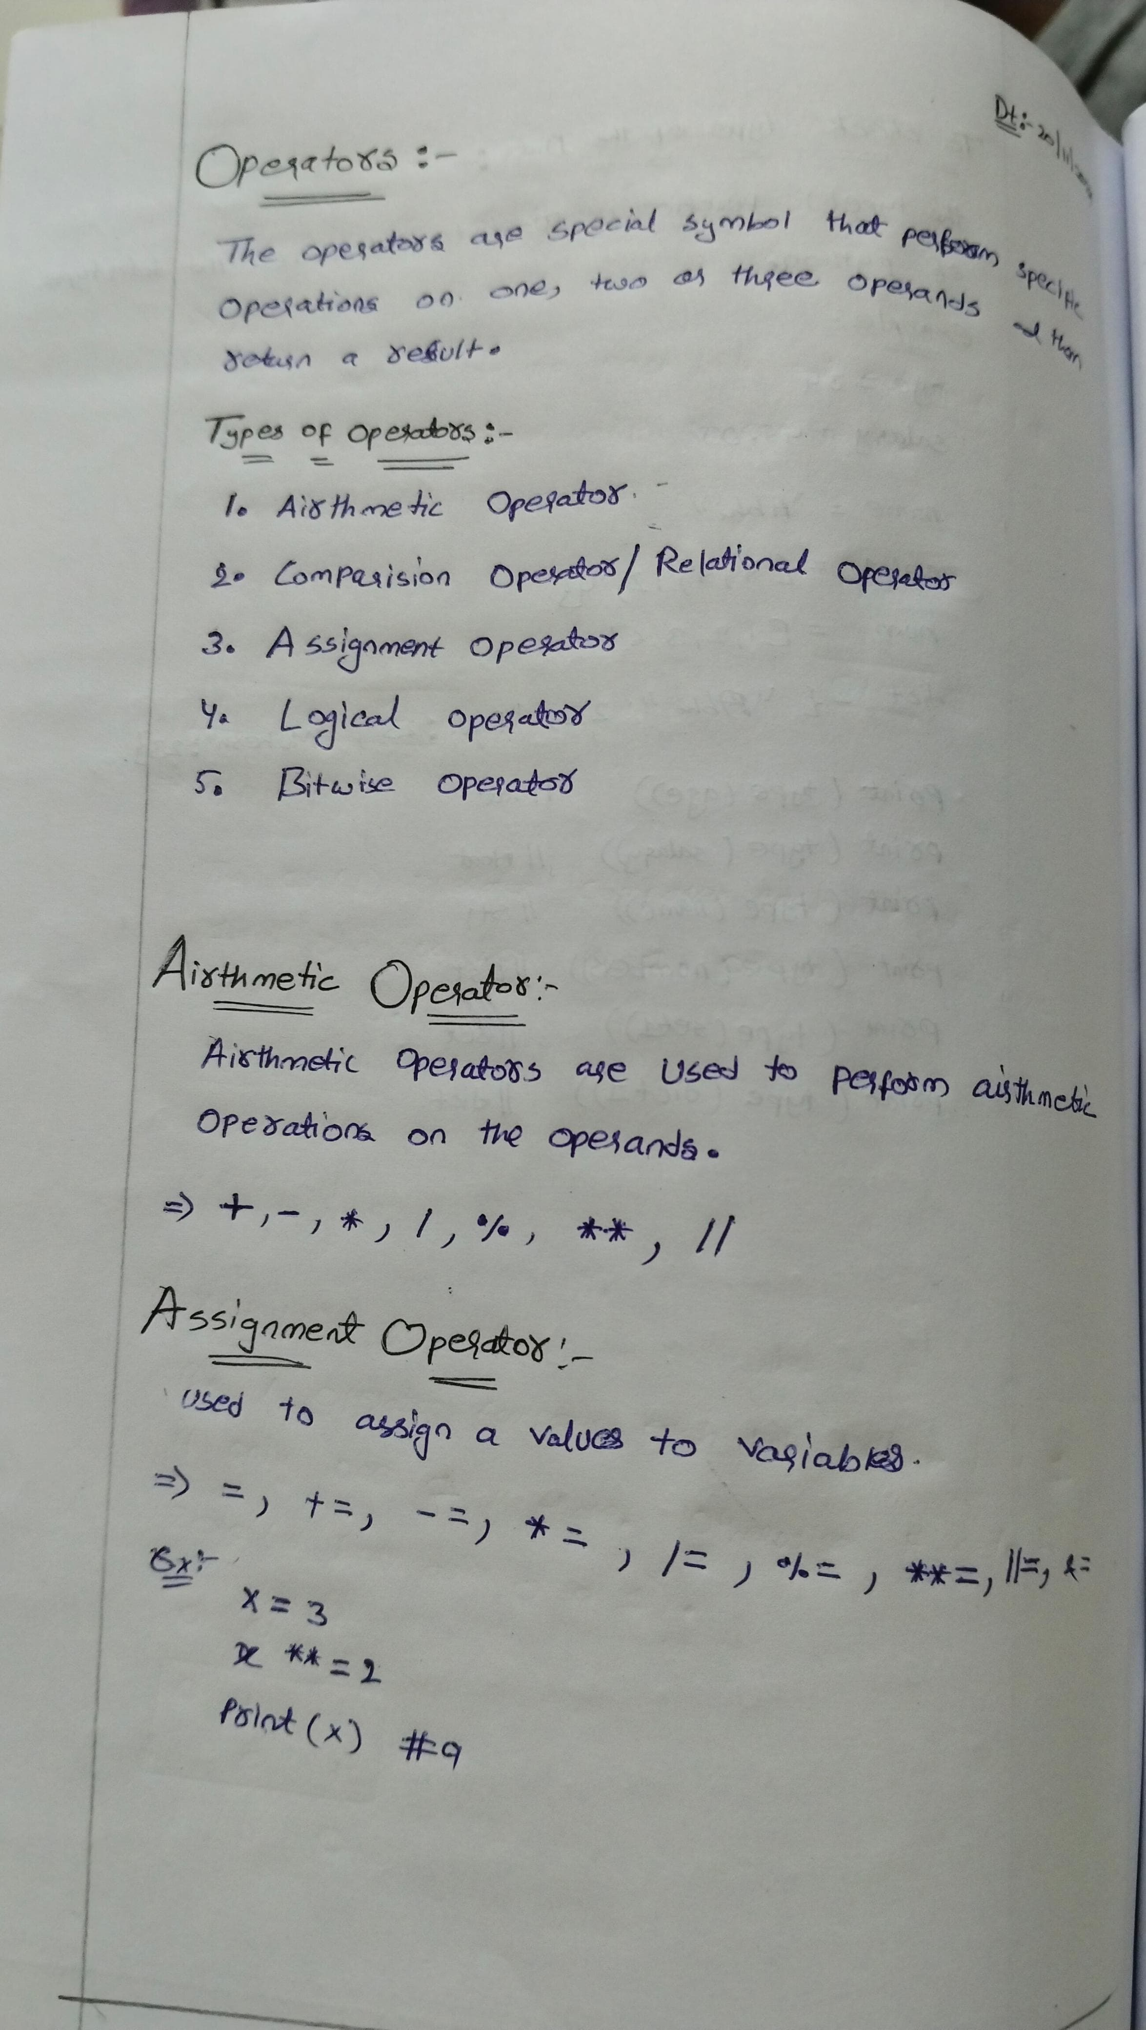

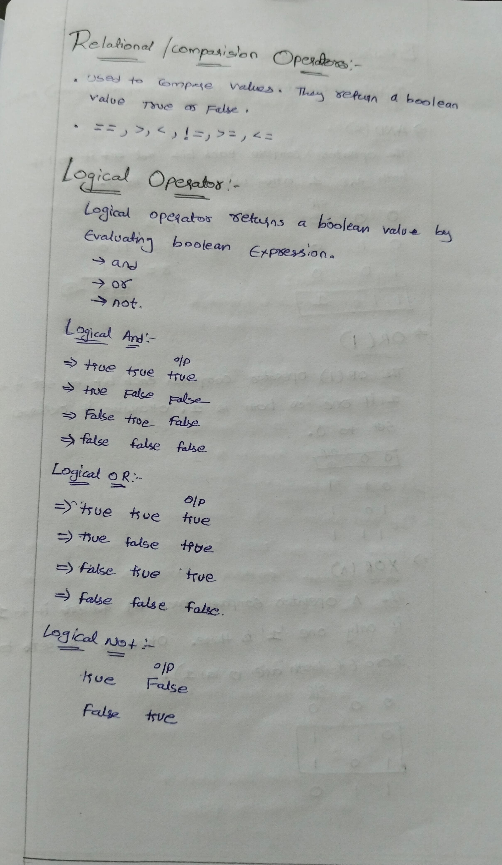

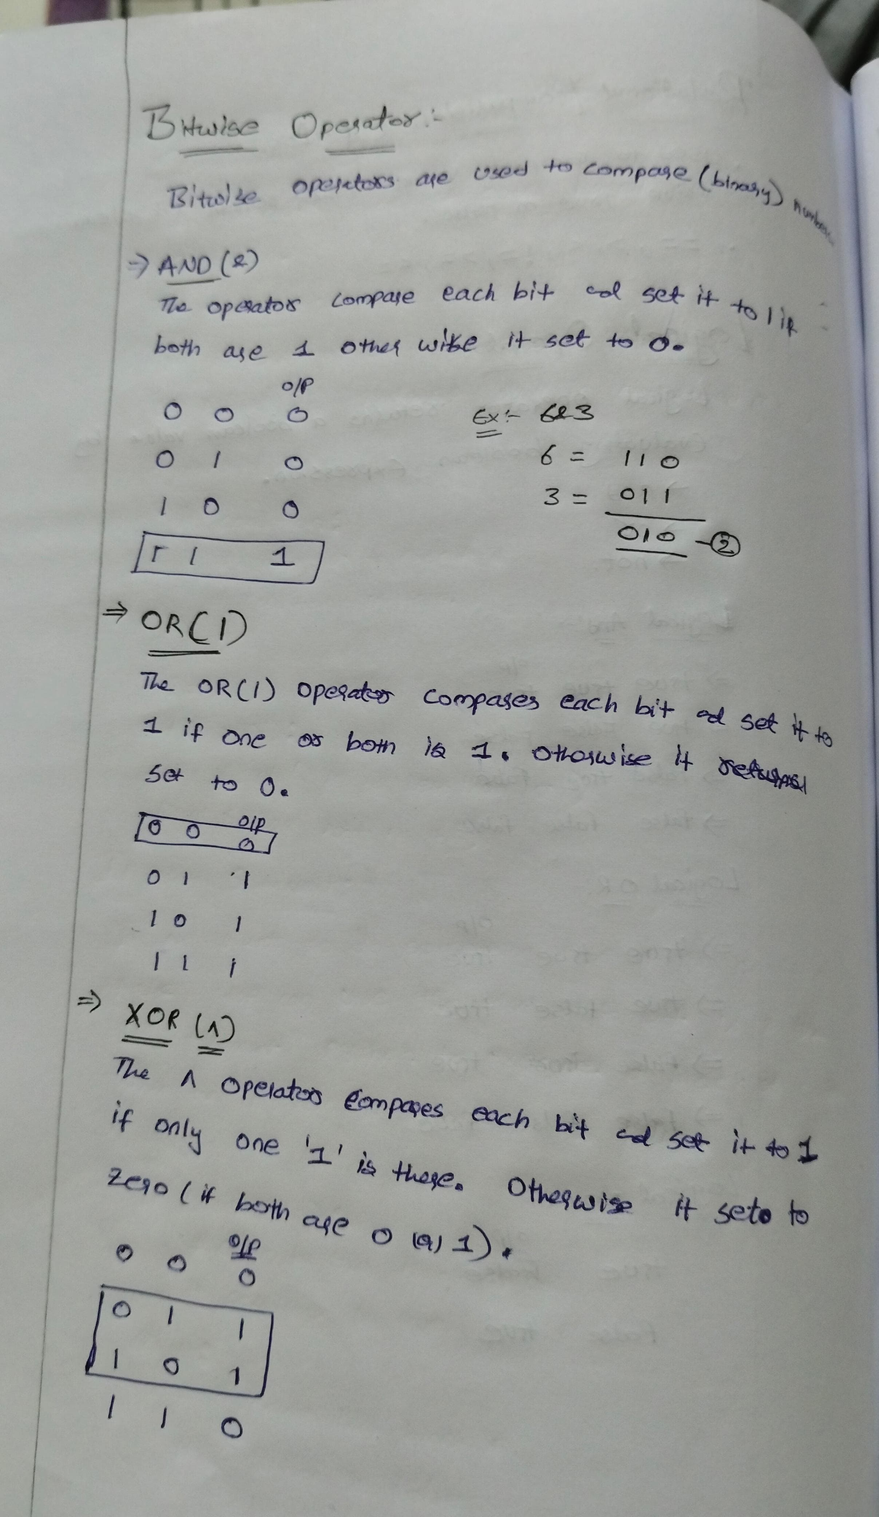

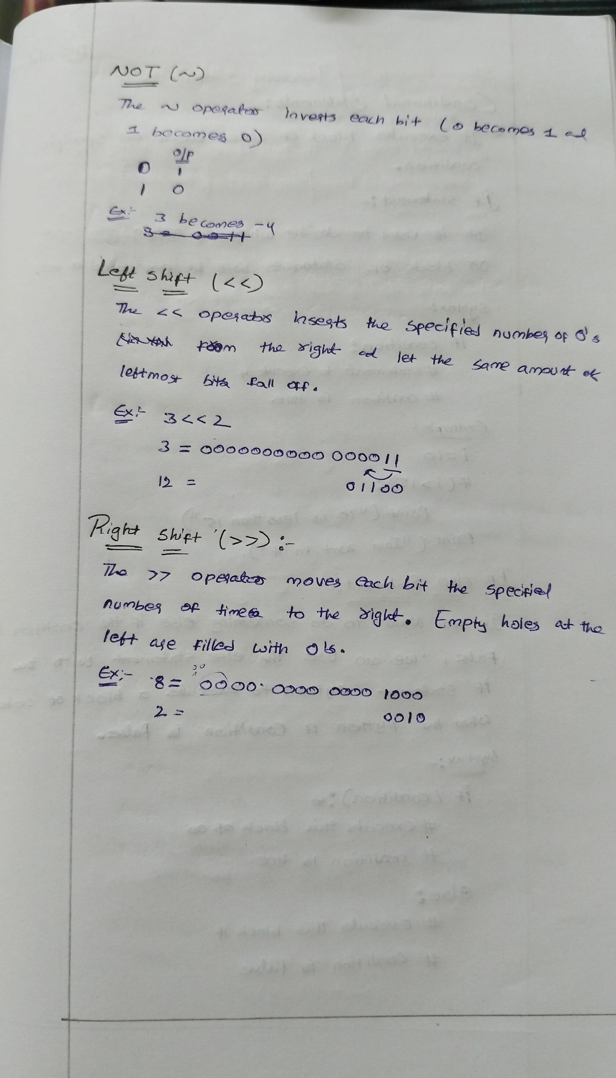

**Conditional statements**

**If Statement:**

The if statement is the most simple decision-making statement. It is used to decide whether a certain statement or block of statements will be executed or not.

**Flowchart of If Statement** Let’s look at the flow of code in the Python If statements

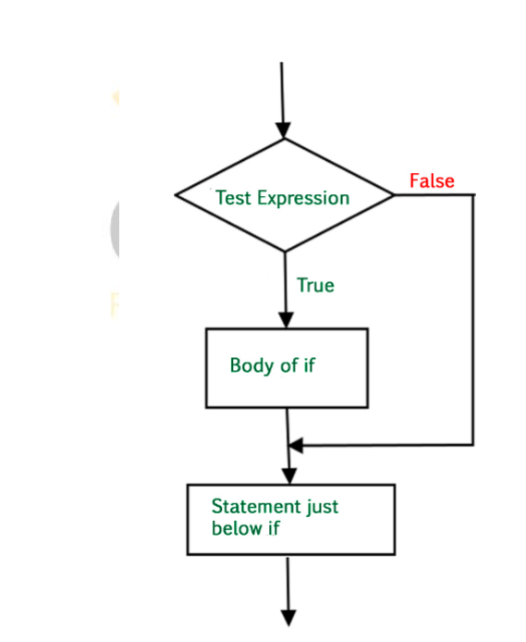

**Syntax of If Statement**:

if condition:  
 # Statements to execute if  
 # condition is true

**Example:**

# if statement example

if 10 > 5:

print("10 greater than 5")

print("Program ended")

**Output:**

10 greater than 5

Program ended

**Python If Else Statement**

The if statement alone tells us that if a condition is true it will execute a block of statements and if the condition is false it won’t. But if we want to do something else if the condition is false, we can use the else statement with the if statement Python to execute a block of code when the Python if condition is false

**Flowchart of If Else Statement** Let’s look at the flow of code in an if else Python statement.

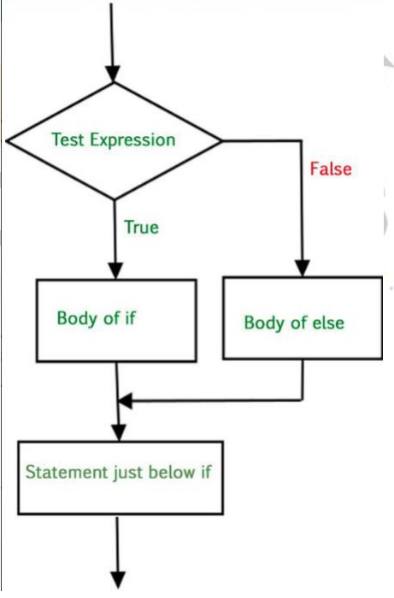

**Syntax of Python If-Else**:

if (condition):  
 # Executes this block if  
 # condition is true  
else:  
 # Executes this block if  
 # condition is false

**Example:**

# if..else statement example

x = 3

if x == 4:

print("Yes")

else:

print("No")

**Output:** No

**Python Nested If Statement**

A nested if is an if statement that is the target of another if statement. Nested if statements mean an if statement inside another if statement.

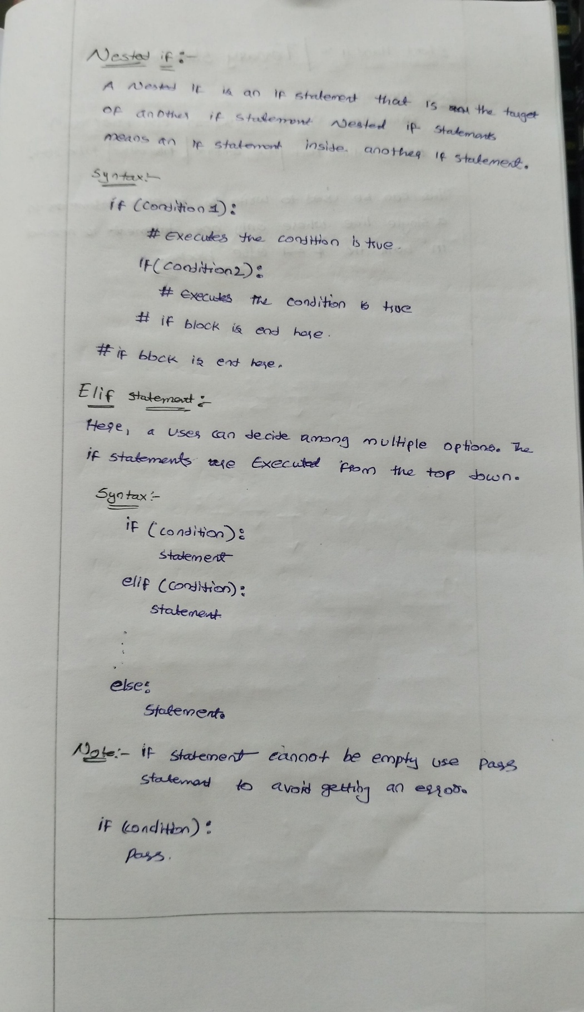

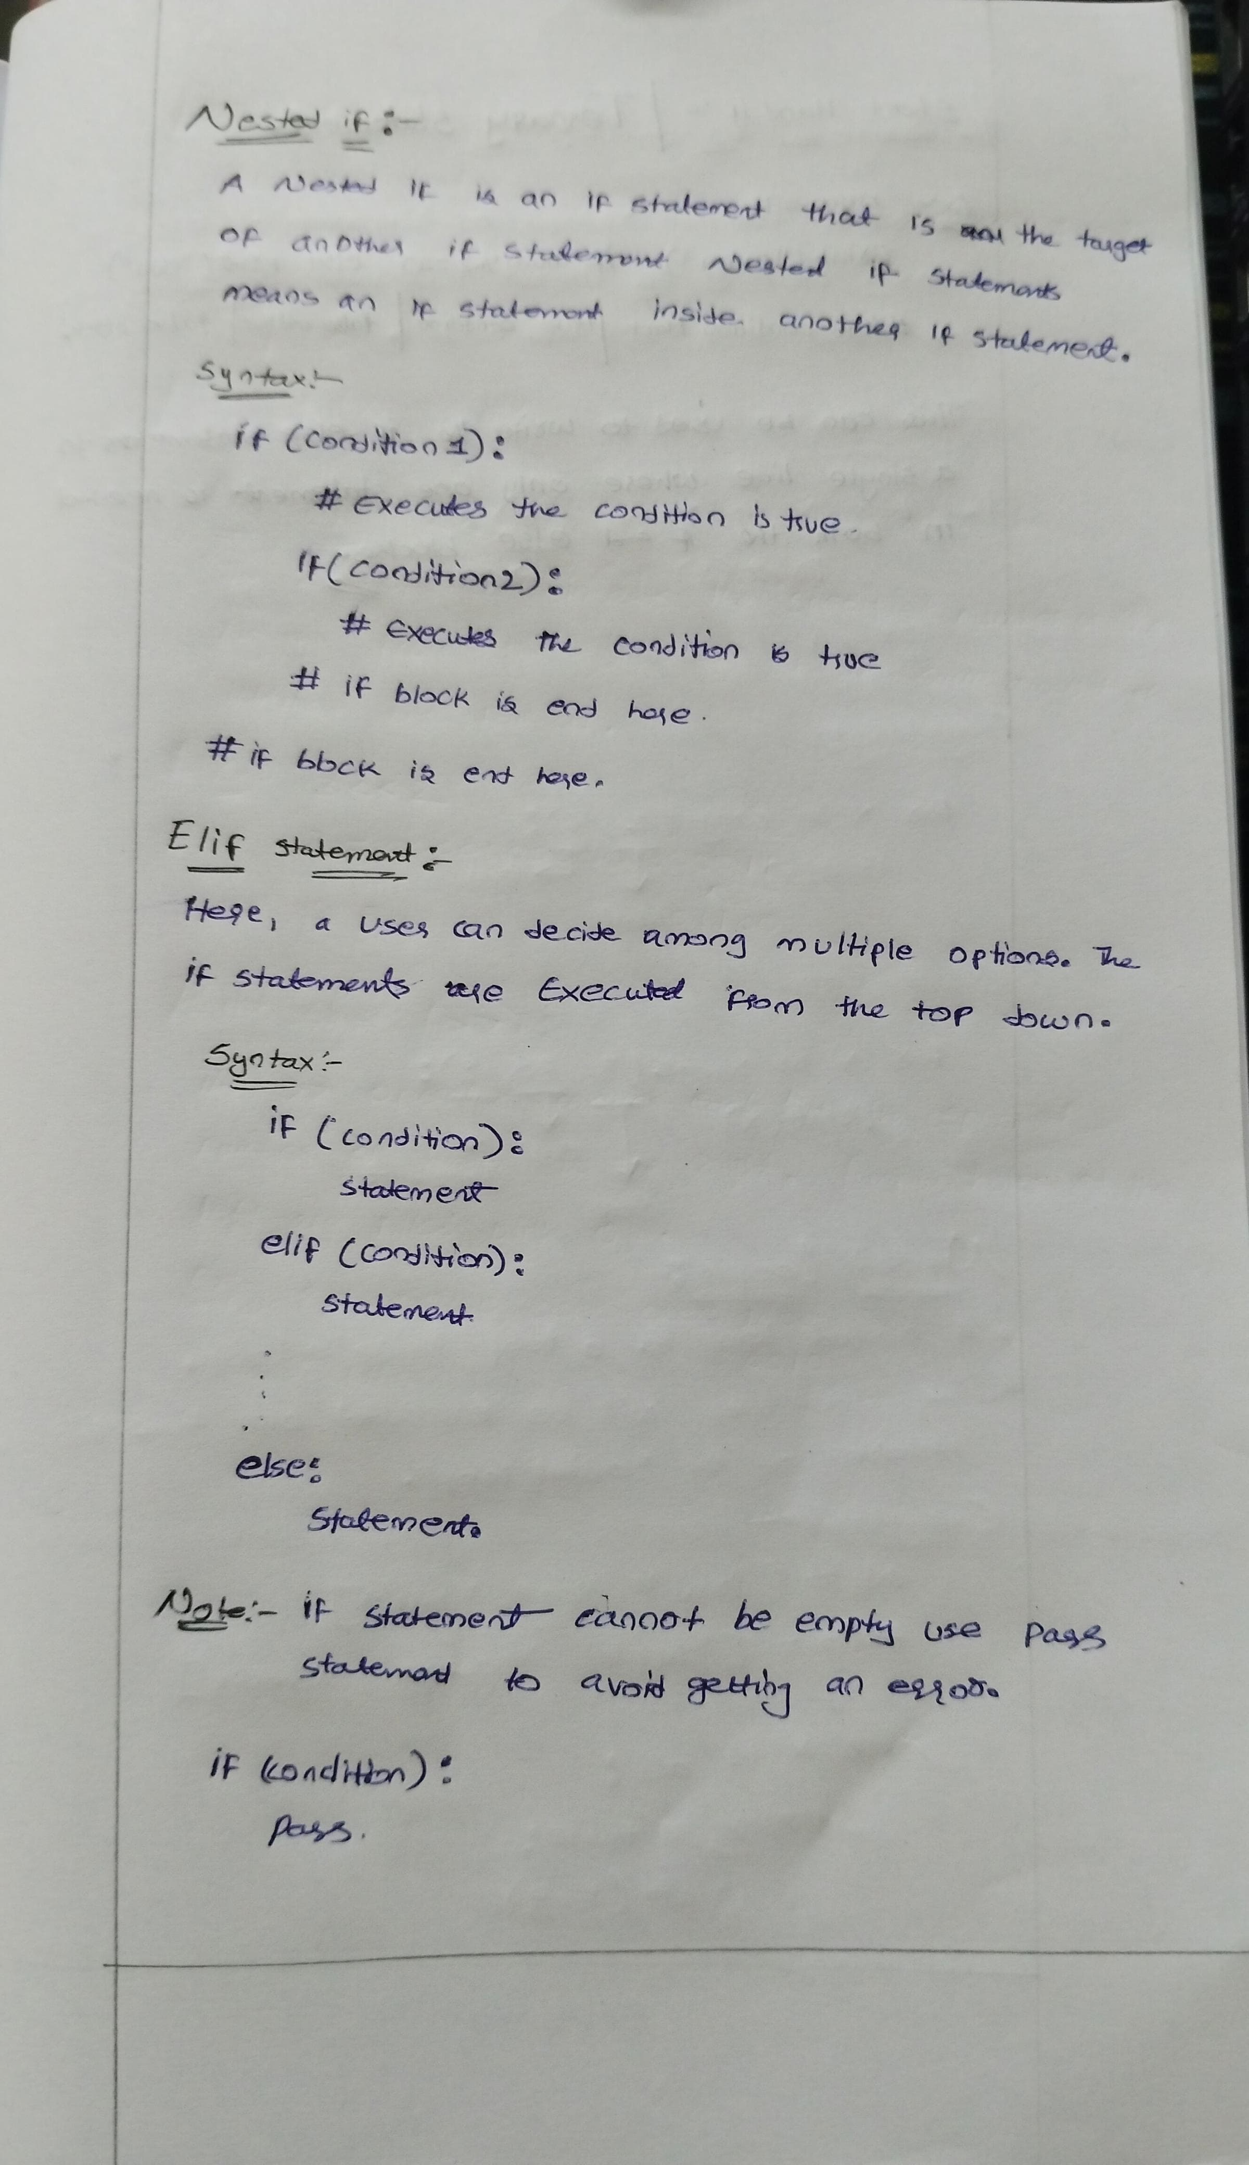

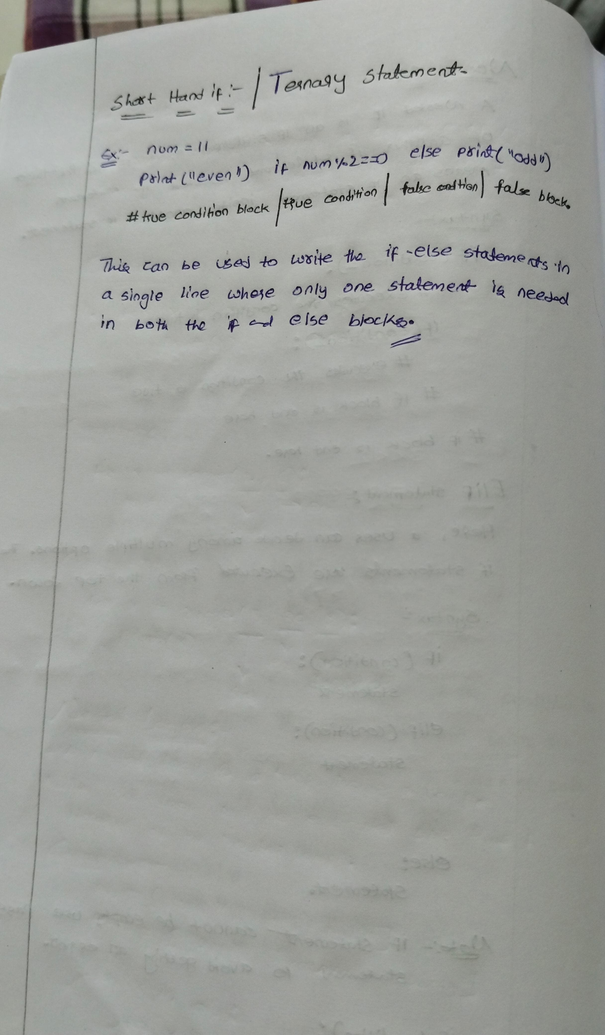

**LOOPS**

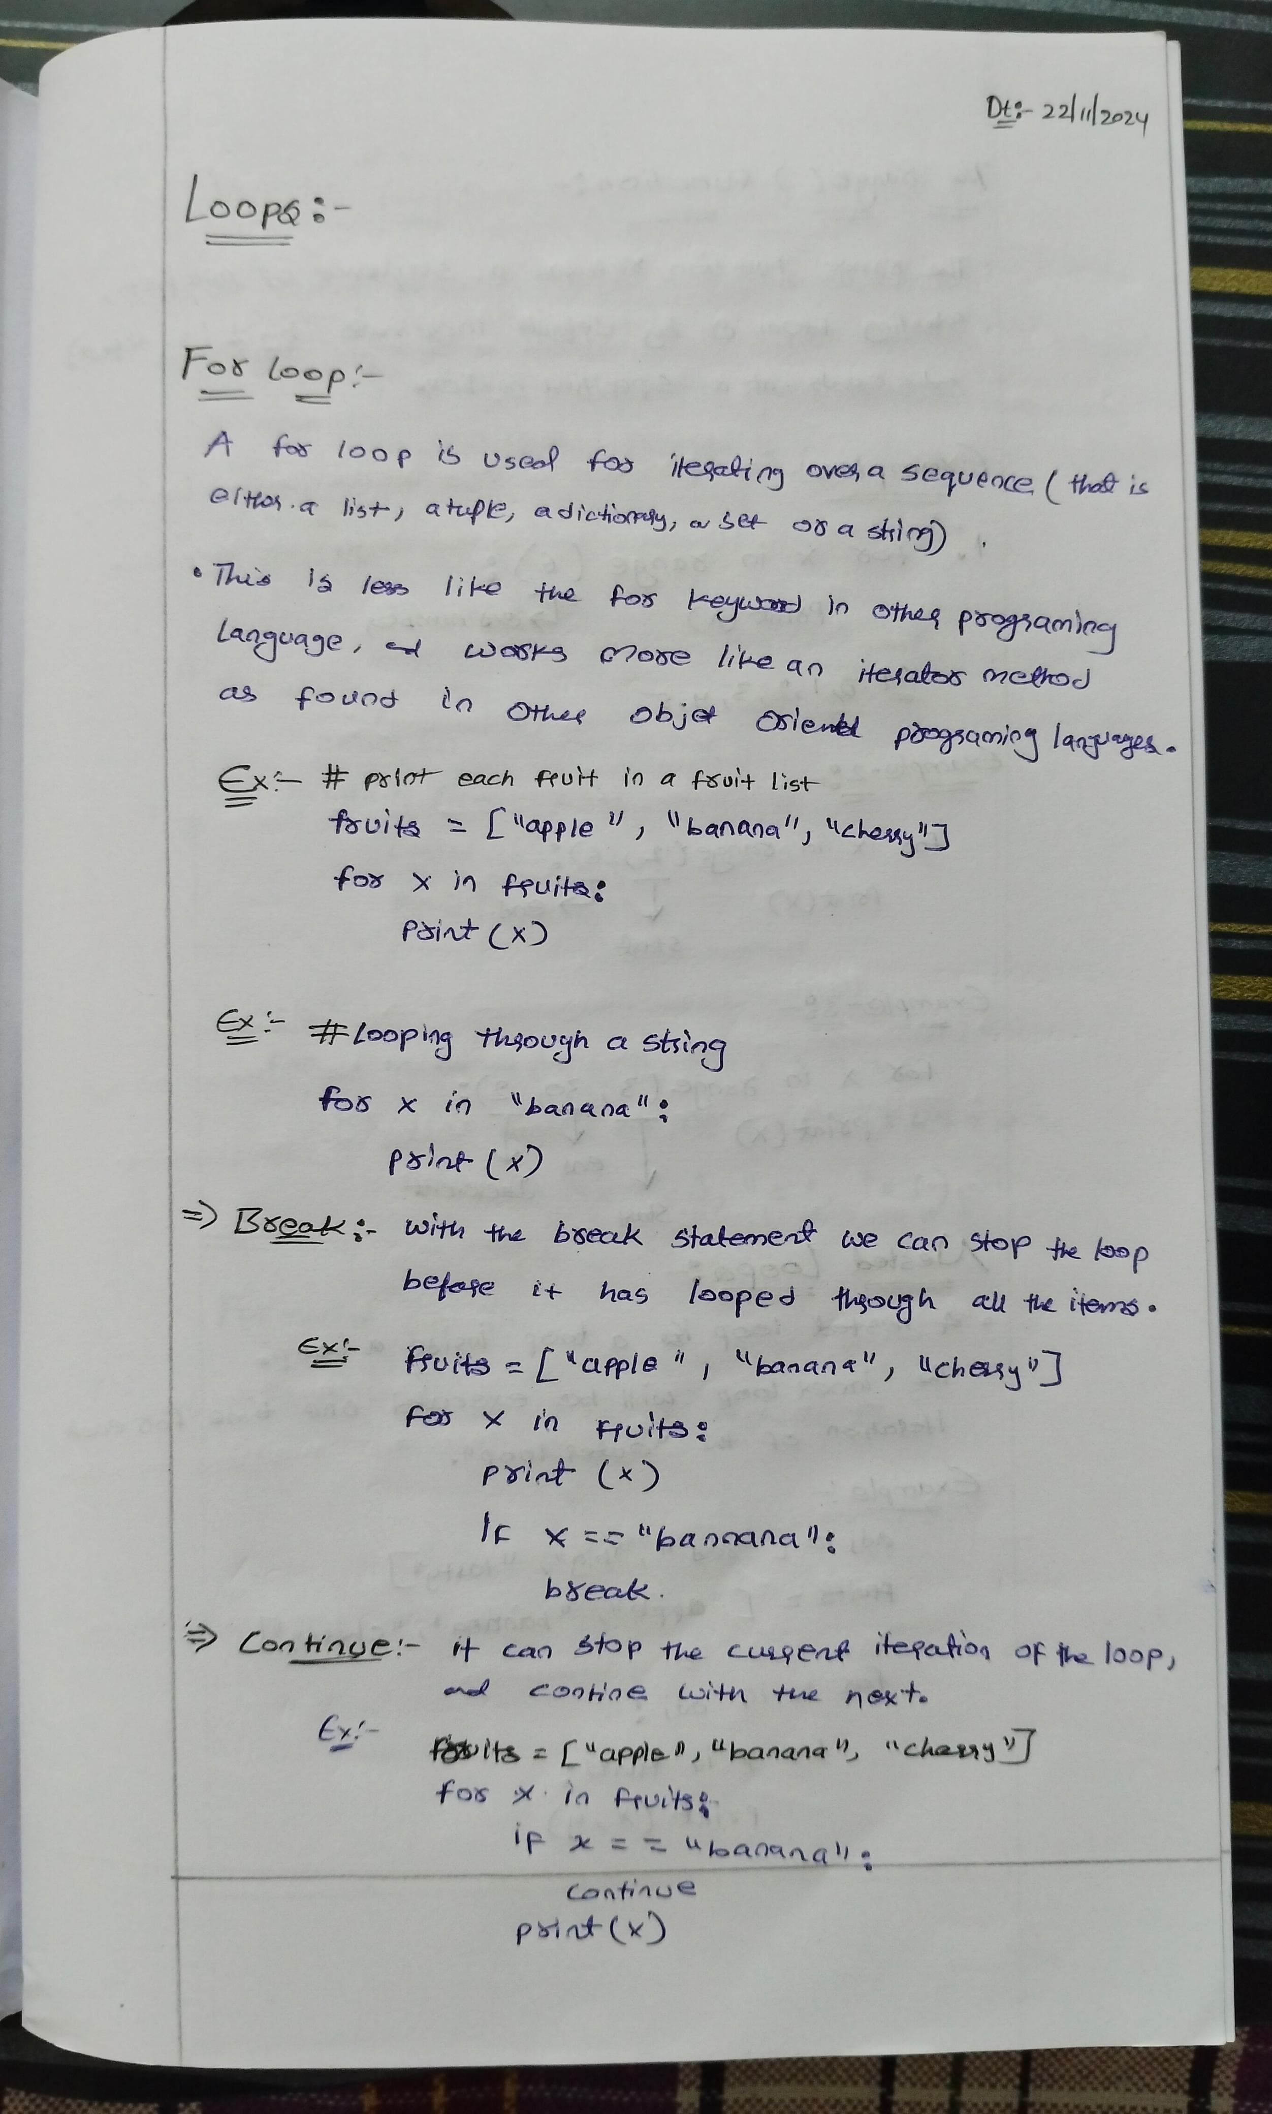

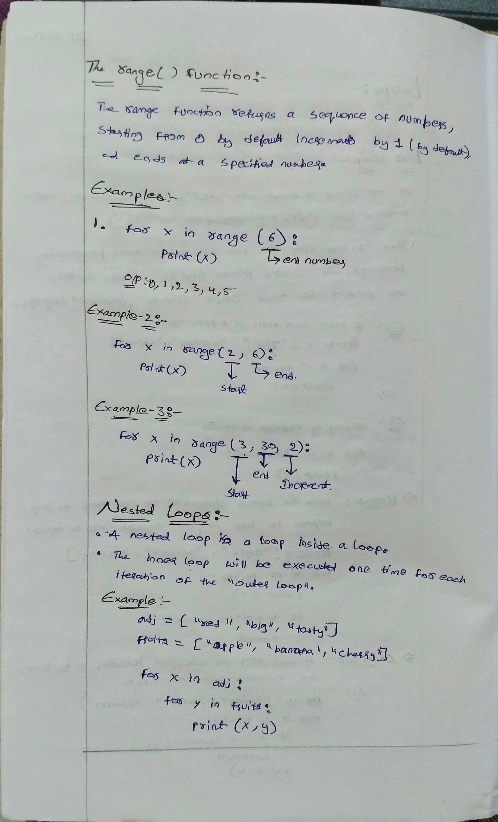

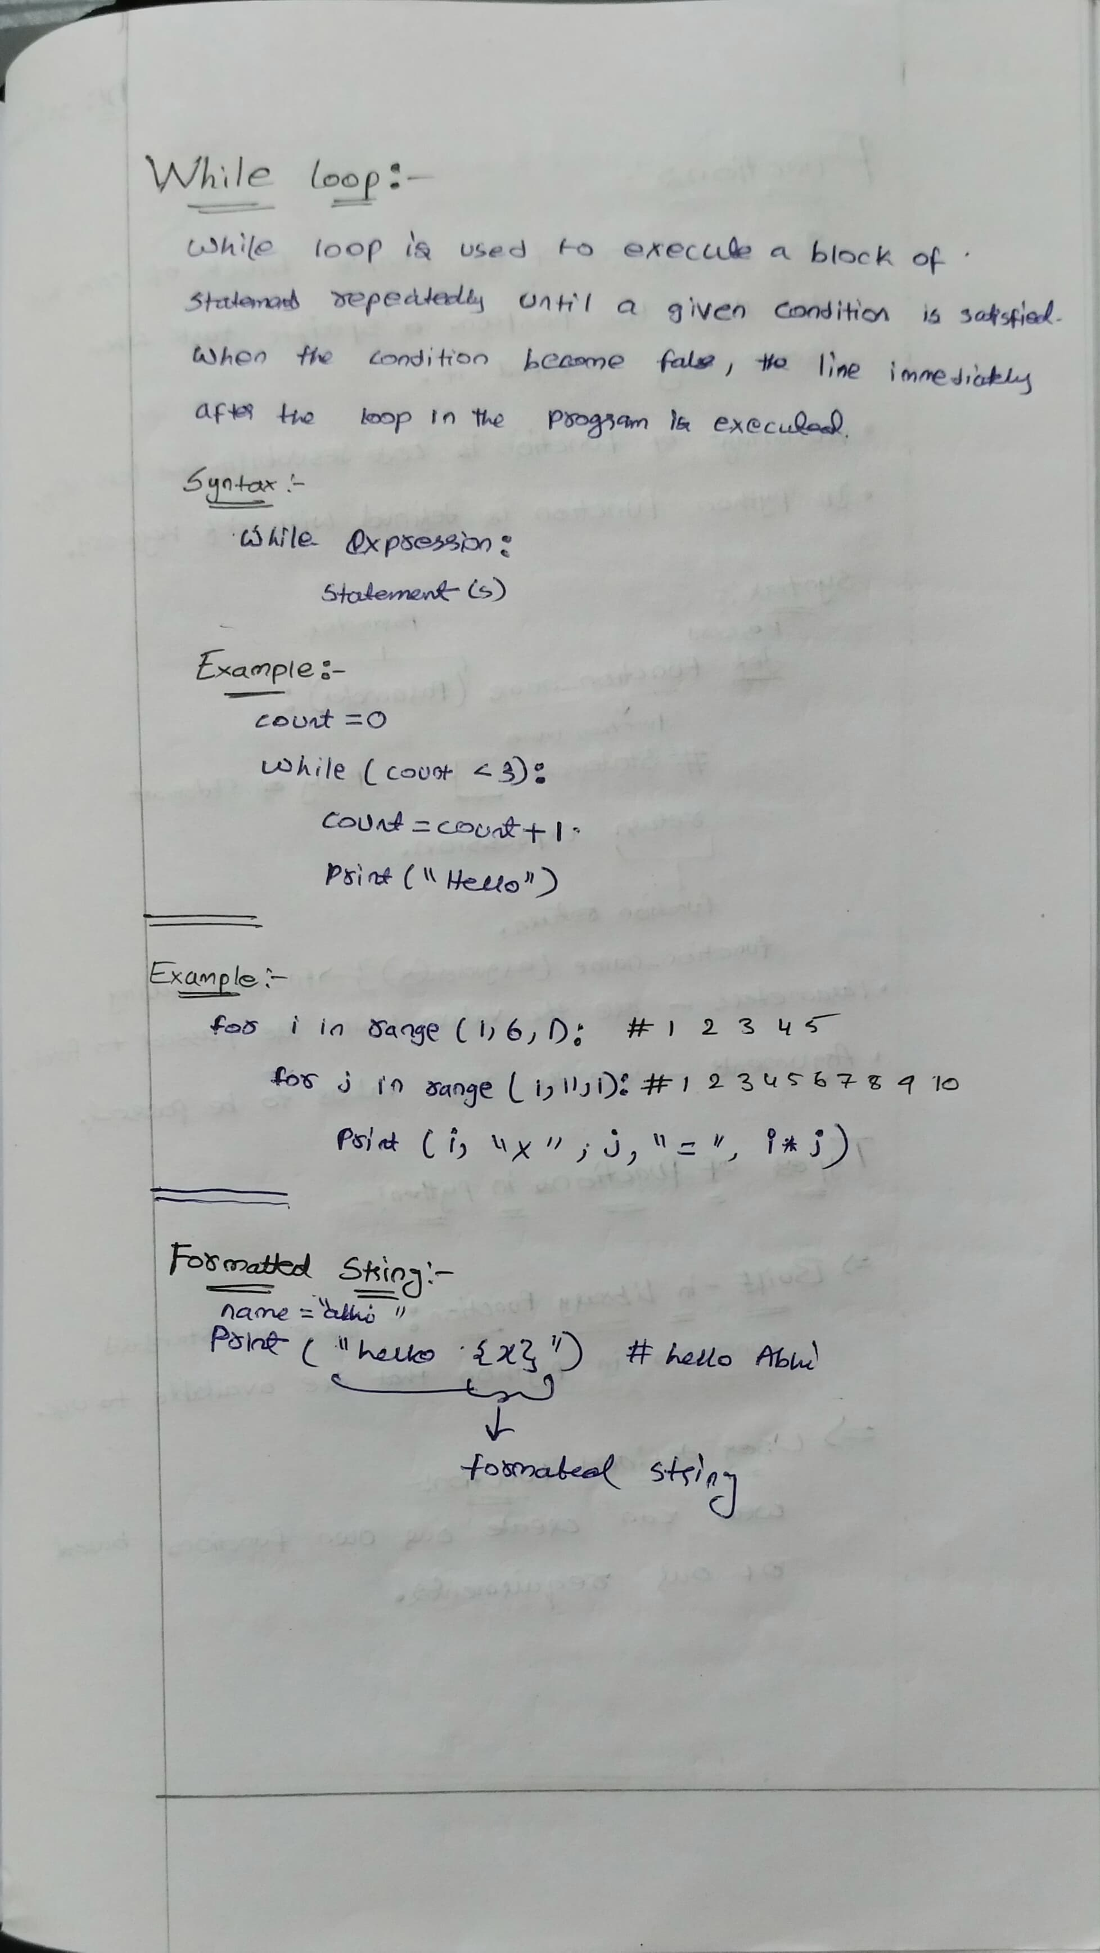

**Functions**

Python Functions

Python Functions is a block of statements that return the specific task. The idea is to put some commonly or repeatedly done tasks together and make a function so that instead of writing the same code again and again for different inputs, we can do the function calls to reuse code contained in it over and over again.

**Some Benefits of Using Functions**

Increase Code Readability

Increase Code Reusability

**Python Function Declaration**

The syntax to declare a function is:

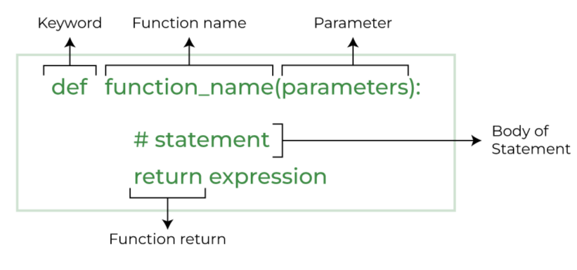

**Types of Functions in Python**

• Below are the different types of functions in Python:

**Built-in library function**: These are Standard functions in Python that are available to use.

**User-defined function**: We can create our own functions based on our requirements.

**Creating a Function in Python**

We can define a function in Python, using the def keyword. We can add any type of functionalities and properties to it as we require. By the following example, we can understand how to write a function in Python. In this way we can create Python function definition by using def keyword.

**Syntax:**

# A simple Python function

def fun():

print("Welcome to GFG")

**Calling a Function in Python**

After creating a function in Python we can call it by using the name of the functions Python followed by parenthesis containing parameters of that particular function. Below is the example for calling def function Python.

**Example:**

# A simple Python function

def fun():

print("Welcome to GFG")

# Driver code to call a function

fun()

**Python Function Arguments**

Arguments are the values passed inside the parenthesis of the function. A function can have any number of arguments separated by a comma.

In this example, we will create a simple function in Python to check whether the number passed as an argument to the function is even or odd.

**Example:**

# A simple Python function to check

# whether x is even or odd

def evenOdd(x):

if (x % 2 == 0):

print("even")

else:

print("odd")

# Driver code to call the function

evenOdd(2)

evenOdd(3)

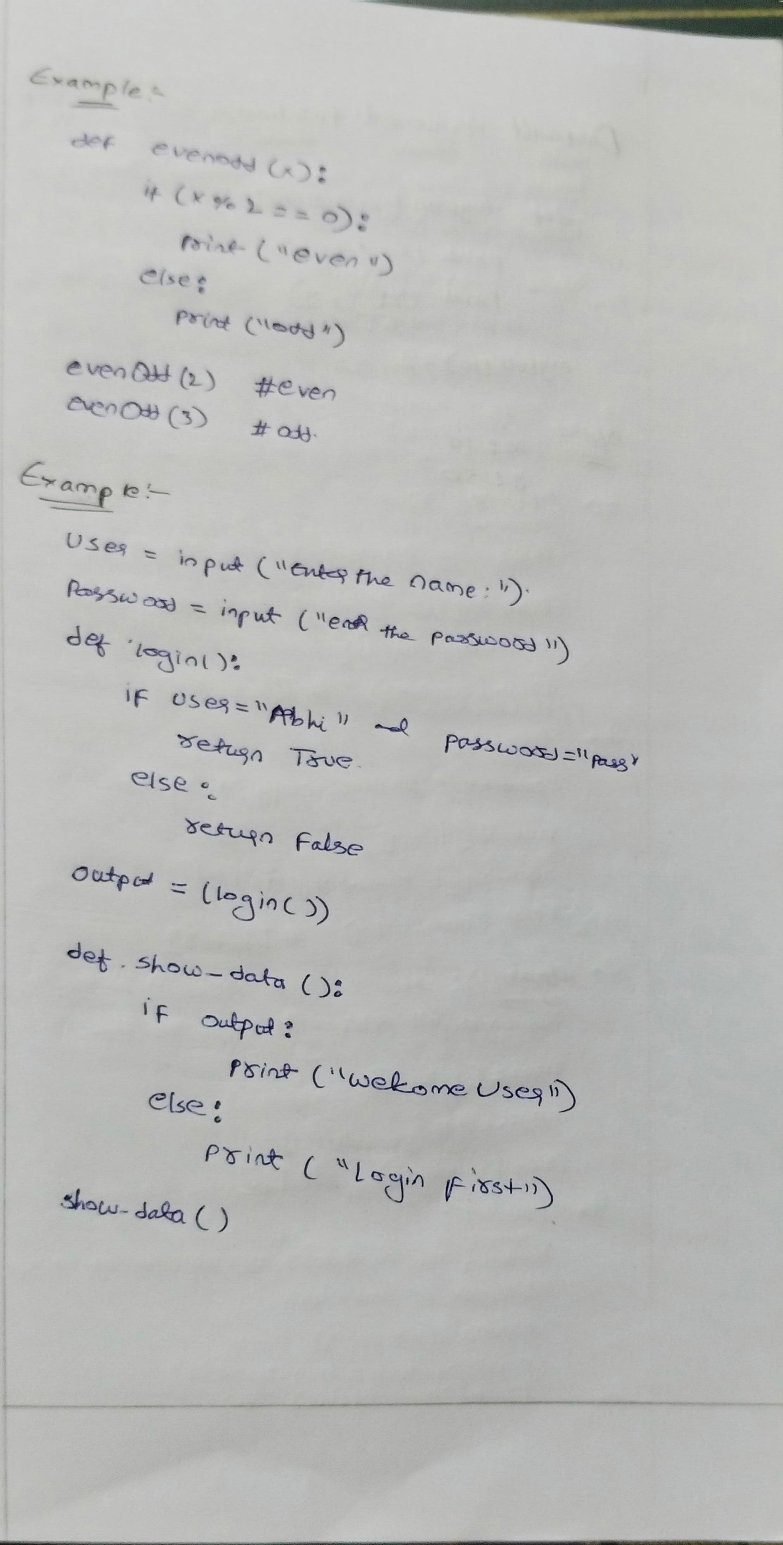

**Python Default arguments**

A default argument is a parameter that assumes a default value if a value is not provided in the function call for that argument. The following example illustrates Default arguments.

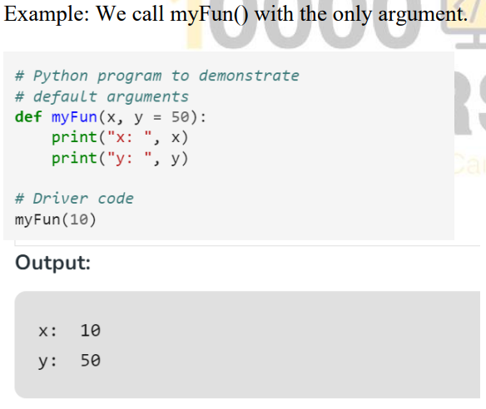

**Taking input in Python**

**input ()** function first takes the input from the user and converts it into a string. The type of the returned object always will be <class ‘str’>. It does not evaluate the expression it just returns the complete statement as String.

**Example-1:**

# Python program showing

# a use of input()

val = input("Enter your value: ")

print(val)

**Example-2:**

username = input("Enter username:")

print("Username is: " + username)

**List Methods**

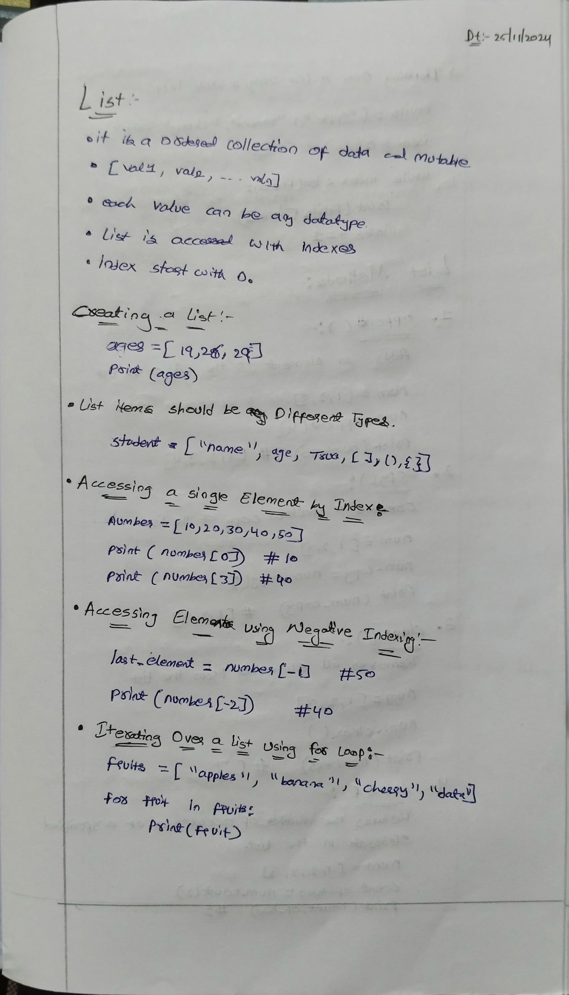

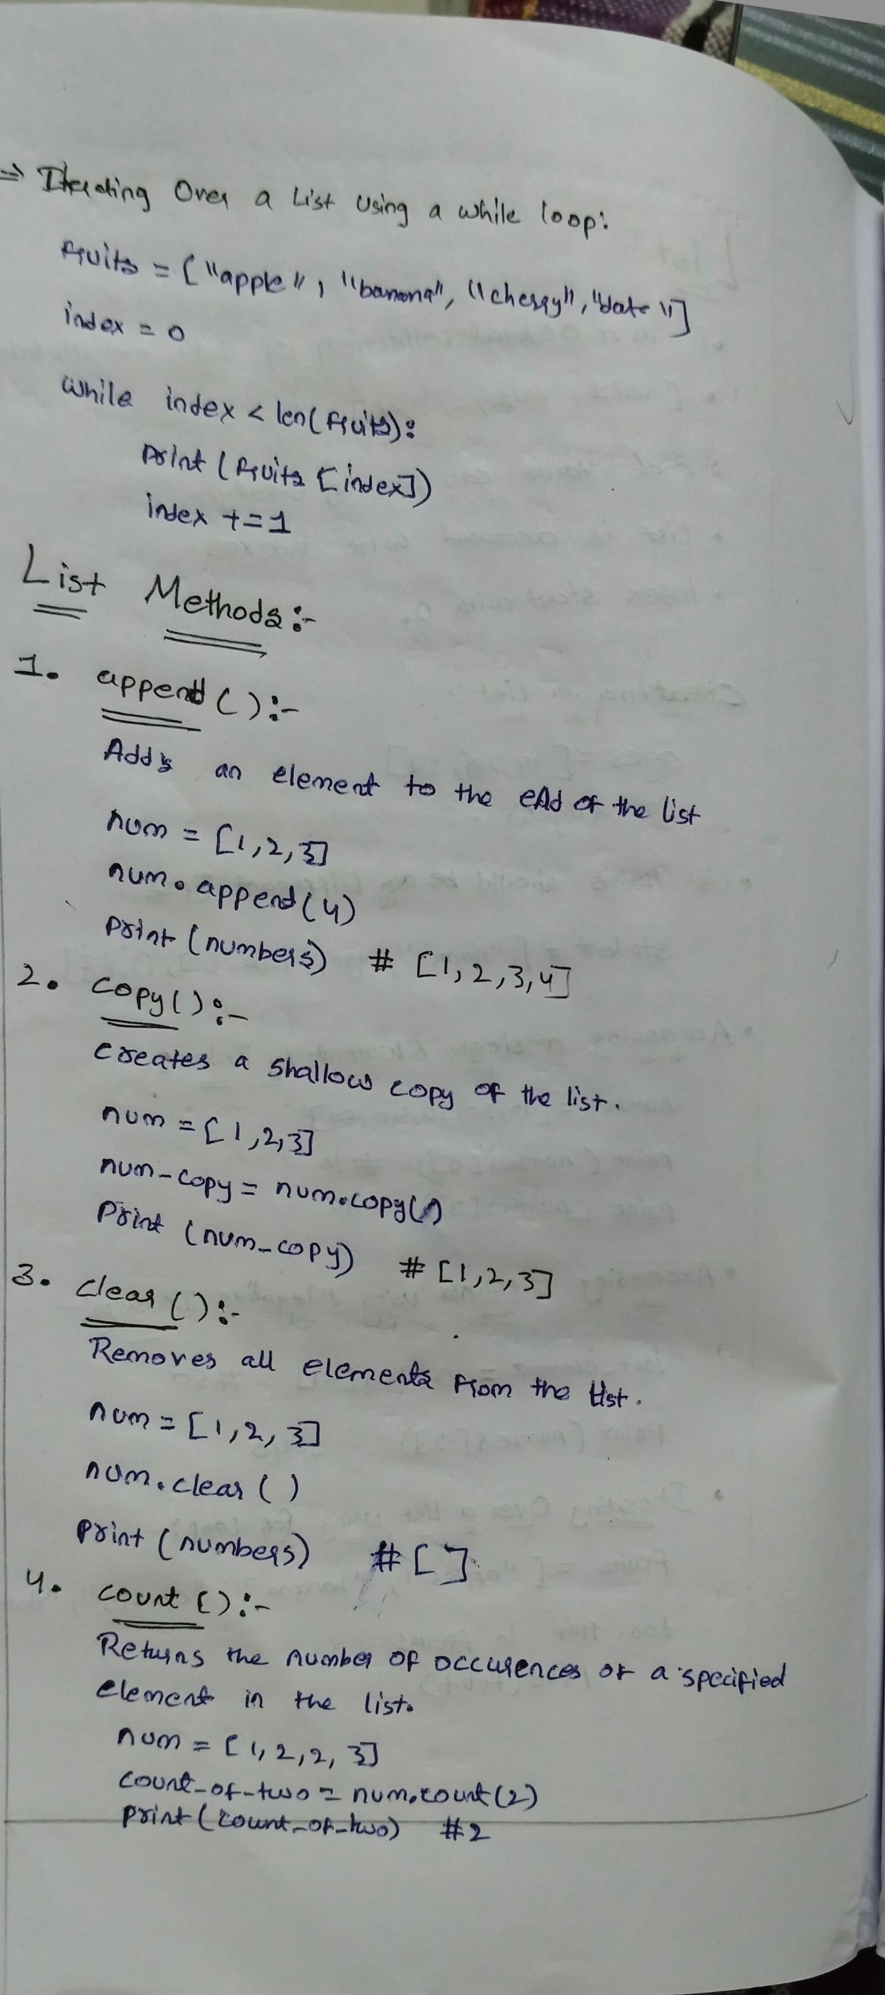



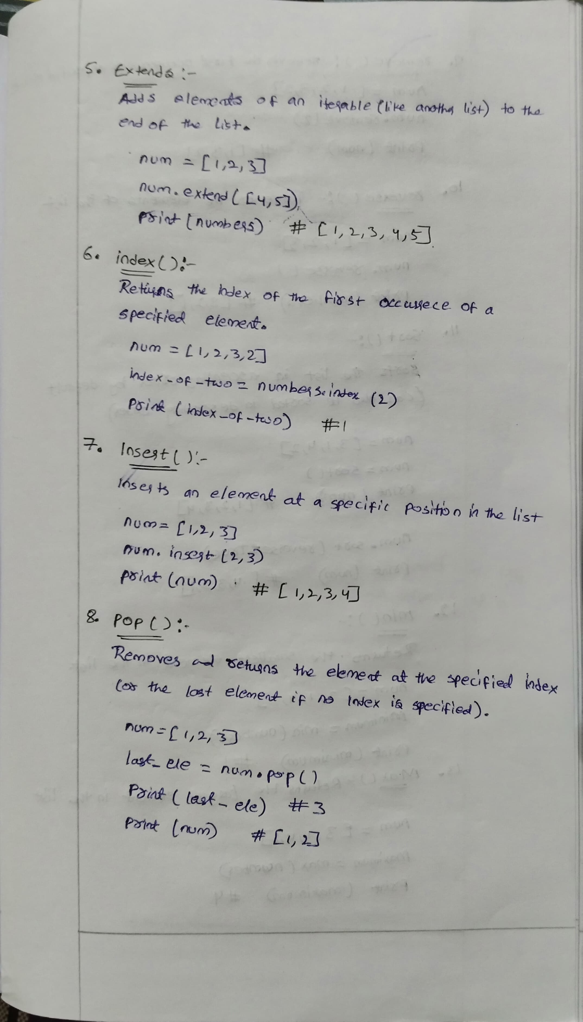



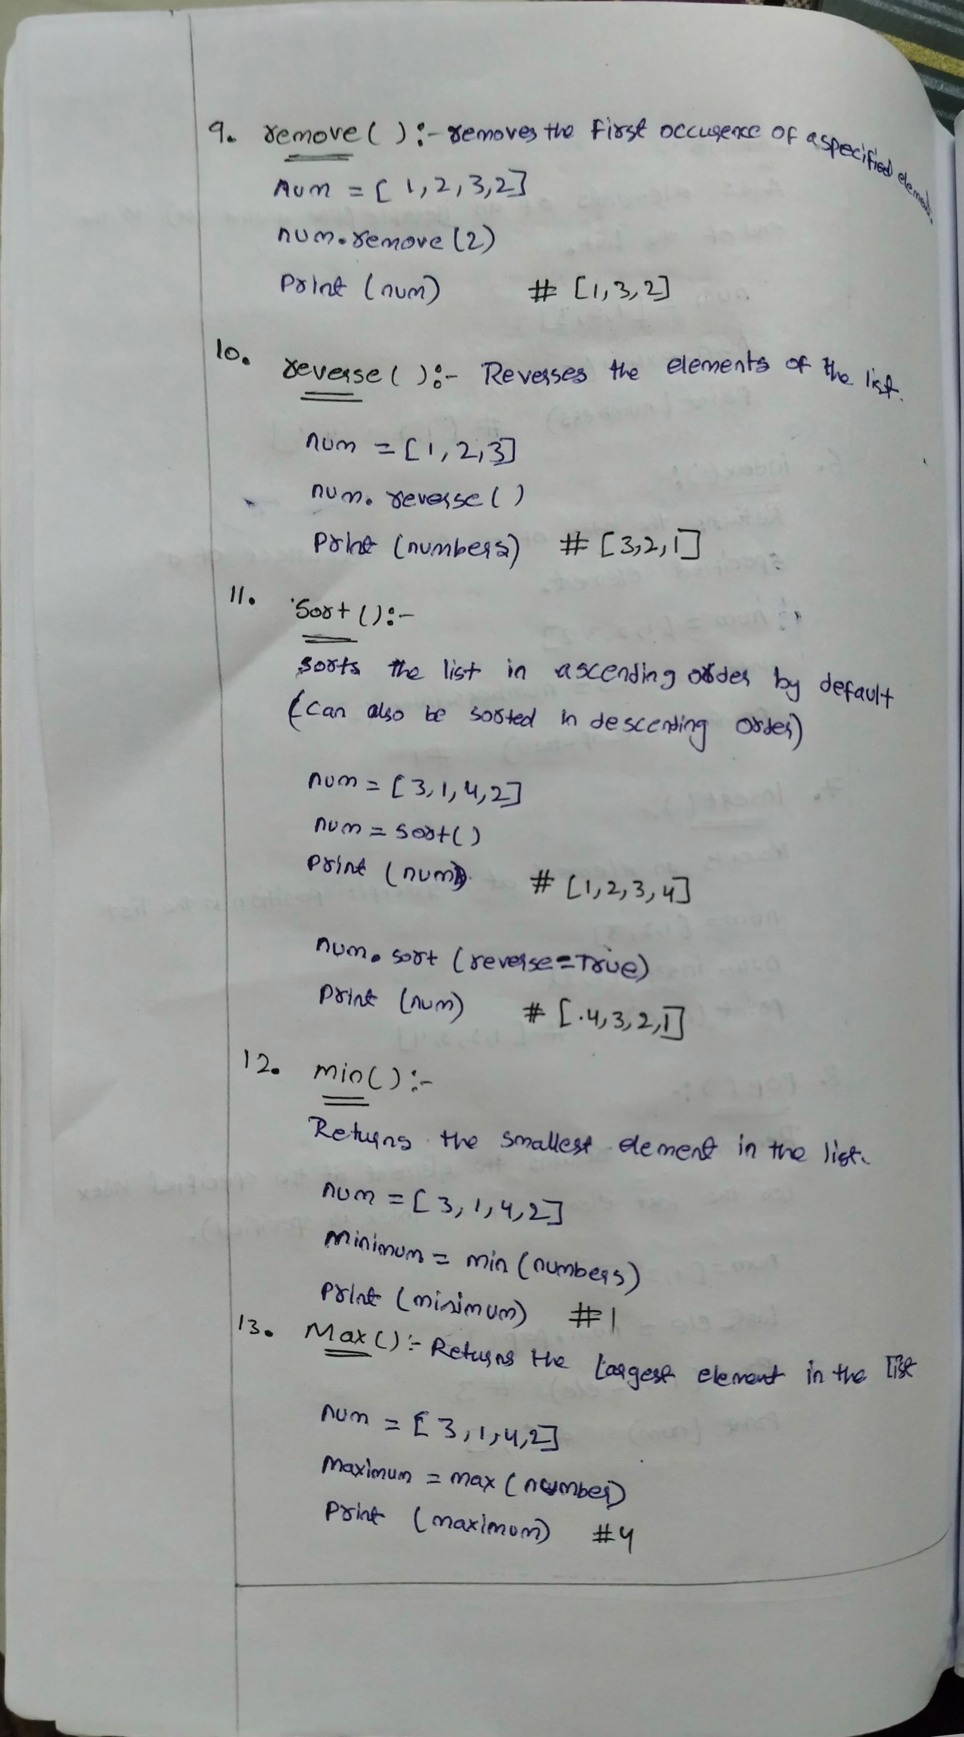

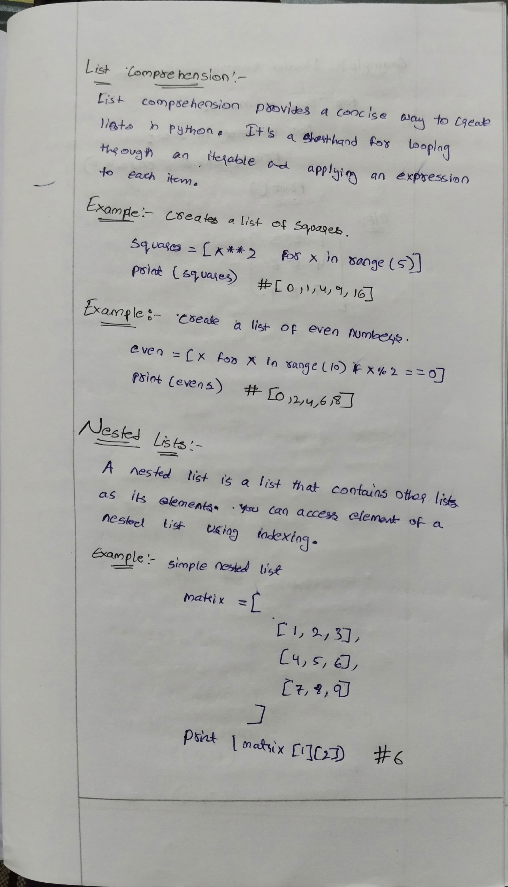

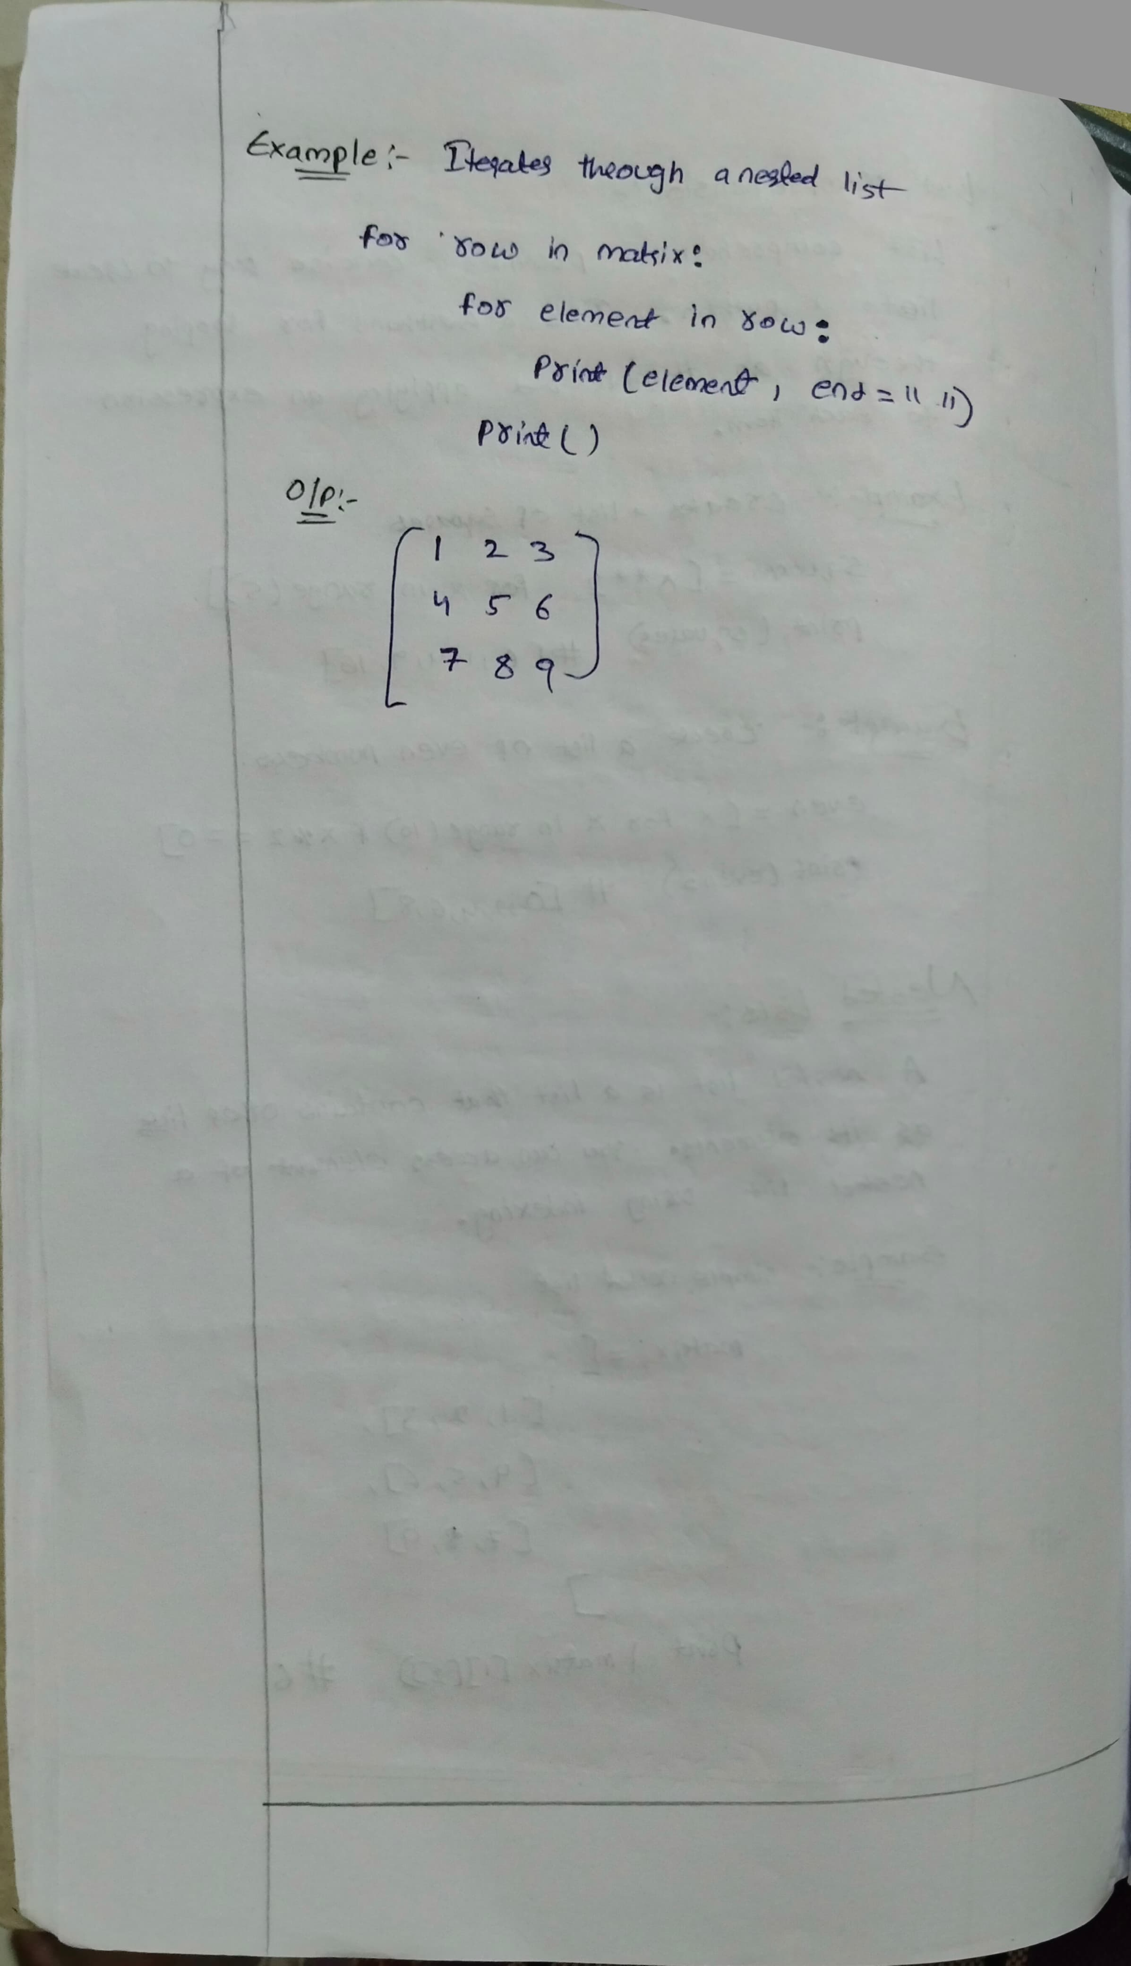

**Tuple methods**

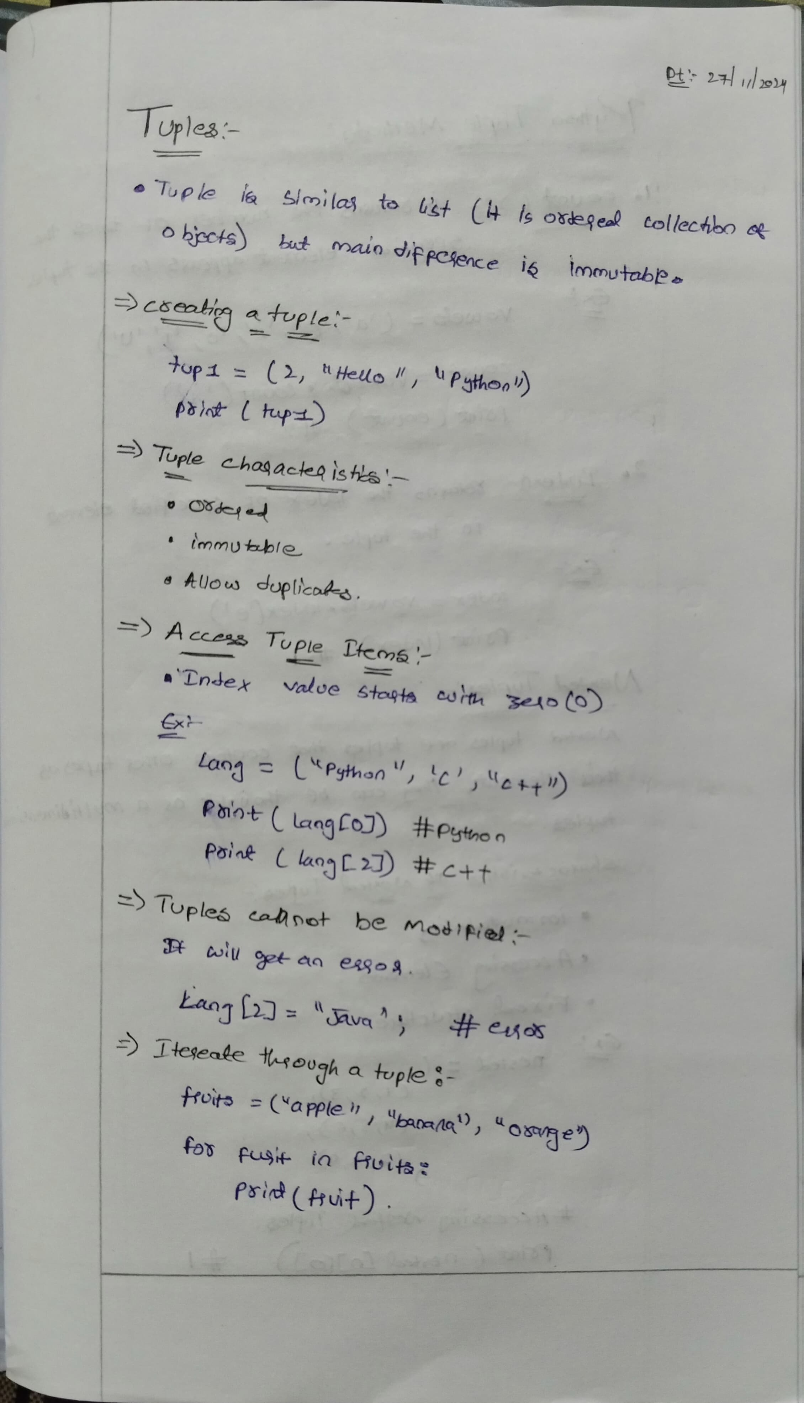

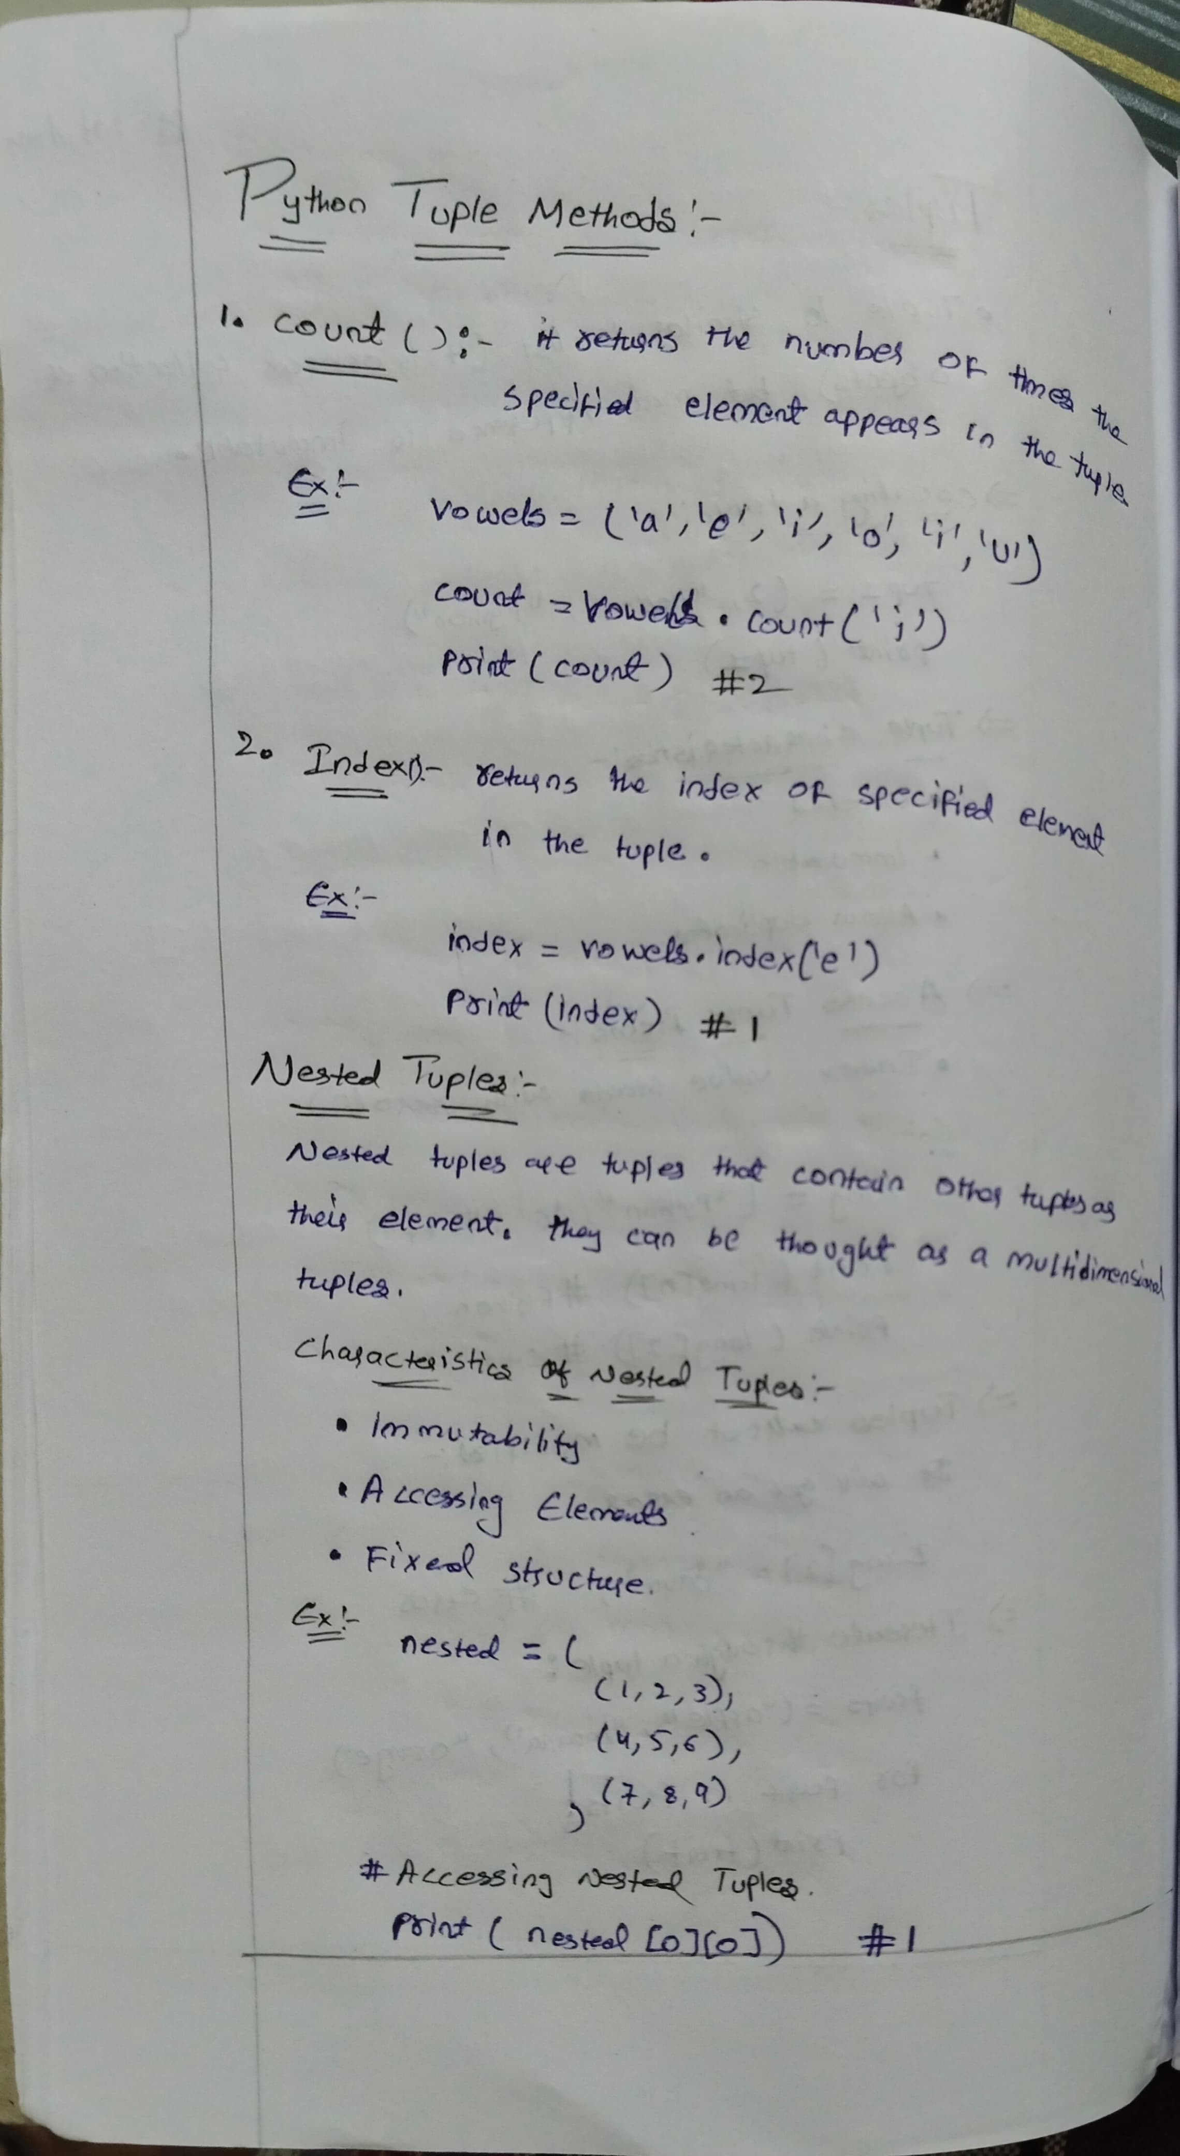

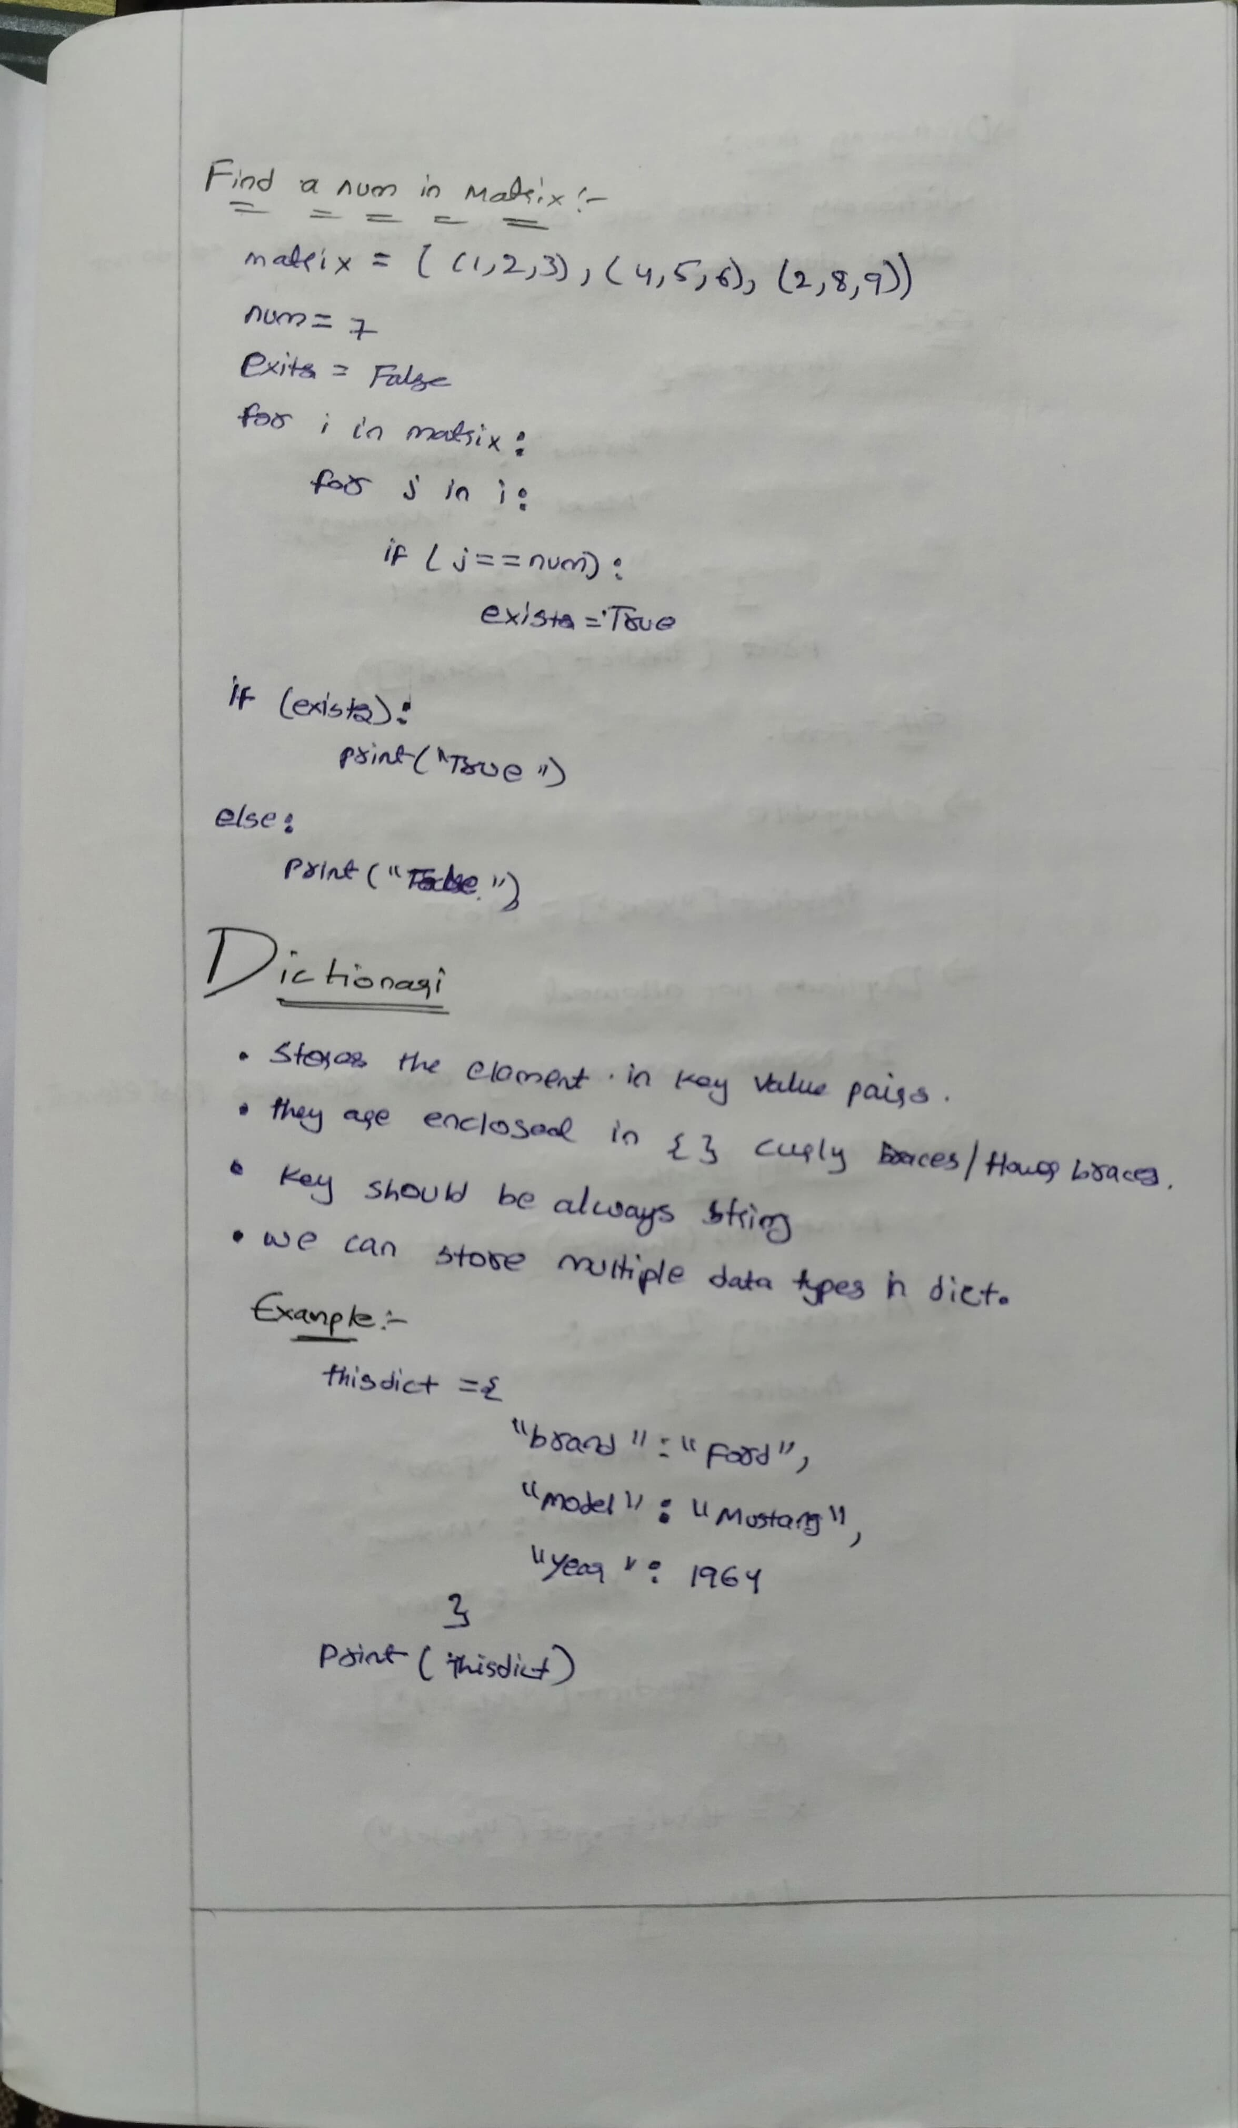

**Dictionary Methods**



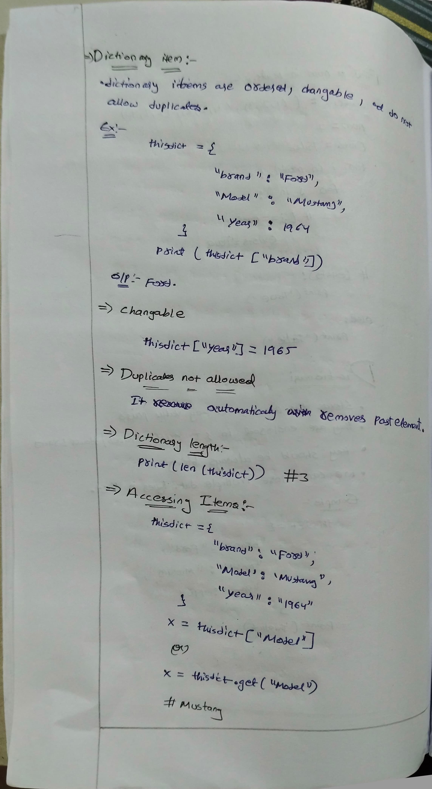

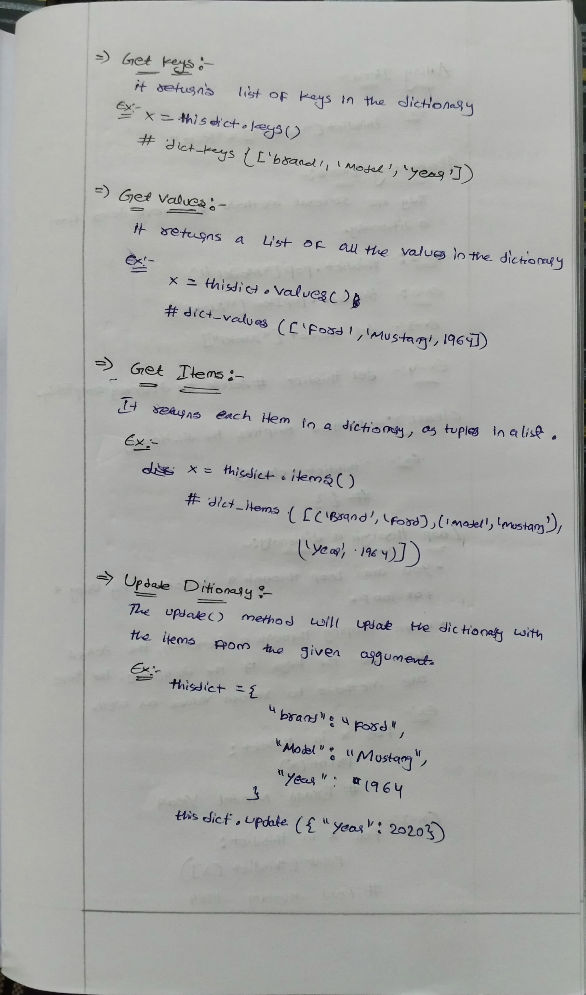

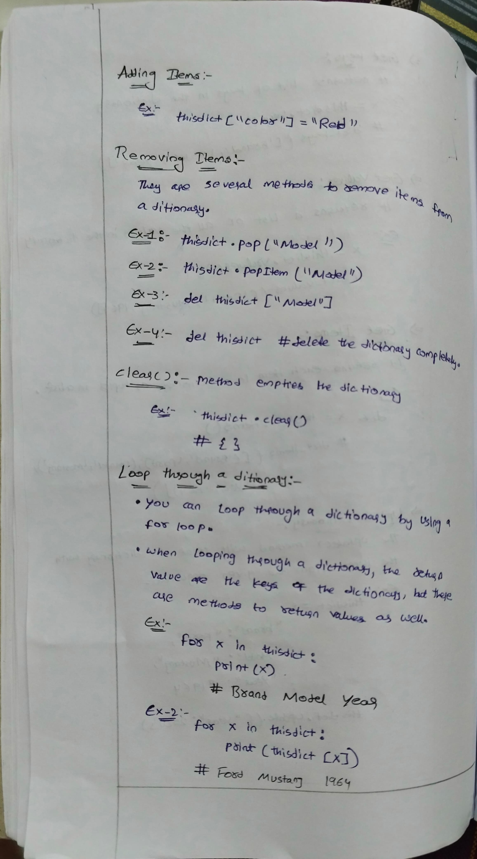

**String and string methods:**

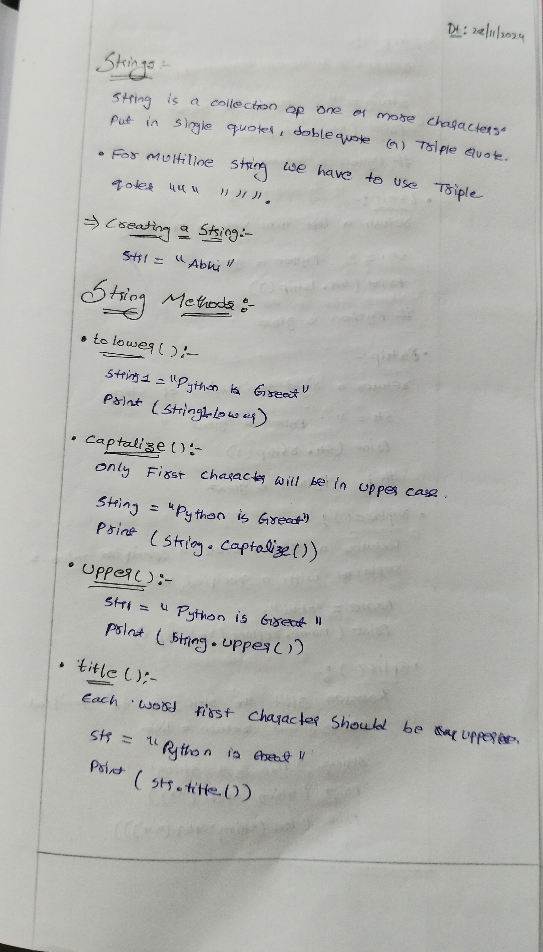

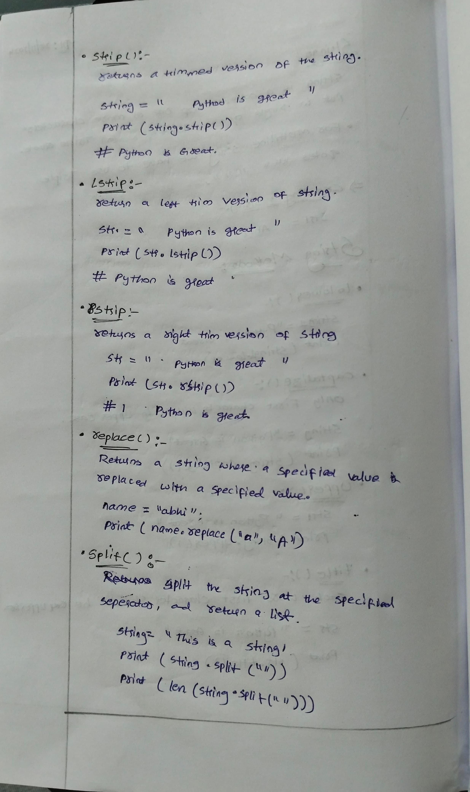

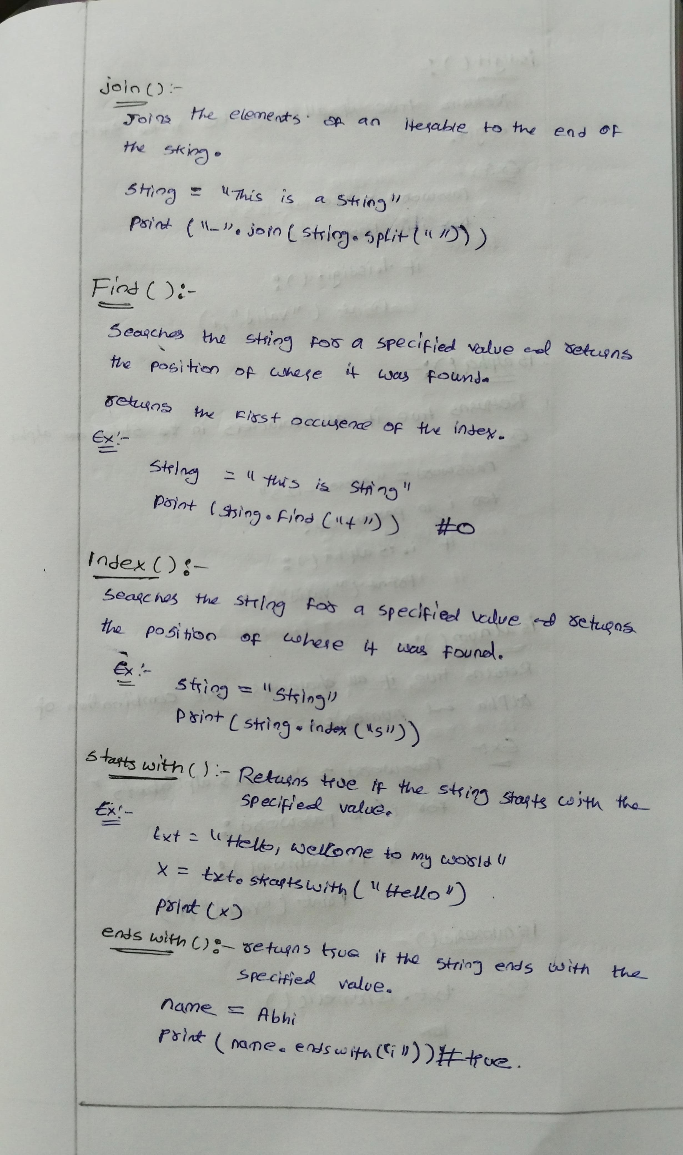

The isalpha() method returns True if all the characters are alphabet letters (a-z).

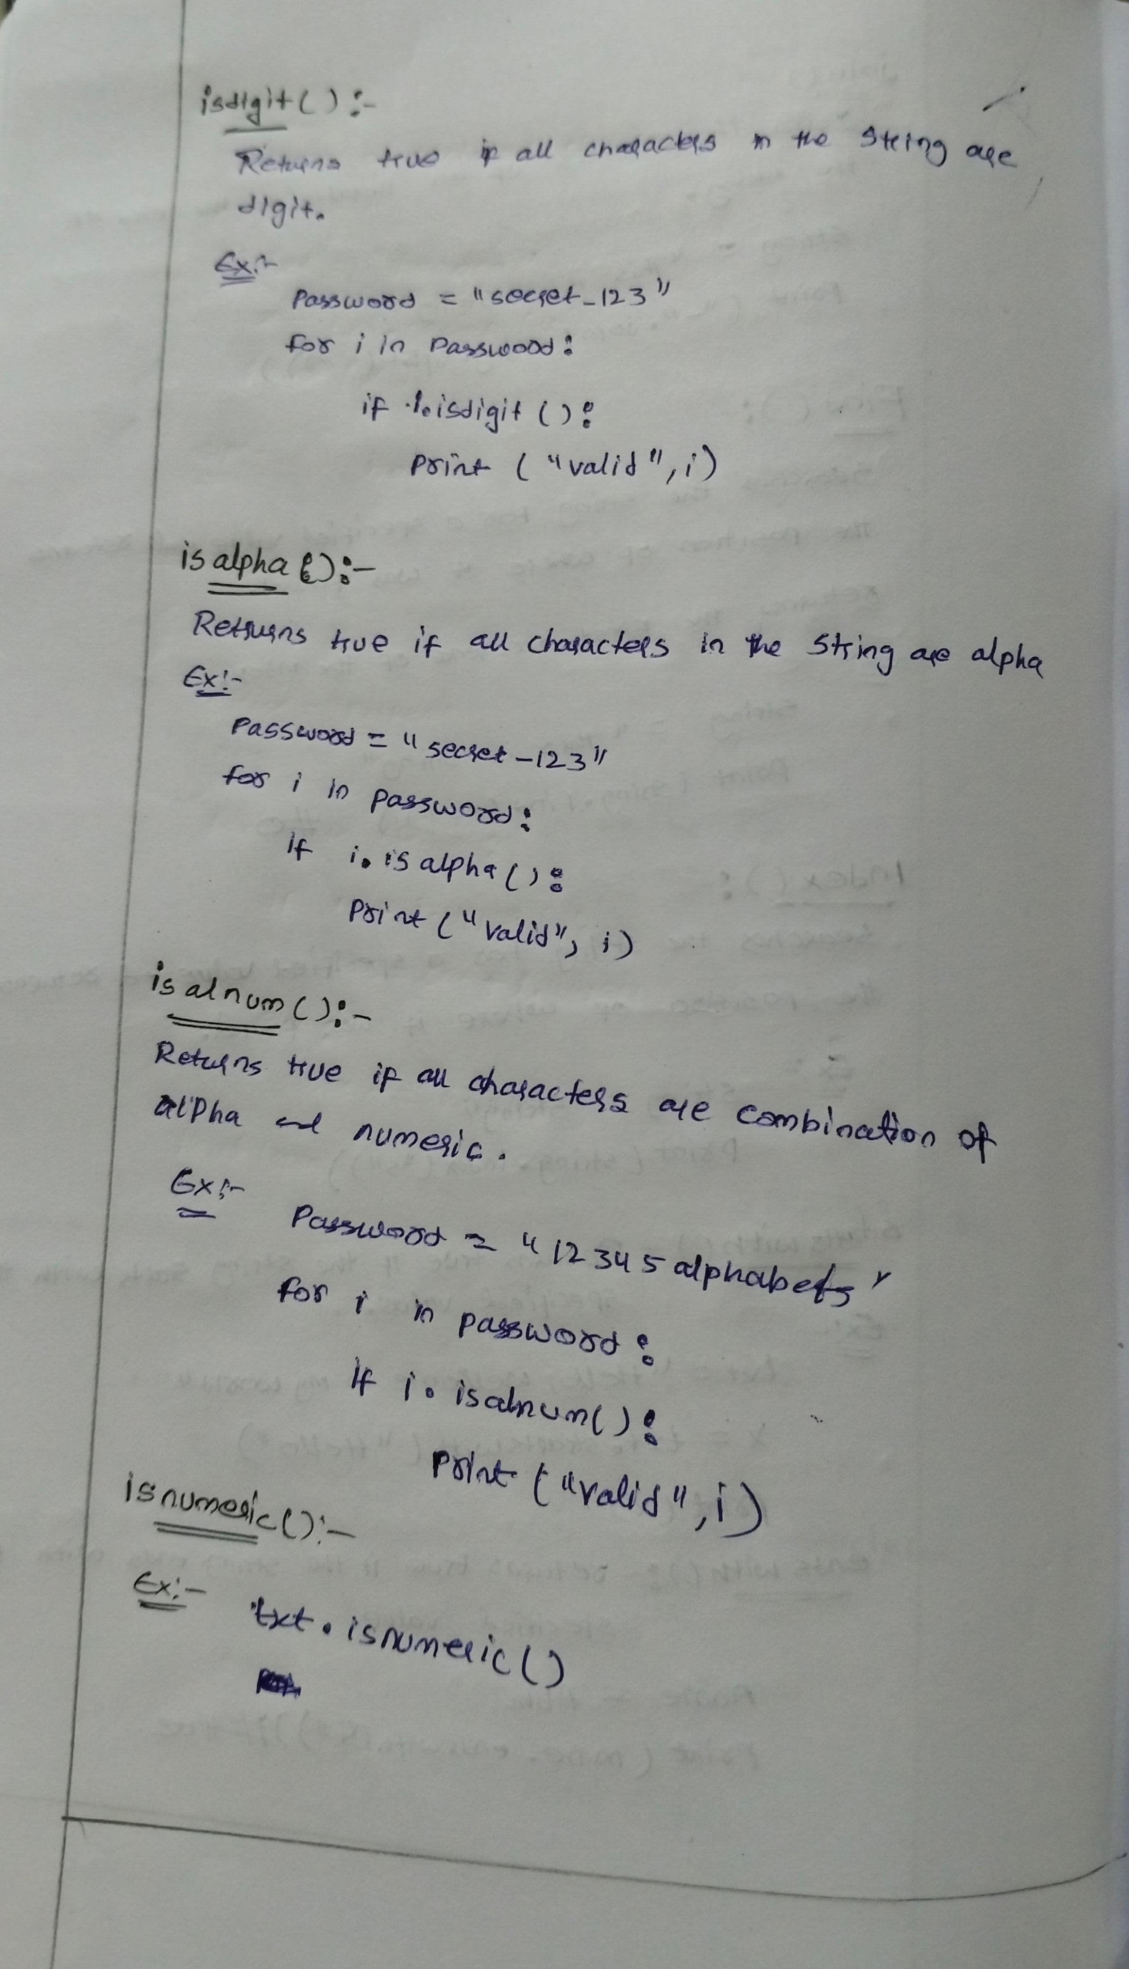

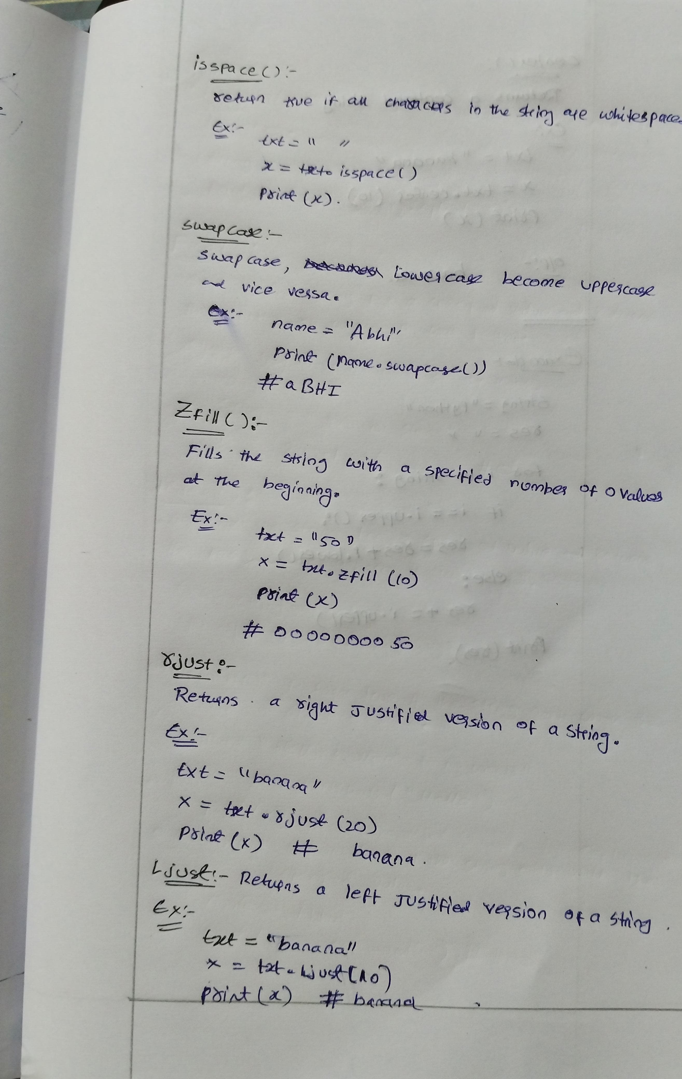

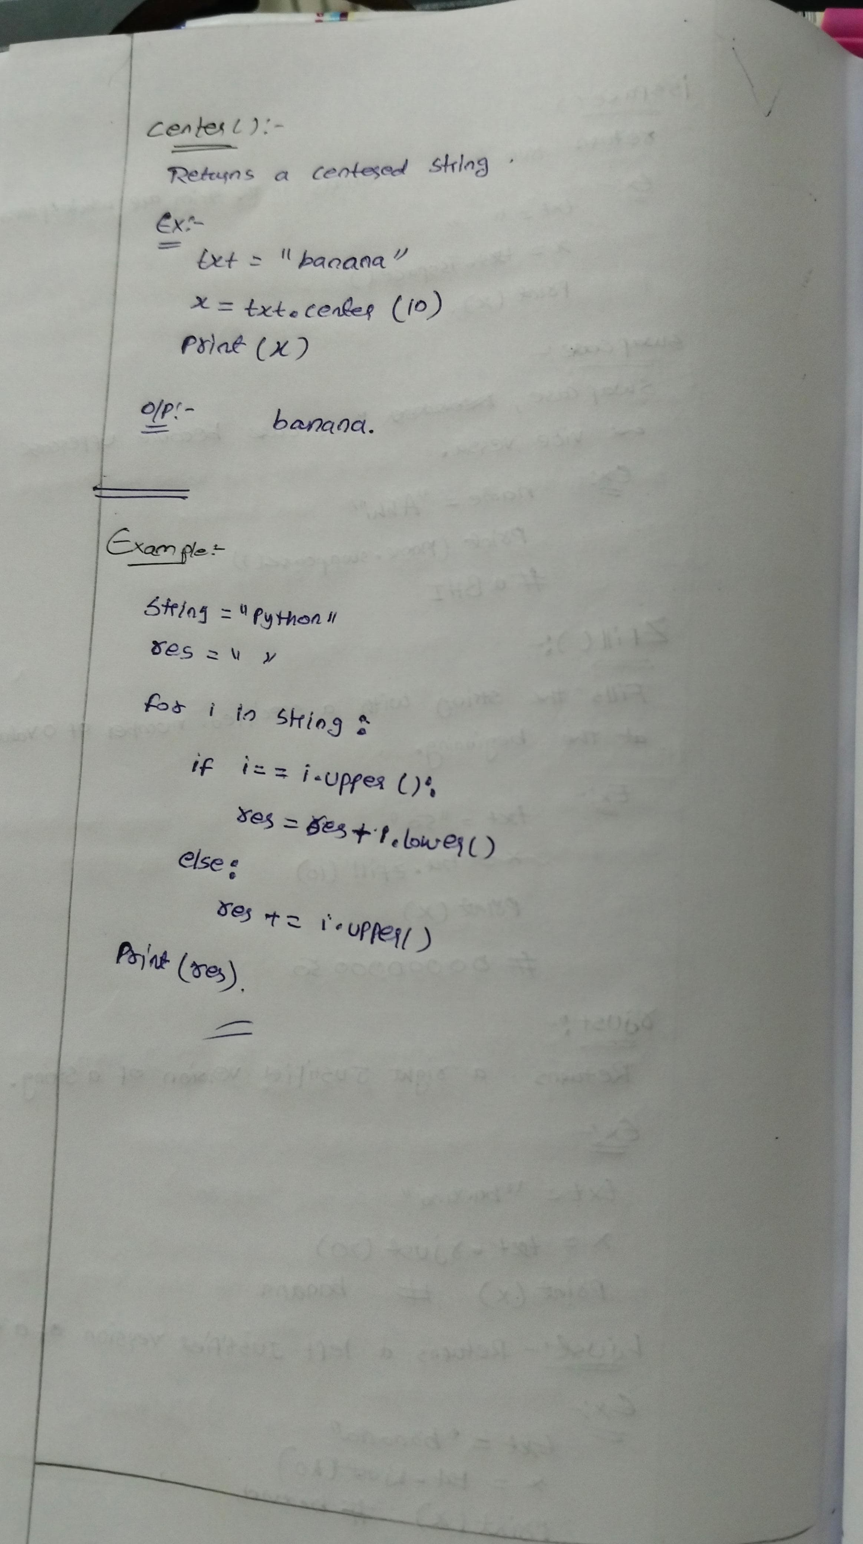

**Number and Number methods:**

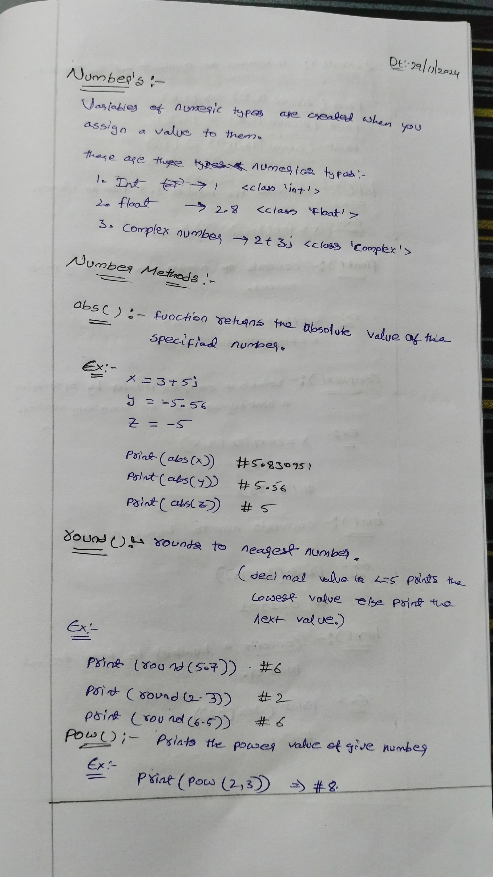

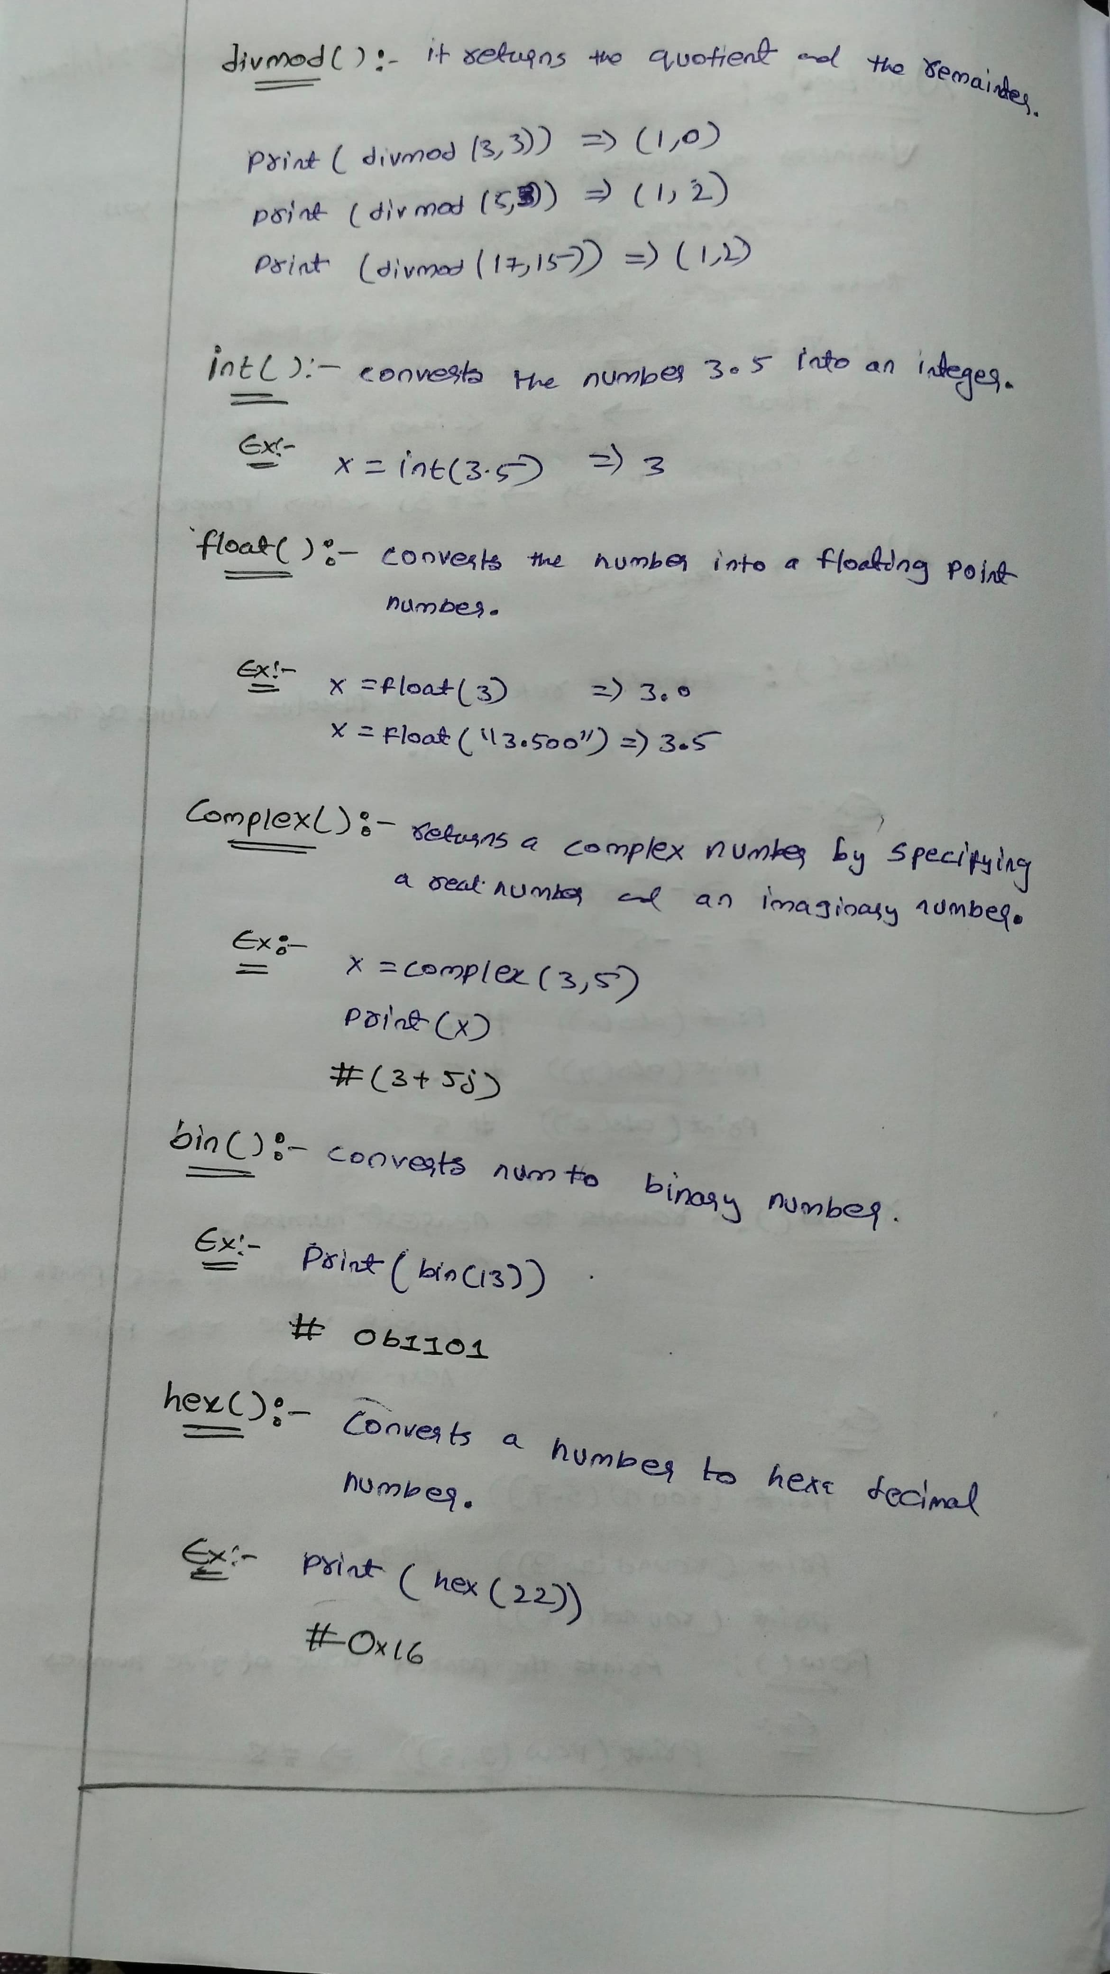

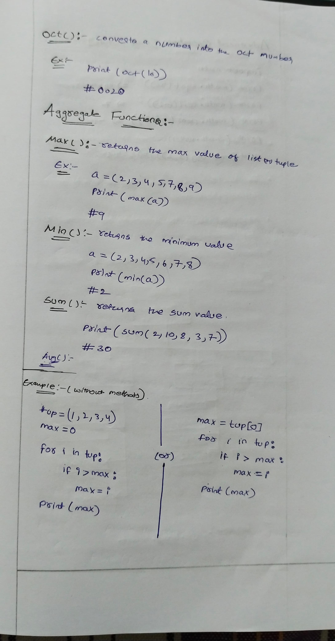

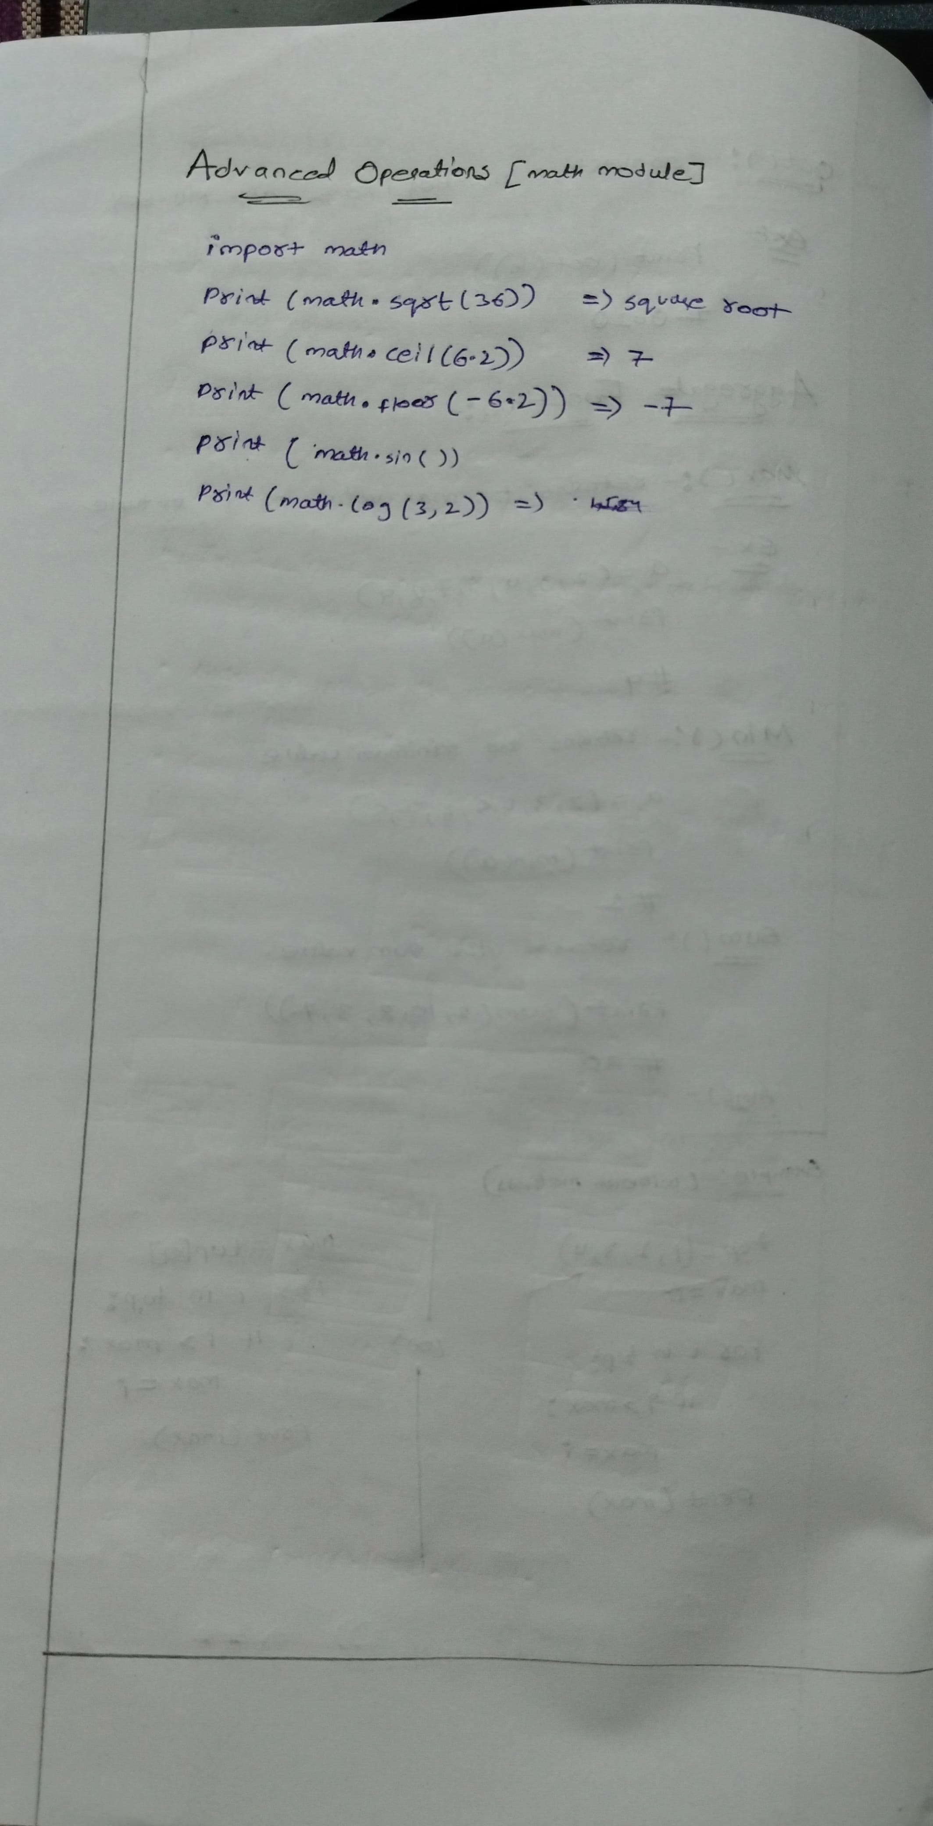

**Modules:**

**Python Module** is a file that contains built-in functions, classes,**its** and variables. There are many **Python modules**, each with its specific work.

In this article, we will cover all about Python modules, such as How to create our own simple module, Import Python modules, From statements in Python, we can use the alias to rename the module, etc.

**What is Python Module**

A [Python](https://www.geeksforgeeks.org/python-programming-language/)module is a file containing Python definitions and statements. A module can define functions, classes, and variables. A module can also include runnable code.

Grouping related code into a module makes the code easier to understand and use. It also makes the code logically organized.

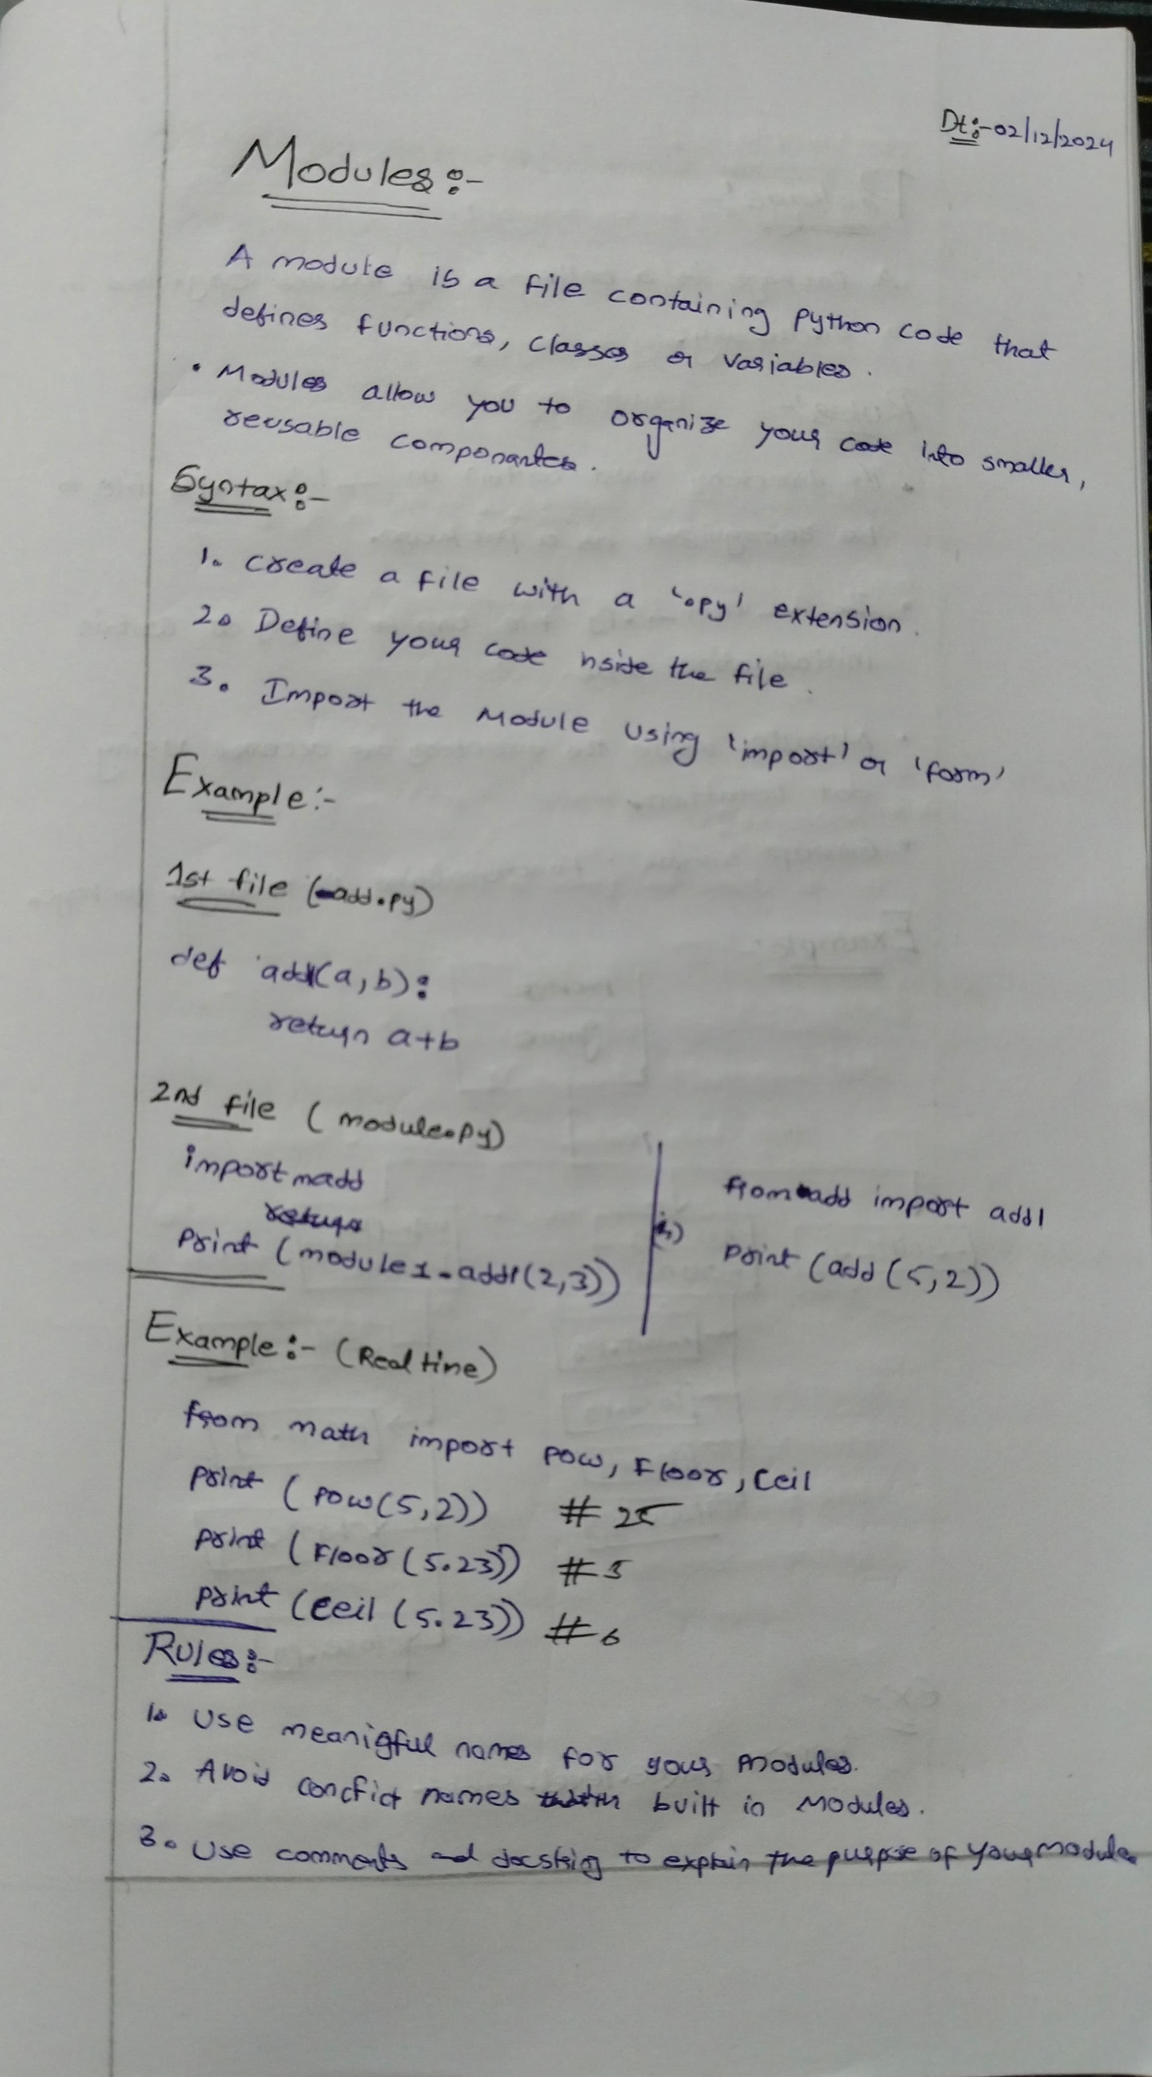

**Packages:**

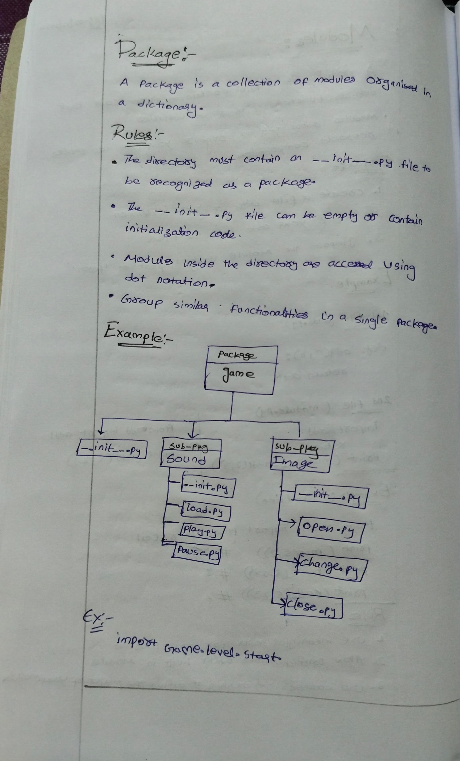

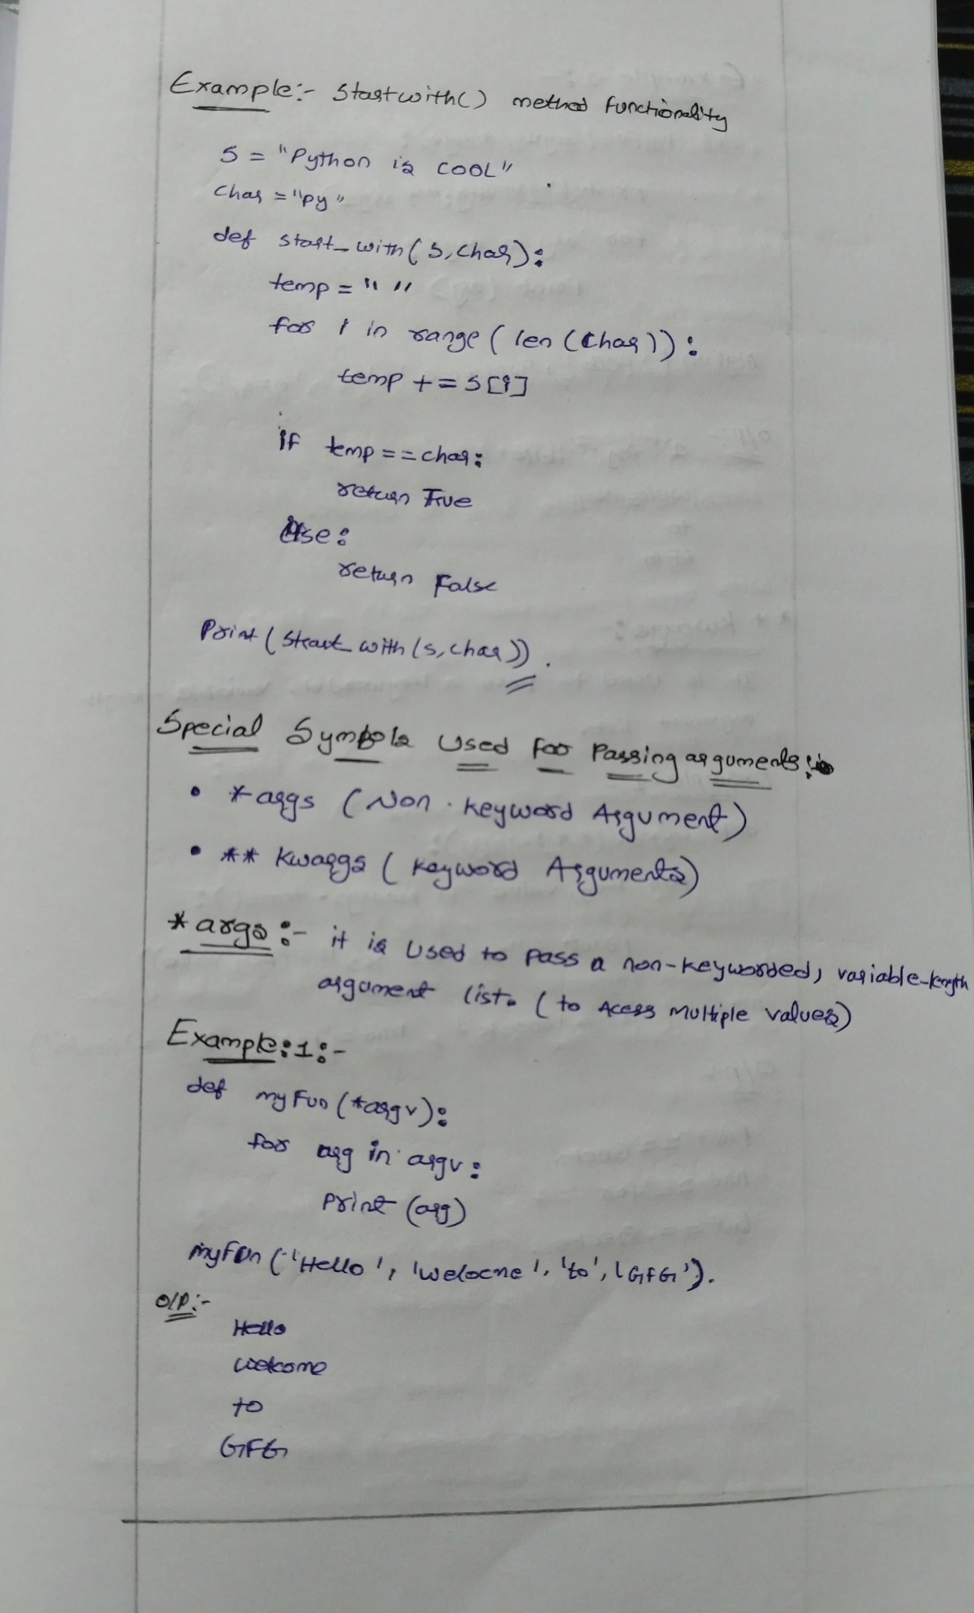

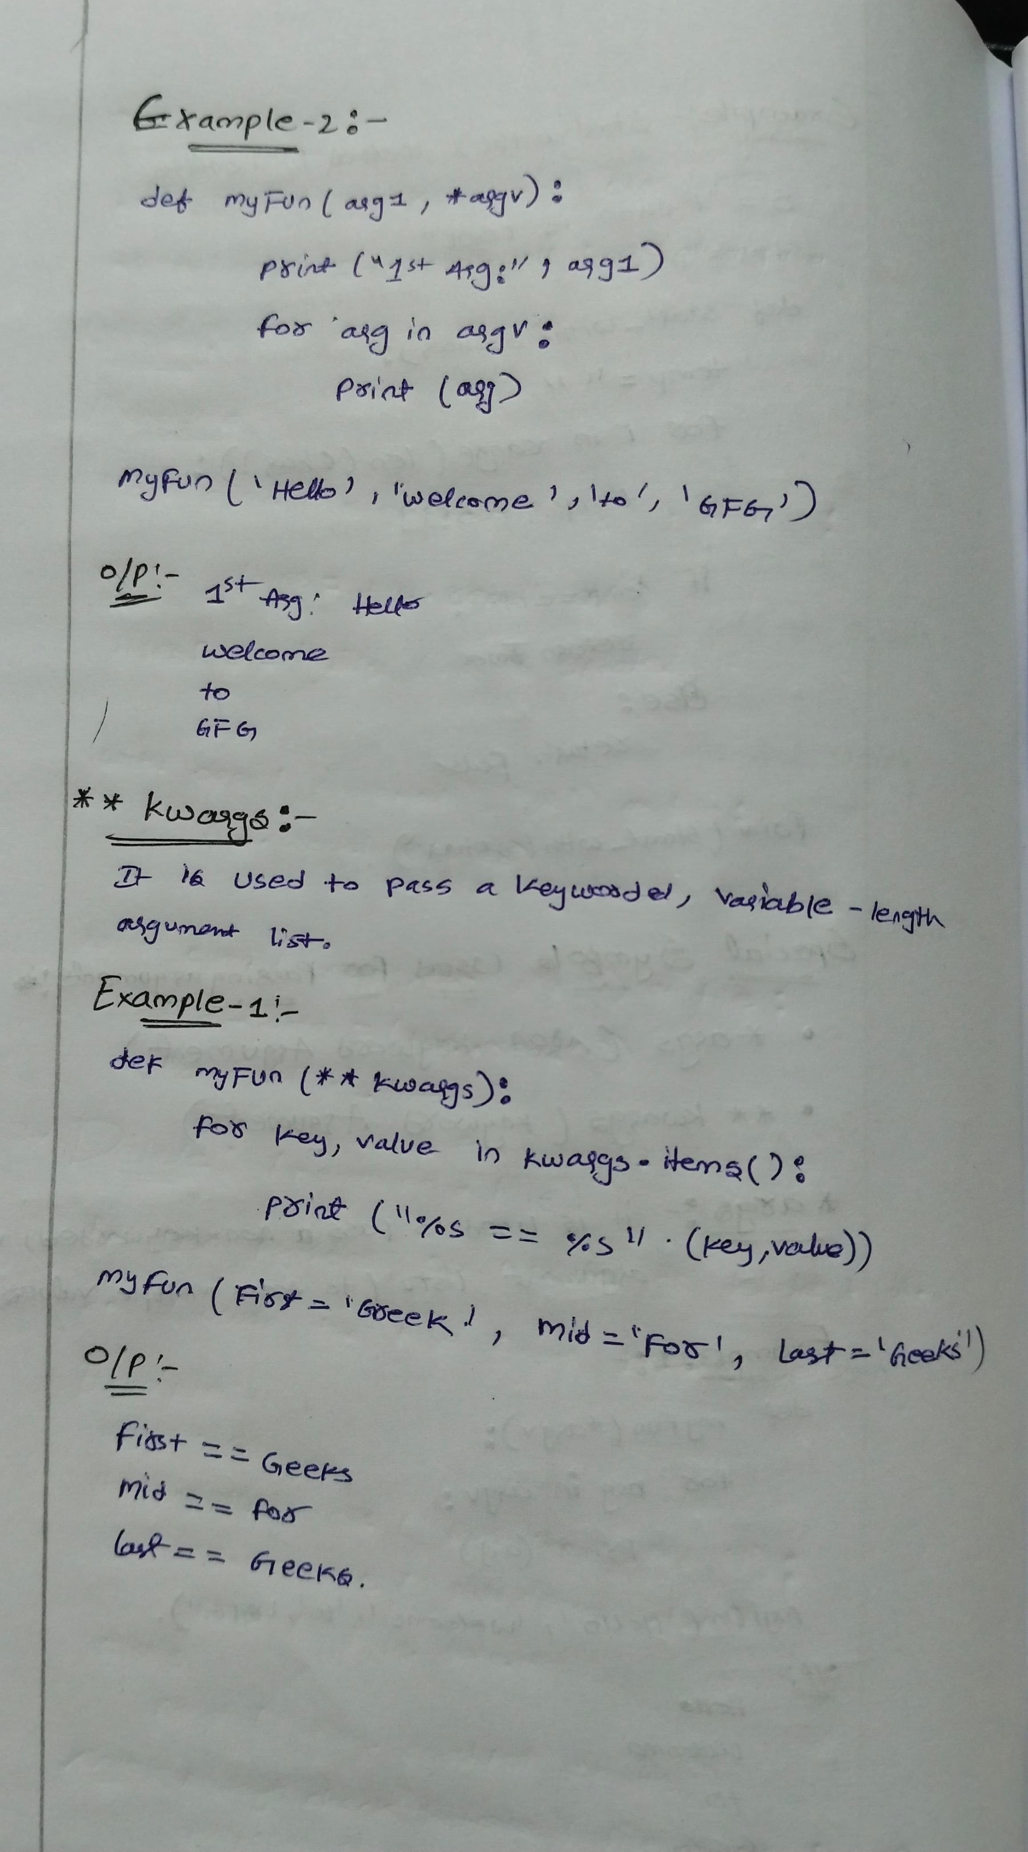

**File Handling:**

file handling and allows users to handle files i.e., to read and write files, along with many other file handling options, to operate on files.

**Advantages of File Handling in Python:** Versatility **,** Flexibility**,** User – friendlyandCross-platform

**File Handling**

The key function for working with files in Python is the open() function.

The open() function takes two parameters; *filename*, and *mode*.

There are four different methods (modes) for opening a file:

* "r" - Read - Default value. Opens a file for reading, error if the file does not exist
* "a" - Append - Opens a file for appending, creates the file if it does not exist
* "w" - Write - Opens a file for writing, creates the file if it does not exist
* "x" - Create - Creates the specified file, returns an error if the file exists

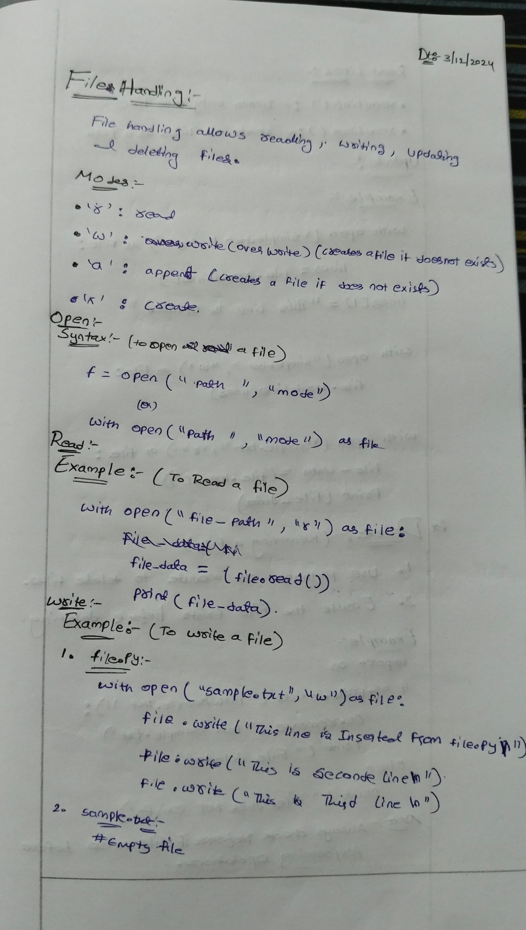

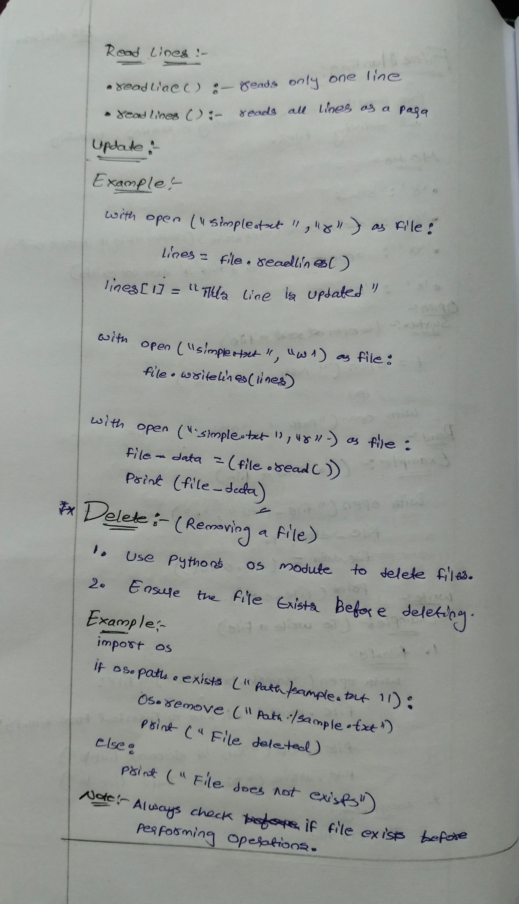

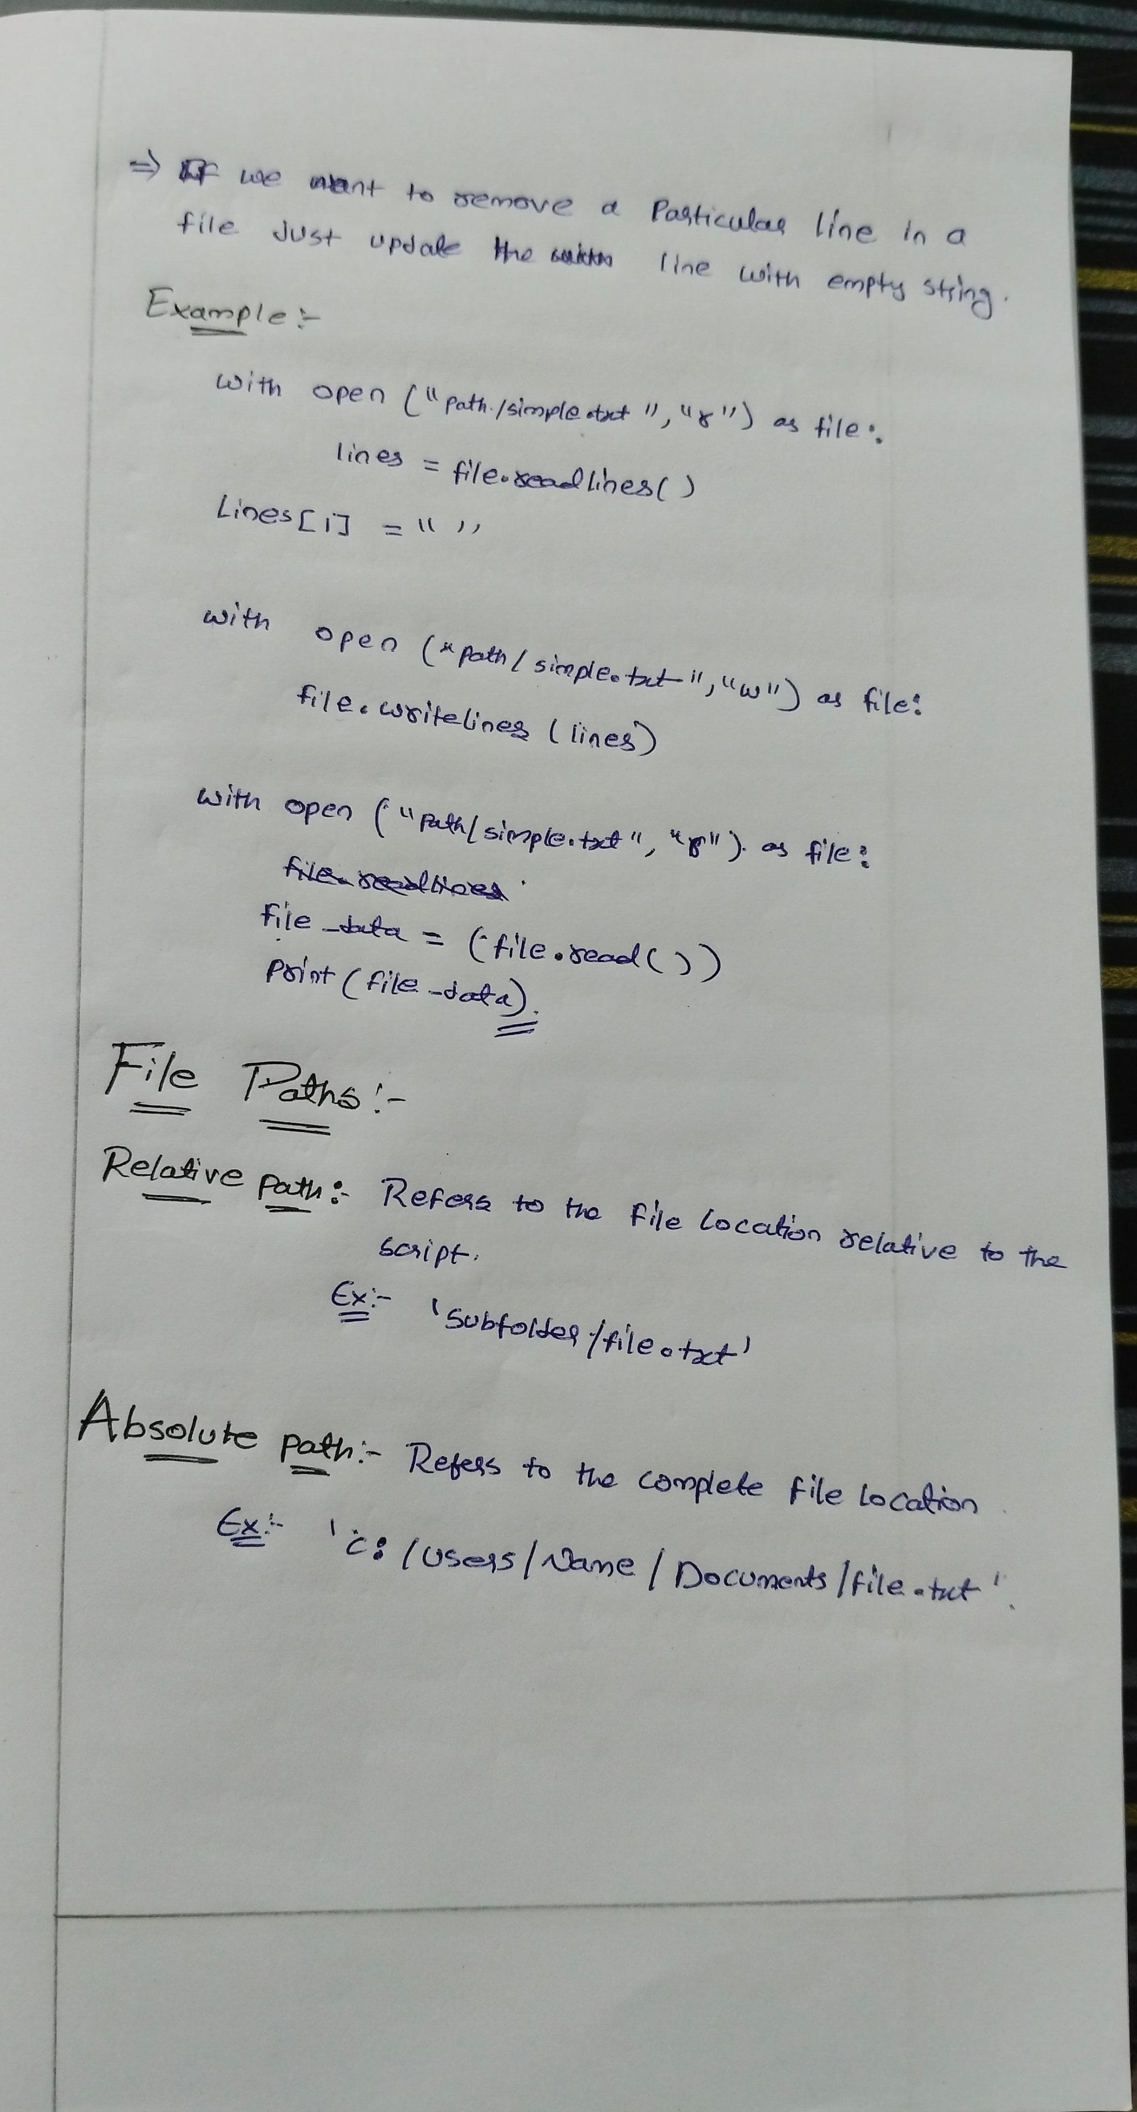

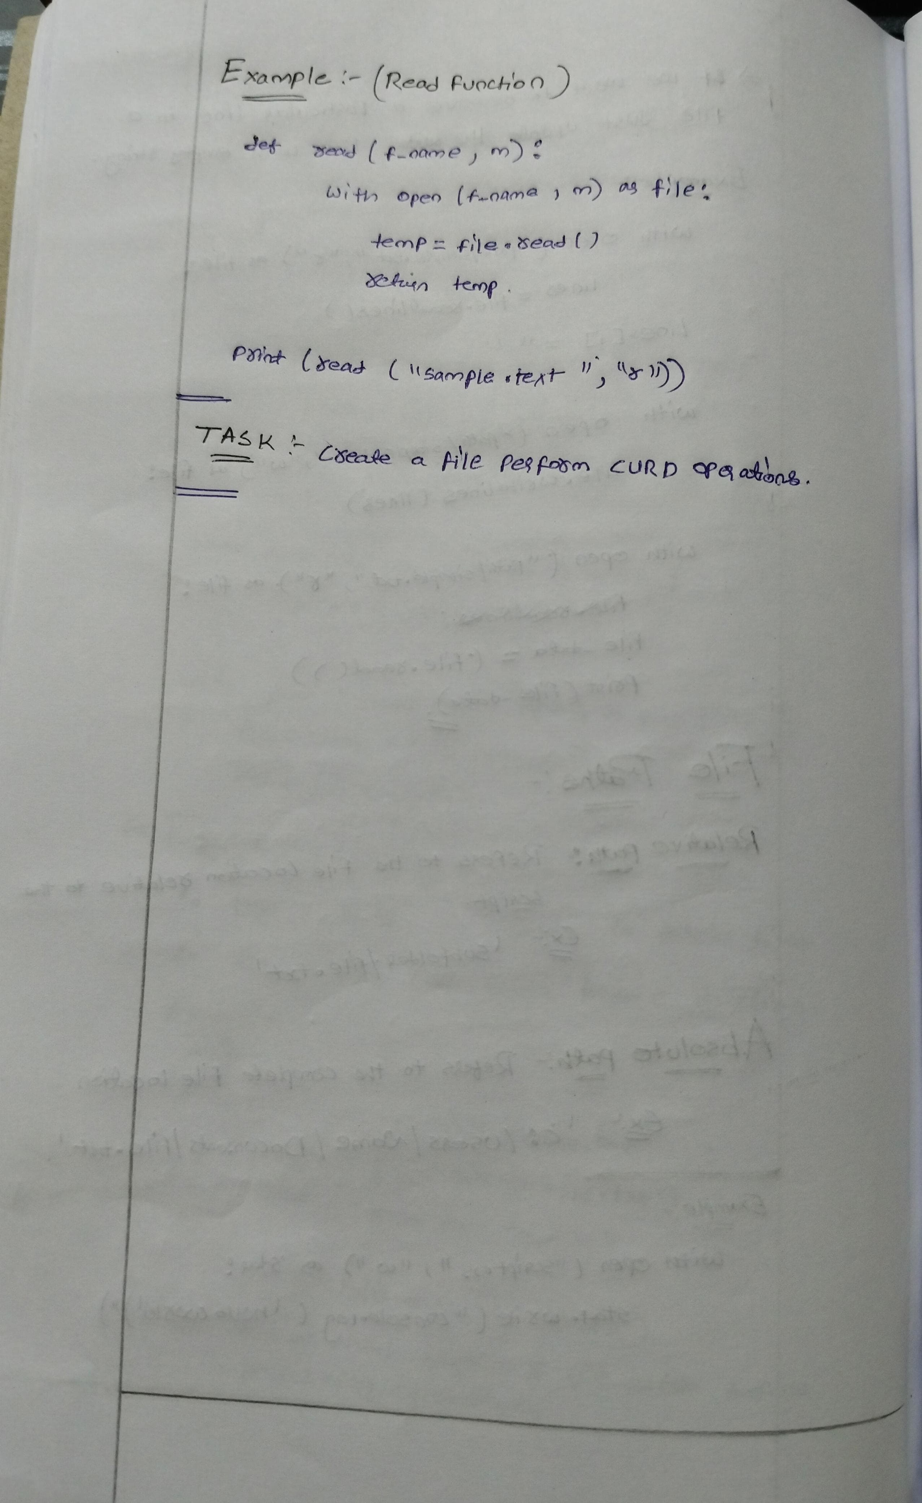

**Regular Expressions**

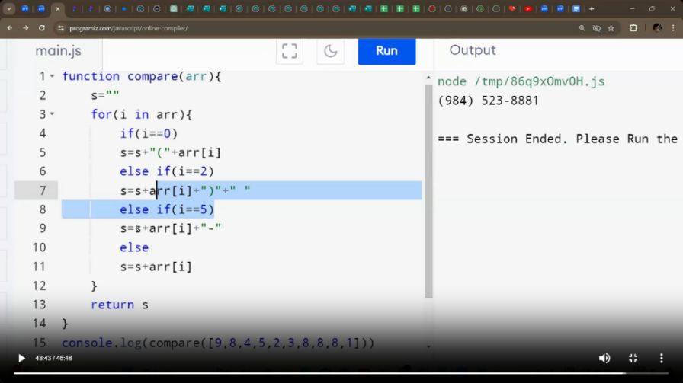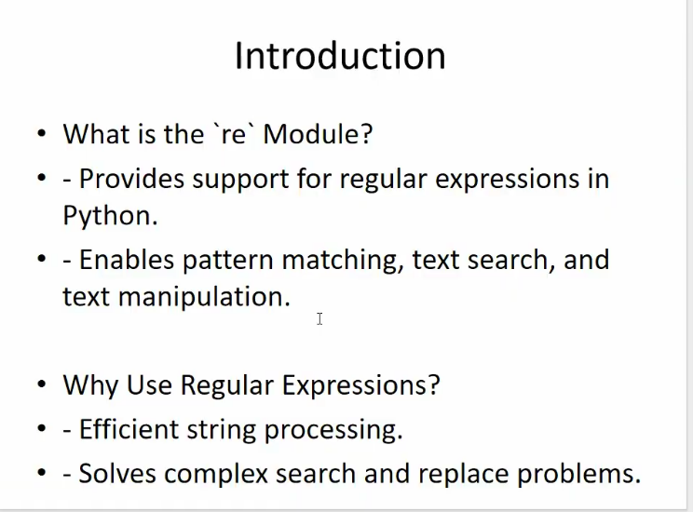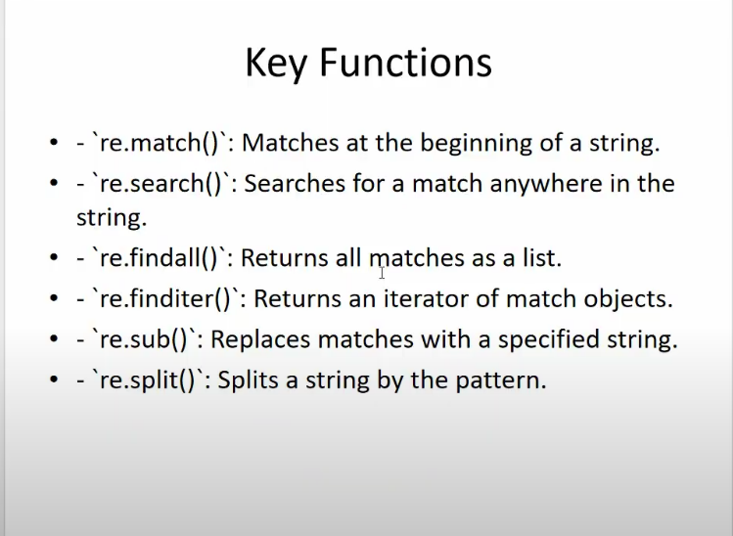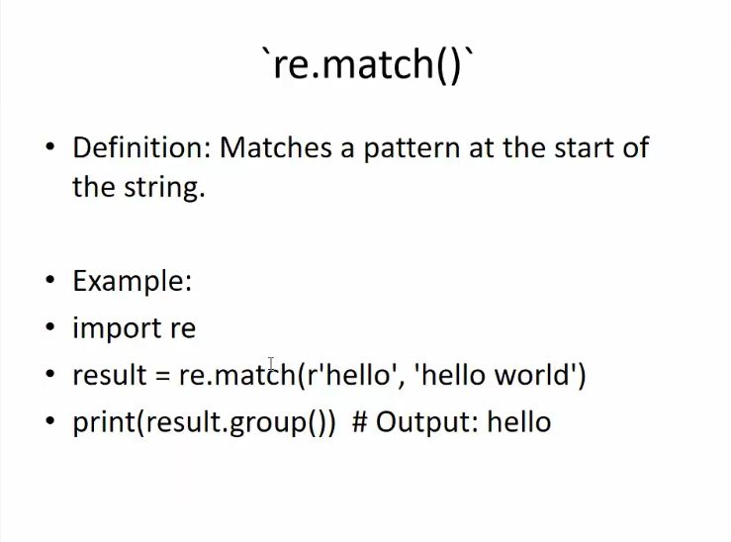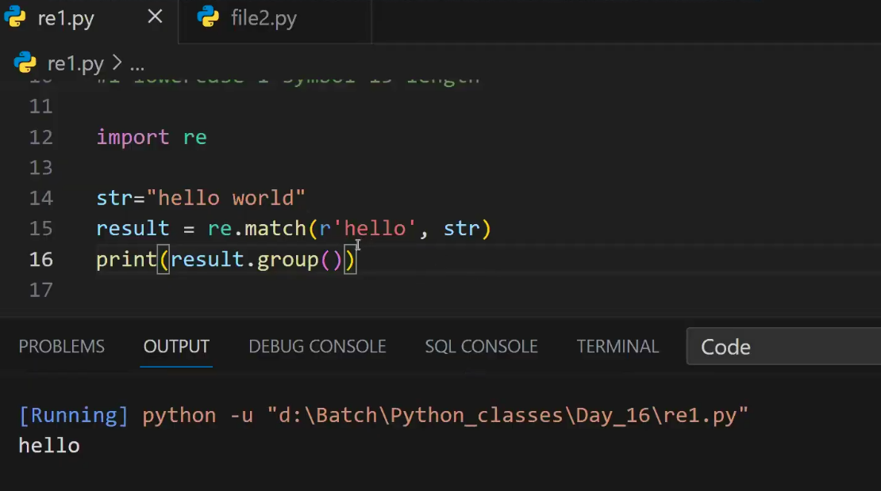

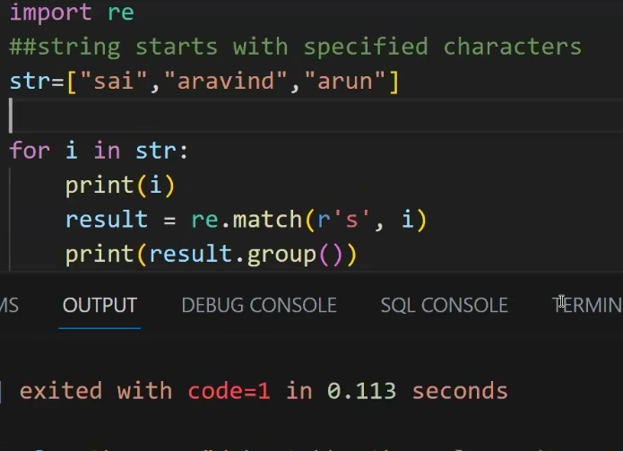

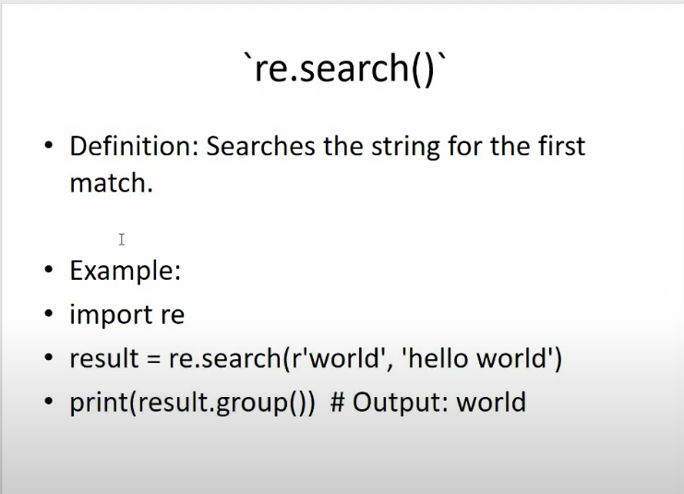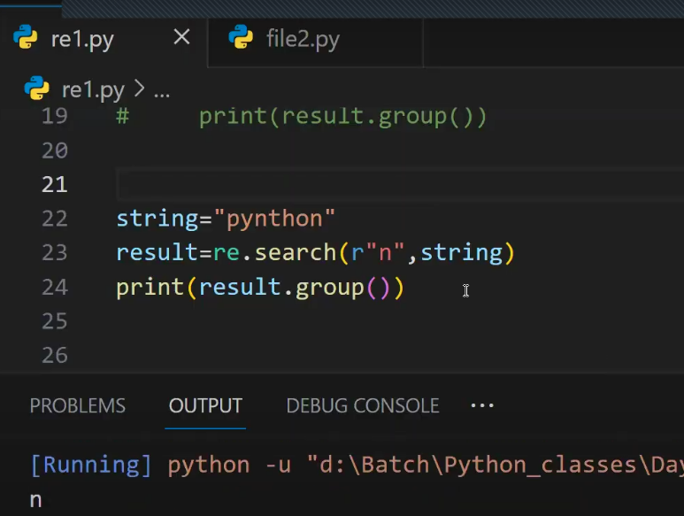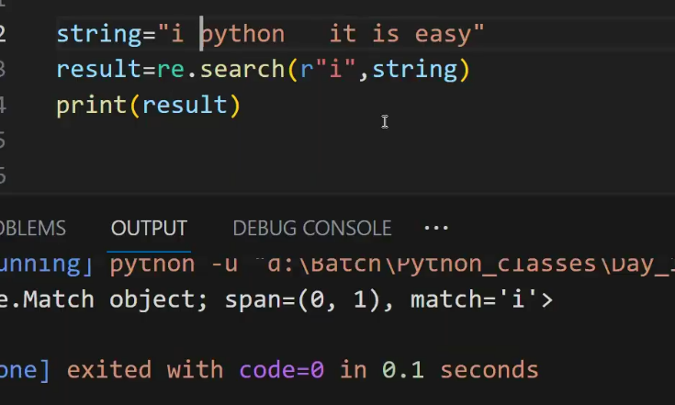

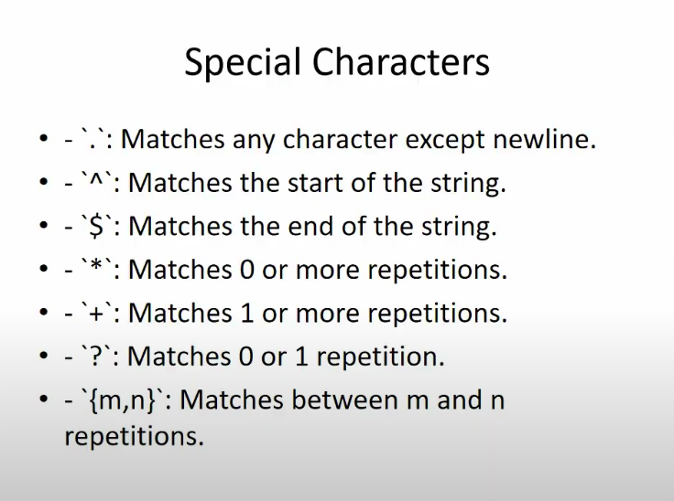

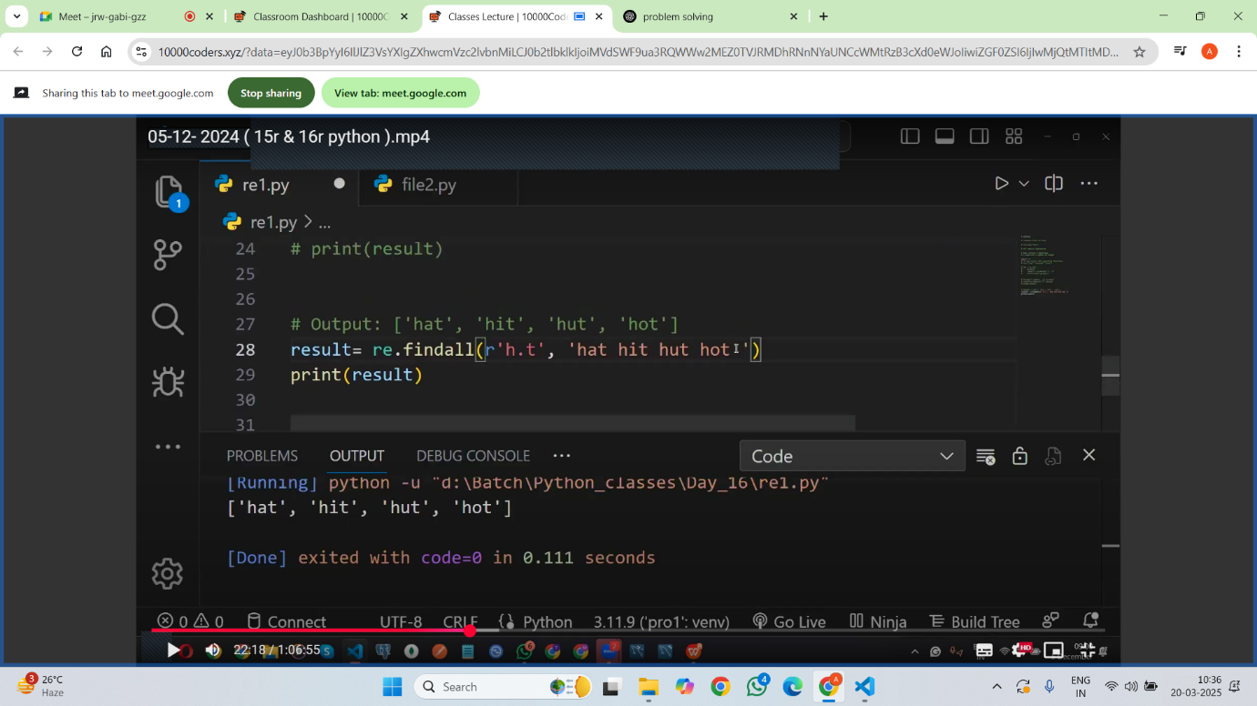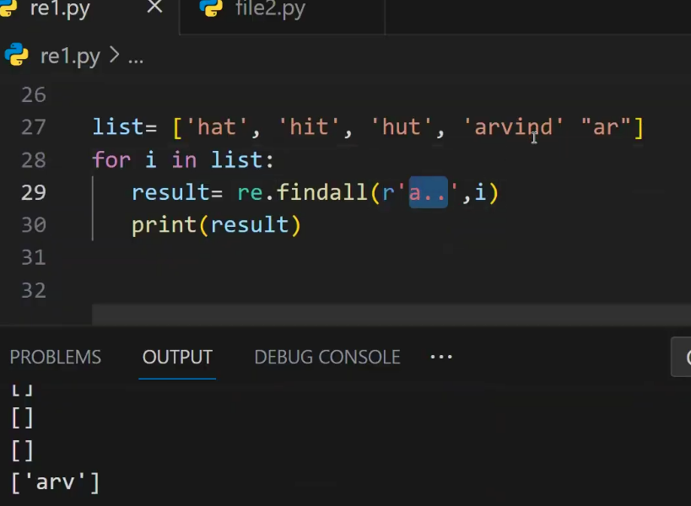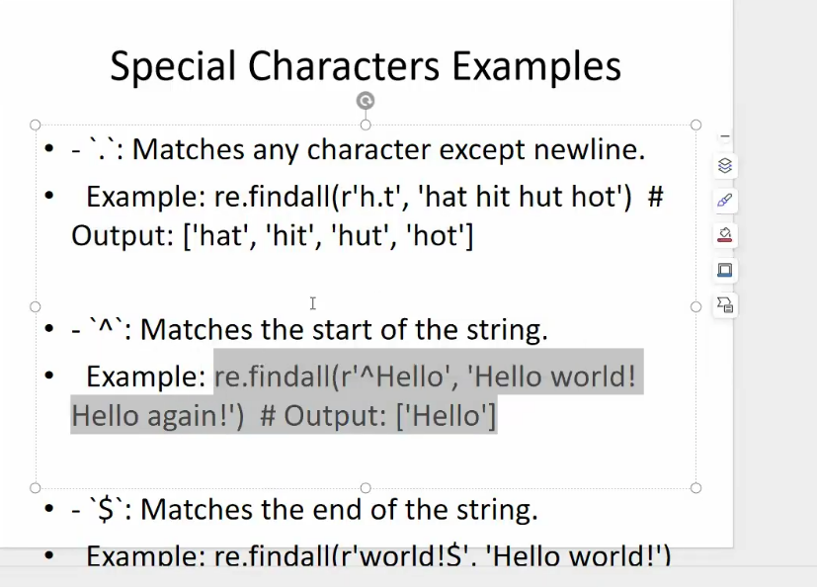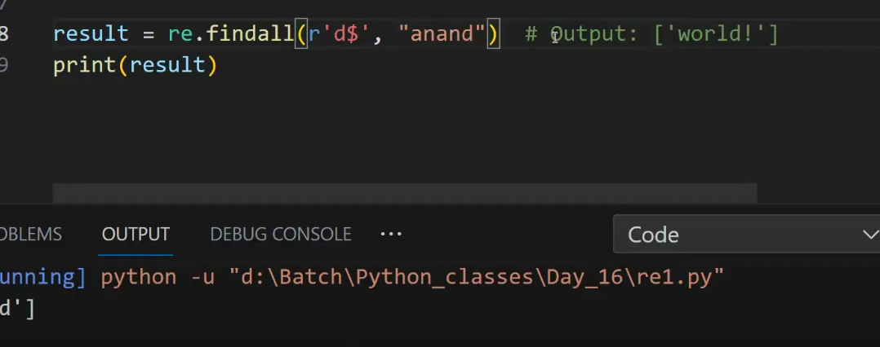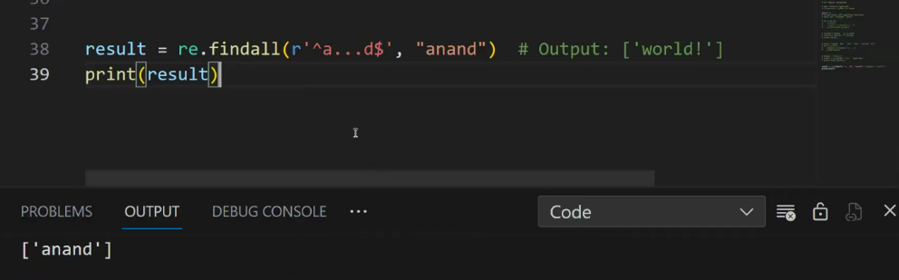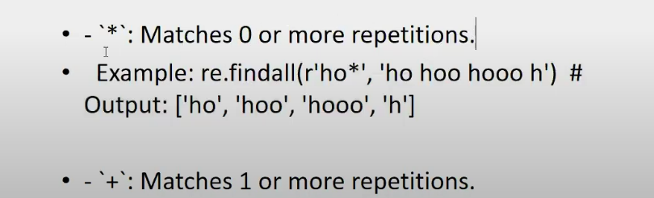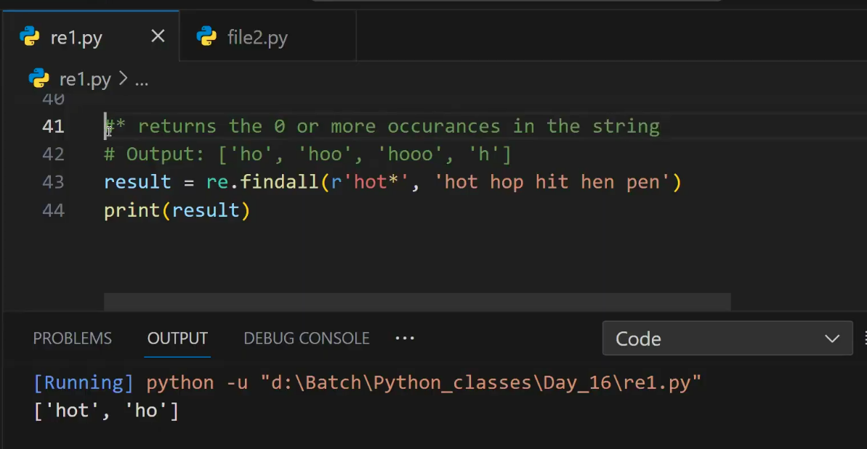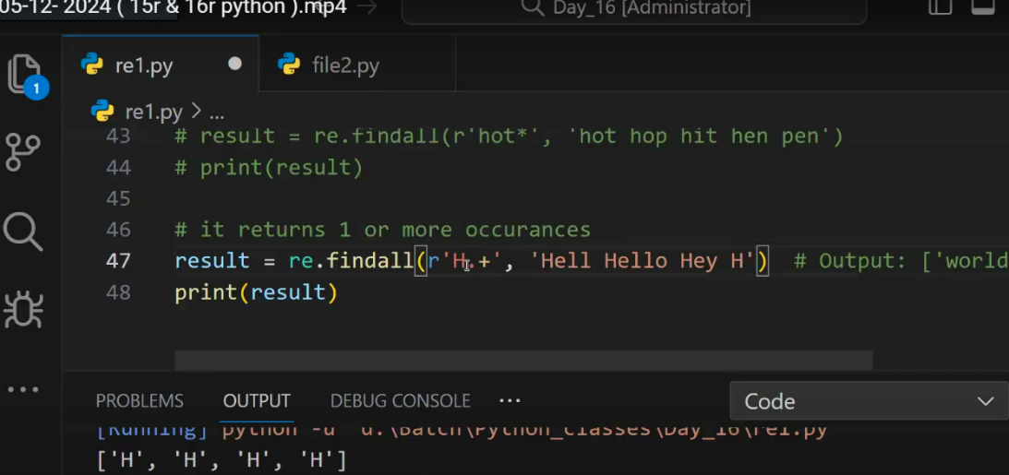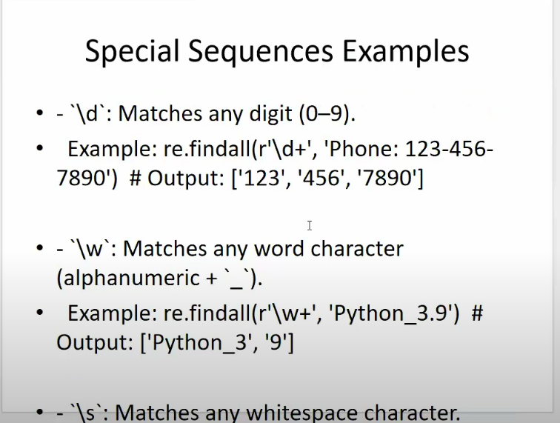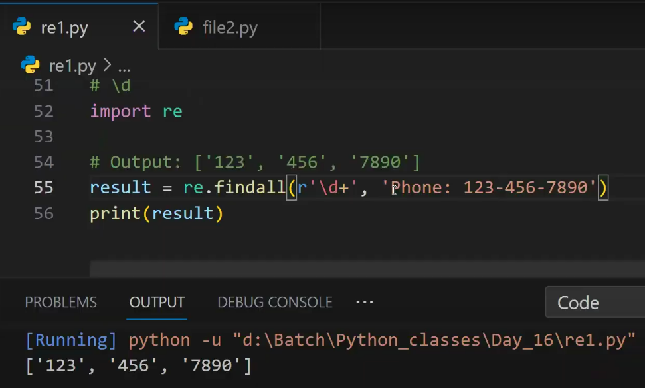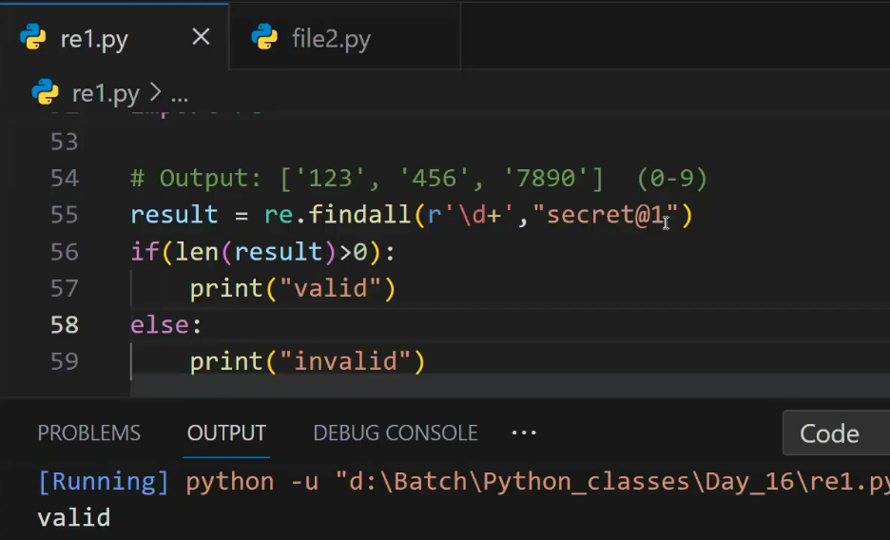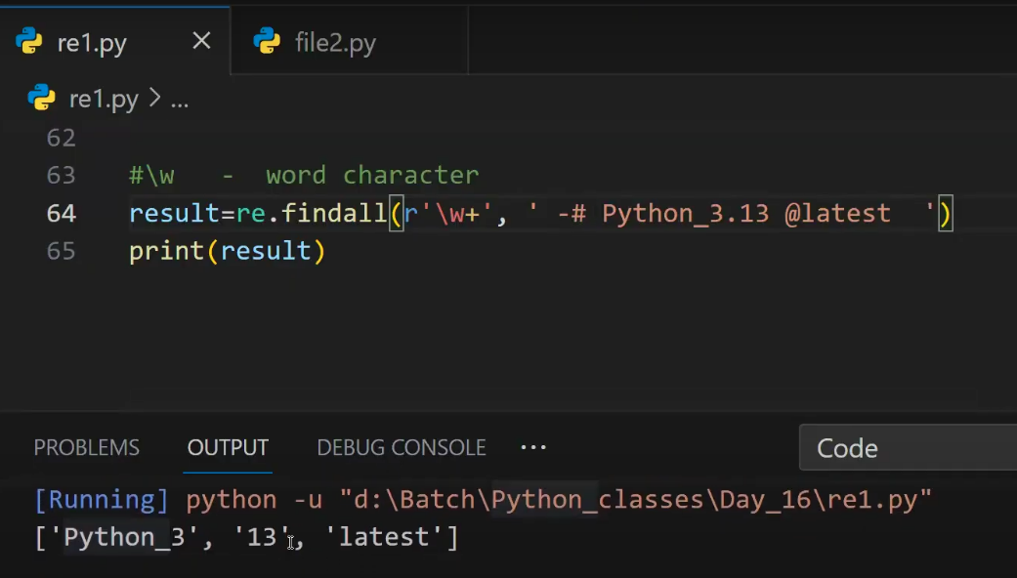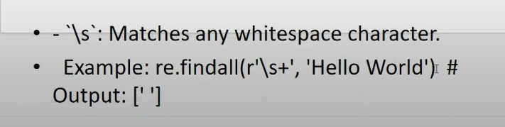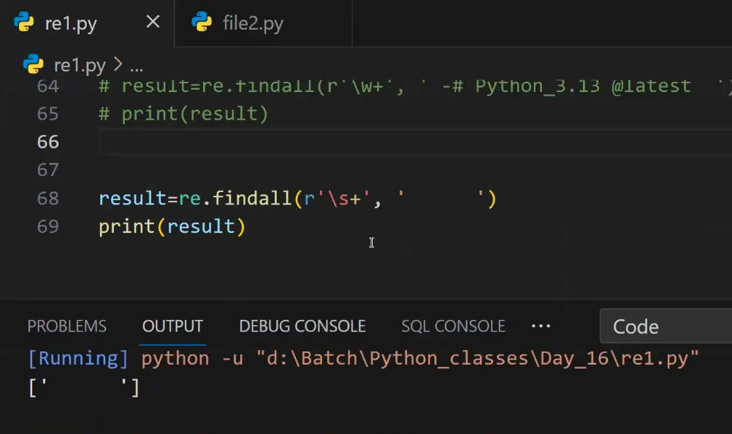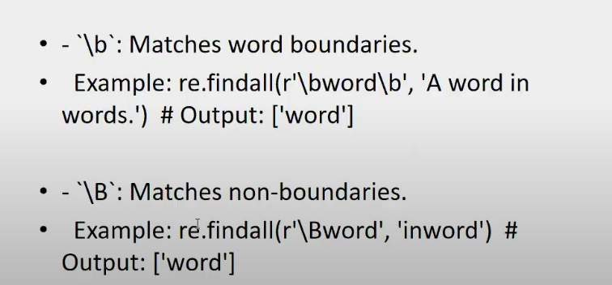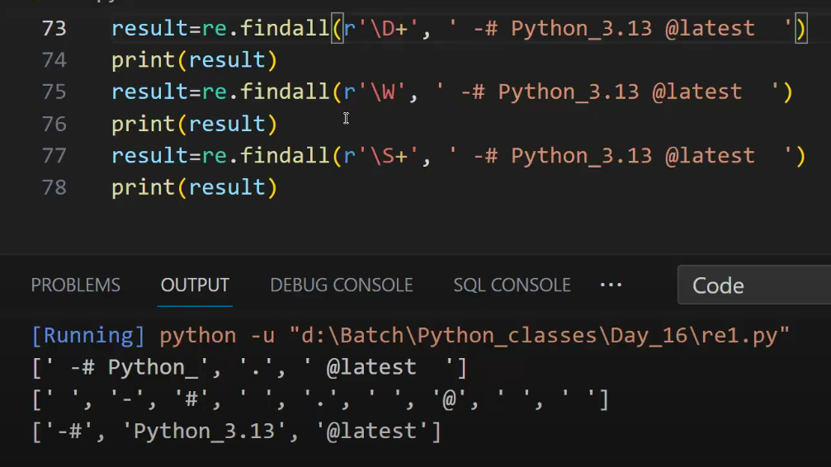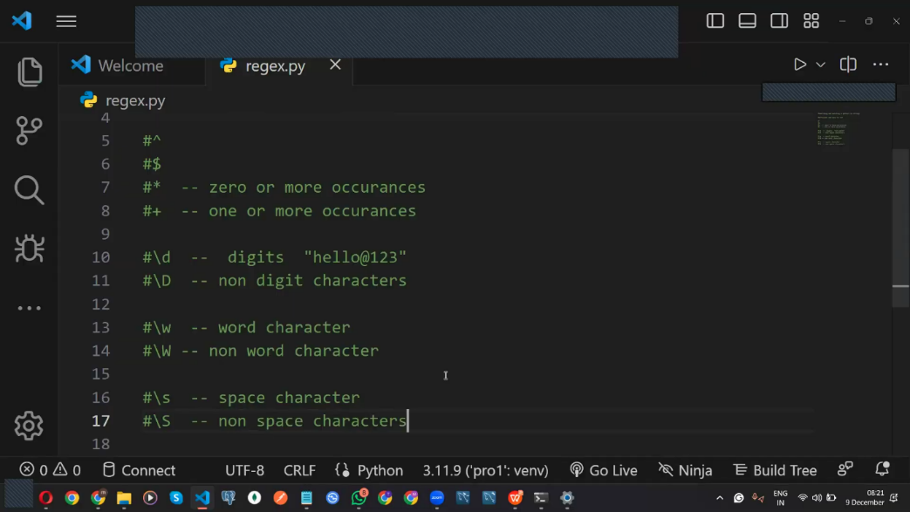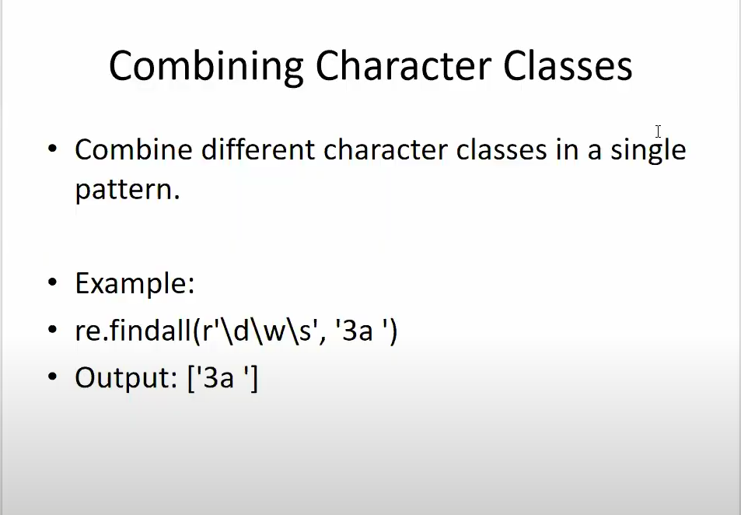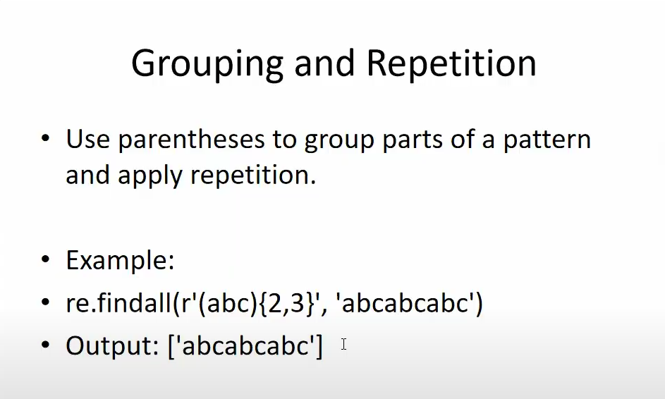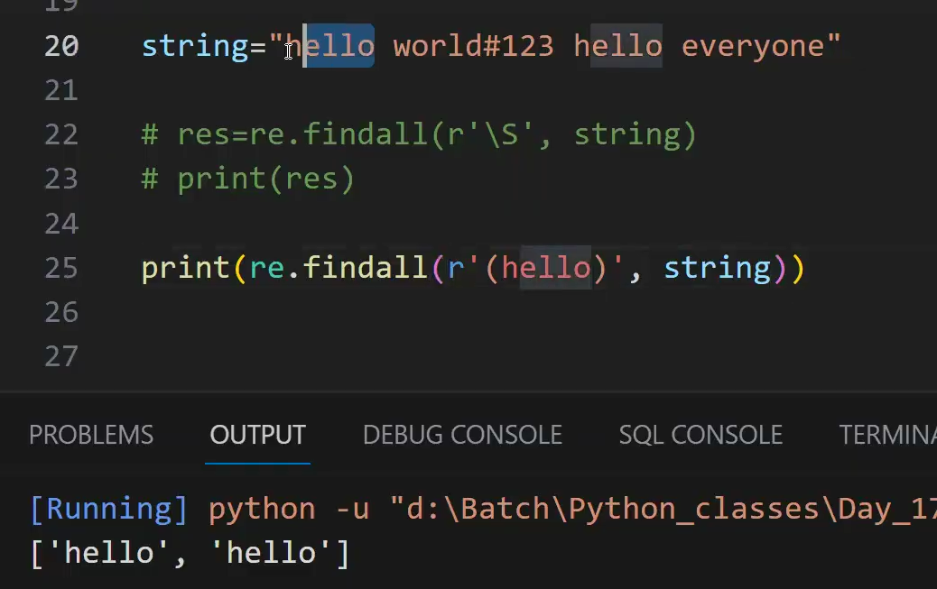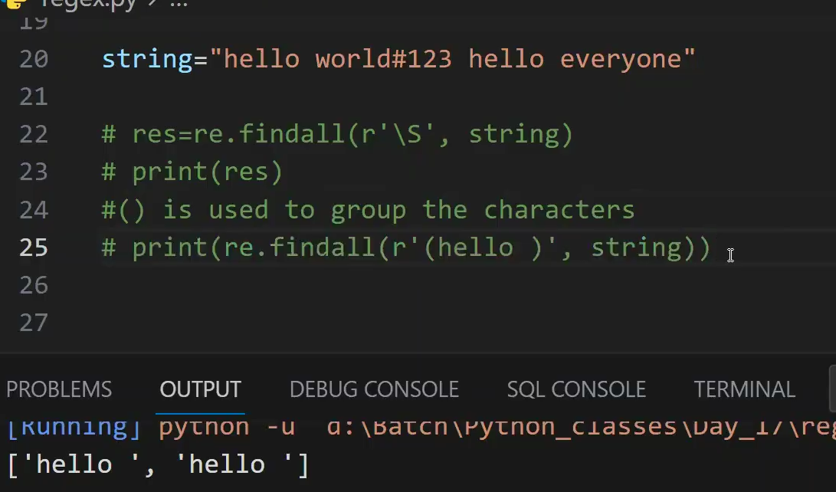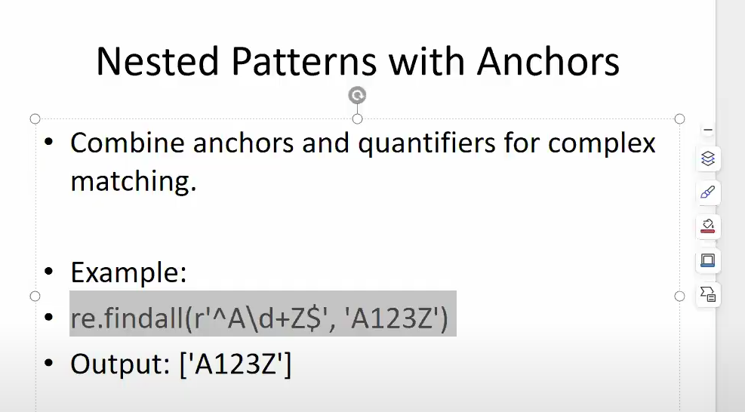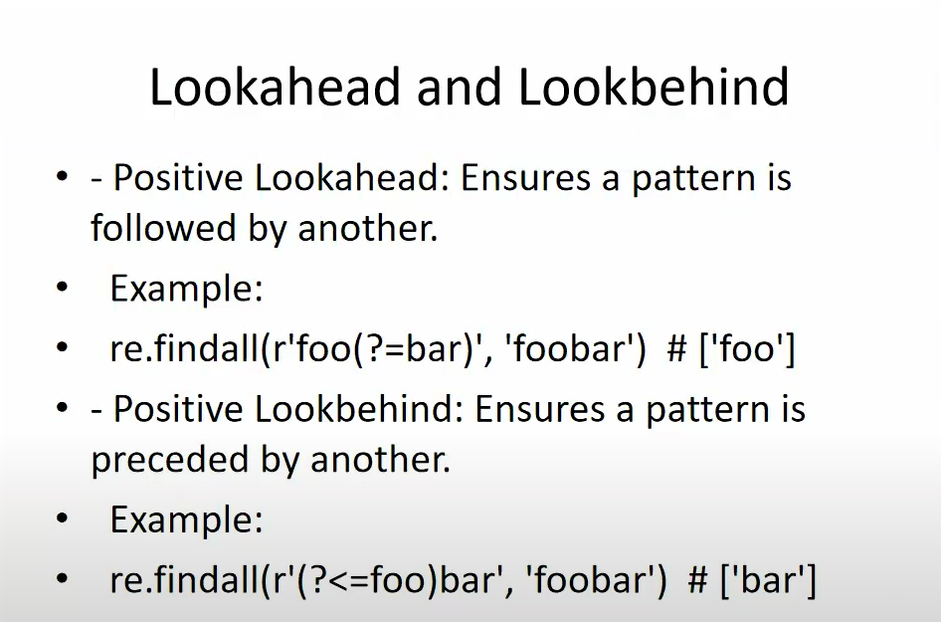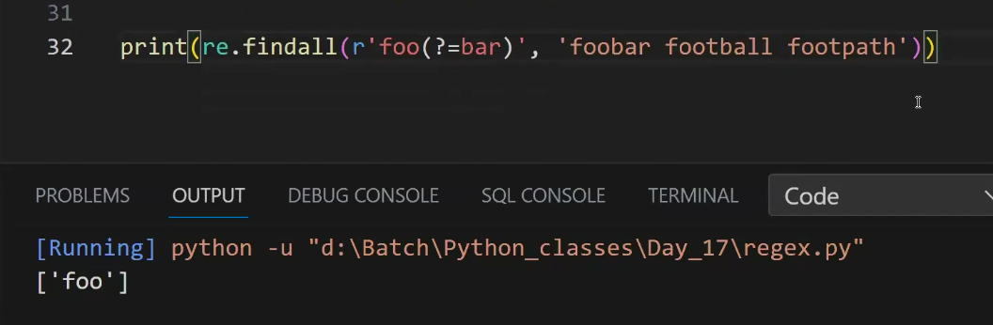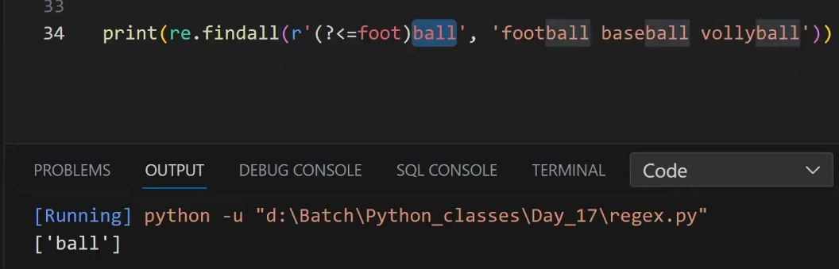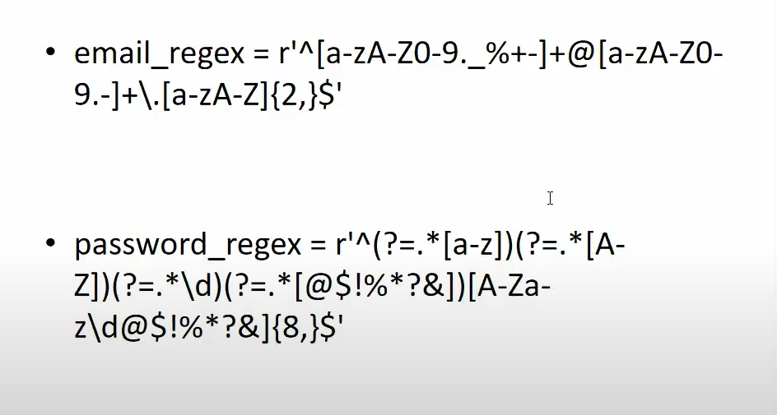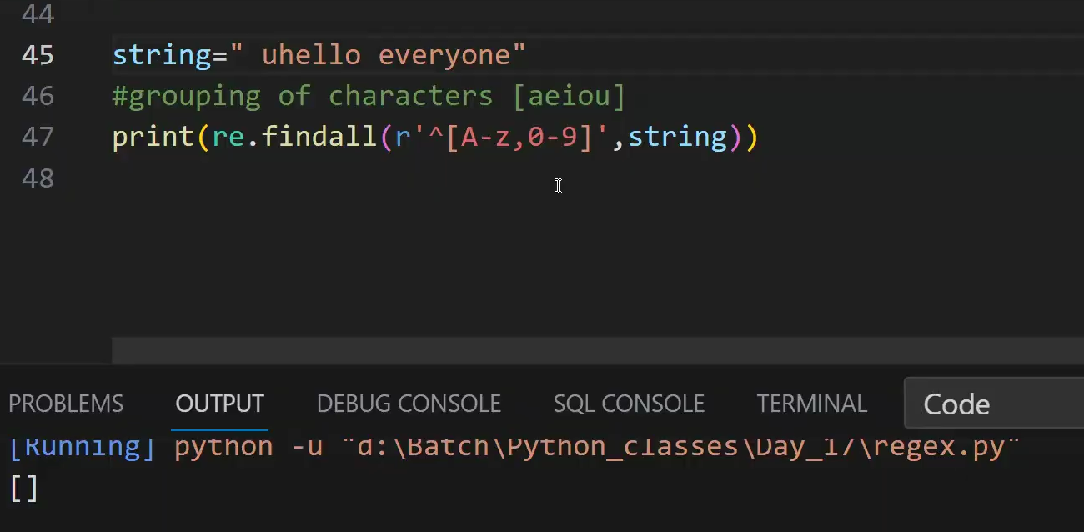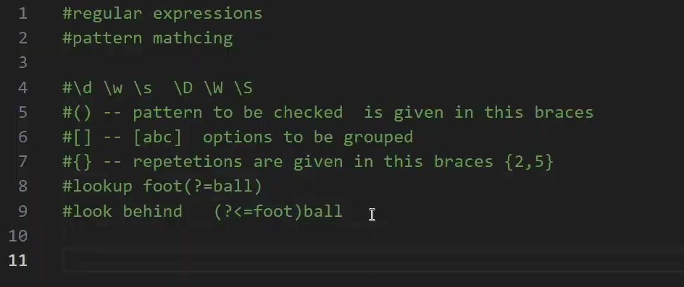

**Errors and Exceptions**

**Errors and Their Types in Python**

Errors in Python occur when the interpreter encounters something it cannot execute. Errors can be broadly classified into **syntax errors** and **exceptions**.

**1. Syntax Errors (Compile-Time Errors)**

A **SyntaxError** occurs when the Python interpreter finds an incorrect syntax (wrong grammar of Python).

**Example:**

if True

print("Hello")

**Error Output:**

SyntaxError: expected ':'

✔ **Fix:** Add a colon : after if True.

**2. Exceptions (Runtime Errors)**

Exceptions occur **at runtime** when a valid syntax is executed but results in an error.

**Types of Exceptions in Python**

Here are some common types of exceptions:

**(i) NameError**

Occurs when trying to use a variable that is not defined.

print(x) # x is not defined

**Error Output:**

NameError: name 'x' is not defined

✔ **Fix:** Define x before using it.

**(ii) TypeError**

Occurs when an operation is performed on an incompatible type.

print(5 + "hello") # Integer + String

**Error Output:**

TypeError: unsupported operand type(s) for +: 'int' and 'str'

✔ **Fix:** Convert data types before operations:

print(str(5) + "hello") # Output: 5hello

**(iii) ValueError**

Occurs when a function receives an argument of the correct type but an inappropriate value.

num = int("abc") # Cannot convert "abc" to an integer

**Error Output:**

ValueError: invalid literal for int() with base 10: 'abc'

✔ **Fix:** Ensure valid input before conversion.

**(iv) IndexError**

Occurs when trying to access an index that is out of range.

lst = [1, 2, 3]

print(lst[5]) # Index out of

range

**Error Output:**

IndexError: list index out of range

✔ **Fix:** Check list length before accessing indexes.

**(v) KeyError**

Occurs when trying to access a dictionary key that does not exist.

my\_dict = {"a": 1, "b": 2}

print(my\_dict["c"]) # Key 'c' does not exist

**Error Output:**

KeyError: 'c'

✔ **Fix:** Use .get() to handle missing keys:

print(my\_dict.get("c", "Key not found")) # Output: Key not found

**(vi) AttributeError**

Occurs when trying to access an attribute that does not exist.

x = 10

x.append(5) # Integers do not have an append() method

**Error Output:**

AttributeError: 'int' object has no attribute 'append'

✔ **Fix:** Use correct data types.

**(vii) ZeroDivisionError**

Occurs when trying to divide a number by zero.

print(10 / 0)

**Error Output:**

ZeroDivisionError: division by zero

✔ **Fix:** Ensure the denominator is not zero before dividing.

**(viii) FileNotFoundError**

Occurs when trying to open a file that does not exist.

with open("nonexistent\_file.txt", "r") as f:

content = f.read()

**Error Output:**

FileNotFoundError: [Errno 2] No such file or directory: 'nonexistent\_file.txt'

✔ **Fix:** Check if the file exists before opening.

**(ix) ImportError / ModuleNotFoundError**

Occurs when trying to import a module that does not exist.

import non\_existent\_module

**Error Output:**

ModuleNotFoundError: No module named 'non\_existent\_module'

✔ **Fix:** Install or check the module name.

**Exception Handling in Python**

Exception handling in Python allows you to gracefully handle runtime errors, preventing program crashes. This is done using try, except, else, and finally blocks.

**1. Basic Exception Handling using try-except**

A try block is used to enclose code that may raise an exception. If an error occurs, the except block handles it.

**Example: Handling Division by Zero**

try:

result = 10 / 0 # Raises ZeroDivisionError

except ZeroDivisionError:

print("Error: Cannot divide by zero!")

✔ **Output:**

Error: Cannot divide by zero!

**2. Handling Multiple Exceptions**

You can handle different types of exceptions separately.

**Example: Handling ZeroDivisionError and ValueError**

try:

num = int(input("Enter a number: "))

result = 10 / num

except ZeroDivisionError:

print("Error: Cannot divide by zero!")

except ValueError:

print("Error: Invalid input! Please enter a number.")

✔ **Input:**

Enter a number: abc

✔ **Output:**

Error: Invalid input! Please enter a number.

**3. Catching Multiple Exceptions in One except Block**

Instead of writing multiple except blocks, you can use a tuple to catch multiple exceptions in a single block.

**Example:**

try:

num = int(input("Enter a number: "))

result = 10 / num

except (ZeroDivisionError, ValueError) as e:

print(f"Error: {e}")

**4. Using else with try-except**

The else block runs **only if no exceptions occur**.

**Example:**

try:

num = int(input("Enter a number: "))

result = 10 / num

except ZeroDivisionError:

print("Error: Cannot divide by zero!")

except ValueError:

print("Error: Invalid input! Please enter a number.")

else:

print("Success! The result is:", result)

✔ **Input:** 5  
✔ **Output:**

Success! The result is: 2.0

**5. Using finally Block**

The finally block **always executes**, whether an exception occurs or not.

**Example:**

try:

f = open("file.txt", "r")

content = f.read()

except FileNotFoundError:

print("Error: File not found!")

finally:

print("Execution completed.")

✔ **Output:**

Error: File not found!

Execution completed.

**6. Raising Custom Exceptions Using raise**

You can manually raise exceptions using raise.

**Example: Raising ValueError**

age = int(input("Enter your age: "))

if age < 0:

**raise** ValueError("Age cannot be negative!")

✔ **Input:** -5  
✔ **Output:**

ValueError: Age cannot be negative!

**7. Creating Custom Exceptions**

You can define your own exception classes by inheriting from Exception.

**Example: Custom Exception for Negative Numbers**

class NegativeNumberError(Exception):

pass

num = int(input("Enter a positive number: "))

if num < 0:

raise NegativeNumberError("Negative numbers are not allowed!")

✔ **Input:** -3  
✔ **Output:**

NegativeNumberError: Negative numbers are not allowed!

**8. Handling All Exceptions (Exception)**

Using Exception in except can catch **all** types of errors.

**Example:**

try:

x = int(input("Enter a number: "))

result = 10 / x

except Exception as e:

print(f"An error occurred: {e}")

✔ **Input:** "abc"  
✔ **Output:**

An error occurred: invalid literal for int() with base 10: 'abc'

**Conclusion**

* **try-except**: Handles exceptions.
* **else**: Runs when no exceptions occur.
* **finally**: Runs **always**, even if an exception occurs.
* **raise**: Manually raises an exception.
* **Custom Exceptions**: Create user-defined exception classes.

Using exception handling properly ensures your program is **robust, user-friendly, and error-free!**

**finally Block in Python**

The finally block is used in Python to execute code **regardless of whether an exception occurs or not**. It is commonly used for **cleanup operations** like closing files, releasing resources, or disconnecting from databases.

**1. Syntax of finally Block**

try:

# Code that may raise an exception

except ExceptionType:

# Handling exception

finally:

# Code that always executes

**2. Example: finally Executes Always**

try:

print("Try block executing...")

result = 10 / 2 # No exception

except ZeroDivisionError:

print("Cannot divide by zero!")

finally:

print("Finally block always executes!")

✔ **Output:**

Try block executing...

Finally block always executes!

**3. finally Block When an Exception Occurs**

Even if an exception occurs, the finally block still executes.

try:

print("Trying to divide by zero...")

result = 10 / 0 # Causes ZeroDivisionError

except ZeroDivisionError:

print("Caught ZeroDivisionError!")

finally:

print("Finally block executed!")

✔ **Output:**

Trying to divide by zero...

Caught ZeroDivisionError!

Finally block executed!

**4. Using finally for Resource Cleanup**

A common use case of finally is ensuring that a file or database connection is properly closed.

**Example: Closing a File**

try:

f = open("example.txt", "r")

content = f.read()

except FileNotFoundError:

print("File not found!")

finally:

print("Closing the file...")

f.close() # This ensures the file is always closed

✔ **Output (if file is missing):**

File not found!

Closing the file...

Even though an exception occurs (FileNotFoundError), the finally block executes, ensuring the file is closed.

**5. finally with return Statement**

Even if a function has a return statement inside try or except, the finally block **still executes before returning**.

def test\_finally():

try:

return "Try block executed"

finally:

print("Finally block executed!")

print(test\_finally())

✔ **Output:**

Finally block executed!

Try block executed

Even though return is inside try, finally executes **before returning**.

**6. finally with raise**

If an exception is raised inside try and not caught in except, the finally block **still runs before the program crashes**.

try:

print("Before exception")

raise ValueError("Something went wrong!") # Raising an exception

finally:

print("Finally executed before crashing!")

✔ **Output:**

Before exception

Finally executed before crashing!

Traceback (most recent call last):

File "<stdin>", line 3, in <module>

ValueError: Something went wrong!

The finally block **executes before the exception terminates the program**.

**7. finally in Nested Try Blocks**

A finally block inside a nested try-except also executes.

try:

try:

print("Inner try block")

raise ZeroDivisionError

finally:

print("Inner finally block")

except ZeroDivisionError:

print("Exception handled in outer block")

finally:

print("Outer finally block")

✔ **Output:**

Inner try block

Inner finally block

Exception handled in outer block

Outer finally block

Both finally blocks **execute regardless of the exception**.

**Conclusion**

* finally **always executes**, even if an exception occurs.
* Used for **cleanup tasks** like closing files, releasing memory, or disconnecting databases.
* Executes **before returning** if return is present.
* **Executes even if an exception is raised** and not caught.

The finally block ensures **reliable cleanup** and helps prevent resource leaks in programs! 🚀

**CSV Files**

* A simple way to store big data sets is to use CSV files (comma separated files).
* CSV files contains plain text and is a well know format that can be read by everyone including Pandas.
* In Python, We can work with CSV (Comma Separated Values) files using the built-in csv module or the popular Pandas library. The csv module provides tools for reading and writing CSV files, while Pandas offers a more user-friendly approach with its read\_csv() and to\_csv() functions.

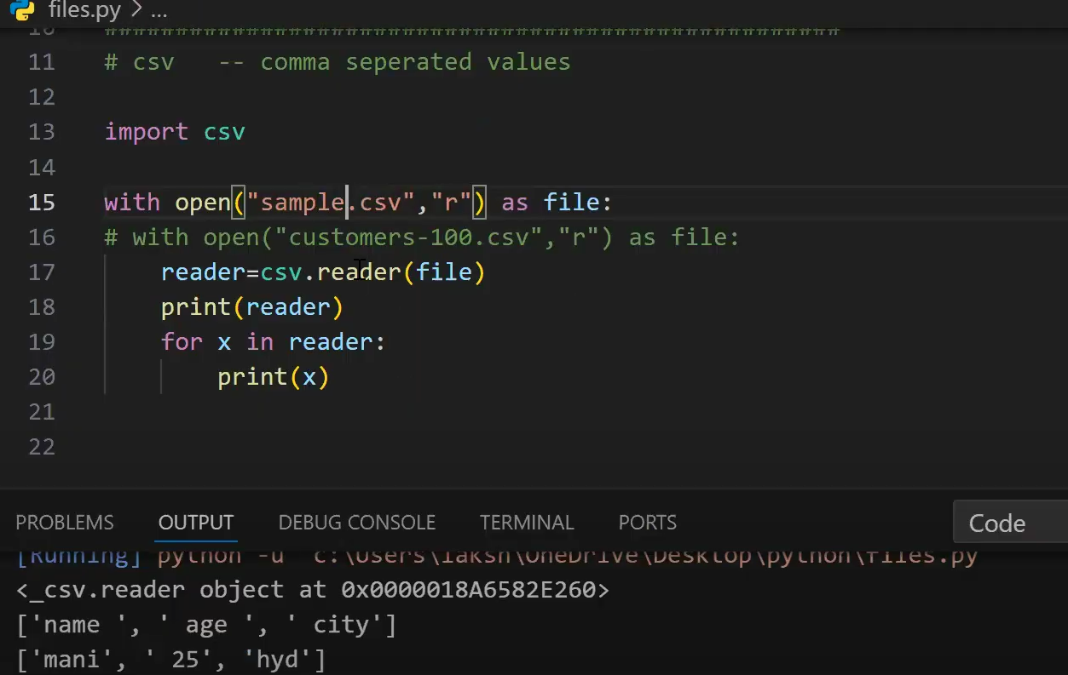

**1. Importing the csv Module**

Before working with CSV files, you need to import Python's built-in csv module.

**import csv**

**2. Reading a CSV File**

You can read a CSV file using the csv.reader() method.

**Example: Reading a CSV File**

Assume **data.csv** contains:

Name,Age,City

Alice,25,New York

Bob,30,London

Charlie,22,Sydney

**Code:**

import csv

with open("data.csv", "r") as file:

reader = csv.reader(file) # Read file

for row in reader:

print(row) # Each row is a list

✔ **Output:**

['Name', 'Age', 'City']

['Alice', '25', 'New York']

['Bob', '30', 'London']

['Charlie', '22', 'Sydney']

**Skipping Headers while Reading**

with open("data.csv", "r") as file:

reader = csv.reader(file)

**next(reader) # Skip header**

for row in reader:

print(row)

✔ **Output (Without Headers):**

['Alice', '25', 'New York']

['Bob', '30', 'London']

['Charlie', '22', 'Sydney']

**3. Writing to a CSV File**

You can write data to a CSV file using csv.writer().

**Example: Writing Data to a CSV File**

import csv

data = [

["Name", "Age", "City"],

["David", 28, "Berlin"],

["Emma", 24, "Paris"]

]

with open("output.csv", "w", newline="") as file:

writer = csv.writer(file) # Create writer object

writer.writerows(data) # Write all rows at once

✔ **Creates output.csv with:**

Name,Age,City

David,28,Berlin

Emma,24,Paris

**Writing One Row at a Time**

with open("output.csv", "w", newline="") as file:

writer = csv.writer(file)

writer.writerow(["Name", "Age", "City"]) # Write header

writer.writerow(["John", 29, "New York"]) # Write single row

**4. Appending to a CSV File**

Use "a" mode to append data **without overwriting**.

**Example: Appending Data**

with open("output.csv", "a", newline="") as file:

writer = csv.writer(file)

writer.writerow(["Sophia", 27, "Toronto"])

✔ **Adds new row to output.csv:**

Name,Age,City

John,35,Chicago

Anna,28,Los Angeles

Sophia,27,Toronto

**5. Reading CSV as Dictionary**

Instead of lists, you can read CSV files as **dictionaries** using csv.DictReader().

**Example: Using DictReader**

import csv

with open("data.csv", "r") as file:

reader = csv.DictReader(file)

for row in reader:

print(row) # Each row is an OrderedDict

✔ **Output:**

{'Name': 'Alice', 'Age': '25', 'City': 'New York'}

{'Name': 'Bob', 'Age': '30', 'City': 'London'}

{'Name': 'Charlie', 'Age': '22', 'City': 'Sydney'}

**6. Writing CSV as Dictionary**

You can write a dictionary into a CSV file using csv.DictWriter().

**Example: Using DictWriter**

import csv

data = [

{"Name": "John", "Age": 35, "City": "Chicago"},

{"Name": "Anna", "Age": 28, "City": "Los Angeles"}

]

with open("output.csv", "w", newline="") as file:

fieldnames = ["Name", "Age", "City"]

writer = csv.DictWriter(file, fieldnames=fieldnames)

writer.writeheader() # Write header

writer.writerows(data) # Write multiple rows

✔ **Creates output.csv with:**

Name,Age,City

John,35,Chicago

Anna,28,Los Angeles

**7. Handling Different Delimiters (e.g., ;, |)**

By default, CSV files use a **comma (,)** as a separator. You can change this using the delimiter argument.

**Example: Using ; as a Separator**

with open("data.csv", "r") as file:

reader = csv.reader(file, delimiter=";") # Change delimiter

for row in reader:

print(row)

✔ **For a file containing:**

Name;Age;City

Alice;25;New York

✔ **Output:**

['Name', 'Age', 'City']

['Alice', '25', 'New York']

**Example: writing a new delimeter**

import csv

data = [

    ["Name", "Age", "City"],

    ["Sophia", 27, "Toronto"],

    ["John", 30, "New York"]

]

with open("data2.csv", "w", newline="") as file:

    writer = csv.writer(file, delimiter="|")  # Use '|' as delimiter

    writer.writerows(data)

**8. Handling Quotes in CSV Files**

Sometimes, CSV fields contain **commas or quotes**. You can handle them using the quotechar argument.

**Example: Handling Quotes**

with open("data.csv", "r") as file:

reader = csv.reader(file, quotechar=' " ')

for row in reader:

print(row)

**9. Checking if a CSV File Exists Before Writing**

import os

import csv

filename = "output.csv"

if not os.path.exists(filename):

with open(filename, "w", newline="") as file:

writer = csv.writer(file)

writer.writerow(["Name", "Age", "City"]) # Write header

This **prevents overwriting existing files**.

**10. Using pandas for CSV Files (Alternative)**

The pandas library provides a simpler way to work with CSV files.

**Reading a CSV File**

import pandas as pd

df = pd.read\_csv("data.csv")

print(df)

**Writing a CSV File**

df.to\_csv("output.csv", index=False)

✔ **This automatically handles headers, delimiters, and formatting!** 🚀

**Conclusion**

✅ csv.reader() → Reads CSV file as a **list of lists**  
✅ csv.writer() → Writes data to a CSV file  
✅ csv.DictReader() → Reads CSV file as **dictionary**  
✅ csv.DictWriter() → Writes data to a CSV file as **dictionary**  
✅ pandas → Easier CSV handling with read\_csv() and to\_csv()

Python’s csv module provides a **powerful yet simple way** to handle structured data!

**NUMPY LIBRARIES**

**NumPy(Numerical Python)**

**NumPy(Numerical Python)** is a fundamental library for Python **numerical computing**. It provides efficient multi-dimensional array objects and various mathematical functions for handling large datasets making it a critical tool for professionals in fields that require heavy computation.

NumPy (Numerical Python) is a **powerful library** for numerical computing in Python. It is mainly used for **working with arrays, matrices, and performing mathematical operations** efficiently.

**Installing NumPy in Python**

To begin using NumPy, you need to install it first. This can be done through pip command:

***pip install numpy***

**Key Features of NumPy**

NumPy has various features that make it popular over lists.

* **N-Dimensional Arrays**: NumPy’s core feature is ndarray, a powerful N-dimensional array object that supports homogeneous data types.
* **Arrays with High Performance**: Arrays are stored in contiguous memory locations, enabling faster computations than Python lists(Please see [Numpy Array vs Python List](https://www.geeksforgeeks.org/python-lists-vs-numpy-arrays/" \t "_blank) for details).
* [**Broadcasting**](https://www.geeksforgeeks.org/numpy-array-broadcasting/)**:** This allows element-wise computations between arrays of different shapes. It simplifies operations on arrays of **various shapes** by automatically aligning their dimensions without creating new data.
* [**Vectorization**](https://www.geeksforgeeks.org/vectorization-in-python/)**:** Eliminates the need for explicit Python loops by applying operations directly on entire arrays.
* **Linear algebra**: NumPy contains routines for linear algebra operations, such as matrix multiplication, decompositions, and determinants.

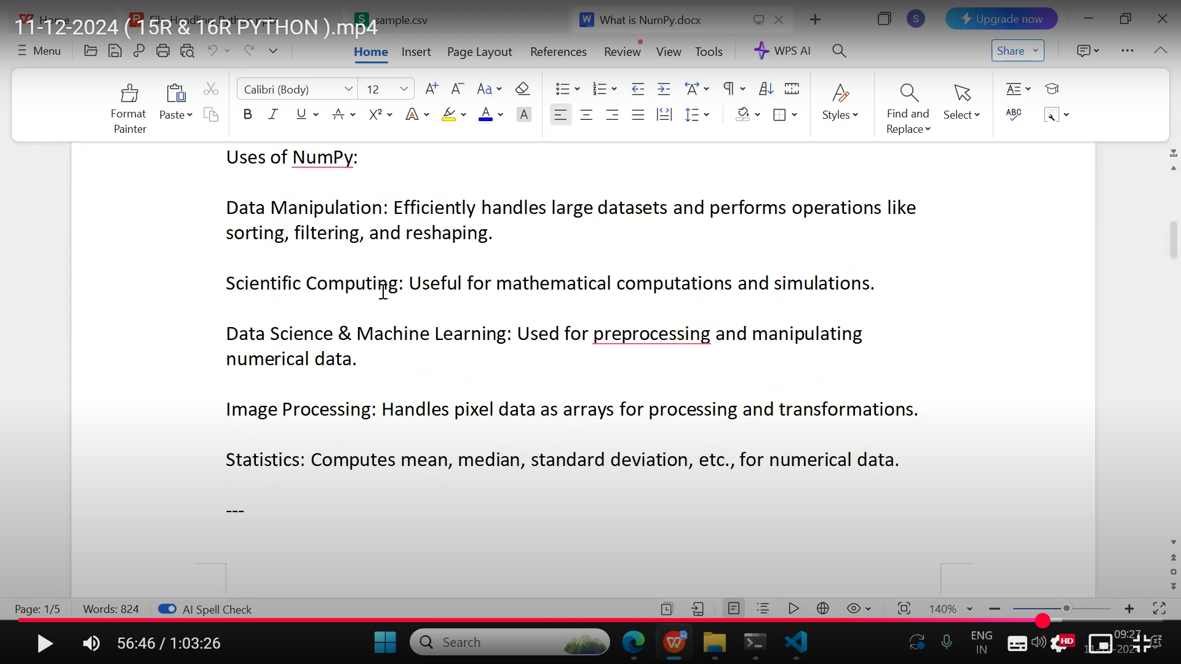

**Create a NumPy ndarray Object**

NumPy is used to work with arrays. The array object in NumPy is called ndarray.

We can create a NumPy ndarray object by using the array() function.

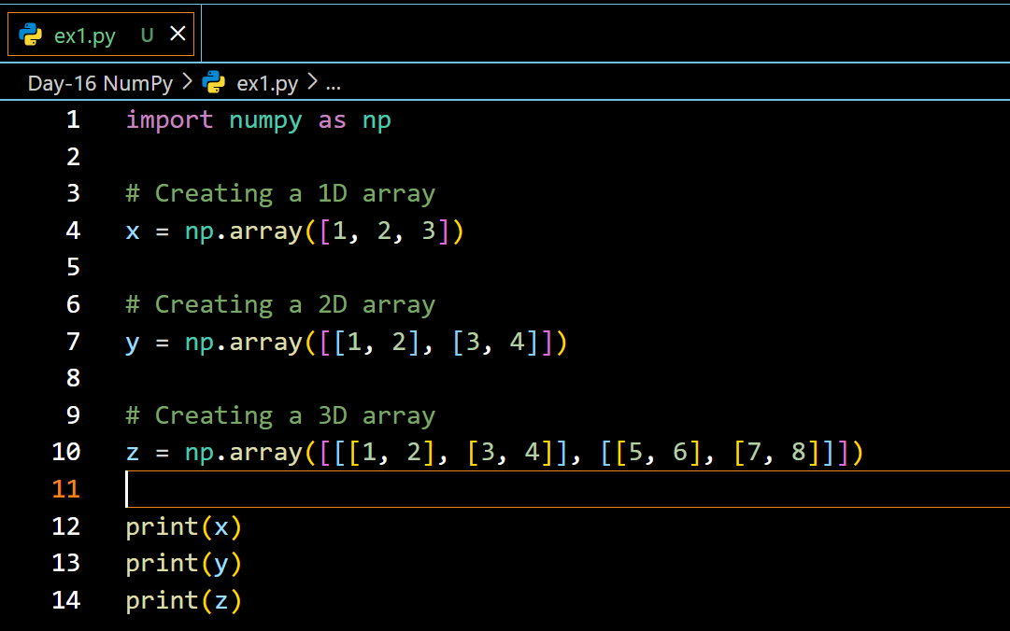

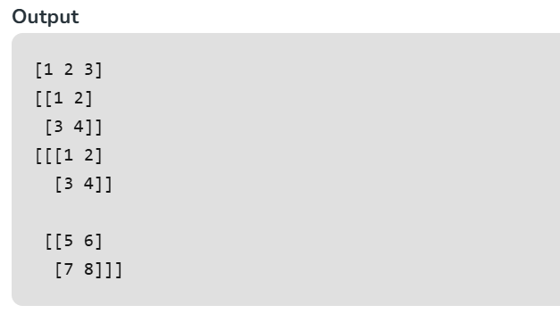

**Checking NumPy Version**

The version string is stored under \_\_version\_\_ attribute.

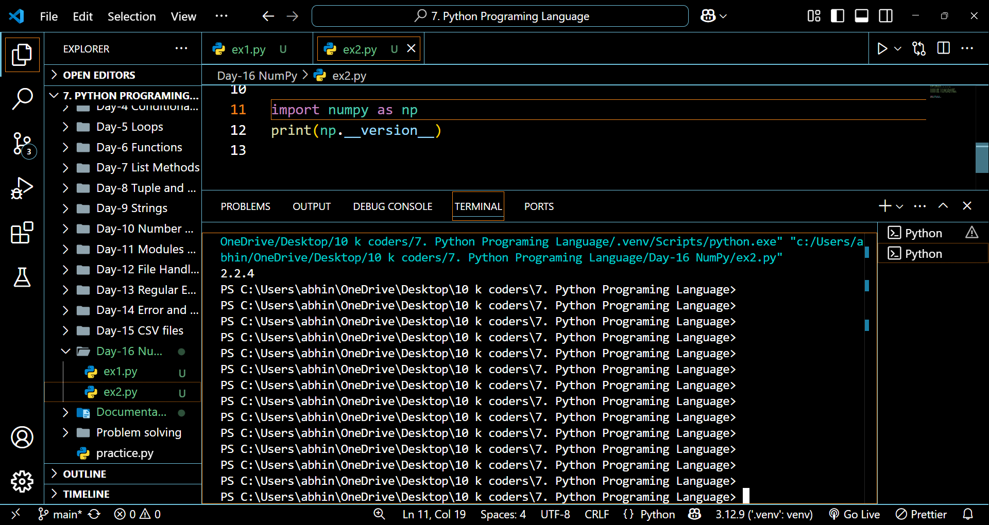

**Access Array Elements**

Array indexing is the same as accessing an array element.

You can access an array element by referring to its index number.

The indexes in NumPy arrays start with 0, meaning that the first element has index 0, and the second has index 1 etc.

**Example:**

import numpy as np

arr = np.array([1, 2, 3, 4])

print(arr[0]) // 1

**Access 2-D Arrays**

To access elements from 2-D arrays we can use comma separated integers representing the dimension and the index of the element.

Think of 2-D arrays like a table with rows and columns, where the dimension represents the row and the index represents the column.

**Example**

Access the element on the first row, second column:

import numpy as np  
arr = np.array([[1,2,3,4,5], [6,7,8,9,10]])  
print('2nd element on 1st row: ', arr[0, 1])

**NumPy Array Slicing**

Slicing in python means taking elements from one given index to another given index.

We pass slice instead of index like this: [*start*:*end*].

We can also define the step, like this: [*start*:*end*:*step*].

If we don't pass start its considered 0

If we don't pass end its considered length of array in that dimension

If we don't pass step its considered 1

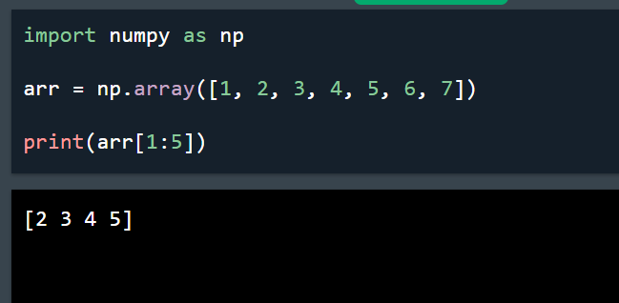 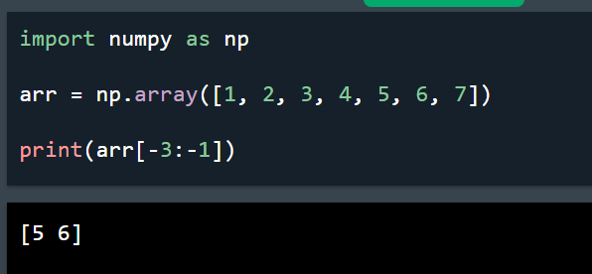

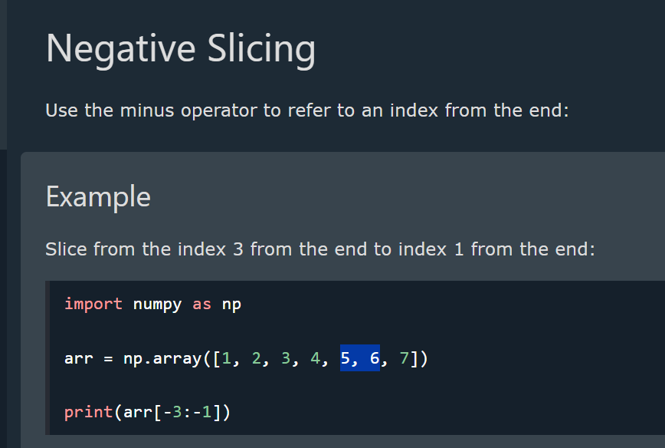

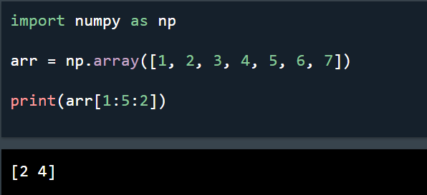 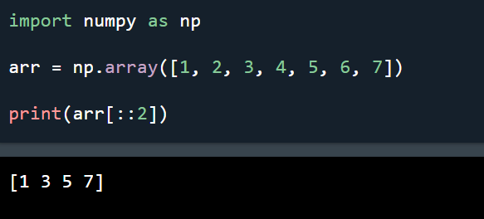

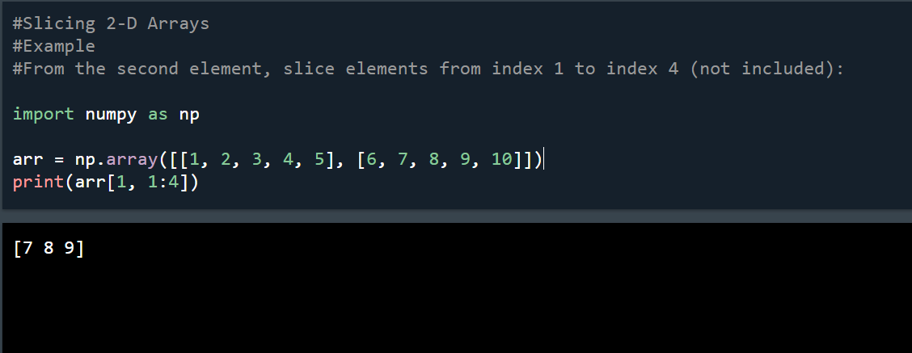

**Data Types in NumPy**

NumPy has some extra data types, and refer to data types with one character, like i for integers, u for unsigned integers etc.

Below is a list of all data types in NumPy and the characters used to represent them.

* i - integer
* b - boolean
* u - unsigned integer
* f - float
* c - complex float
* m - timedelta
* M - datetime
* O - object
* S - string
* U - unicode string
* V - fixed chunk of memory for other type ( void )

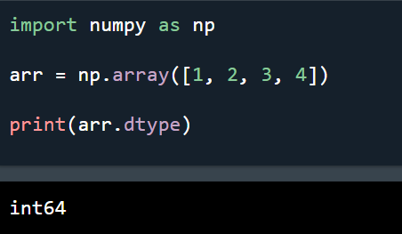

**Creating Arrays With a Defined Data Type**

We use the array() function to create arrays, this function can take an optional argument: dtype that allows us to define the expected data type of the array elements:

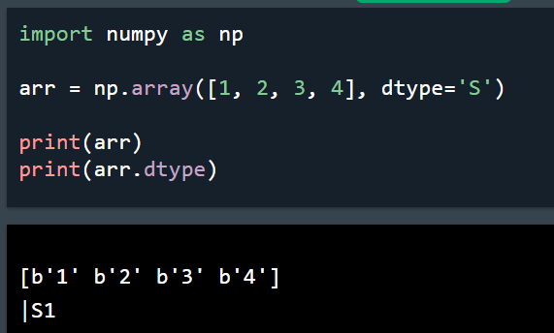 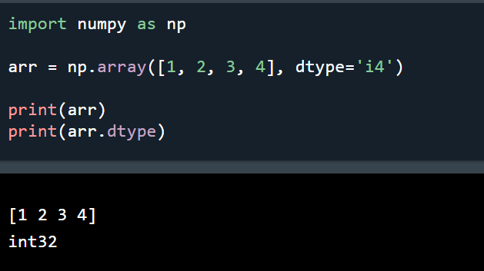

**Converting Data Type on Existing Arrays**

The best way to change the data type of an existing array, is to make a copy of the array with the astype() method.

The astype() function creates a copy of the array, and allows you to specify the data type as a parameter.

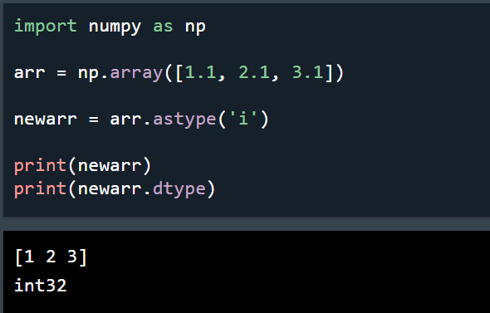

**NumPy Array Properties**

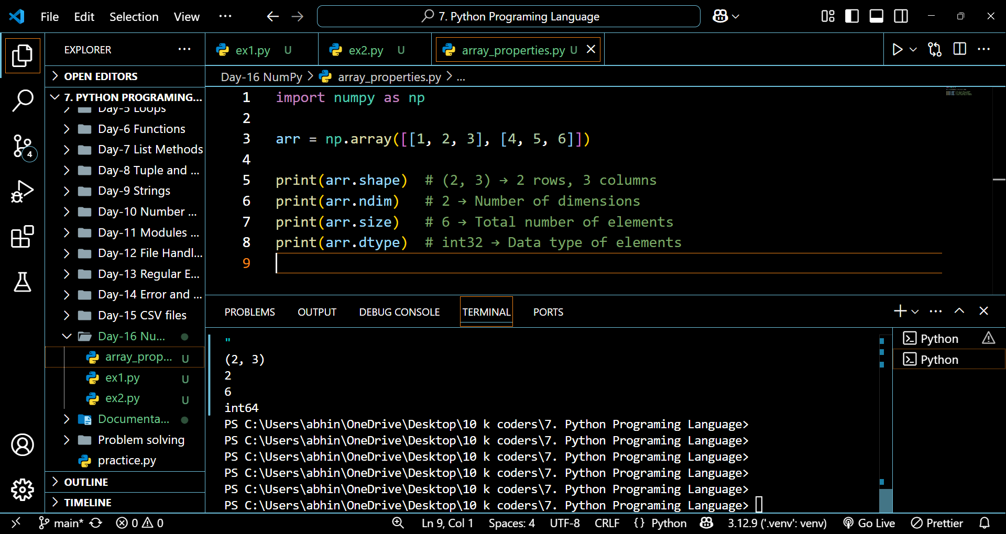



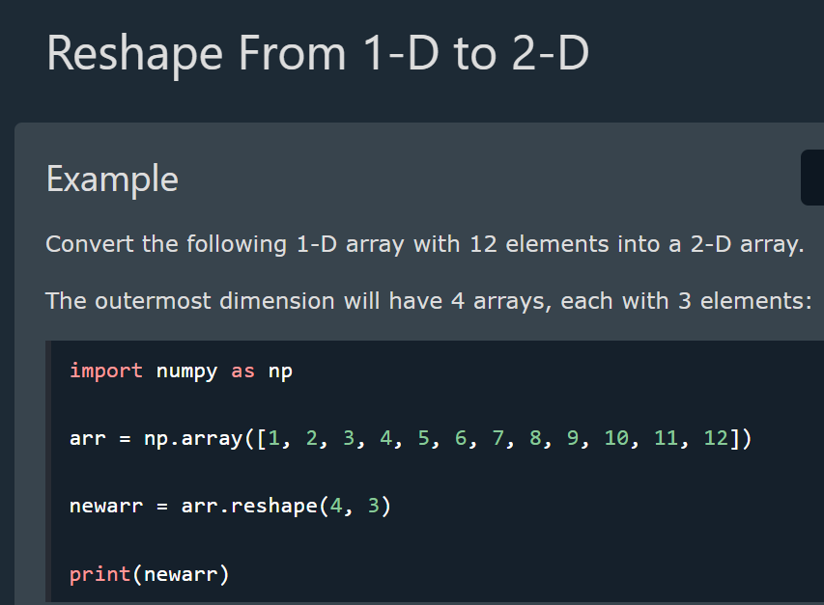

**Reshape From 1-D to 3-D**

**Example**

Convert the following 1-D array with 12 elements into a 3-D array.

The outermost dimension will have 2 arrays that contains 3 arrays, each with 2 elements:

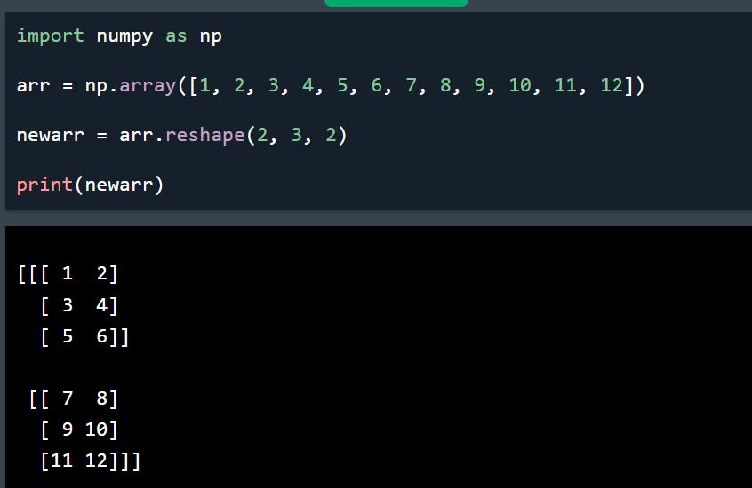

**Generating Special Arrays**

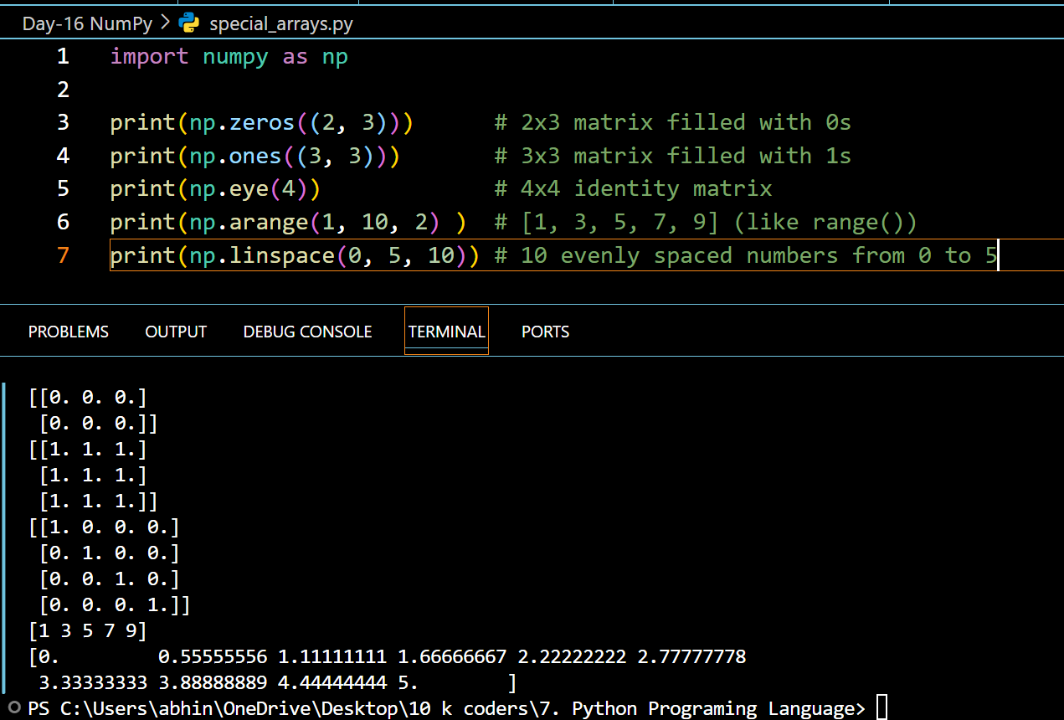

**Array Operations using numPy**

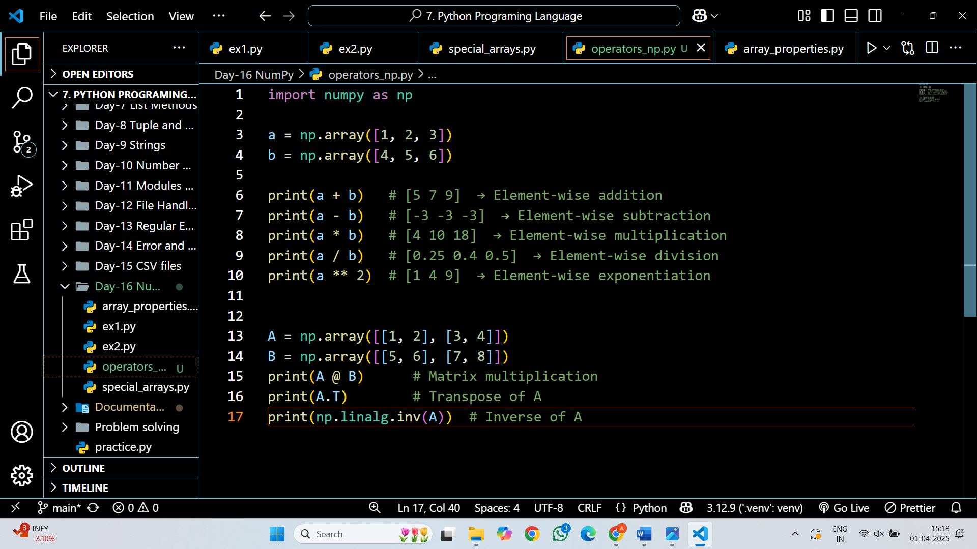

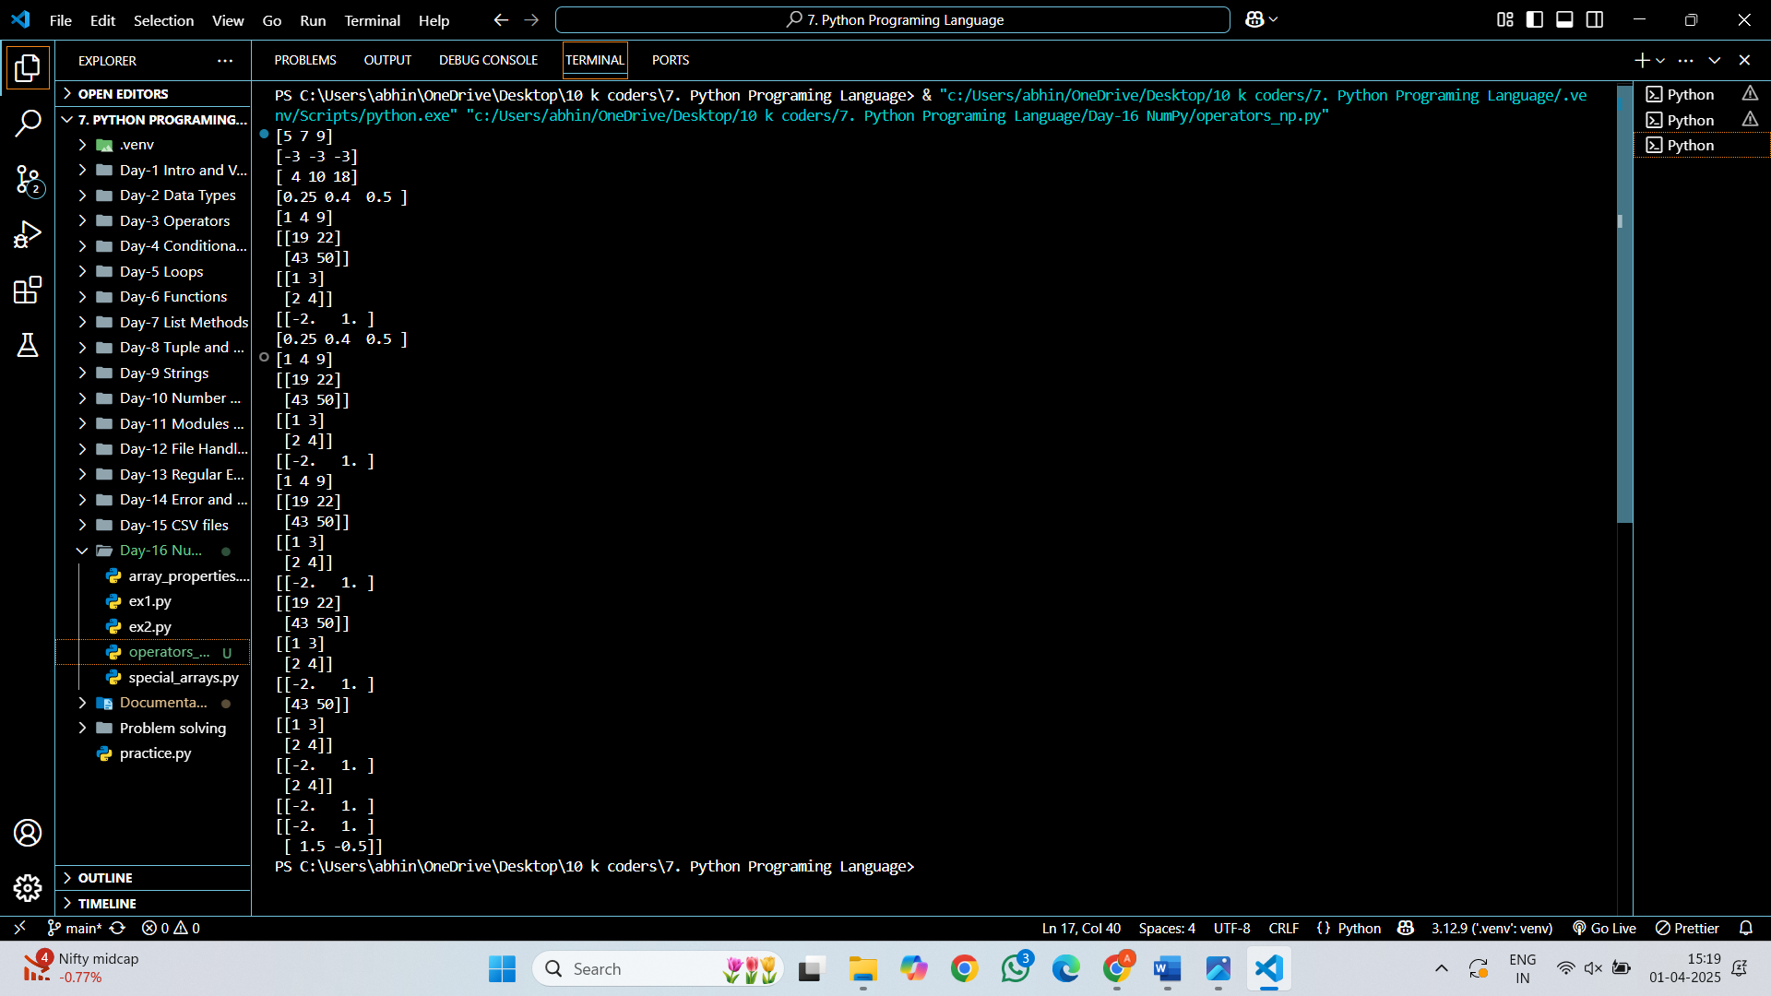

**Logical Operators**

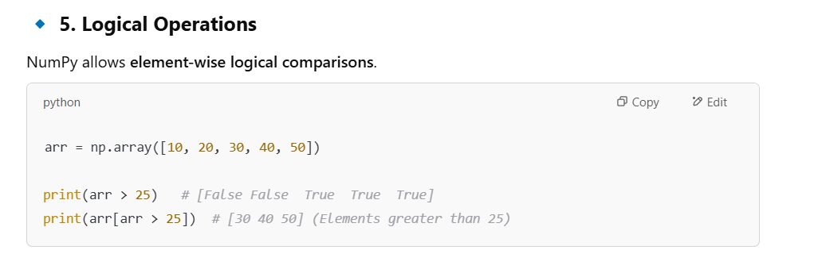

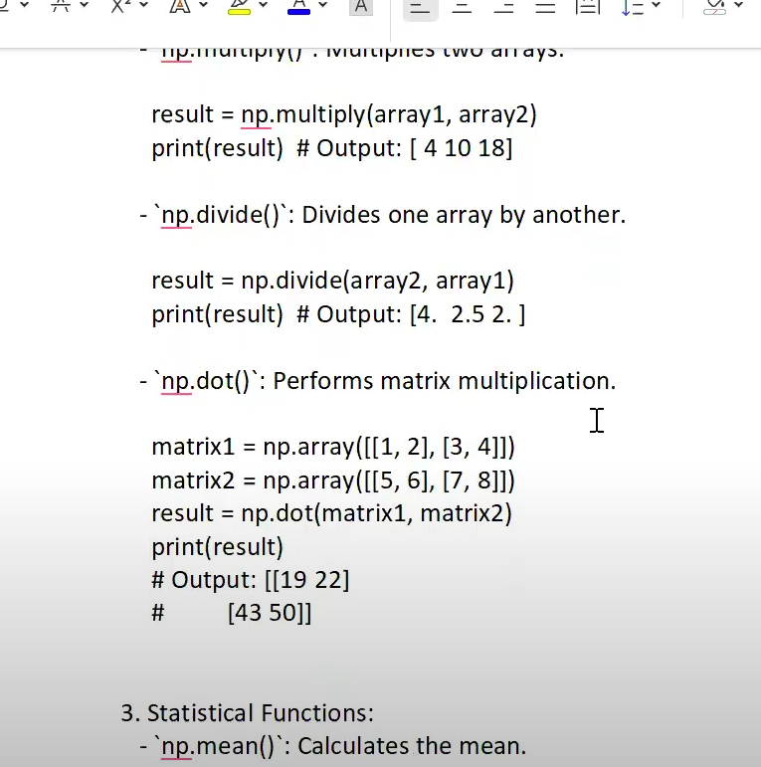

**Aggregate Functions**

NumPy provides built-in functions for mathematical operations.

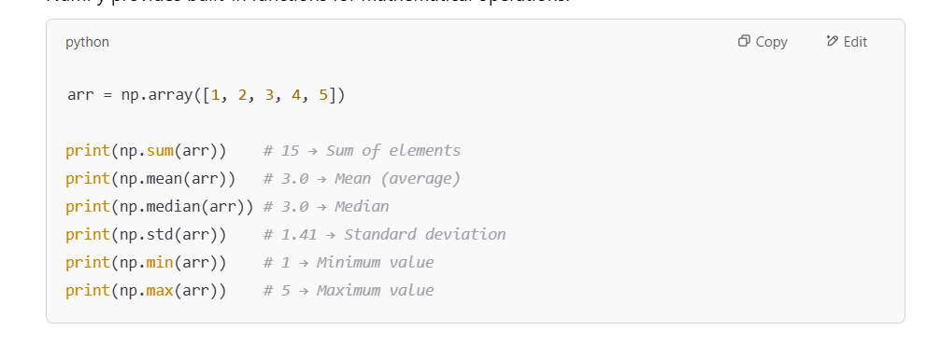

**NumPy Array Iterating**

Iterating means going through elements one by one.

As we deal with multi-dimensional arrays in numpy, we can do this using basic for loop of python.

If we iterate on a 1-D array it will go through each element one by one.

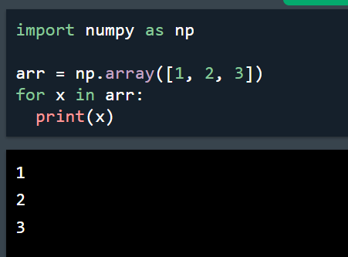 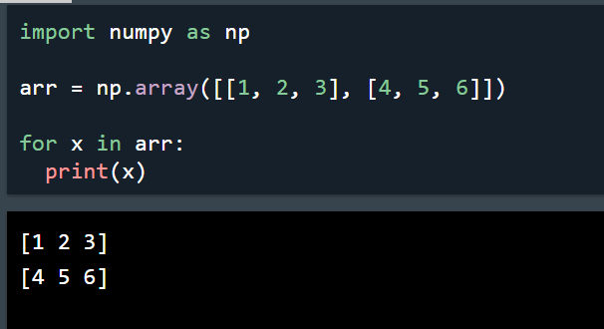

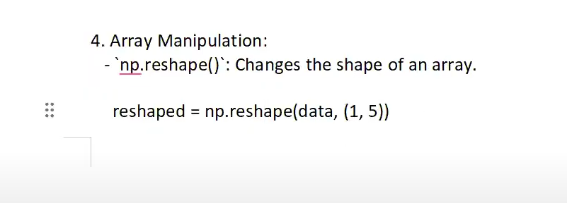

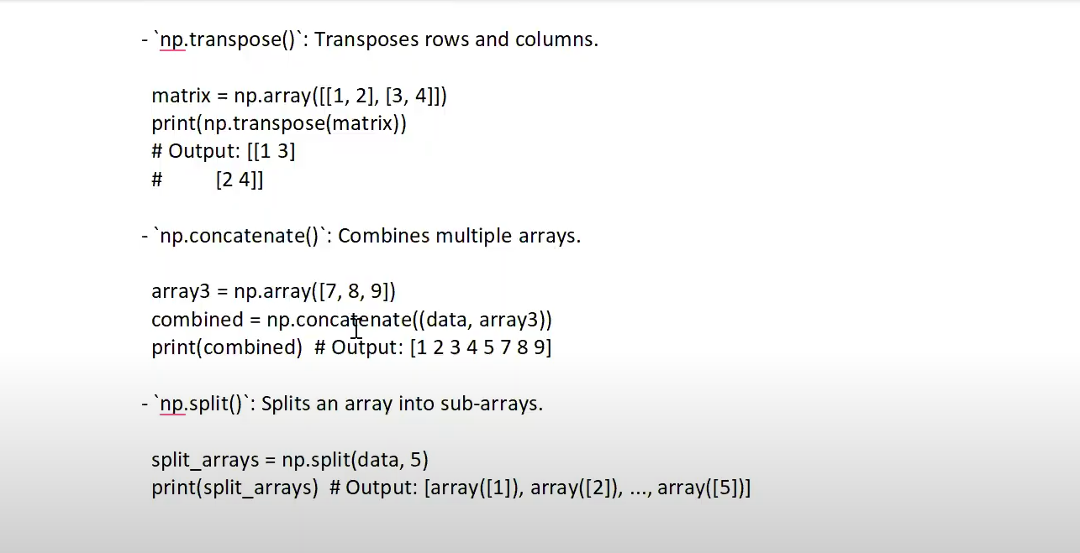

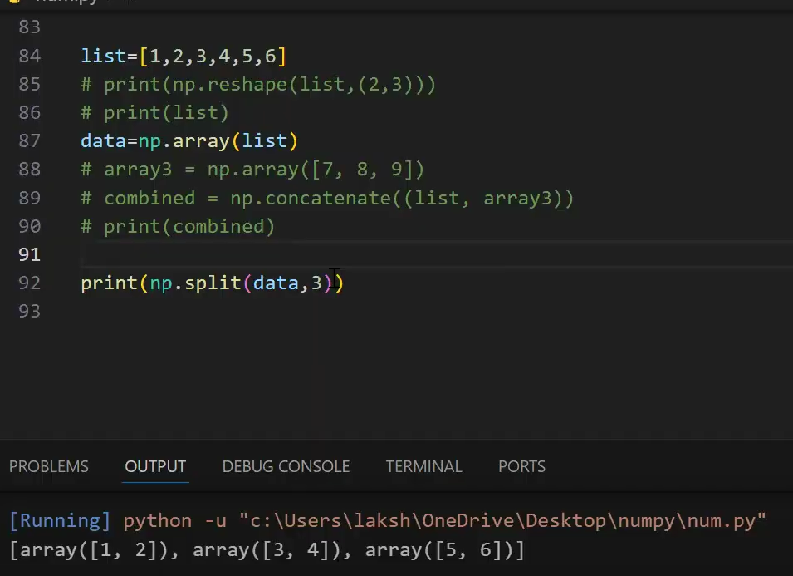



**Searching Arrays**

You can search an array for a certain value, and return the indexes that get a match.

To search an array, use the **where()** method.

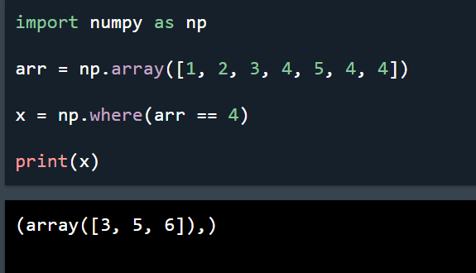 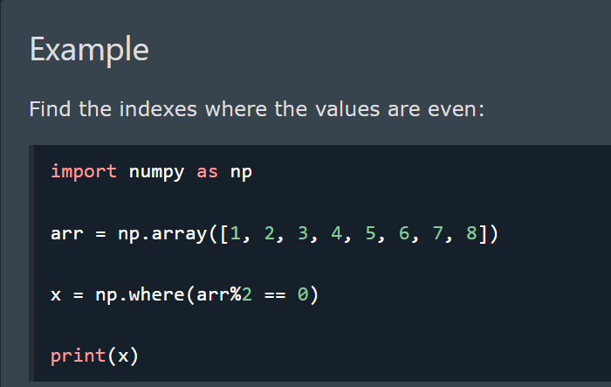

**Search Sorted**

There is a method called **searchsorted()** which performs a binary search in the array, and returns the index where the specified value would be inserted to maintain the search order.

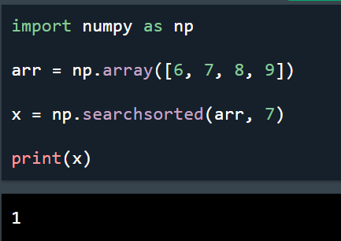 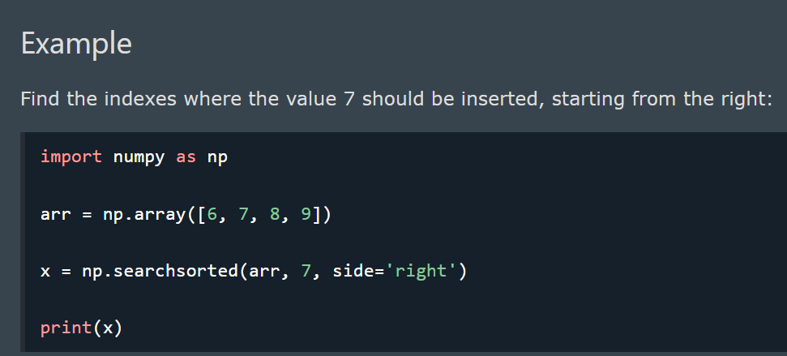

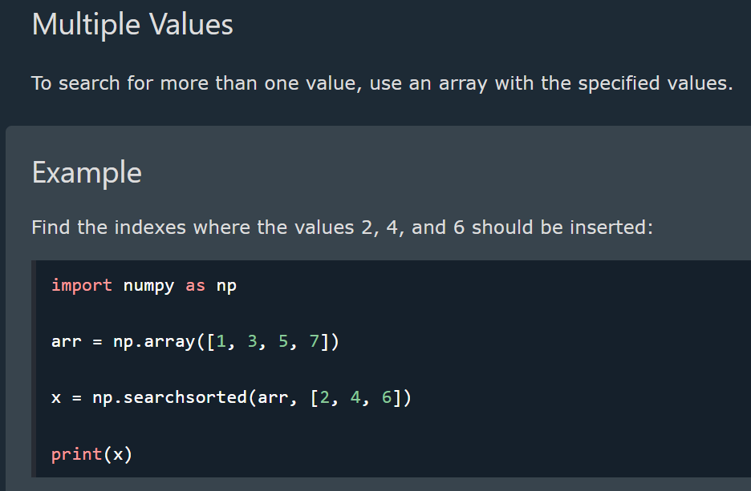

**Sorting Arrays**

Sorting means putting elements in an *ordered sequence*.

*Ordered sequence* is any sequence that has an order corresponding to elements, like numeric or alphabetical, ascending or descending.

The NumPy ndarray object has a function called sort(), that will sort a specified array.

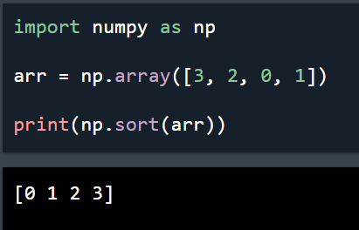 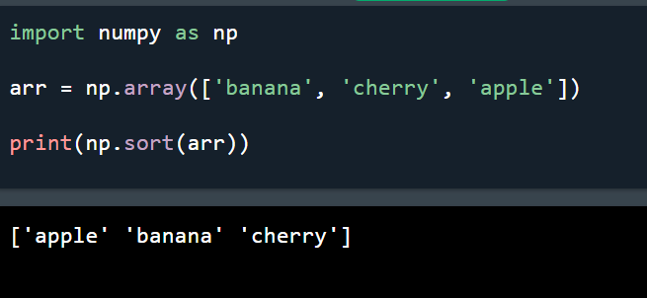

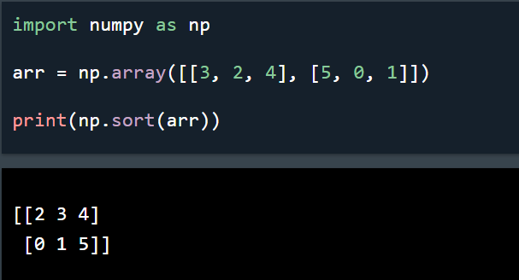

**Filtering Arrays**

Getting some elements out of an existing array and creating a new array out of them is called *filtering*.

In NumPy, you filter an array using a *boolean index list*.

If the value at an index is True that element is contained in the filtered array, if the value at that index is False that element is excluded from the filtered array.

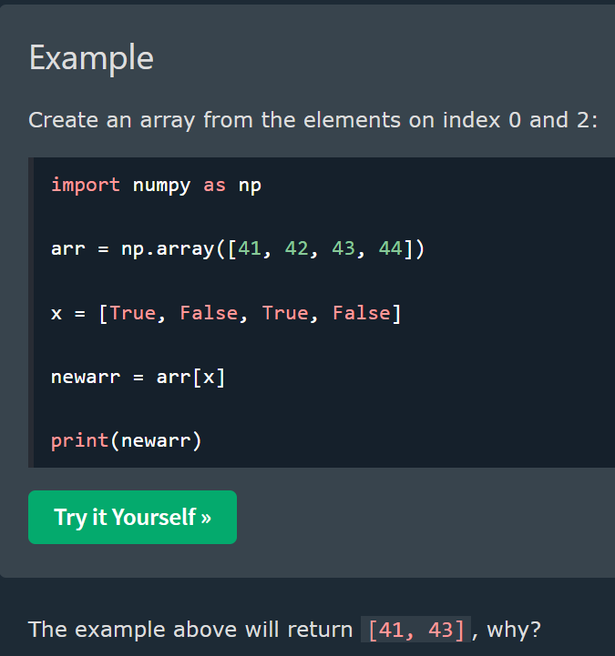

**Random Number Operations**

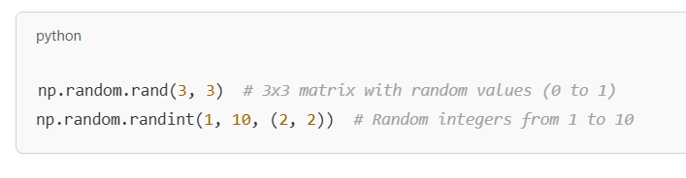

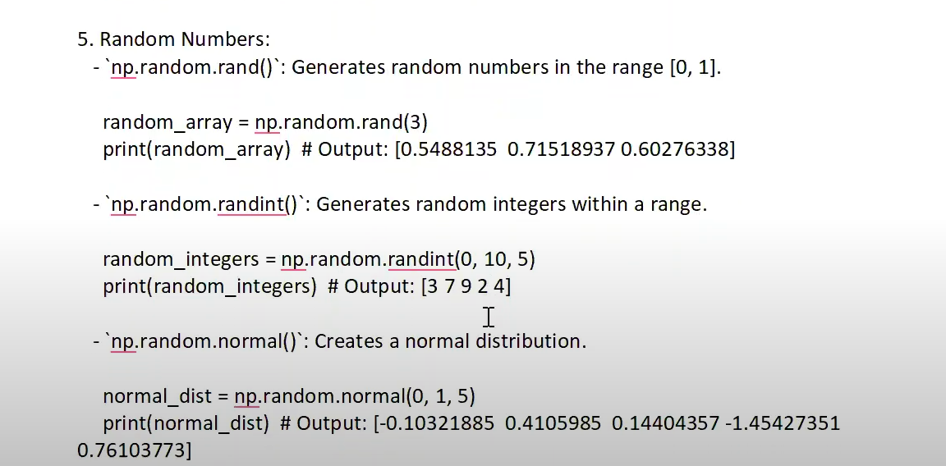

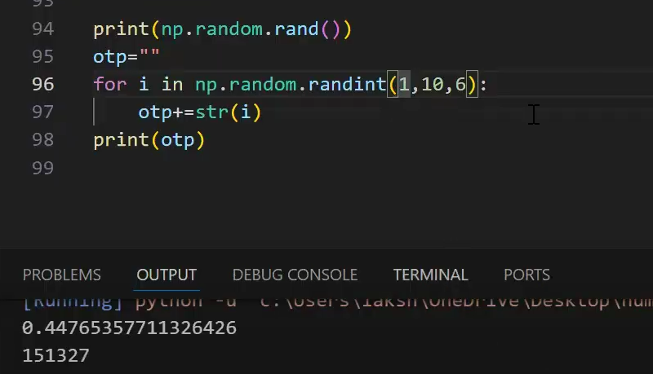

**Broadcasting in numPy**

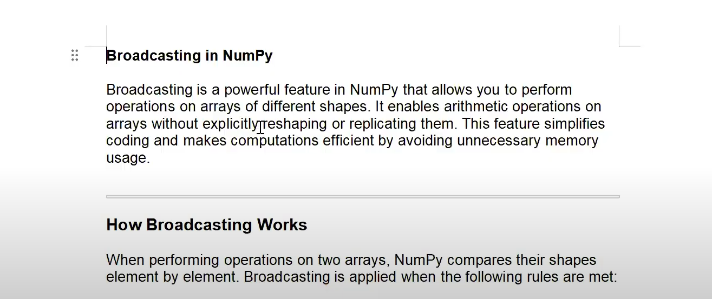

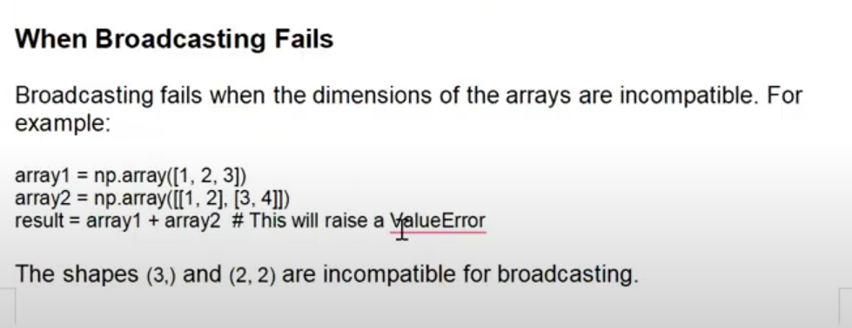

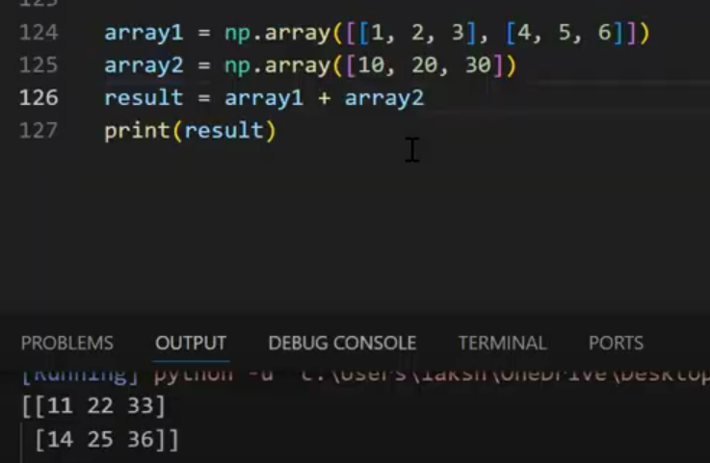



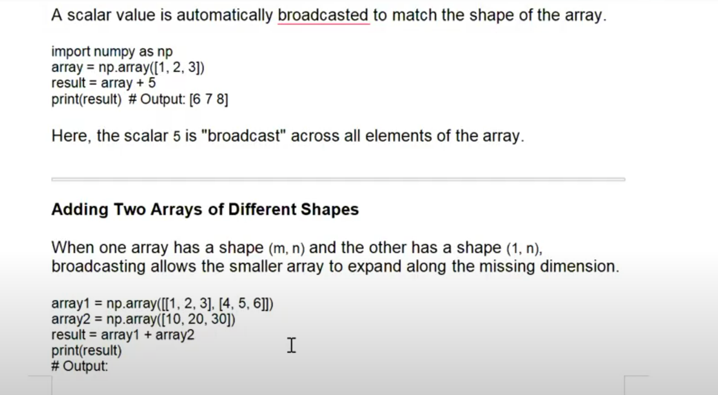

**Pandas**

**What is Pandas?**

* Pandas is a Python library used for working with data sets
* Pandas is a **powerful library** for **data analysis and manipulation** in Python. It provides **DataFrames** and **Series**, which make handling structured data easy.
* It has functions for analyzing, cleaning, exploring, and manipulating data.
* The name "Pandas" has a reference to both "Panel Data", and "Python Data Analysis" and was created by Wes McKinney in 2008.

**Installation of pandas:**

To install pandas, follow these steps based on your setup:

**1. Using pip (Recommended)**

If you have Python installed, you can install pandas using pip:

**pip install pandas**

If you need to upgrade pandas, use:

**pip install --upgrade pandas**

**Verifying Installation**

After installation, check if pandas is installed by running:

import pandas as pd

print(pd.\_\_version\_\_)

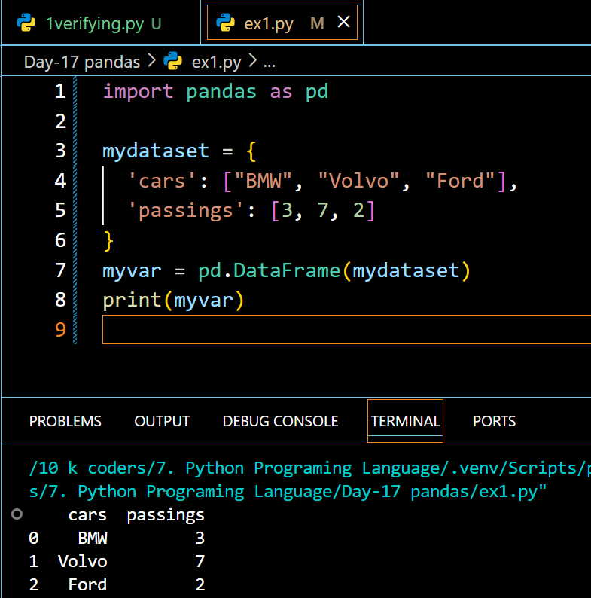

**Pandas Series**

**What is a Series?**

A Pandas Series is like a column in a table.

It is a one-dimensional array holding data of any type.

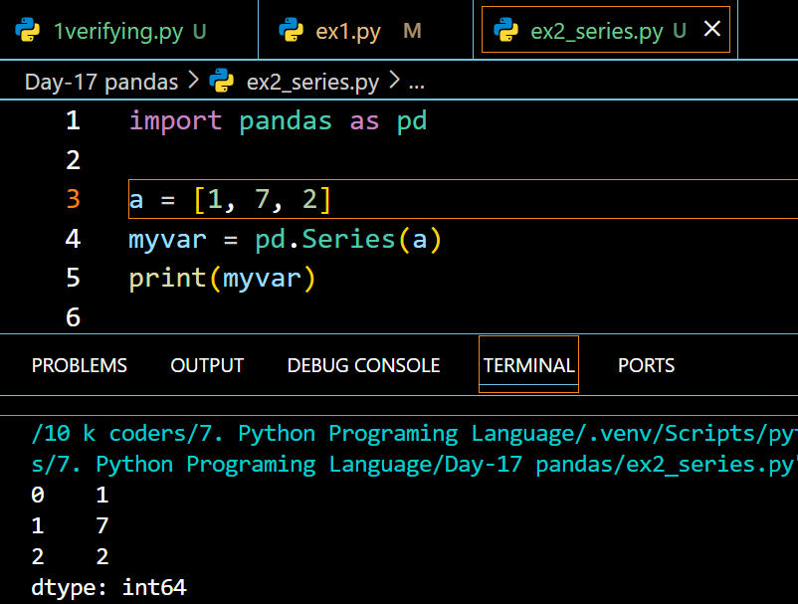

**Labels**

If nothing else is specified, the values are labeled with their index number. First value has index 0, second value has index 1 etc.

This label can be used to access a specified value.

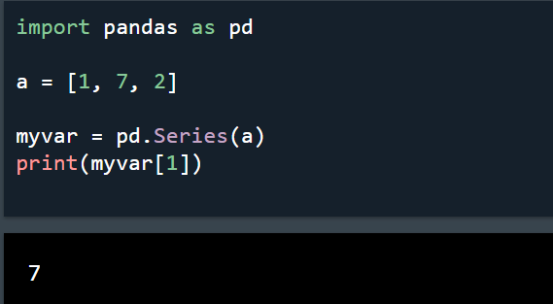

**Create Labels**

With the index argument, you can name your own labels.

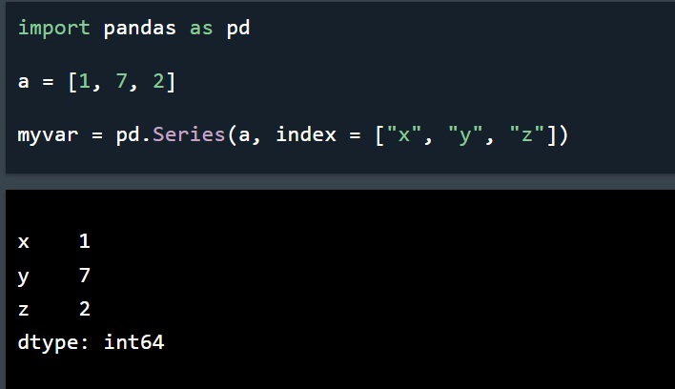

**Key/Value Objects as Series**

You can also use a key/value object, like a dictionary, when creating a Series.

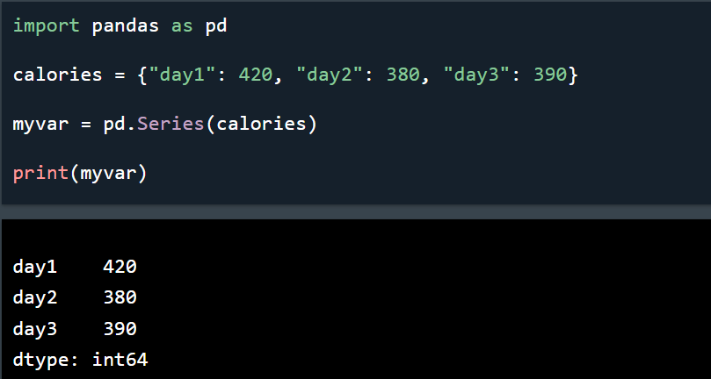

To select only some of the items in the dictionary, use the index argument and specify only the items you want to include in the Series.

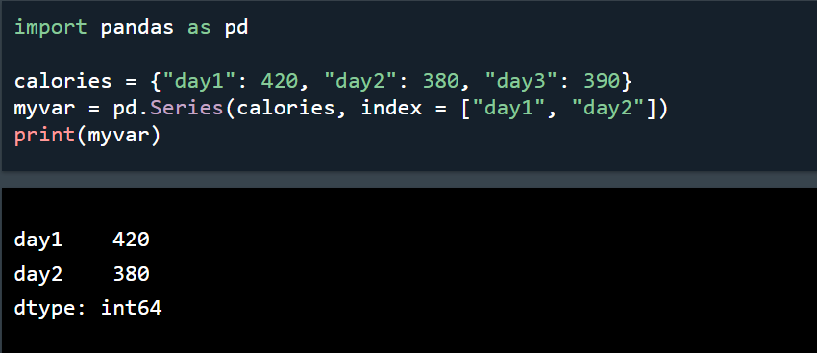

**DataFrames**

A Pandas DataFrame is a 2 dimensional data structure, like a 2 dimensional array, or a table with rows and columns.

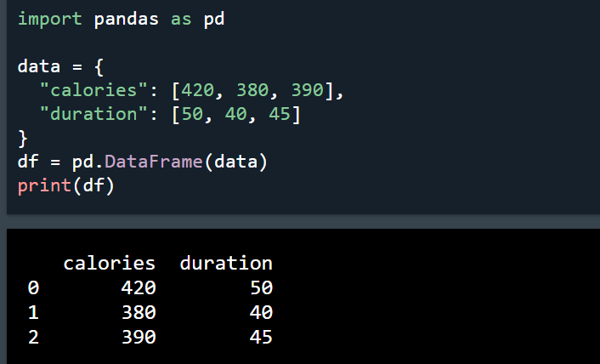

**Locate Row**

As you can see from the result above, the DataFrame is like a table with rows and columns.

Pandas use the loc attribute to return one or more specified row(s)

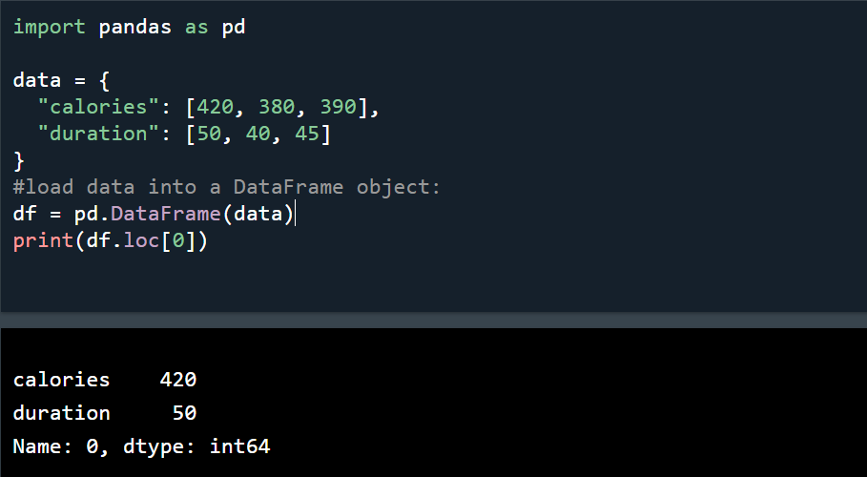

**Example**

Return row 0 and 1:

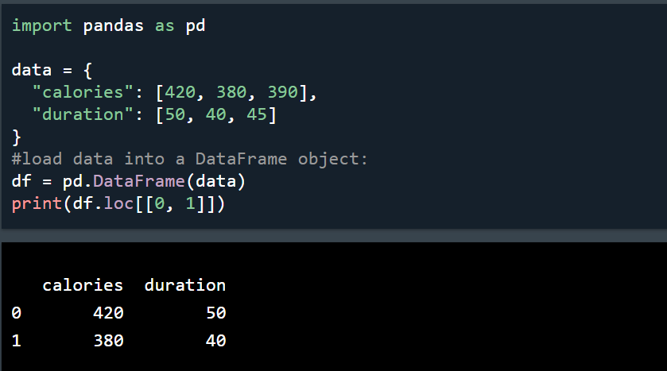

**Named Indexes**

With the index argument, you can name your own indexes.

**Example**

Add a list of names to give each row a name:

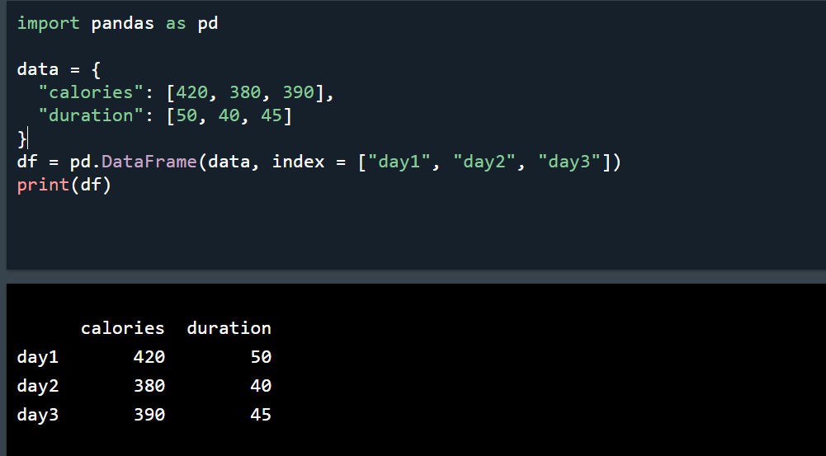

**Locate Named Indexes**

Use the named index in the loc attribute to return the specified row(s).

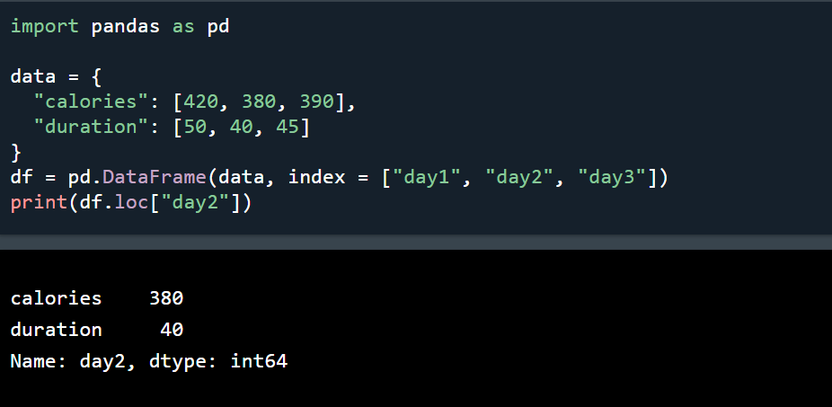

**Read CSV Files**

* A simple way to store big data sets is to use CSV files (comma separated files).
* CSV files contains plain text and is a well know format that can be read by everyone including Pandas.
* In our examples we will be using a CSV file called 'data.csv'.
* [Download data.csv](https://www.w3schools.com/python/pandas/data.csv). or [Open data.csv](https://www.w3schools.com/python/pandas/data.csv.txt).

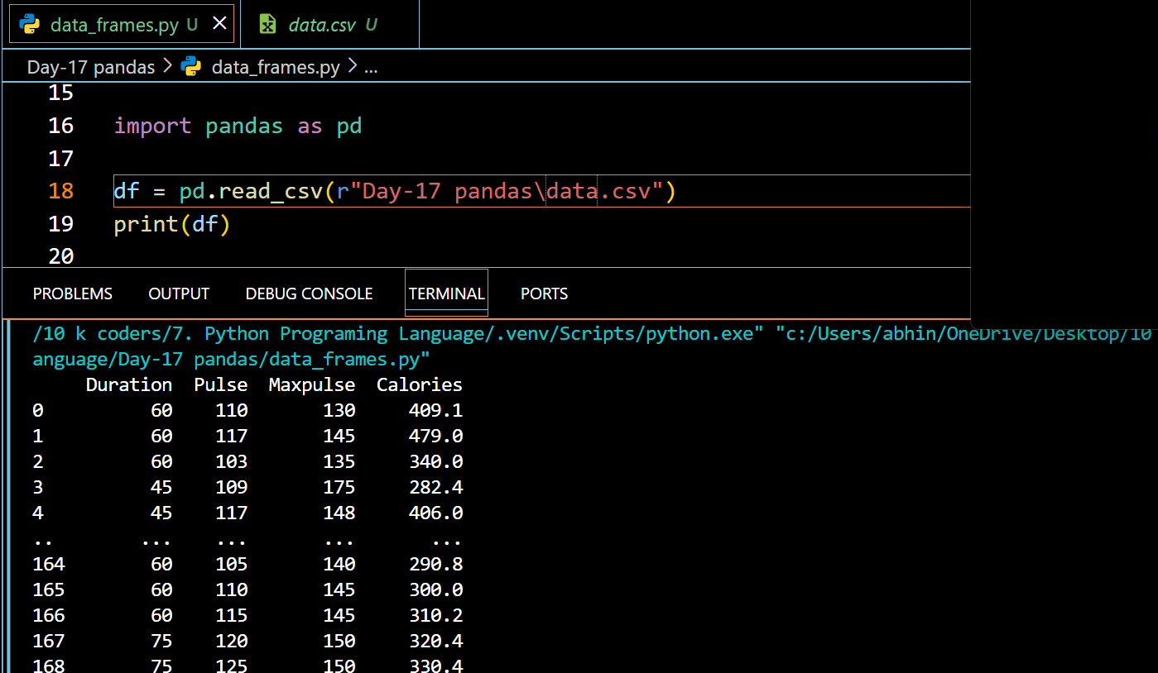

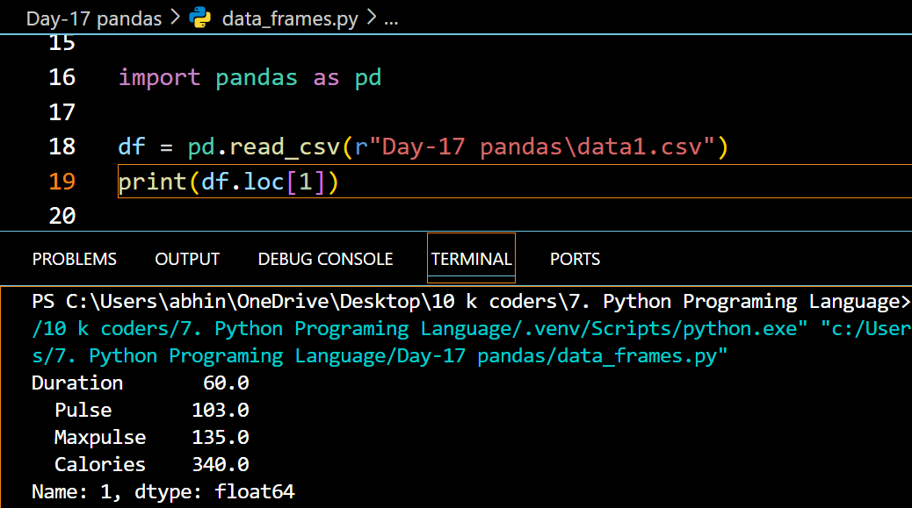

**Tip:** use to\_string() to print the entire DataFrame.

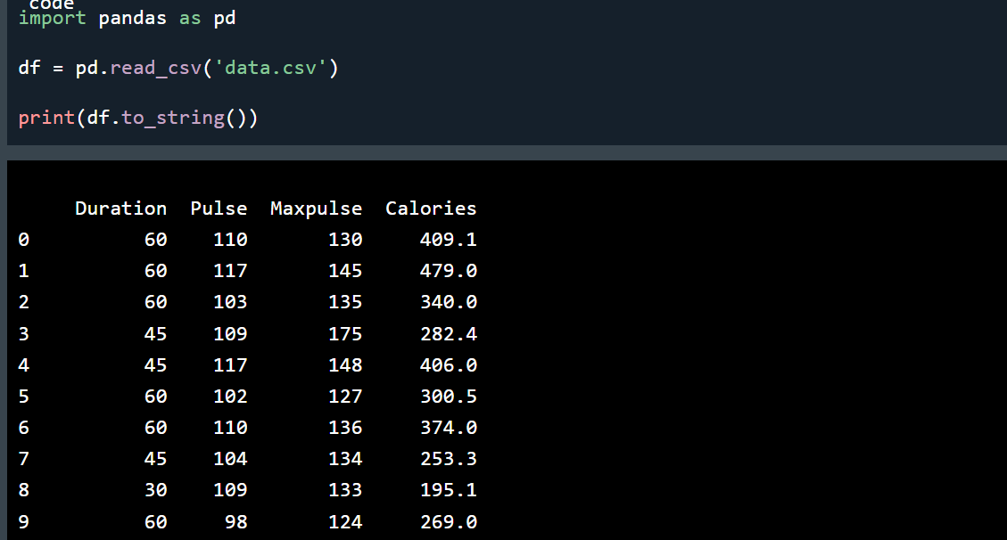

**Read JSON**

Big data sets are often stored, or extracted as JSON.

JSON is plain text, but has the format of an object, and is well known in the world of programming, including Pandas.

In our examples we will be using a JSON file called 'data.json'

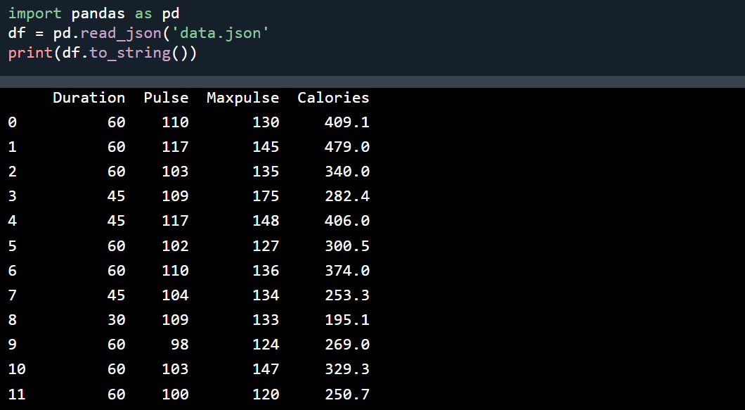

**Basic Methods:**

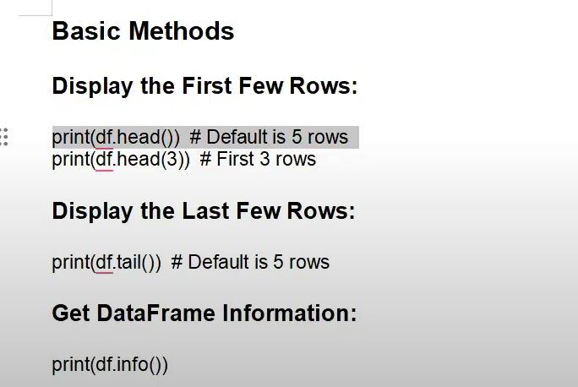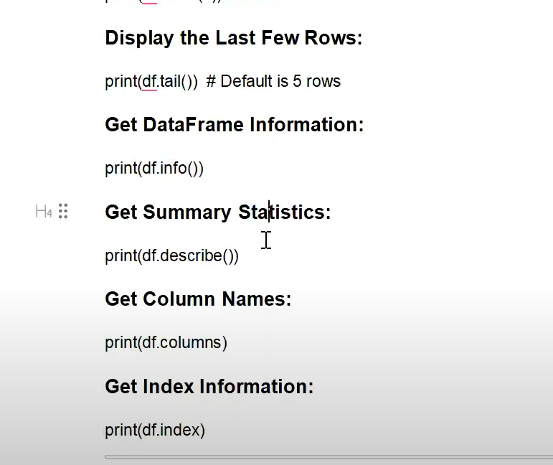

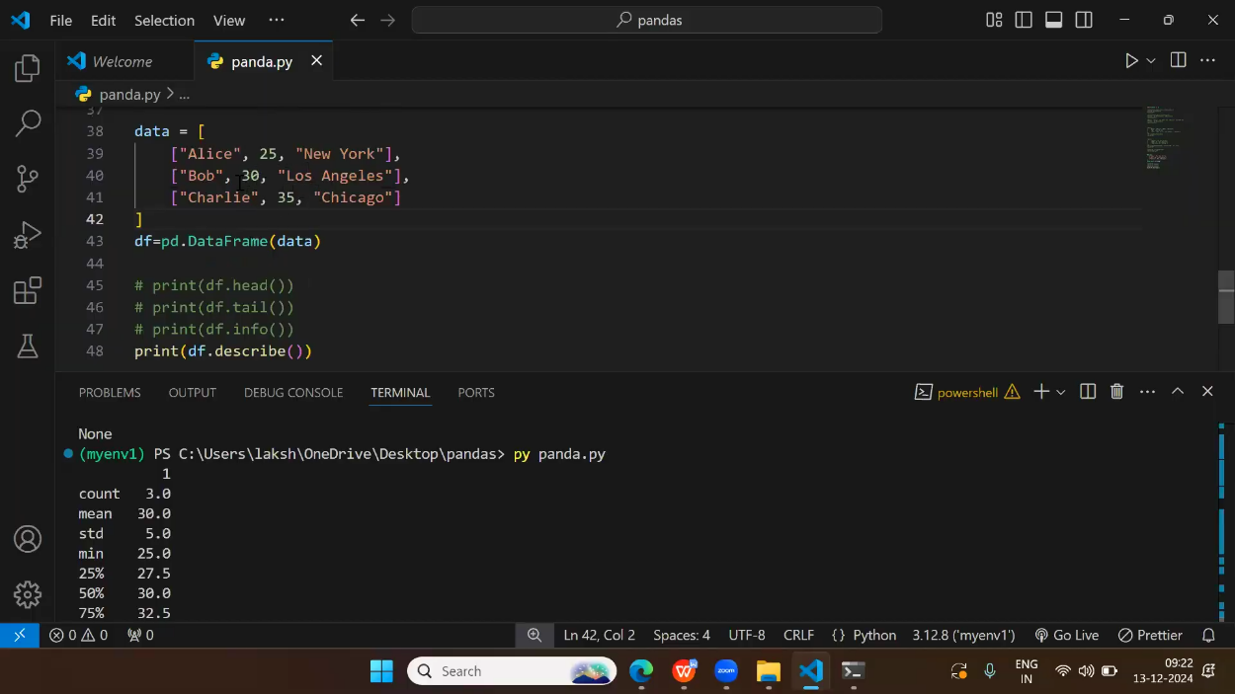

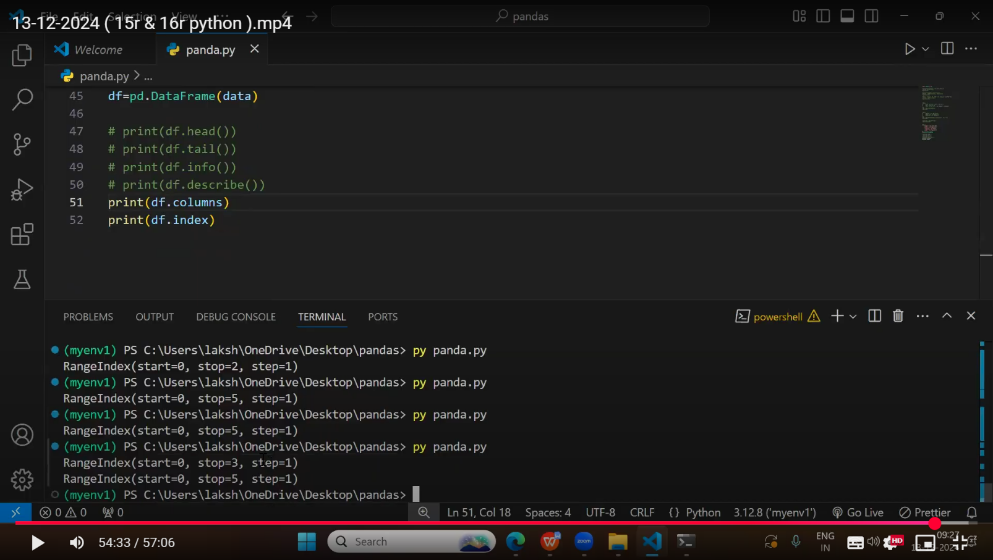

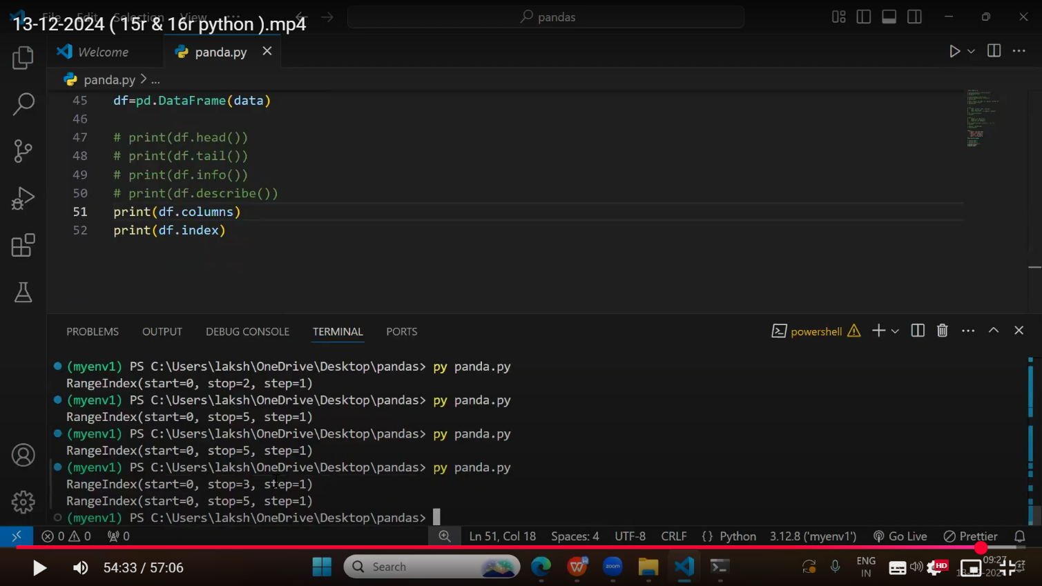

**Selecting methods**

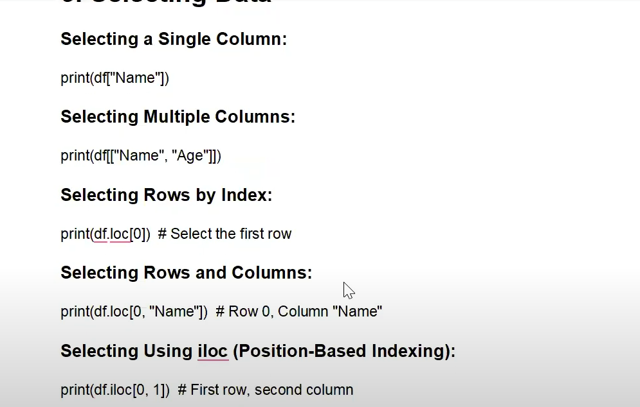

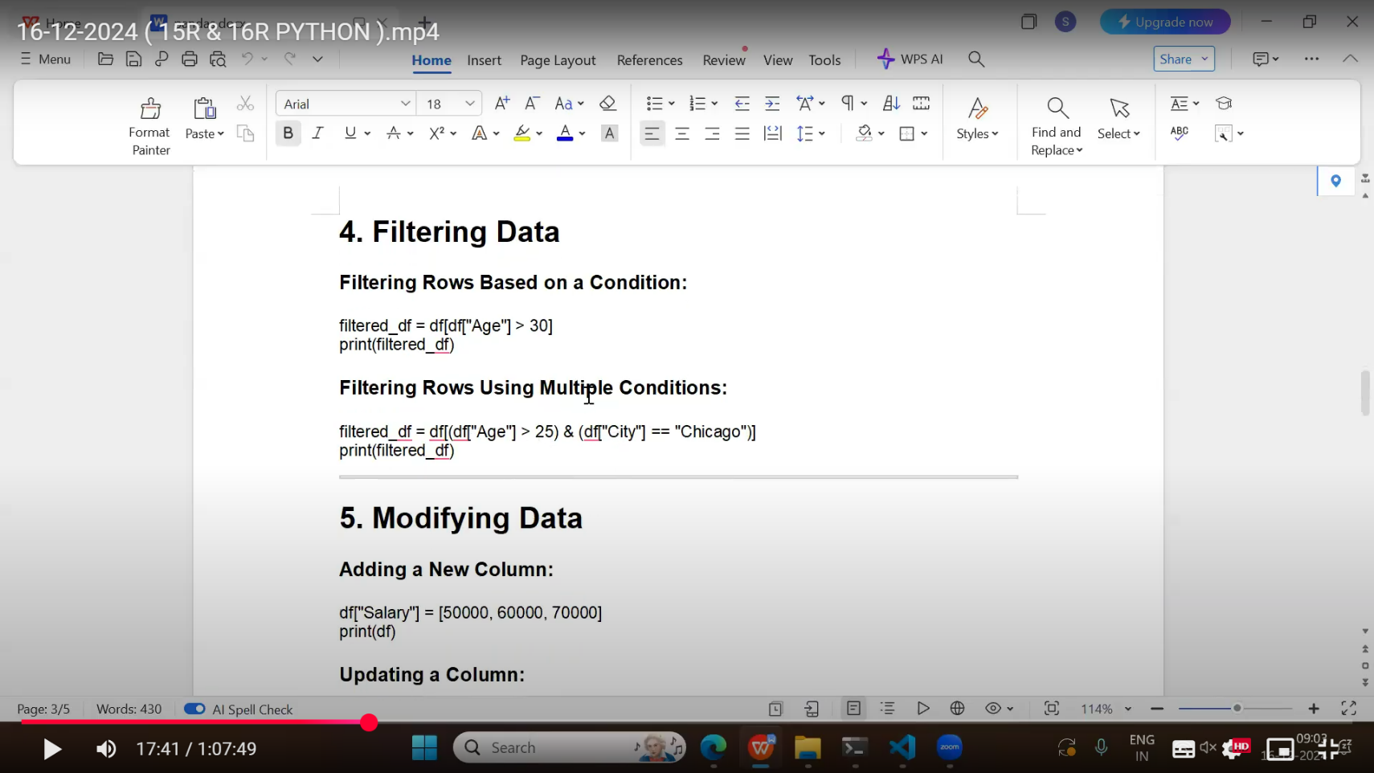

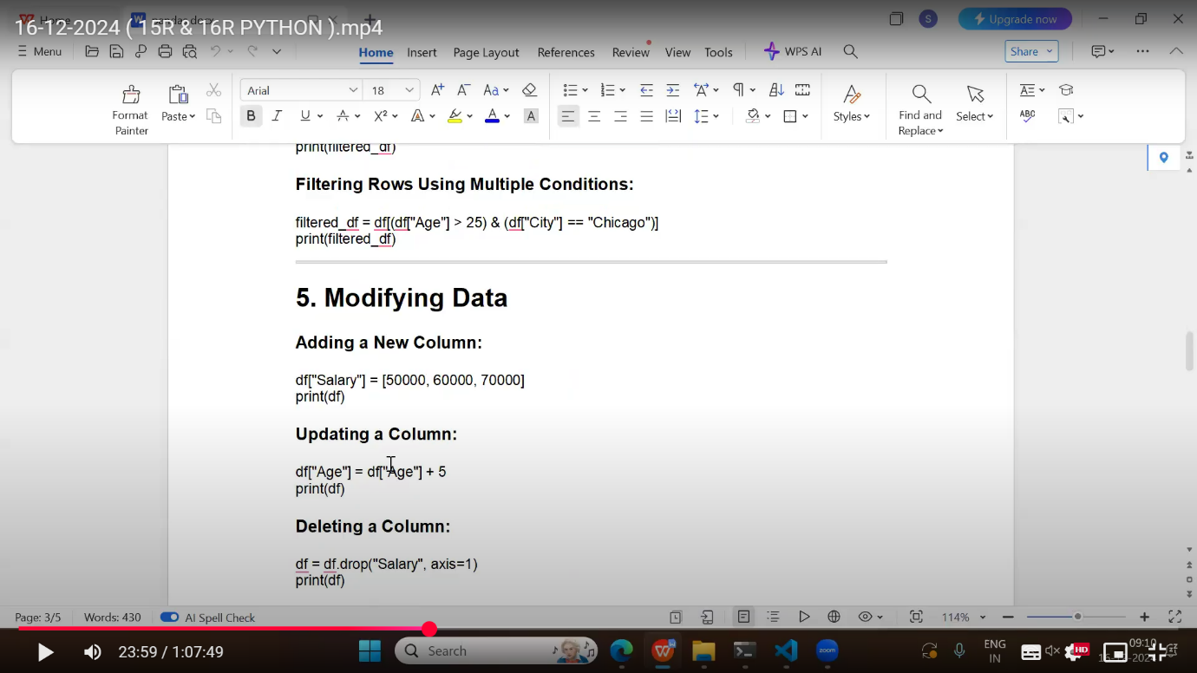

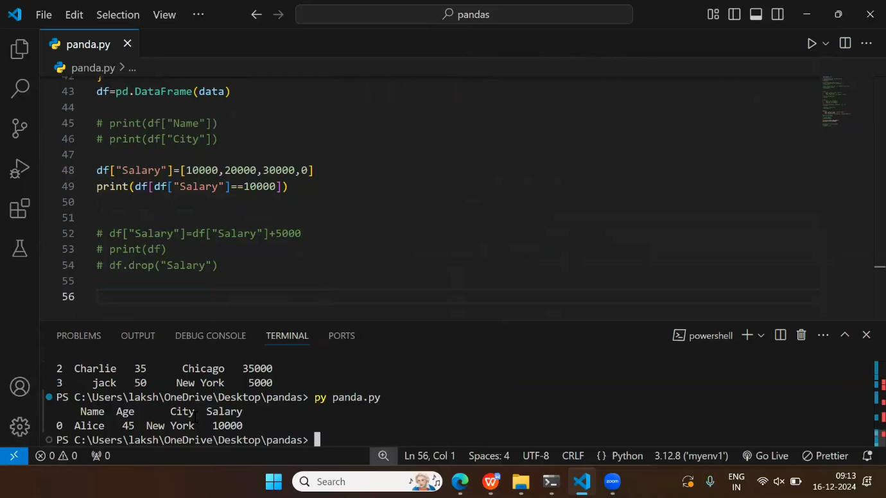



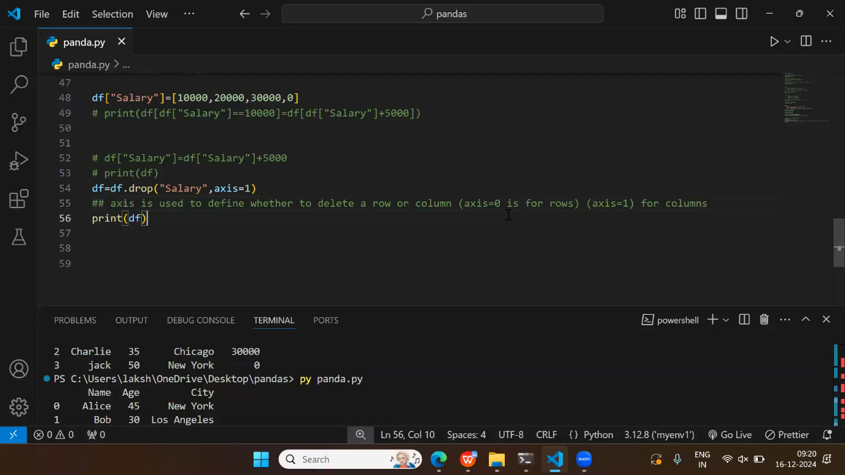

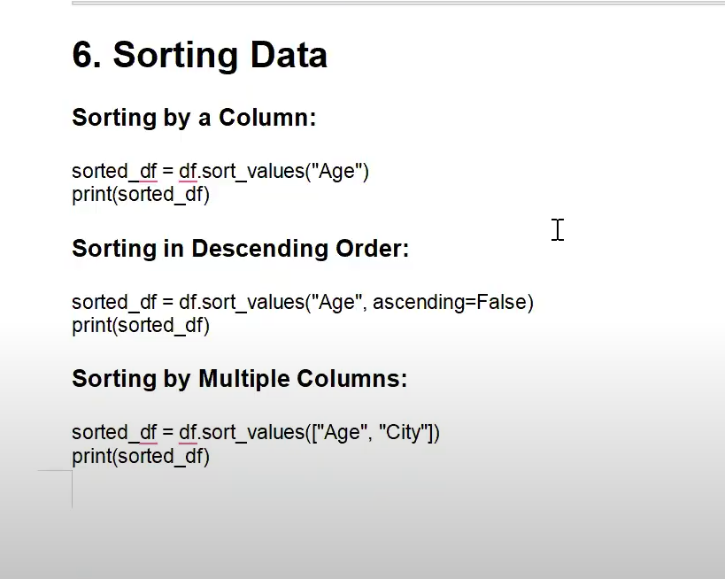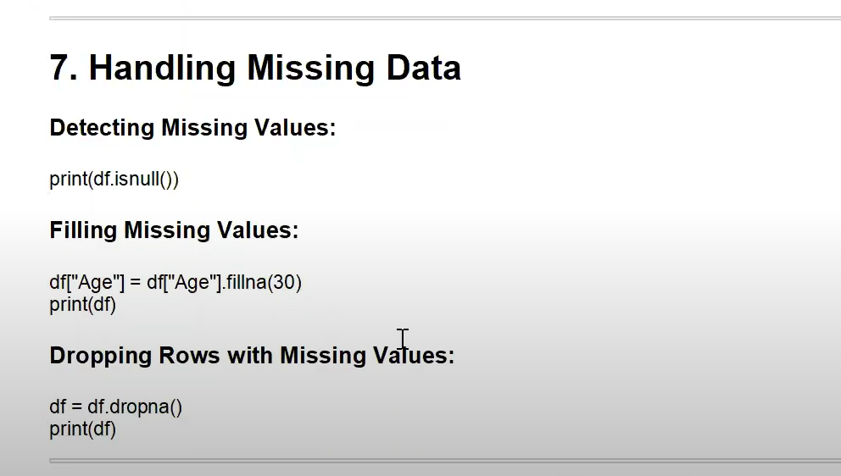

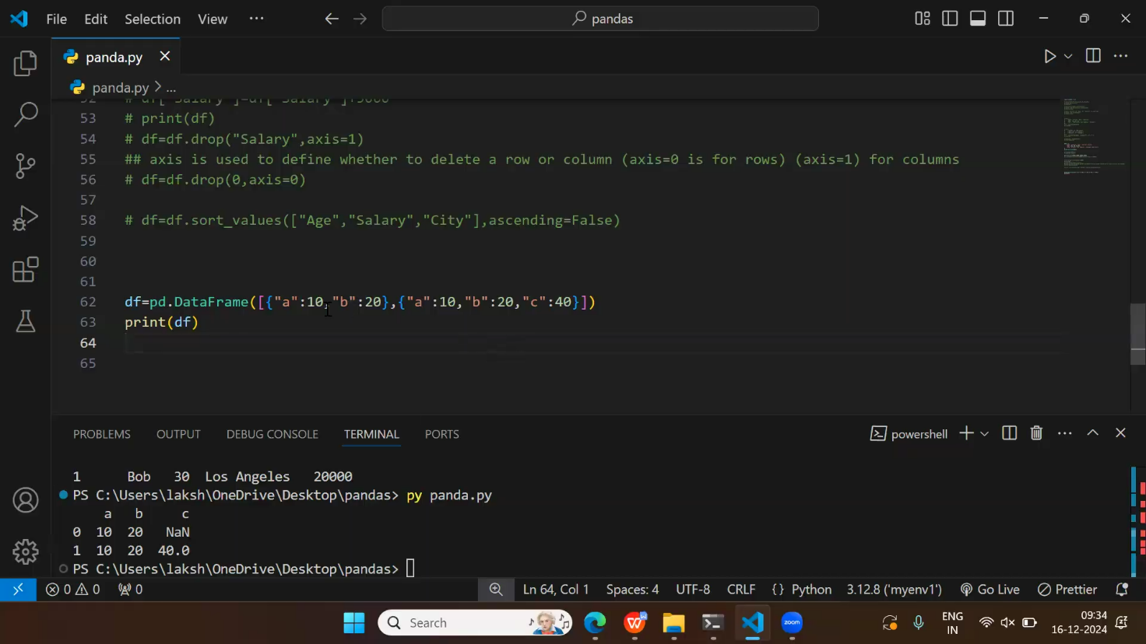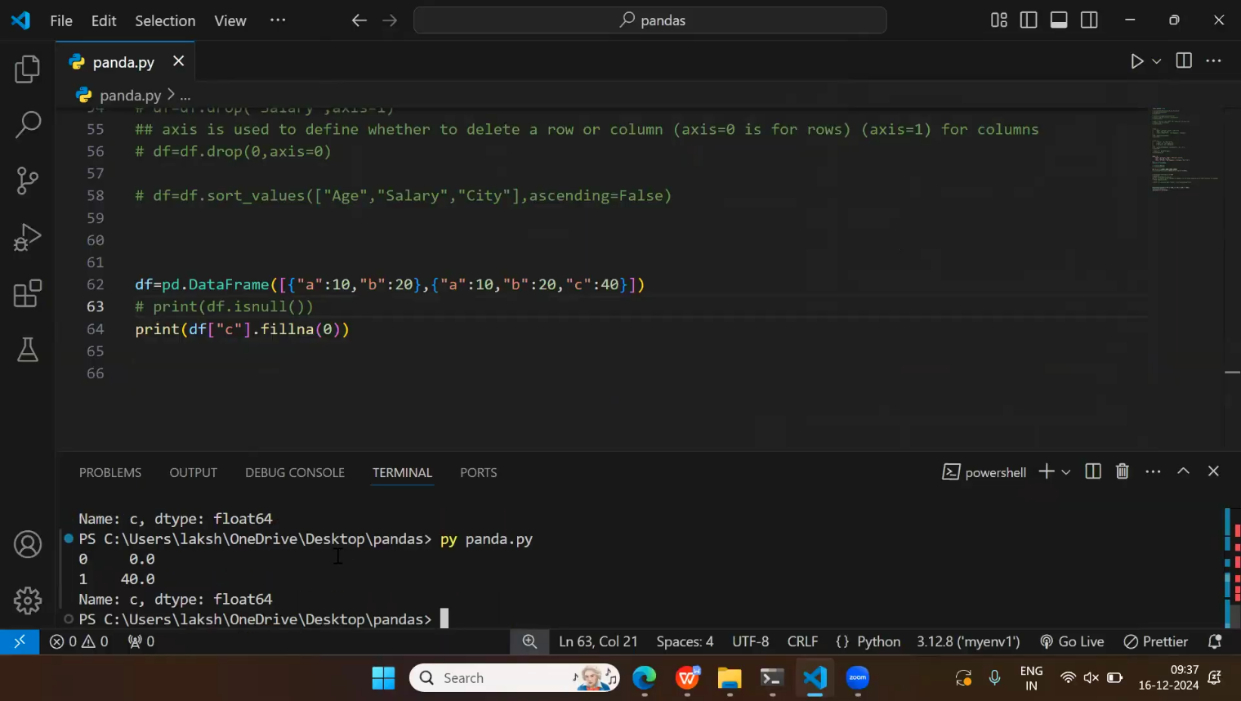

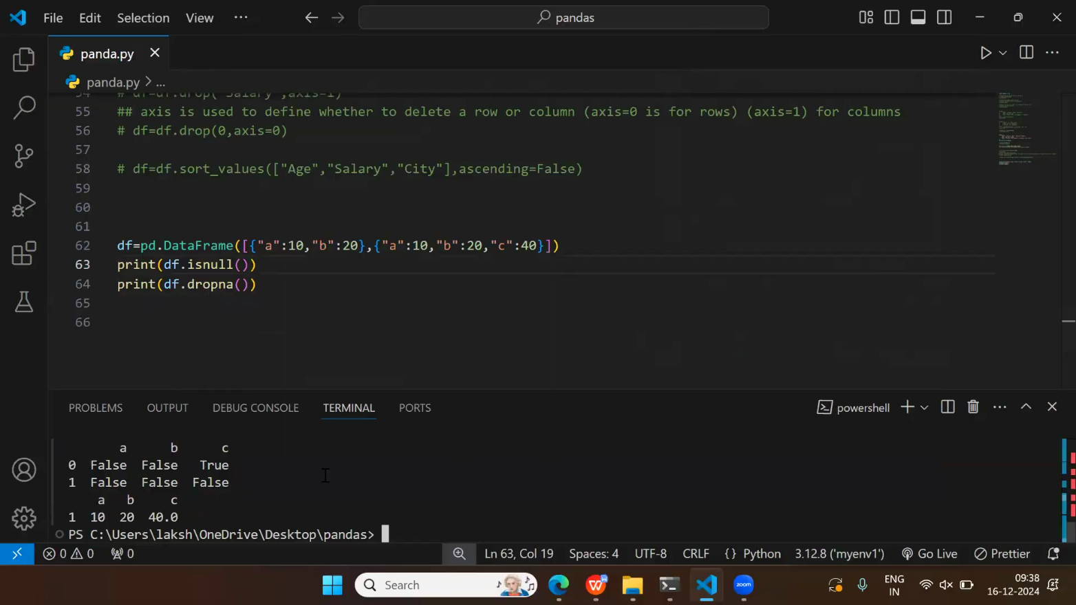

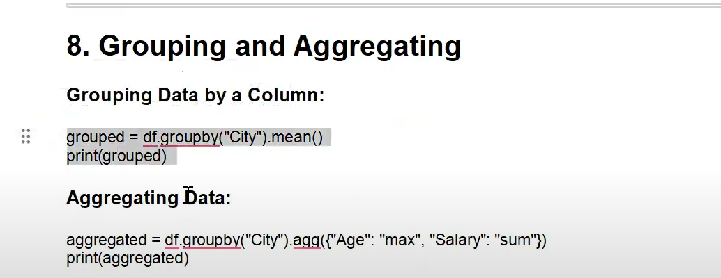

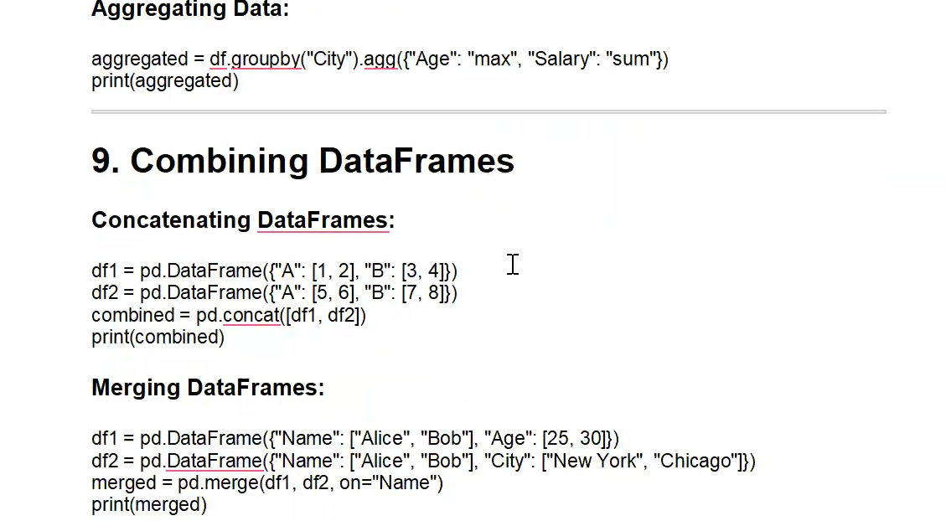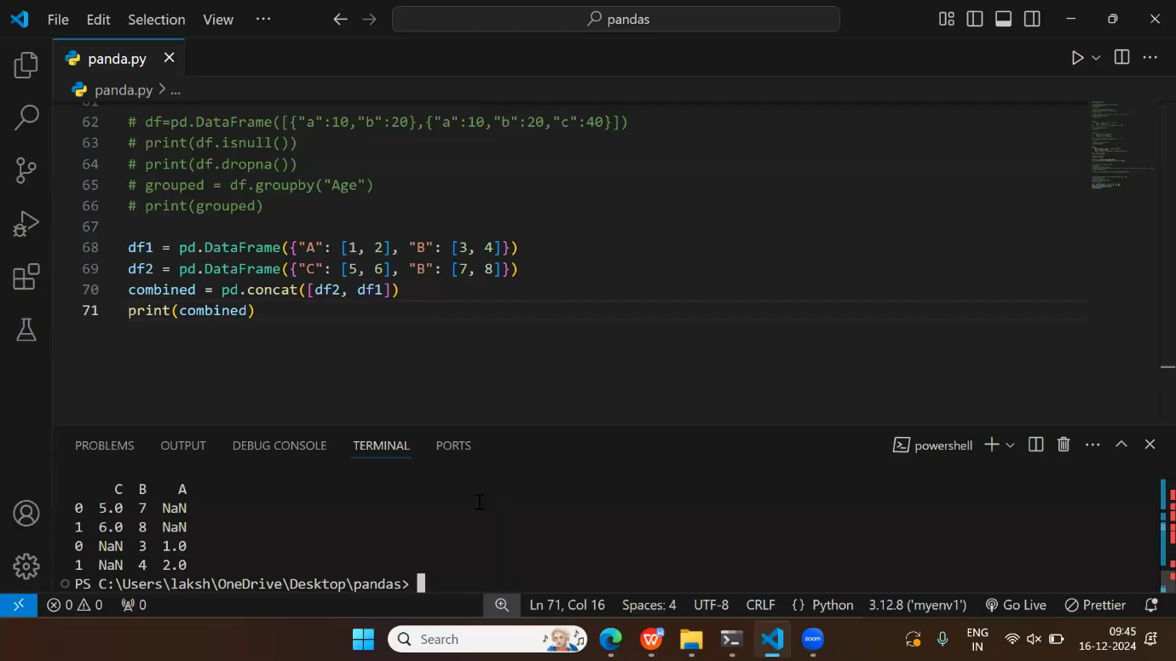

**Writing to a CSV file:**

df.to\_csv(‘output.csv’, index=False)

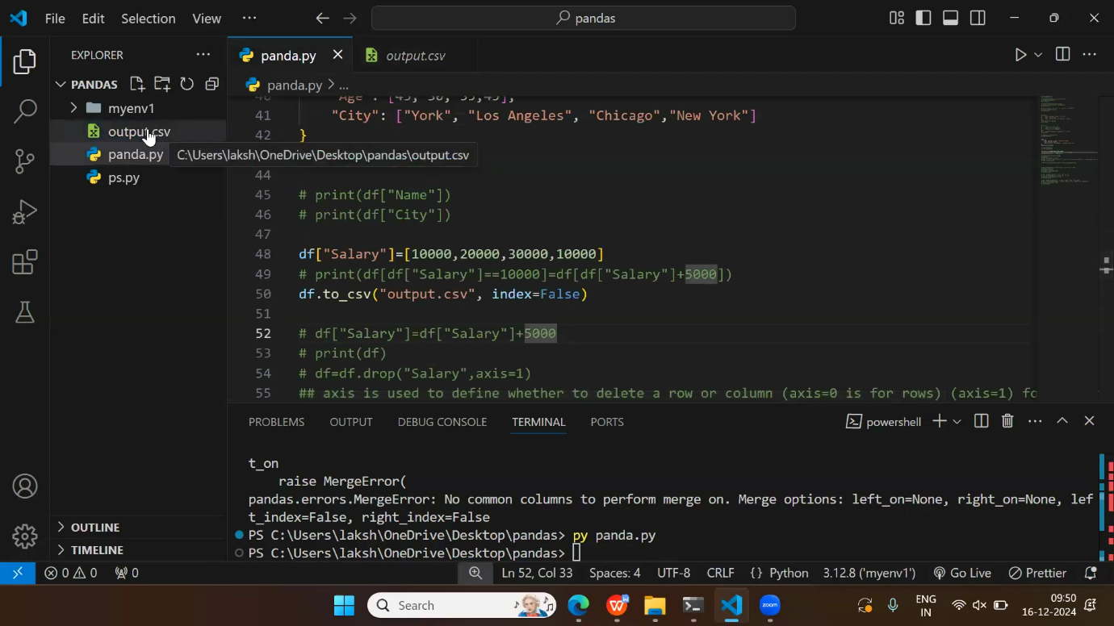

**Removing Duplicates**

To discover duplicates, we can use the duplicated() method.

The duplicated() method returns a Boolean values for each row:

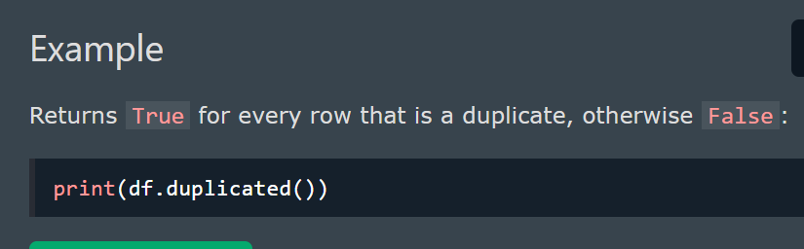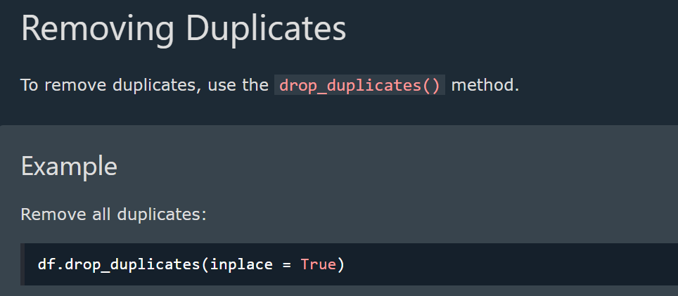

**Pandas - Data Correlations**

Finding Relationships

A great aspect of the Pandas module is the corr() method.

The corr() method calculates the relationship between each column in your data set.

The examples in this page uses a CSV file called: 'data.csv'.

[Download data.csv](https://www.w3schools.com/python/pandas/data.csv). or [Open data.csv](https://www.w3schools.com/python/pandas/data.csv.txt)

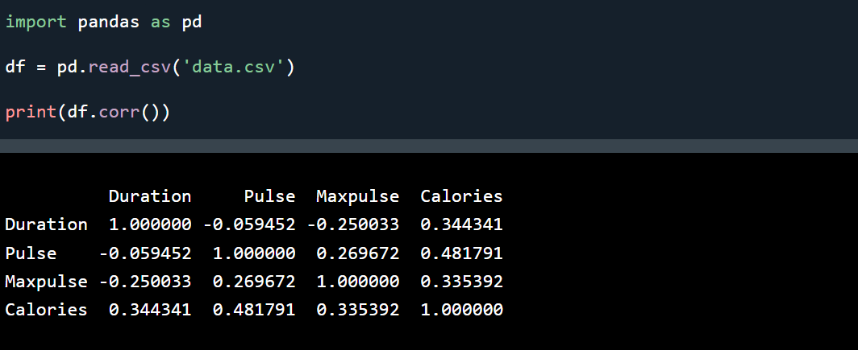

**Result Explained**

* The Result of the corr() method is a table with a lot of numbers that represents how well the relationship is between two columns.
* The number varies from -1 to 1.
* 1 means that there is a 1 to 1 relationship (a perfect correlation), and for this data set, each time a value went up in the first column, the other one went up as well.
* 0.9 is also a good relationship, and if you increase one value, the other will probably increase as well.
* -0.9 would be just as good relationship as 0.9, but if you increase one value, the other will probably go down.
* 0.2 means NOT a good relationship, meaning that if one value goes up does not mean that the other will.

**Plotting**

* Pandas uses the plot() method to create diagrams.
* We can use Pyplot, a submodule of the Matplotlib library to visualize the diagram on the screen.
* Read more about [ploting](https://www.w3schools.com/python/pandas/pandas_plotting.asp)

**Matplotlib**

**What is Matplotlib?**

* Matplotlib is a low level graph plotting library in python that serves as a visualization utility.
* Matplotlib was created by John D. Hunter.
* Matplotlib is open source and we can use it freely.
* Matplotlib is mostly written in python, a few segments are written in C, Objective-C and Javascript for Platform compatibility.

**Installing Matplotlib**

If not installed, use:

**pip install matplotlib**

**Import Matplotlib**

Once Matplotlib is installed, import it in your applications by adding the import *module* statement:

**import matplotlib**

Now Matplotlib is imported and ready to use:

**Checking Matplotlib Version**

The version string is stored under \_\_version\_\_ attribute.

**Example**

import matplotlib  
print(matplotlib.\_\_version\_\_)

**Importing Pyplot**

import matplotlib.pyplot as plt

**Pyplot**

pyplot is a **module in Matplotlib** used for **creating visualizations** like line plots, bar charts, histograms, and scatter plots. It provides an **interface similar to MATLAB** and makes it easy to plot and customize graphs.

* Plotting x and y points
* The plot() function is used to draw points (markers) in a diagram.
* By default, the plot() function draws a line from point to point.
* The function takes parameters for specifying points in the diagram.
* Parameter 1 is an array containing the points on the x-axis.
* Parameter 2 is an array containing the points on the y-axis.

**Markers**

You can use the keyword argument marker to emphasize each point with a specified marker:

**Marker Reference**

You can choose any of these markers:

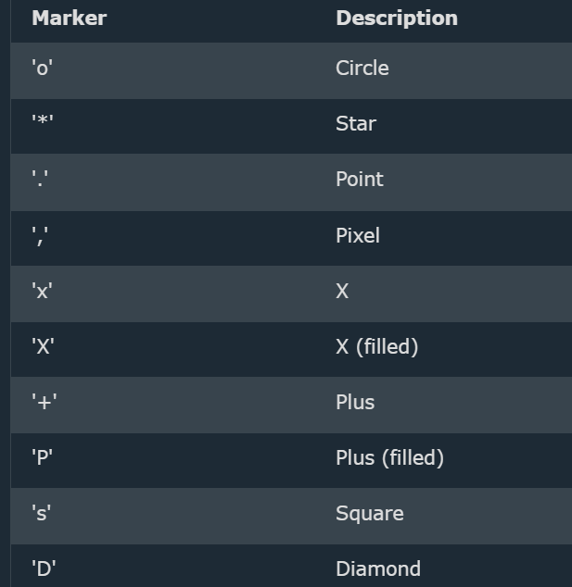 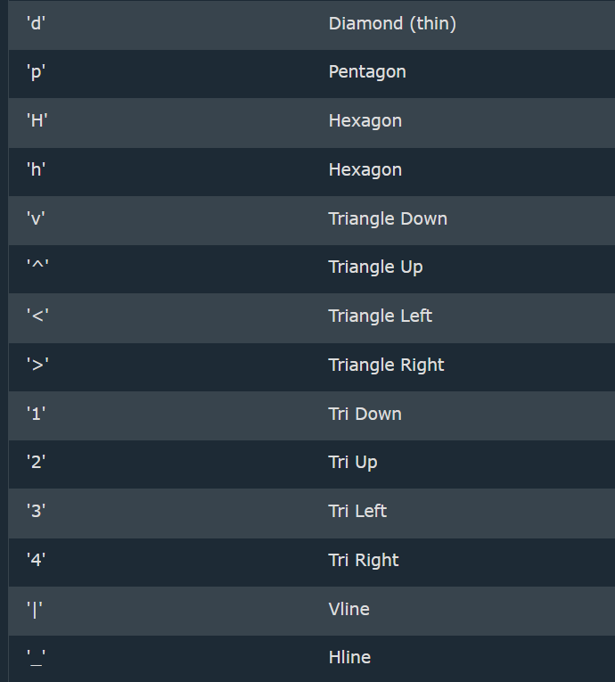

**Line Reference**

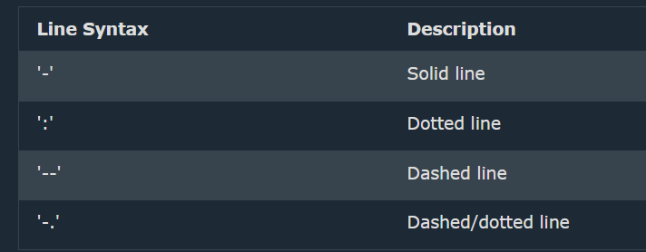

**Color Reference**

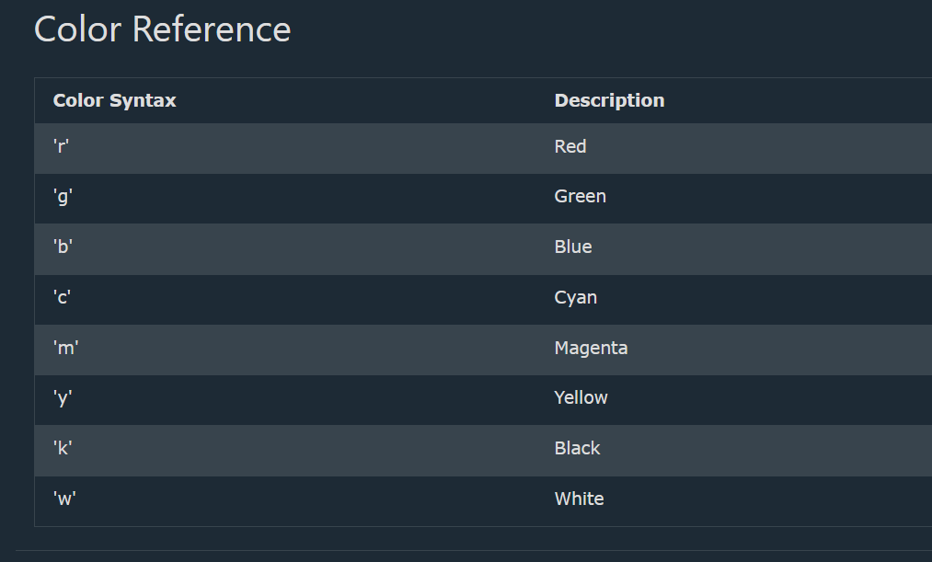

**Marker Size**

You can use the keyword argument **markersize** or the shorter version, **ms** to **set the size of the markers:**

**Example**

Set the size of the markers to 20:

import matplotlib.pyplot as plt  
import numpy as np  
  
ypoints = np.array([3, 8, 1, 10])  
plt.plot(ypoints, marker = 'o', ms = 20)  
plt.show()

**Marker Color**

You can use the keyword argument **markeredgecolor** or the shorter **mec** to **set the color of the *edge* of the markers**:

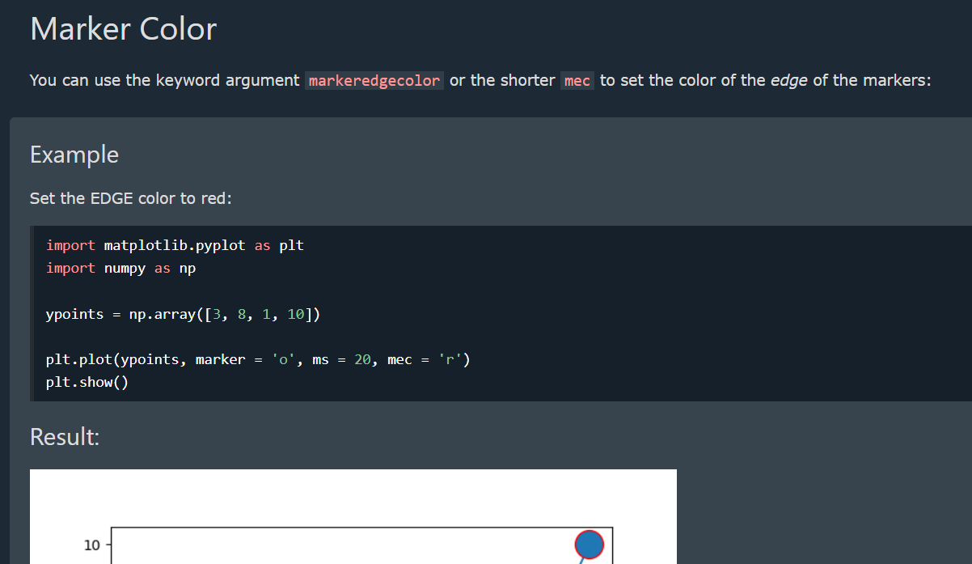

You can use the keyword argument **markerfacecolor** or the shorter **mfc** to **set the color inside the edge of the markers**:

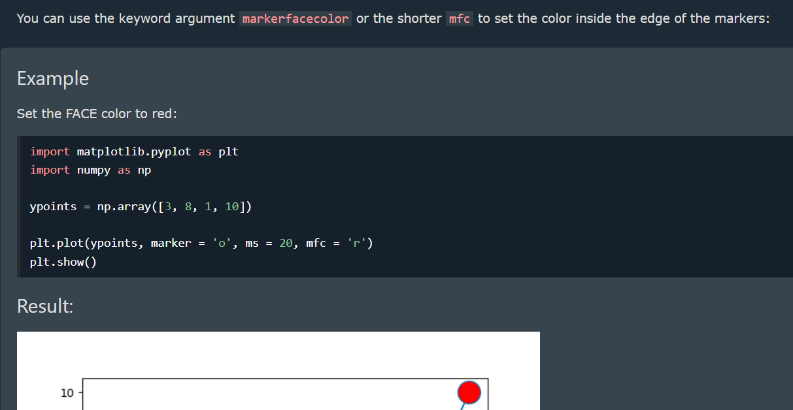

**Line Color**

You can use the keyword argument color or the shorter **c** to **set the color of the line**:

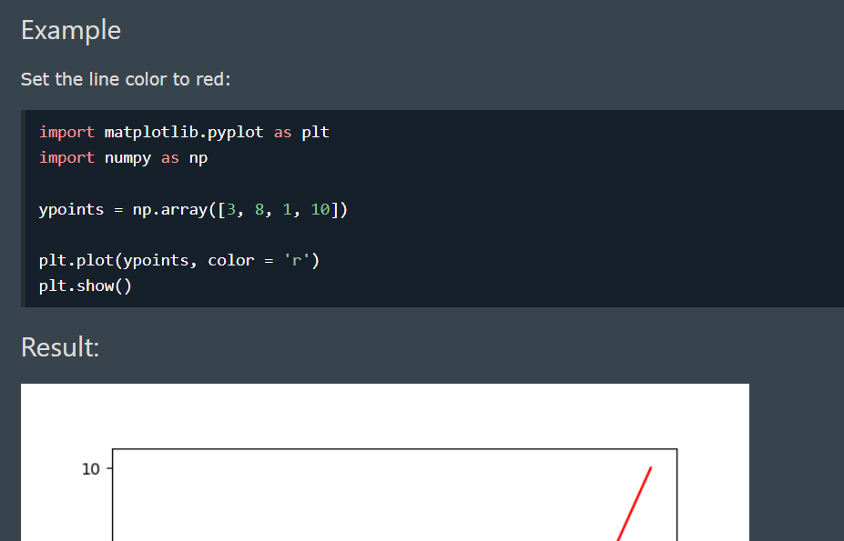

**Line Width**

You can use the keyword argument linewidth or the shorter **lw** to change the width of the line.

The value is a floating number, in points:

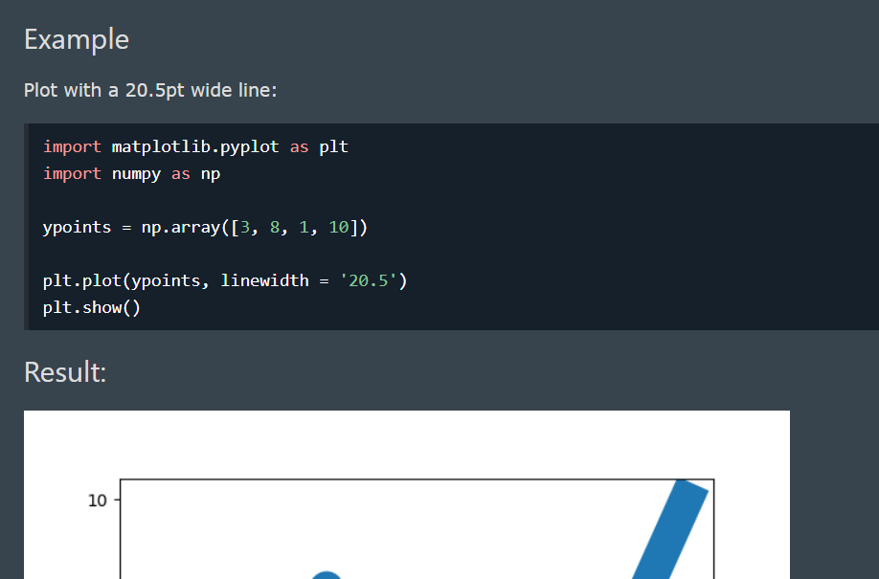

**Multiple Lines**

You can plot as many lines as you like by simply adding more **plt.plot()** functions:

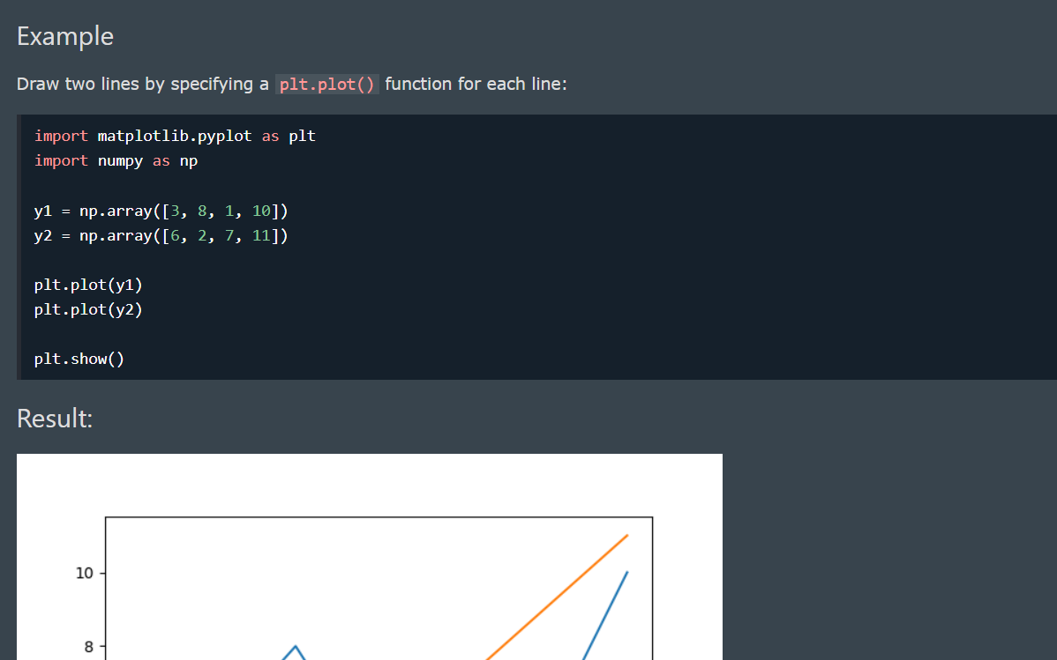

**Basic Structure of Pyplot**

import matplotlib.pyplot as plt

x = [1, 2, 3, 4, 5]

y = [10, 15, 8, 20, 18]

plt.plot(x, y) # Create a line plot

plt.show() # Display the plot

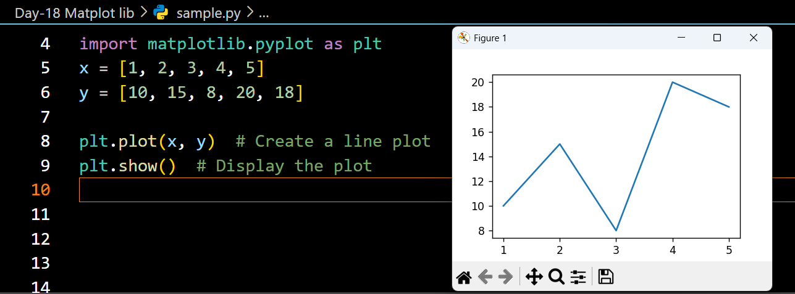

**Adding Labels & Title**

* With Pyplot, you can use the **xlabel() and ylabel() functions to set a label for the x- and y-axis**.
* With Pyplot, you can use the **title()** function to set a title for the plot.
* You can use the loc parameter in **title()** to **position the title**. Legal values are: 'left', 'right', and 'center'. Default value is 'center'.

plt.plot(x, y, marker="o", linestyle="--", color="b")

plt.xlabel("X-axis Label") # Label for X-axis

plt.ylabel("Y-axis Label") # Label for Y-axis

plt.title("Line Plot Example") # Title of the Graph

plt.show()

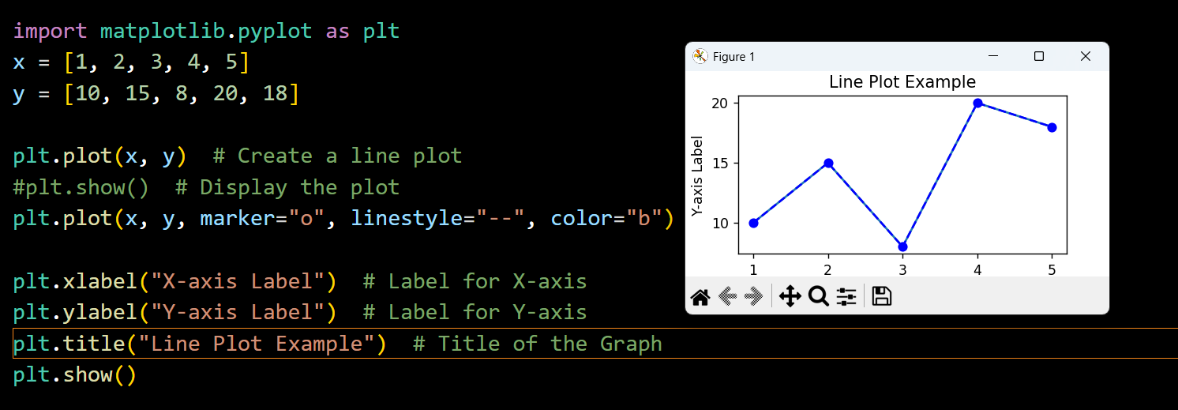

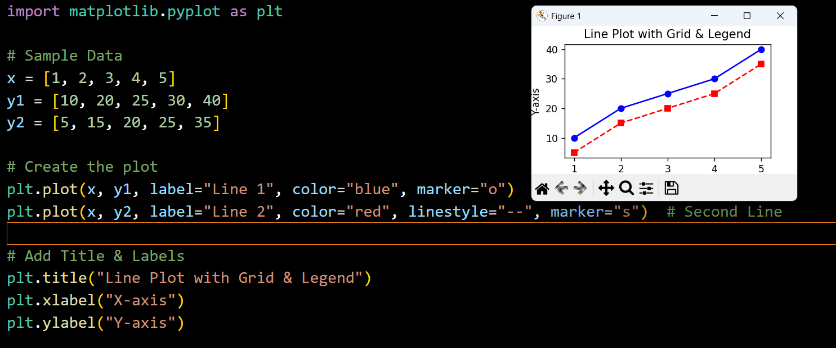

**Adding a Grid & Legend**

* In **Matplotlib**, you can add a **grid** using **plt.grid(True)** and a **legend** using **plt.legend()**
* You can use the axis parameter in the **grid()** function to specify which grid lines to display.
* Legal values are: 'x', 'y', and 'both'. Default value is 'both'.
* You can also set the line properties of the grid, like this: grid(color = '*color*', linestyle = '*linestyle*', linewidth = *number*).

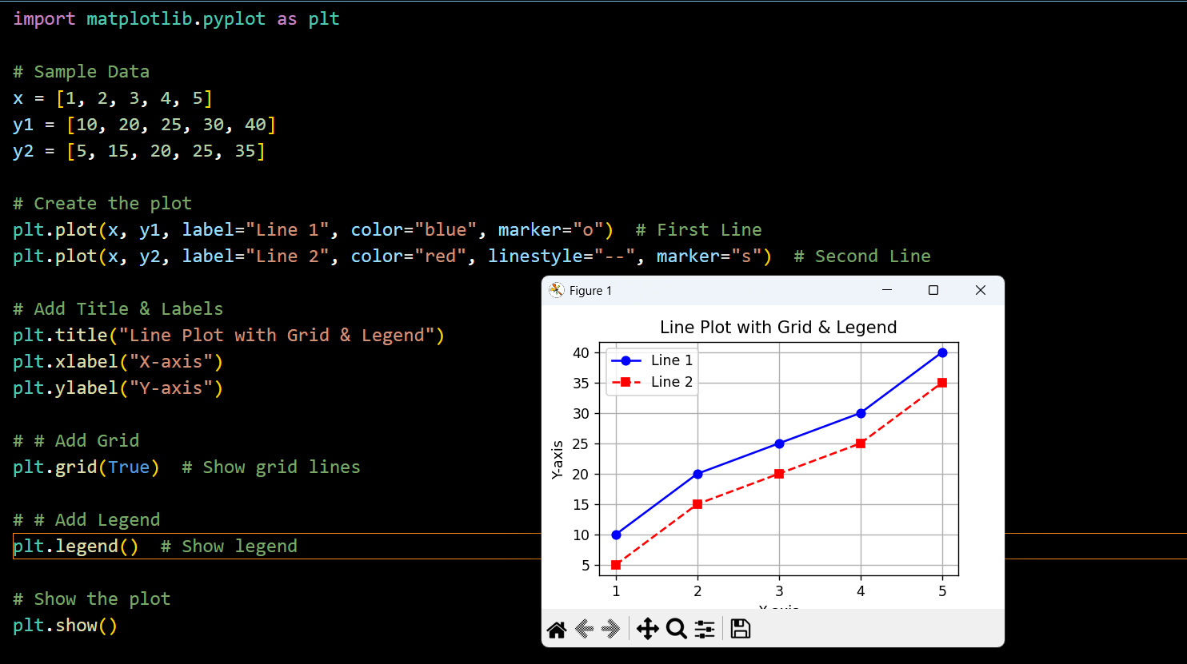

**Display Multiple Plots**

With the **subplot()** function you can draw multiple plots in one figure:

**The subplot() Function**

* The **subplot()** function takes three arguments that describes the layout of the figure.
* The layout is organized in rows and columns, which are represented by the *first*and *second*argument.
* The third argument represents the index of the current plot.

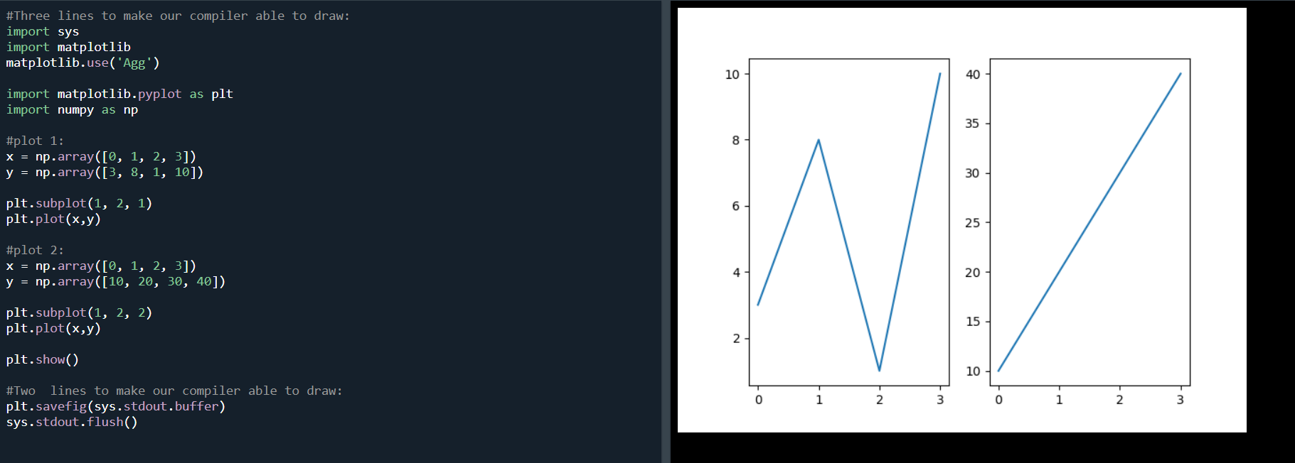

**Different Plot Types**

**Line Plot**

plt.plot(x, y, marker="o", linestyle="-", color="blue")

plt.show()

**Bar Chart**

* With Pyplot, you can use the **bar() function to draw bar graphs**
* If you want the bars to be **displayed horizontally** instead of vertically, use the **barh()** function
* The **bar() and barh()** take the keyword argument color to set the color of the bars
* plt.bar(x, y, color = "red")
* The **bar()** takes the keyword argument **width** to **set the width of the bars**
* The **barh()** takes the keyword argument **height** to **set the height of the bars**

categories = ["A", "B", "C", "D"]

values = [5, 7, 3, 8]

plt.bar(categories, values, color="green")

plt.show()

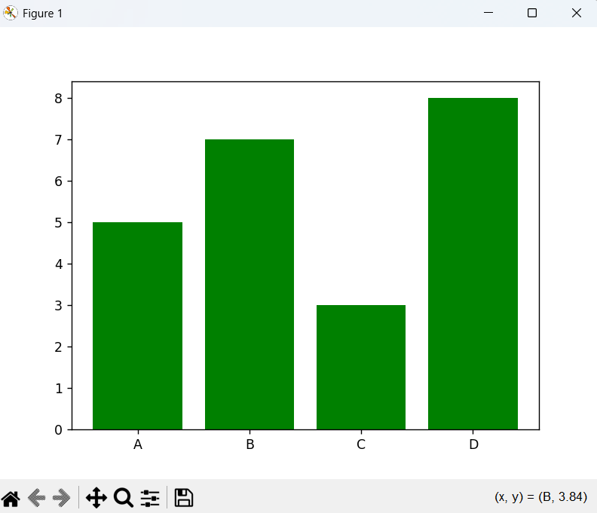

**Scatter Plot**

* With Pyplot, you can use the **scatter()** function to draw a scatter plot.
* The **scatter()** function plots one dot for each observation. It needs two arrays of the same length, one for the values of the x-axis, and one for values on the y-axis
* You can even set a specific **color for each dot** by using an array of colors as value for the **c argument**
* You can change the **size of the dots** with the **s** argument.
* You can **adjust the transparency** of the dots with the **alpha** argument.

plt.scatter(categories, values, color="red", marker="x")

plt.show()

**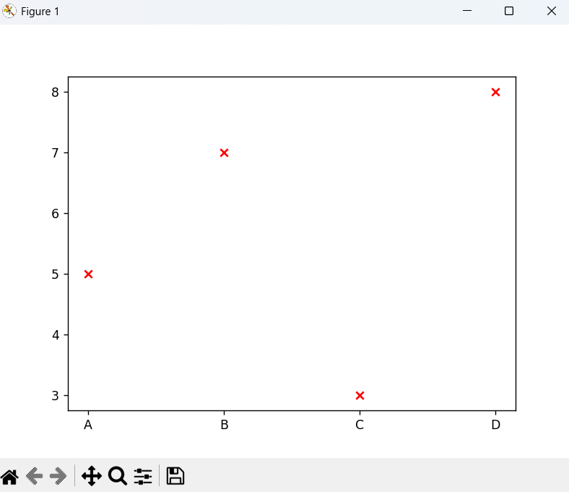**

**Compare Plots**

In the example above, there seems to be a relationship between speed and age, but what if we plot the observations from another day as well? Will the scatter plot tell us something else?

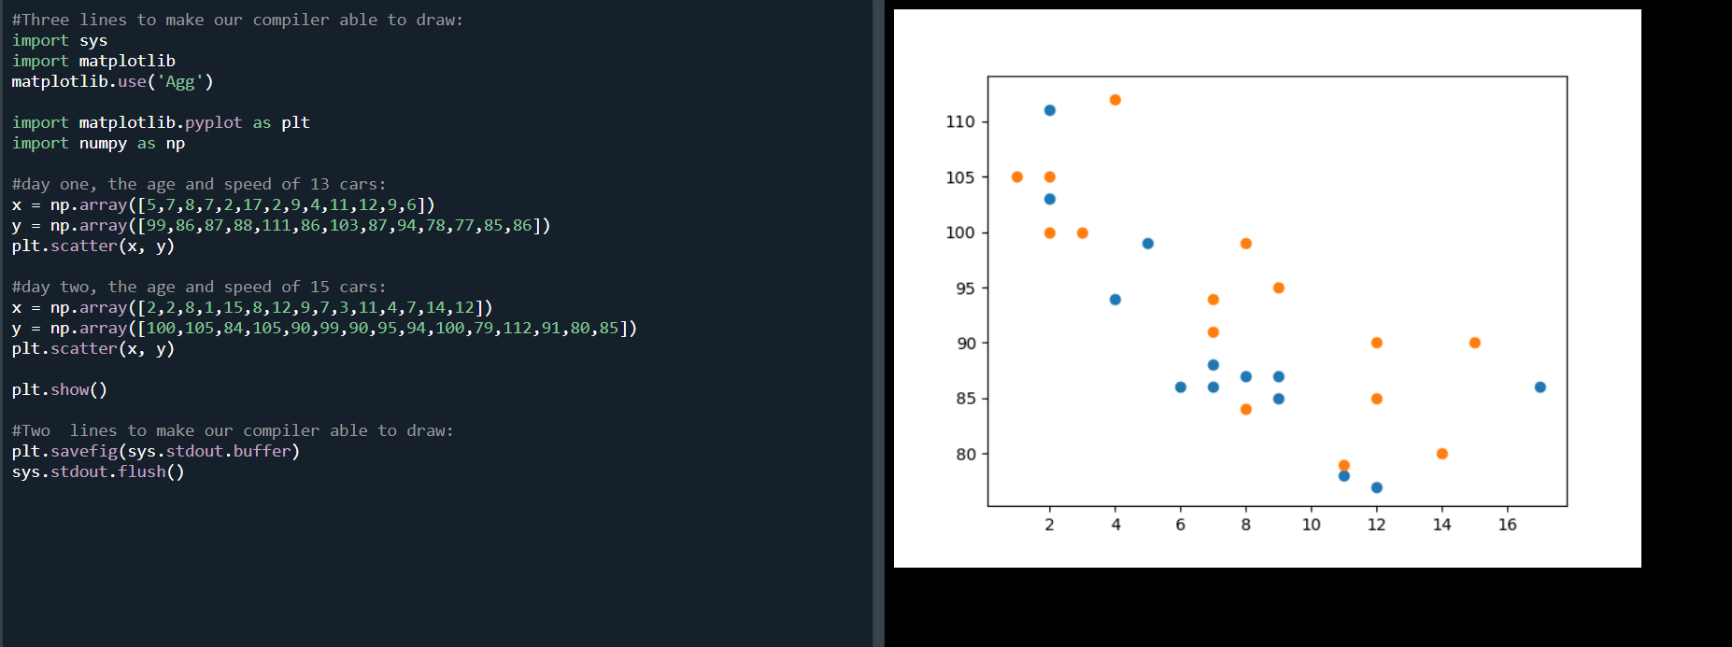

**Histogram**

* A histogram is a graph showing *frequency* distributions.
* It is a graph showing the number of observations within each given interval.
* The **hist()** function will read the array and produce a histogram

import numpy as np

data = np.random.randn(1000) # Random data

plt.hist(data, bins=20, color="purple", edgecolor="black")

plt.show()

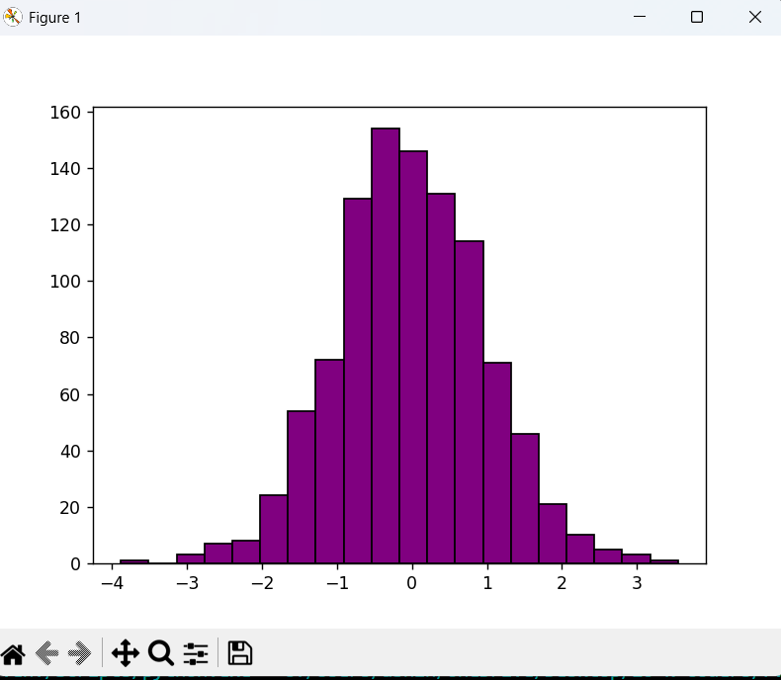

**Pie Chart**

* With Pyplot, you can use the **pie()** function to draw pie charts
* Add labels to the pie chart with the **labels** parameter.
* The labels parameter must be an array with one label for each wedge
* Maybe you want one of the wedges to stand out? The explode parameter allows you to do that.
* The **explode parameter**, if specified, and not None, must be an array with one value for each wedge.
* **Add a shadow** to the pie chart by setting the **shadows** parameter to True
* To **add a list of explanation for each wedge**, use the **legend()** function
* To **add a header to the legend**, add the **title parameter to the legend function**.

labels = ["Python", "Java", "C++", "JavaScript"]

sizes = [40, 25, 20, 15]

plt.pie(sizes, labels=labels, autopct="%1.1f%%", colors=["blue", "red", "green", "yellow"])

plt.title("Pie Chart Example")

plt.show()

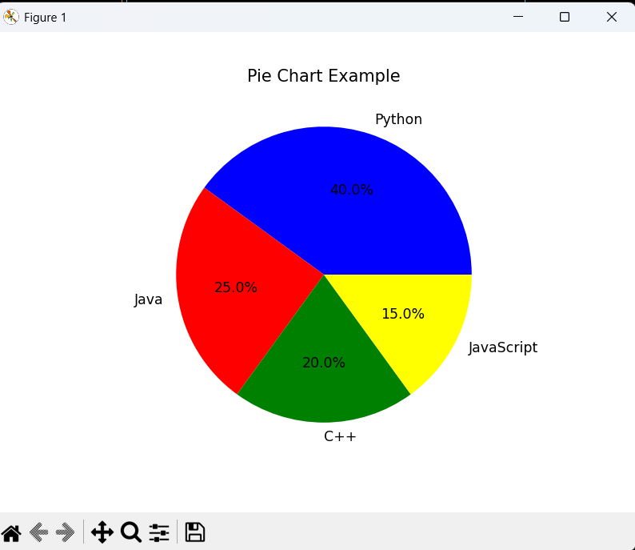

**Object-Oriented Programming (OOP)**

**What is OOP?**

Object-Oriented Programming (OOP) is a programming paradigm that organizes software design around objects, which represent real-world entities. These objects encapsulate **data (attributes)** and **behavior (methods)**, making the code more modular and reusable.

(or)

"OOPS" uses objects, which are created from classes, to structure data and code, enabling modular, reusable, and scalable code through concepts like encapsulation, inheritance, polymorphism, and abstraction.

**Key Concepts of OOP in Python**

1. **Class** – A blueprint for creating objects.
2. **Object** – An instance of a class.
3. **Encapsulation** – Hiding the internal details of an object and restricting direct access to some of its components.
4. **Abstraction** – Hiding complex implementation details and exposing only the necessary parts.
5. **Inheritance** – A mechanism that allows a new class to derive properties and behavior from an existing class.
6. **Polymorphism** – The ability to take multiple forms, e.g., methods with the same name but different implementations in different classes.

**OOP follows four main principles:**

1. **Encapsulation** – Hiding the internal state of an object and restricting access to it.
2. **Abstraction** – Hiding complex implementation details and exposing only the necessary parts.
3. **Inheritance** – Enabling new classes to derive properties and methods from existing ones.
4. **Polymorphism** – Allowing the same interface to be used for different underlying data types.

**Why Do We Use OOP?**

OOP is used because it provides:

✅ **Better Code Organization** – It structures code into objects, making it more readable and maintainable.  
✅ **Reusability** – Classes can be reused in different parts of a program, reducing redundancy.  
✅ **Scalability** – Easier to expand and modify code without affecting other parts of the program.  
✅ **Data Security** – Encapsulation ensures that sensitive data is not directly accessible.  
✅ **Code Maintenance** – The modular approach allows updates and debugging without affecting the entire system.

**Example Without OOP (Procedural Approach)**

# Procedural Programming

car\_brand = "Toyota"

car\_model = "Corolla"

def display\_info():

print(f"Car: {car\_brand} {car\_model}")

display\_info()

❌ The above approach lacks **encapsulation**, **reusability**, and **modularity**.

**Example With OOP (Object-Oriented Approach)**

class Car:

def \_\_init\_\_(self, brand, model):

self.brand = brand

self.model = model

def display\_info(self):

print(f"Car: {self.brand} {self.model}")

car1 = Car("Toyota", "Corolla")

car1.display\_info()

✅ **More structured, reusable, and scalable!**

**Difference Between OOP in Python and Other Languages**

|  |
| --- |

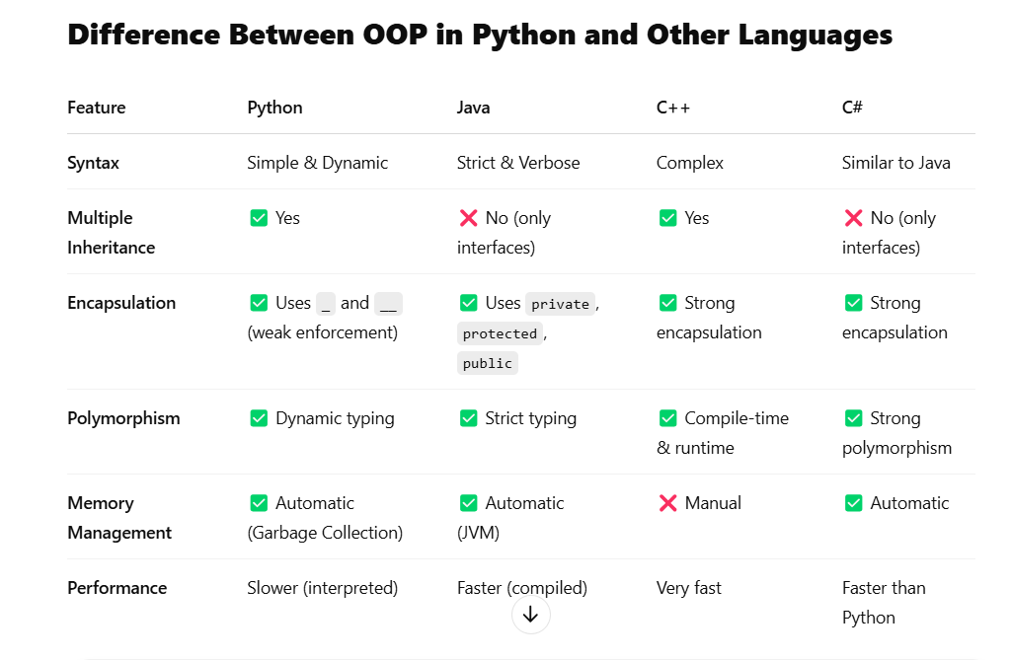

**Key Differences:**

1. Python is more **dynamic** and **flexible**, while Java, C++, and C# require **strict type declarations**.
2. Python supports **multiple inheritance**, while Java and C# use interfaces.
3. Python is **interpreted**, making it slower than compiled languages like C++ and Java.
4. Python has **automatic memory management**, whereas C++ requires manual handling.

**Benefits of OOP**

**✅ 1. Code Reusability (DRY Principle)**

* Inheritance allows reusing existing code without rewriting it.
* Example: A Car class can be reused in multiple projects.

**✅ 2. Modularity (Easier Code Organization)**

* Classes help break down large code into smaller, manageable parts.
* Example: A BankAccount class can have different methods like deposit() and withdraw().

**✅ 3. Encapsulation (Data Security)**

* Prevents direct modification of sensitive data.
* Example: A private \_\_balance attribute in a BankAccount class.

**✅ 4. Scalability & Flexibility**

* Polymorphism allows the same method to work for different types.
* Example: A make\_sound() method can work for both Dog and Cat classes.

**✅ 5. Real-World Representation**

* Objects model real-world entities, making software design intuitive.
* Example: Car, Employee, Customer, etc.

**What is a Class?**

A **class** in Python is a blueprint or template for creating objects. It defines attributes (variables) and methods (functions) that the objects will have.

**Syntax of a Class in Python**

class ClassName:

# Constructor (optional)

def \_\_init\_\_(self, param1, param2):

self.param1 = param1

self.param2 = param2

# Method

def method\_name(self):

print("Method executed")

* class keyword is used to define a class.
* \_\_init\_\_() is a special method (constructor) that initializes object attributes.
* self represents the instance of the class.

**What is an Object?**

An **object** is an instance of a class. When a class is defined, no memory is allocated until an object is created.

**Creating an Object in Python**

# Define a class

class Car:

def \_\_init\_\_(self, brand, model):

self.brand = brand

self.model = model

def display\_info(self):

print(f"Car: {self.brand} {self.model}")

# Creating an object of the class

car1 = Car("Toyota", "Corolla")

car1.display\_info()

**Explanation:**

* Car is a class that has attributes brand and model and a method display\_info().
* car1 = Car("Toyota", "Corolla") creates an object of the class.
* car1.display\_info() calls the method to display the details of the car.

**1. Class Attributes and Instance Attributes**

* **Class Attributes** are shared among all objects of the class.
* **Instance Attributes** are unique to each object.

class Car:

wheels = 4 # Class attribute (common to all instances)

def \_\_init\_\_(self, brand, model):

self.brand = brand # Instance attribute

self.model = model # Instance attribute

car1 = Car("Toyota", "Corolla")

car2 = Car("Honda", "Civic")

print(car1.wheels) # Output: 4

print(car2.wheels) # Output: 4

print(car1.brand) # Output: Toyota

print(car2.brand) # Output: Honda

**2. The \_\_init\_\_() Method (Constructor)**

* It initializes attributes when an object is created.
* It automatically runs when an object is instantiated.

class Person:

def \_\_init\_\_(self, name, age):

self.name = name

self.age = age

person1 = Person("Alice", 25)

print(person1.name) # Output: Alice

print(person1.age) # Output: 25

**3. Methods in a Python Class – Detailed Explanation**

In Python, methods are functions defined inside a class that operate on class attributes. There are three types of methods:

1. Instance Methods – Work on specific objects (instances) of a class.
2. Class Methods – Work on the class itself, not on instances.
3. Static Methods – Independent functions inside a class that don’t modify class or instance attributes.

**1. Instance Methods (self)**

**Definition**

* Instance methods work with **specific instances** of a class.
* They **can modify instance attributes** and **access instance-specific data**.
* They take self as the first parameter, which represents the instance of the class.

**Example of Instance Method**

class Car:

def \_\_init\_\_(self, brand, model):

self.brand = brand # Instance variable

self.model = model # Instance variable

def display\_info(self): # Instance method

print(f"Car: {self.brand} {self.model}")

# Creating an object

car1 = Car("Toyota", "Corolla")

car1.display\_info() # Output: Car: Toyota Corolla

**Key Points**

✅ Uses self to access instance attributes.  
✅ Can **read and modify** instance variables.  
✅ Called using an **object of the class** (car1.display\_info()).

**2. Class Methods (@classmethod)**

**Definition**

* Class methods work with **the class itself**, not with instances.
* They take cls as the first parameter, which represents the class.
* They **can modify class attributes** (but not instance attributes).
* Decorated with @classmethod.

**Example of Class Method**

class Car:

wheels = 4 # Class variable

def \_\_init\_\_(self, brand, model):

self.brand = brand

self.model = model

@classmethod

def change\_wheels(cls, new\_wheels):

cls.wheels = new\_wheels # Modifying class attribute

@classmethod

def show\_wheels(cls):

print(f"All cars have {cls.wheels} wheels")

# Using class method without creating an object

Car.change\_wheels(6) # Changing class attribute

Car.show\_wheels() # Output: All cars have 6 wheels

**Key Points**

✅ Uses cls instead of self to access class attributes.  
✅ Modifies class variables, affecting all instances.  
✅ Can be called using either **a class or an instance** (Car.show\_wheels() or car1.show\_wheels()).

**3. Static Methods (@staticmethod)**

**Definition**

* Static methods **do not access instance (self) or class (cls) variables**.
* They behave like regular functions but are **inside a class** for better organization.
* Decorated with @staticmethod.

**Example of Static Method**

class MathOperations:

@staticmethod

def add(x, y):

return x + y

@staticmethod

def multiply(x, y):

return x \* y

# Calling static methods without creating an object

print(MathOperations.add(5, 10)) # Output: 15

print(MathOperations.multiply(4, 6)) # Output: 24

**Key Points**

✅ **No self or cls**, meaning it cannot access instance or class attributes.  
✅ Works like a normal function but is grouped logically inside a class.  
✅ Can be called using **a class or an instance** (MathOperations.add(5, 10)).

**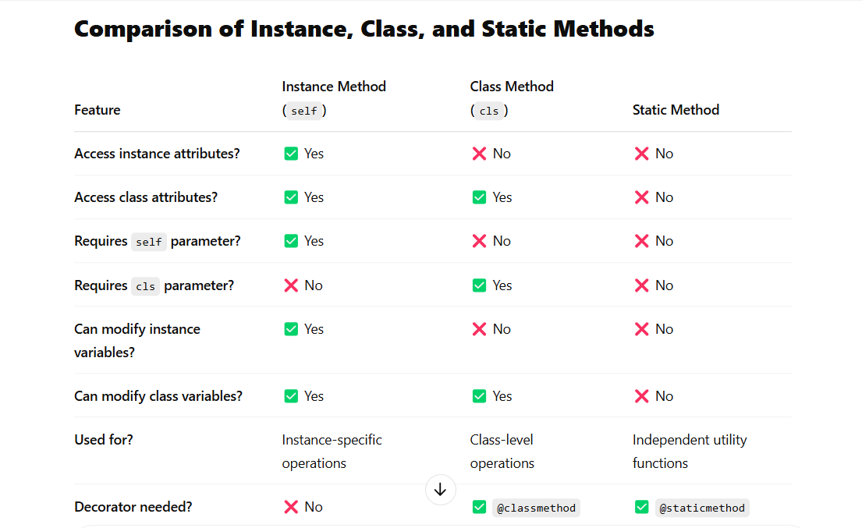**

**When to Use Each Method?**

| **Scenario** | **Method to Use** |
| --- | --- |
| Need to modify or access instance attributes | **Instance Method** |
| Need to modify or access class attributes | **Class Method** |
| Need a function inside a class that does not interact with instance or class variables | **Static Method** |

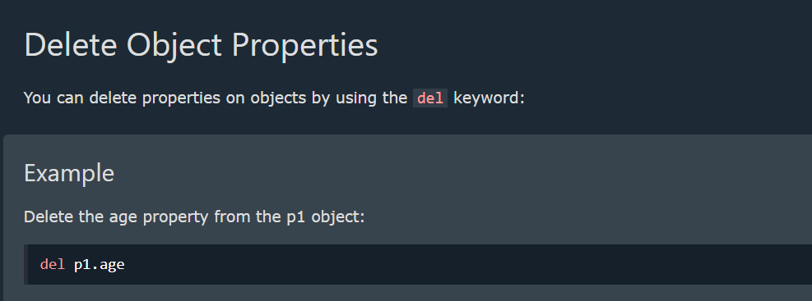 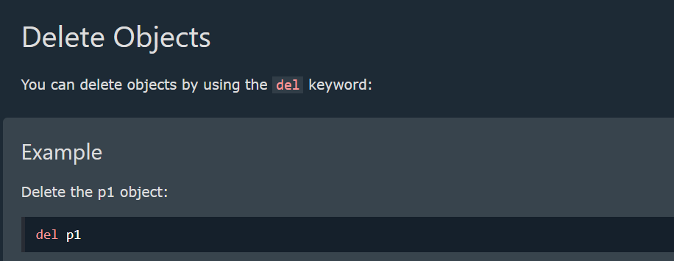

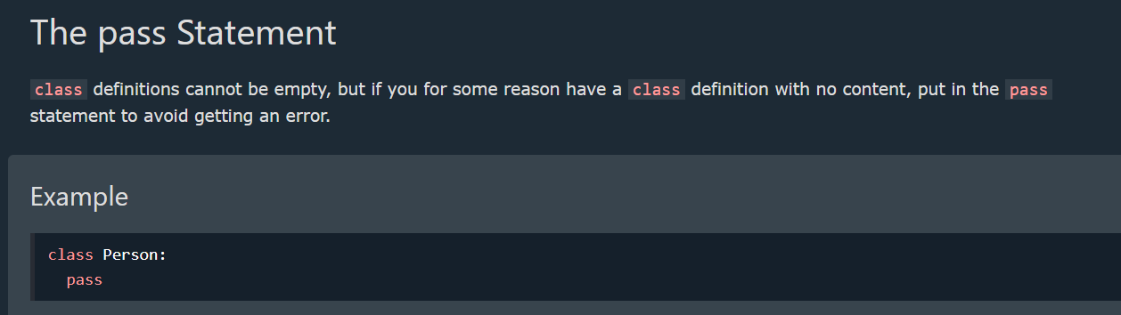

**Inheritance**

**What is Inheritance?**

Inheritance is a fundamental concept of Object-Oriented Programming (OOP) that allows one class (**child/subclass**) to inherit the attributes and methods of another class (**parent/base class**).

It enables **code reusability**, **hierarchical class organization**, and **extensibility** in programs.

**Types of Inheritance in Python**

Python supports five types of inheritance:

1. **Single Inheritance** – One child class inherits from one parent class.
2. **Multiple Inheritance** – A child class inherits from multiple parent classes.
3. **Multilevel Inheritance** – A child class inherits from another child class (grandparent → parent → child).
4. **Hierarchical Inheritance** – Multiple child classes inherit from a single parent class.
5. **Hybrid Inheritance** – A combination of two or more types of inheritance.

**1. Single Inheritance**

A child class inherits from a single parent class.

**Example: Single Inheritance**

# Parent class

class Animal:

def \_\_init\_\_(self, name):

self.name = name

def speak(self):

print("This animal makes a sound.")

# Child class inheriting from Animal

class Dog(Animal):

def speak(self): # Overriding parent method

print(f"{self.name} barks.")

# Creating an object of the child class

dog = Dog("Buddy")

dog.speak() # Output: Buddy barks.

✅ **Code reuse**: The Dog class inherits properties from Animal.  
✅ **Method Overriding**: The speak() method in Dog replaces the one in Animal.

**2. Multiple Inheritance**

A child class inherits from **two or more parent classes**.

**Example: Multiple Inheritance**

# Parent class 1

class Father:

def personality(self):

print("Father is disciplined.")

# Parent class 2

class Mother:

def nature(self):

print("Mother is caring.")

# Child class inheriting from both

class Child(Father, Mother):

def show\_traits(self):

self.personality() # Inherited from Father

self.nature() # Inherited from Mother

# Creating object

child = Child()

child.show\_traits()

# Output:

# Father is disciplined.

# Mother is caring.

✅ **Can inherit from multiple sources**.  
❌ **May cause conflicts** if the same method exists in multiple parent classes.

🔹 **Note**: Python follows the **Method Resolution Order (MRO)** to decide which method to call when multiple parent classes have methods with the same name.

**3. Multilevel Inheritance**

A child class inherits from another child class, forming a **chain of inheritance** (grandparent → parent → child).

**Example: Multilevel Inheritance**

# Grandparent class

class Grandparent:

def show\_grandparent(self):

print("I am the grandparent.")

# Parent class inheriting from Grandparent

class Parent(Grandparent):

def show\_parent(self):

print("I am the parent.")

# Child class inheriting from Parent

class Child(Parent):

def show\_child(self):

print("I am the child.")

# Creating an object of Child

child = Child()

child.show\_grandparent() # Output: I am the grandparent.

child.show\_parent() # Output: I am the parent.

child.show\_child() # Output: I am the child.

✅ **Creates a hierarchy of classes**.  
✅ **Allows gradual specialization of behaviors**.  
❌ **Too many inheritance levels** can make code complex and harder to manage.

**4. Hierarchical Inheritance**

Multiple child classes inherit from a **single parent class**.

**Example: Hierarchical Inheritance**

# Parent class

class Vehicle:

def general\_info(self):

print("Vehicles are used for transportation.")

# Child class 1

class Car(Vehicle):

def car\_info(self):

print("Cars have four wheels.")

# Child class 2

class Bike(Vehicle):

def bike\_info(self):

print("Bikes have two wheels.")

# Creating objects

car = Car()

car.general\_info() # Output: Vehicles are used for transportation.

car.car\_info() # Output: Cars have four wheels.

bike = Bike()

bike.general\_info() # Output: Vehicles are used for transportation.

bike.bike\_info() # Output: Bikes have two wheels.

✅ **Reduces code duplication** since multiple child classes use the same parent class.  
❌ **If changes are made in the parent class, all child classes may be affected**.

**5. Hybrid Inheritance**

A combination of multiple types of inheritance (e.g., Multiple + Multilevel).

**Example: Hybrid Inheritance**

# Parent class

class Engine:

def engine\_info(self):

print("Engine is essential for a vehicle.")

# Parent class 2

class Vehicle:

def vehicle\_info(self):

print("A vehicle is used for transportation.")

# Intermediate class (inherits from Engine and Vehicle)

class Car(Engine, Vehicle):

def car\_info(self):

print("Cars usually have 4 wheels.")

# Final subclass

class SportsCar(Car):

def sports\_car\_info(self):

print("Sports cars are fast.")

# Creating an object of SportsCar

sports\_car = SportsCar()

sports\_car.engine\_info() # Output: Engine is essential for a vehicle.

sports\_car.vehicle\_info() # Output: A vehicle is used for transportation.

sports\_car.car\_info() # Output: Cars usually have 4 wheels.

sports\_car.sports\_car\_info() # Output: Sports cars are fast.

✅ **Combines different types of inheritance for flexibility**.  
❌ **Can be complex** due to multiple parent-child relationships.

**Method Overriding in Inheritance**

A **child class can override** a method from its parent class by defining a method with the same name.

**Example: Overriding a Method**

class Parent:

def show\_message(self):

print("This is the parent class.")

class Child(Parent):

def show\_message(self): # Overriding parent method

print("This is the child class.")

child = Child()

child.show\_message() # Output: This is the child class.

✅ **Allows customization of behavior in child classes**.  
✅ **Parent class remains unchanged**.

**Using super() in Inheritance**

The super() function is used to **call a method from the parent class** inside the child class.

**Example: Using super()**

class Parent:

def show\_message(self):

print("This is the parent class.")

class Child(Parent):

def show\_message(self):

super().show\_message() # Call parent method

print("This is the child class.")

child = Child()

child.show\_message()

# Output:

# This is the parent class.

# This is the child class.

✅ **Avoids redundant code by reusing the parent class method**.

**Key Takeaways**

| **Feature** | **Description** |
| --- | --- |
| **Single Inheritance** | One child inherits from one parent. |
| **Multiple Inheritance** | One child inherits from multiple parents. |
| **Multilevel Inheritance** | Parent → Child → Grandchild. |
| **Hierarchical Inheritance** | One parent, multiple children. |
| **Hybrid Inheritance** | Combination of two or more inheritance types. |
| **Method Overriding** | Child class redefines a method from the parent. |
| **super() Function** | Calls a method from the parent class in the child class. |

**Polymorphism in Classes**

* Polymorphism allows methods in **different classes to have the same name but different behaviors**.
* Polymorphism means **"many forms."** It allows the **same function or method to be used for different types of objects**.

**Example of Polymorphism**

class Animal:

def make\_sound(self):

print("Some generic animal sound")

class Dog(Animal):

def make\_sound(self):

print("Woof!")

class Cat(Animal):

def make\_sound(self):

print("Meow!")

animals = [Dog(), Cat()]

for animal in animals:

animal.make\_sound() # Calls the respective method in each subclass

**Types of Polymorphism in Python**

1. **Method Overriding (Runtime Polymorphism)** – Child class redefines a method from the parent class.
2. **Method Overloading (Compile-time Polymorphism) – Not directly supported in Python** (handled using default arguments).
3. **Operator Overloading** – Using operators (+, \*, ==, etc.) with user-defined classes.
4. **Polymorphism with Functions and Classes** – Functions and methods working with different objects.

**1. Method Overriding (Runtime Polymorphism)**

A **child class provides its own implementation** of a method defined in the **parent class**.

**Example: Animals Making Sounds (Method Overriding)**

class Animal:

def make\_sound(self):

print("Animal makes a sound.")

class Dog(Animal):

def make\_sound(self): # Overriding parent method

print("Dog barks.")

class Cat(Animal):

def make\_sound(self): # Overriding parent method

print("Cat meows.")

# Creating objects

animals = [Dog(), Cat(), Animal()]

# Using polymorphism

for animal in animals:

animal.make\_sound()

**Output**

Dog barks.

Cat meows.

Animal makes a sound.

✅ **Method Overriding allows different classes to have different behaviors for the same method.**  
✅ **Achieves runtime polymorphism.**

**2. Method Overloading (Using Default Arguments in Python)**

Python does not **directly support** method overloading like Java or C++. However, we can **achieve it using default arguments or variable-length arguments**.

**Example: Addition Function (Method Overloading using Default Arguments)**

class MathOperations:

def add(self, a, b=0, c=0):

return a + b + c

math = MathOperations()

print(math.add(5)) # Output: 5

print(math.add(5, 10)) # Output: 15

print(math.add(5, 10, 20)) # Output: 35

✅ **Handles different numbers of arguments using default values.**  
✅ **No need to define multiple functions with different parameters.**

**3. Operator Overloading (Magic Methods in Python)**

Python allows us to **override operators** like +, -, \*, etc., by defining special methods like \_\_add\_\_(), \_\_sub\_\_(), etc.

**Example: Adding Two Custom Objects**

class Book:

def \_\_init\_\_(self, pages):

self.pages = pages

def \_\_add\_\_(self, other): # Overloading +

return Book(self.pages + other.pages)

def \_\_str\_\_(self):

return f"Total pages: {self.pages}"

book1 = Book(100)

book2 = Book(200)

book3 = book1 + book2 # Uses \_\_add\_\_()

print(book3) # Output: Total pages: 300

✅ **Allows arithmetic operations on user-defined objects.**  
✅ **Enhances the readability and usability of custom classes.**

**4. Polymorphism with Functions and Classes**

A single function can operate on **different types of objects** without modification.

**Example: A Common Function for Different Shapes**

class Circle:

def area(self, radius):

return 3.14 \* radius \* radius

class Square:

def area(self, side):

return side \* side

# Function using polymorphism

def print\_area(shape, value):

print(f"Area: {shape.area(value)}")

# Creating objects

circle = Circle()

square = Square()

# Calling function with different objects

print\_area(circle, 5) # Output: Area: 78.5

print\_area(square, 4) # Output: Area: 16

✅ **Function print\_area() works for both Circle and Square.**  
✅ **No need for separate functions for each shape.**

**Encapsulation in Python 🔒**

**Encapsulation** is one of the core principles of **Object-Oriented Programming (OOP)**. It refers to **hiding data (variables) and restricting direct access** to them. This helps in **data protection and better control** over the attributes of a class.

**🔹 1. Why Use Encapsulation?**

✅ **Protects Data** – Prevents accidental modification.  
✅ **Restricts Direct Access** – Variables are accessed through methods.  
✅ **Improves Code Maintainability** – Controlled access via getter & setter methods.

**🔹 2. Encapsulation in Python (Using Private Variables)**

In Python, we make variables **private** by using **double underscores (\_\_)** before the variable name.

class BankAccount:

def \_\_init\_\_(self, balance):

self.\_\_balance = balance # Private variable

def get\_balance(self): # Getter method to access private variable

return self.\_\_balance

def deposit(self, amount): # Public method to modify private variable

if amount > 0:

self.\_\_balance += amount

return f"Deposited {amount}. New balance: {self.\_\_balance}"

else:

return "Deposit amount must be positive"

# Creating an object

account = BankAccount(1000)

# Accessing private variable using getter method

print(account.get\_balance()) # ✅ Output: 1000

# Depositing money using public method

print(account.deposit(500)) # ✅ Output: Deposited 500. New balance: 1500

# Trying to access private variable directly (❌ Will not work)

# print(account.\_\_balance) # ❌ AttributeError: 'BankAccount' object has no attribute '\_\_balance'

**🔹 3. Accessing Private Variables (Name Mangling): ⚠️ Not recommended but possible**

Even though private variables cannot be accessed directly, Python allows access using **name mangling** (\_ClassName\_\_variable).

print(account.\_BankAccount\_\_balance) # ⚠️ Not recommended but possible

This is a **workaround**, but it **defeats the purpose of encapsulation**.

**🔹 4. Using Getter and Setter Methods**

We can use **getter and setter methods** to safely access and modify private variables.

class Student:

def \_\_init\_\_(self, name, age):

self.\_\_name = name

self.\_\_age = age

def get\_age(self): # Getter method

return self.\_\_age

def set\_age(self, new\_age): # Setter method

if new\_age > 0:

self.\_\_age = new\_age

else:

print("Age must be positive")

# Creating object

s1 = Student("Alice", 20)

print(s1.get\_age()) # ✅ Output: 20

s1.set\_age(25) # ✅ Modifying private variable safely

print(s1.get\_age()) # ✅ Output: 25

**🔹 5. Using @property Decorator (More Pythonic Way)**

Instead of defining get and set methods manually, Python provides **@property decorators**.

class Employee:

def \_\_init\_\_(self, salary):

self.\_\_salary = salary # Private variable

@property

def salary(self): # Getter method

return self.\_\_salary

@salary.setter

def salary(self, amount): # Setter method

if amount > 0:

self.\_\_salary = amount

else:

print("Salary must be positive")

# Creating object

e1 = Employee(50000)

print(e1.salary) # ✅ Output: 50000 (calls the getter method)

e1.salary = 60000 # ✅ Calls the setter method

print(e1.salary) # ✅ Output: 60000

e1.salary = -1000 # ❌ Output: "Salary must be positive"

**Abstraction in Python (OOPs) 🚀**

**Abstraction** is one of the core principles of **Object-Oriented Programming (OOP)**. It is the process of **hiding implementation details** and **showing only the necessary features** of an object.

**🔹 1. Why Use Abstraction?**

✅ **Hides unnecessary details** – Users don’t need to know how things work internally.  
✅ **Simplifies complex systems** – Makes code easier to maintain and use.  
✅ **Improves security** – Prevents direct modification of internal data.

**🔹 2. Abstraction in Python (Using Abstract Classes & Methods)**

Python provides **ABC (Abstract Base Class)** from the abc module to implement abstraction.

from abc import ABC, abstractmethod

class Animal(ABC): # Abstract Class

@abstractmethod

def make\_sound(self): # Abstract Method (No implementation)

pass

class Dog(Animal): # Concrete Class

def make\_sound(self):

return "Woof! Woof!"

class Cat(Animal): # Concrete Class

def make\_sound(self):

return "Meow! Meow!"

# Creating objects

dog = Dog()

cat = Cat()

print(dog.make\_sound()) # ✅ Output: Woof! Woof!

print(cat.make\_sound()) # ✅ Output: Meow! Meow!

# animal = Animal() ❌ Error: Cannot instantiate abstract class

**🔹 3. Explanation**

* ABC (Abstract Base Class) is used to create an **abstract class**.
* @abstractmethod forces **child classes** to implement the method.
* We **cannot create an object of an abstract class** (Animal in this case).
* Only **child classes (Dog, Cat) provide implementation** of make\_sound().

**🔹 4. Real-World Example: Payment System**

from abc import ABC, abstractmethod

class Payment(ABC): # Abstract Class

@abstractmethod

def process\_payment(self, amount):

pass

class CreditCardPayment(Payment): # Concrete Class

def process\_payment(self, amount):

return f"Processing credit card payment of ${amount}"

class PayPalPayment(Payment): # Concrete Class

def process\_payment(self, amount):

return f"Processing PayPal payment of ${amount}"

# Creating objects

payment1 = CreditCardPayment()

payment2 = PayPalPayment()

print(payment1.process\_payment(100)) # ✅ Output: Processing credit card payment of $100

print(payment2.process\_payment(200)) # ✅ Output: Processing PayPal payment of $200

**🔹 5. Key Differences Between Abstraction & Encapsulation**

**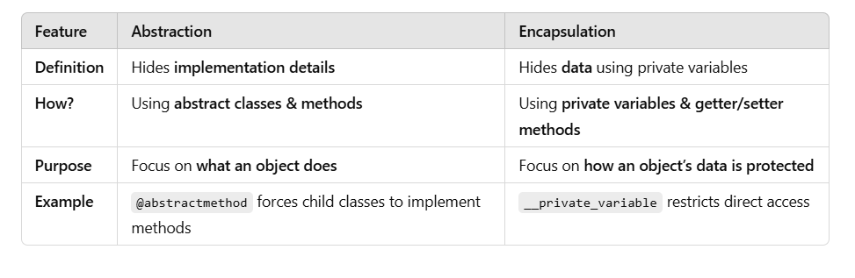**

**🚀 Summary**

✅ **Abstraction hides implementation details** using **abstract classes & methods**.  
✅ ABC (Abstract Base Class) & @abstractmethod **enforce method implementation** in child classes.  
✅ **Cannot create objects of abstract classes**.  
✅ **Real-world applications**: Payment systems, databases, frameworks, etc.

**OS Module in Python** 🖥️

Python has a built-in os module with methods for interacting with the operating system, like creating files and directories, management of files and directories, input, output, environment variables, process management, etc.

**1. Importing the OS Module**

import os

**2. Working with the File System**

**2.1. Get the Current Working Directory**

print(os.getcwd()) # Output: Current directory path

**2.2. Change the Current Directory**

os.chdir("/path/to/directory") # Change working directory

print(os.getcwd()) # Verify the change

**2.3. List Files and Directories**

print(os.listdir()) # Lists files & folders in current directory

print(os.listdir("/path/to/directory")) # List files in a specific directory

**2.4. Create a Directory**

os.mkdir("new\_folder") # Creates a folder

**Create multiple directories (Nested Folders)**

os.makedirs("parent\_folder/child\_folder")

**2.5. Remove a Directory**

os.rmdir("new\_folder") # Removes a folder (only if empty)

**Remove multiple directories**

os.removedirs("parent\_folder/child\_folder")

**2.6. Rename a File or Directory**

os.rename("old\_name.txt", "new\_name.txt") # Renames a file

os.rename("old\_folder", "new\_folder") # Renames a directory

**3. Working with Files**

**3.1. Check if a File Exists**

print(os.path.exists("example.txt")) # Output: True/False

**3.2. Check if a Path is a File or Directory**

print(os.path.isfile("example.txt")) # True if it's a file

print(os.path.isdir("my\_folder")) # True if it's a directory

**3.3. Get File Size**

print(os.path.getsize("example.txt")) # Output: Size in bytes

**3.4. Get Absolute Path**

print(os.path.abspath("example.txt"))

**4. Environment Variables**

**4.1. Get an Environment Variable**

print(os.environ.get("HOME")) # Output: Home directory (Linux/Mac)

print(os.environ.get("USERNAME")) # Output: Username (Windows)

**4.2. Set an Environment Variable**

os.environ["MY\_VARIABLE"] = "Hello, World!"

print(os.environ["MY\_VARIABLE"]) # Output: Hello, World!

**5. Executing System Commands**

**5.1. Run a Shell Command**

os.system("ls") # Linux/Mac - List files

os.system("dir") # Windows - List files

**5.2. Open a File Using Default Application**

os.startfile("example.txt") # Windows

os.system("open example.txt") # Mac

os.system("xdg-open example.txt") # Linux

**6. Process Management**

**6.1. Get Process ID**

print(os.getpid()) # Output: Current process ID

**6.2. Get Parent Process ID**

print(os.getppid()) # Output: Parent process ID

**6.3. Create a Child Process**

pid = os.fork() # Only on Linux/macOS

if pid == 0:

print("Child process")

else:

print("Parent process")

**7. Path Operations with os.path**

The os.path module helps in handling **file paths**.

**7.1. Join Paths**

path = os.path.join("folder", "file.txt")

print(path) # Output: folder/file.txt (Linux/Mac) or folder\file.txt (Windows)

**7.2. Get File Extension**

print(os.path.splitext("example.txt")) # Output: ('example', '.txt')

**7.3. Get Directory Name**

print(os.path.dirname("/path/to/file.txt")) # Output: /path/to

**7.4. Get Base File Name**

print(os.path.basename("/path/to/file.txt")) # Output: file.txt

**8. Summary of OS Module Functions**

| **Function** | **Description** |
| --- | --- |
| os.getcwd() | Get current directory |
| os.chdir(path) | Change directory |
| os.listdir(path) | List files & directories |
| os.mkdir(name) | Create a directory |
| os.rmdir(name) | Remove an empty directory |
| os.rename(old, new) | Rename file/directory |
| os.path.exists(path) | Check if path exists |
| os.path.isfile(path) | Check if it’s a file |
| os.path.isdir(path) | Check if it’s a directory |
| os.environ.get(var) | Get environment variable |
| os.system(command) | Run shell command |
| os.getpid() | Get process ID |

**Conclusion**

The os module is powerful for file handling, directory management, environment variables, and system commands. Would you like practice exercises or a mini-project using the os module? 🚀

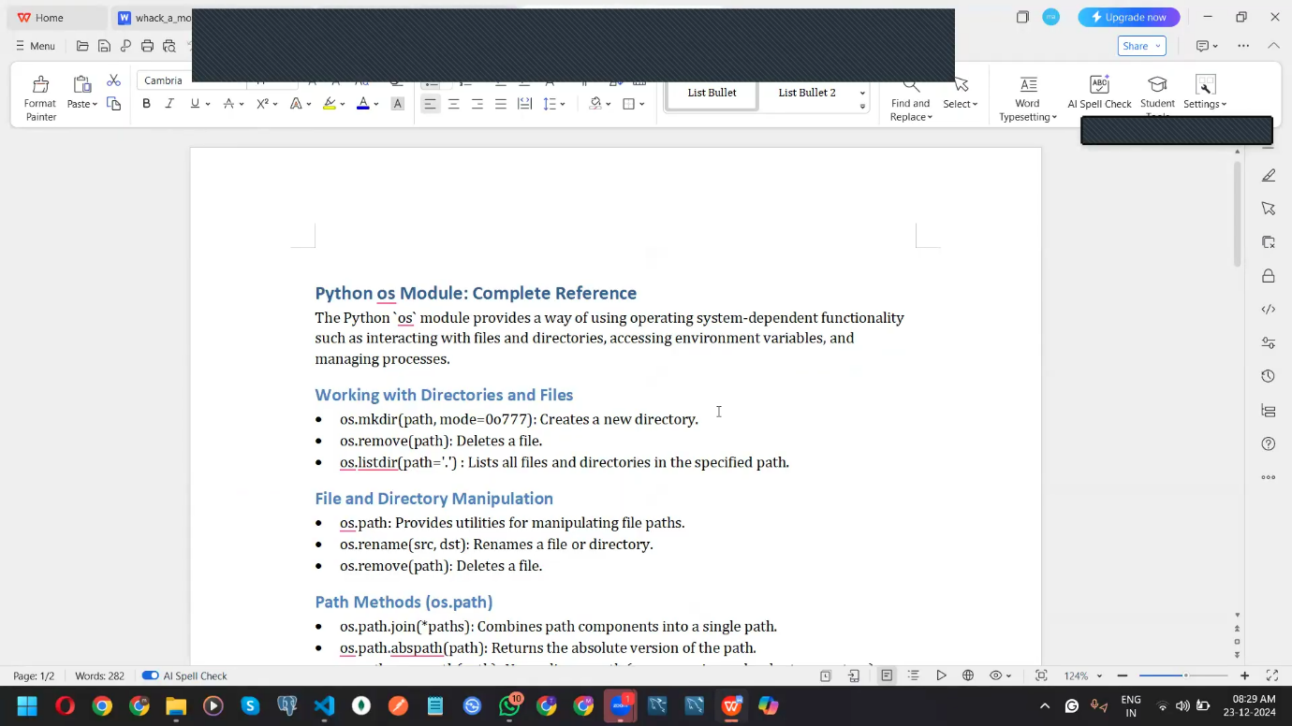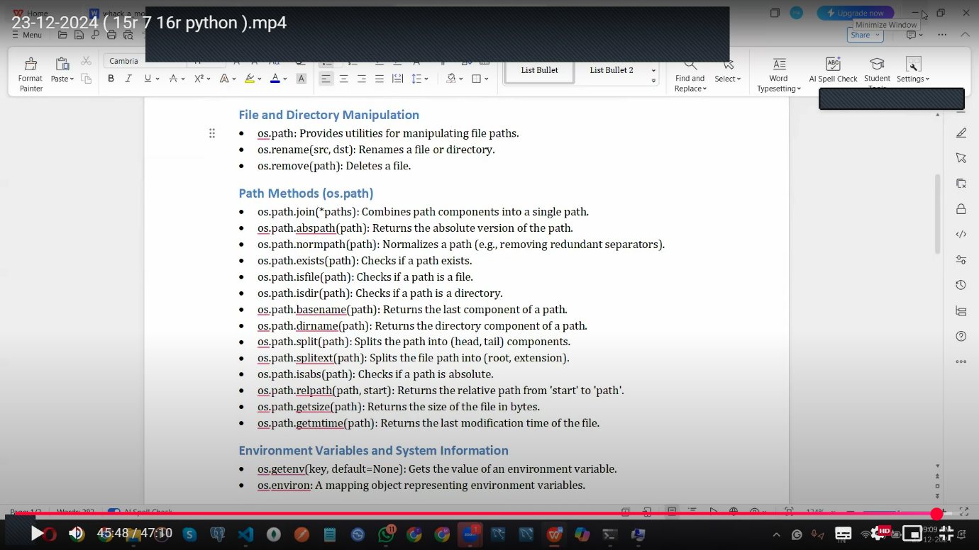

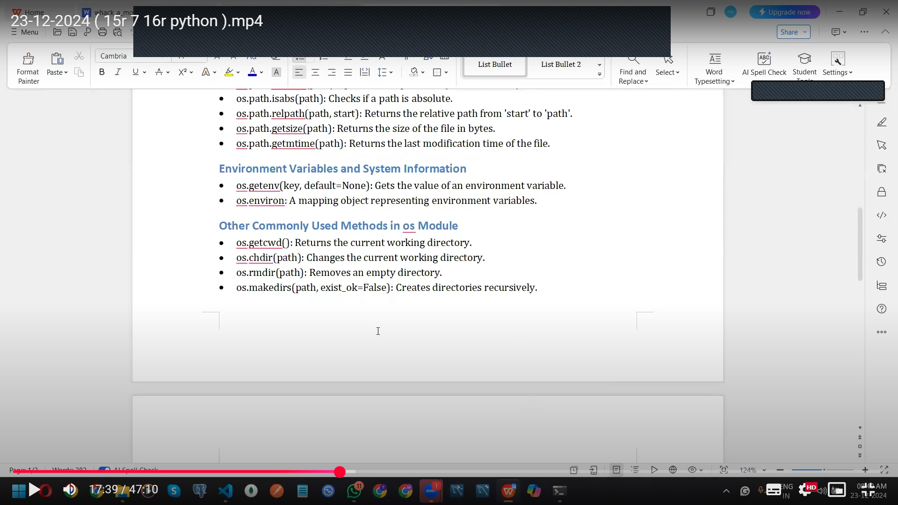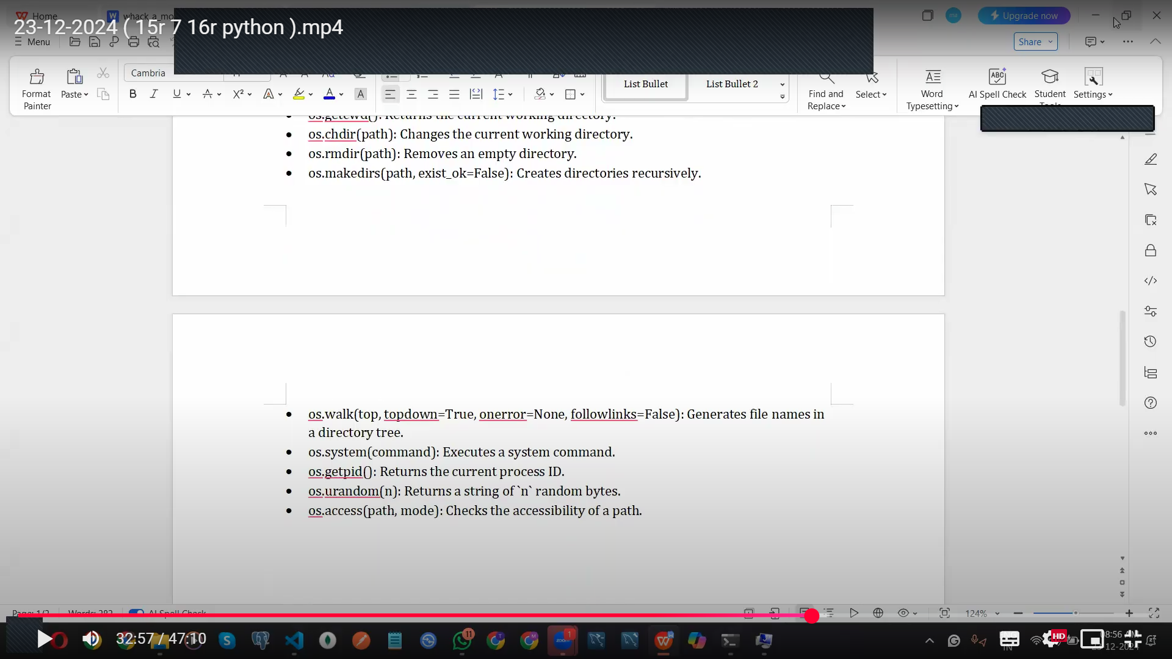

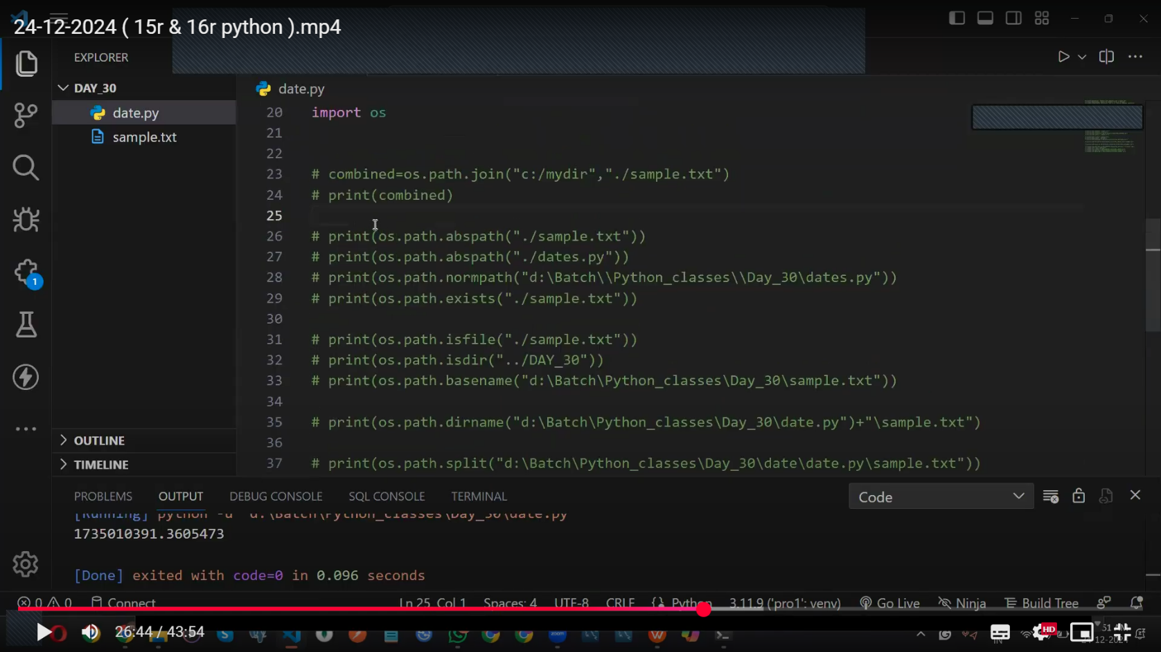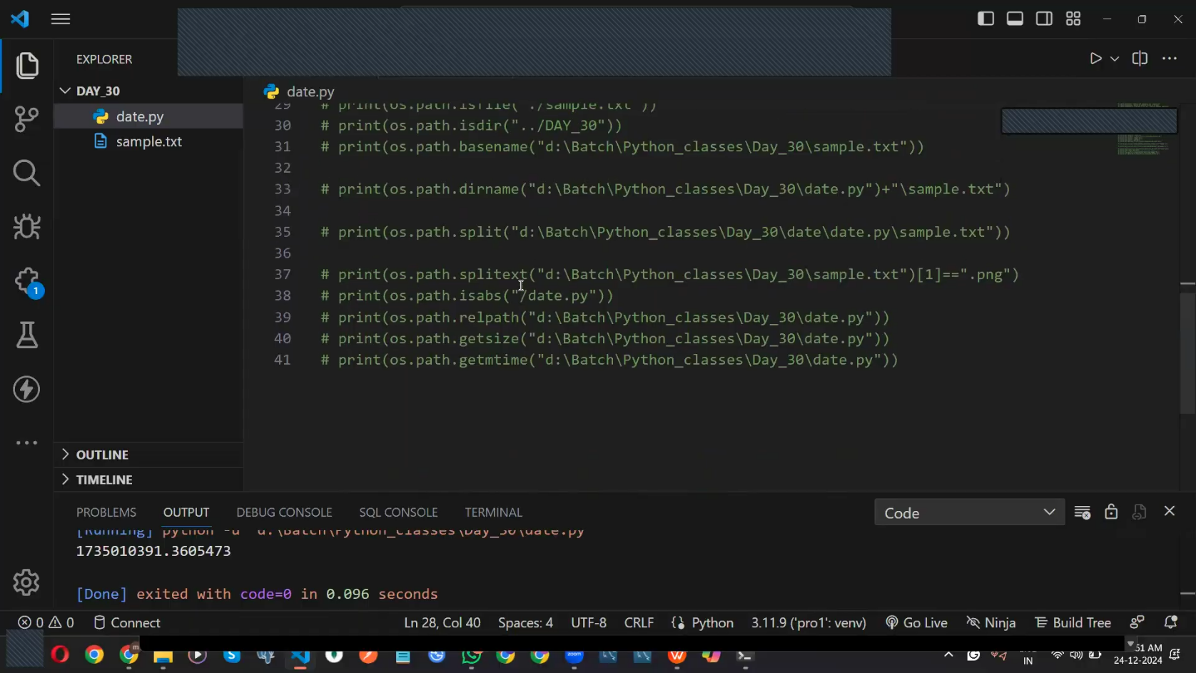

**datetime Module in Python**

The datetime module in Python provides classes and functions to work with **dates, times, and time intervals**.

The datetime module in Python is used to **work with dates and times**. It allows you to get the current date/time, format it, perform date arithmetic, and more.

**1. Importing the Module**

import datetime

**2. Getting Current Date and Time**

now = datetime.datetime.now()

print(now) # Example: 2025-04-04 21:00:30.123456

To get only the **date** or **time**:

print(now.date()) # 2025-04-04

print(now.time()) # 21:00:30.123456

**3. Get Today’s Date**

today = datetime.date.today()

print(today) # Example: 2025-04-04

**4. Create a Specific Date or Time**

my\_date = datetime.date(2025, 12, 25)

print(my\_date) # 2025-12-25

my\_time = datetime.time(14, 30, 0)

print(my\_time) # 14:30:00

**5. Date Arithmetic (Add/Subtract Days)**

Use timedelta for date calculations:

from datetime import timedelta

today = datetime.date.today()

tomorrow = today + timedelta(days=1)

yesterday = today - timedelta(days=1)

print("Today:", today)

print("Tomorrow:", tomorrow)

print("Yesterday:", yesterday)

**Date Arithmetic (Timedelta)**

**➤ Creating a timedelta**

from datetime import timedelta

delta = timedelta(days=5, hours=3)

print(delta) # 5 days, 3:00:00

**➤ Adding/Subtracting dates**

now = datetime.now()

future = now + timedelta(days=7)

past = now - timedelta(days=30)

print(future) # 7 days from now

print(past) # 30 days ago

**6. Formatting Date and Time (strftime)**

Convert a datetime object to a string format:

from datetime import timedelta

now = datetime.datetime.now()

formatted = now.strftime("%Y-%m-%d %H:%M:%S")

print(formatted) # 2025-04-04 21:03:00

print(now.strftime("%Y-%m-%d")) # 2025-04-04

print(now.strftime("%d/%m/%Y")) # 04/04/2025

print(now.strftime("%I:%M %p")) # 02:23 PM

print(now.strftime("%A, %B %d")) # Friday, April 04

| **Format Code** | **Meaning** | **Example** |
| --- | --- | --- |
| %Y | Year (4 digits) | 2025 |
| %m | Month (01 to 12) | 04 |
| %d | Day of the month | 04 |
| %H | Hour (24-hour) | 14 |
| %I | Hour (12-hour) | 02 |
| %p | AM or PM | PM |
| %A | Full weekday name | Friday |
| %B | Full month name | April |

**7. Parsing Date String (strptime)**

Convert a string into a datetime object:

from datetime import datetime

date\_string = "25/12/2023 10:30 AM"

parsed\_date = datetime.strptime(date\_string, "%d/%m/%Y %I:%M %p")

print(parsed\_date) # Output: 2023-12-25 10:30:00

**8. Get Day, Month, Year, etc.**

now = datetime.datetime.now()

print(now.year) # 2025

print(now.month) # 4

print(now.day) # 4

print(now.hour) # 21

print(now.minute) # 0

**9. Working with date and time classes**

**➤ date object (only date)**

from datetime import date

today = date.today()

print(today) # Output: 2025-04-04

print(today.year) # 2025

**➤ time object (only time)**

from datetime import time

t = time(10, 45, 30)

print(t) # Output: 10:45:30

print(t.hour) # 10

**10. Get Day of the Week**

today = datetime.today()

print(today.strftime("%A")) # Output: Friday

# Using weekday() method

print(today.weekday()) # Output: 4 (Monday=0, Sunday=6)

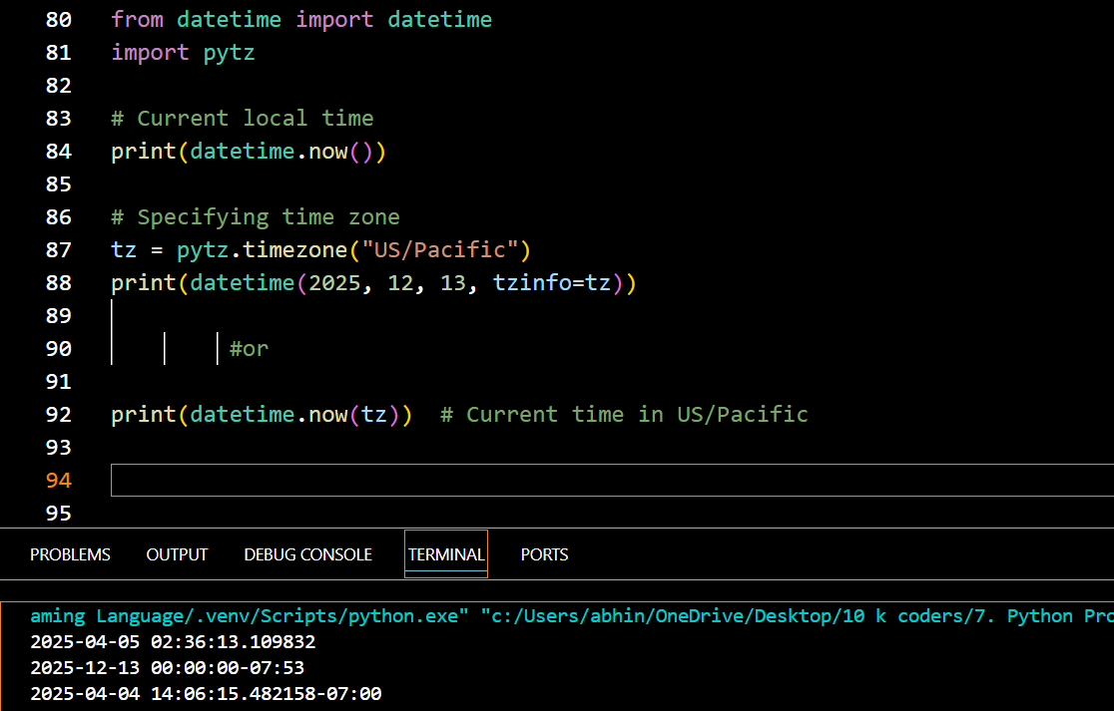

**✅ Summary Table**

| **Function / Class** | **Description** |
| --- | --- |
| datetime.now() | Current date and time |
| datetime.today() | Today's date |
| datetime.strptime() | Parse string to datetime |
| datetime.strftime() | Format datetime to string |
| datetime(year, m, d, h, m) | Create custom datetime object |
| date.today() | Returns current date |
| timedelta(days=, hours=) | Create time difference |
| datetime + timedelta | Future date |
| datetime - timedelta | Past date |

**💡 Real-World Example: Countdown Timer**

from datetime import datetime, timedelta

event\_date = datetime(2025, 12, 31, 23, 59)

now = datetime.now()

remaining = event\_date - now

print(f"Time remaining for New Year: {remaining.days} days and {remaining.seconds // 3600} hours")

Would you like a **mini-project using datetime** like a digital clock, birthday countdown, or age calculator? ⏳

**Database connection**